3GPP TSG SA WG5 Meeting 136-e S5-212091

electronic meeting, online, 01 March – 09 March

Source: Nokia, Nokia Shanghai Bell

Title: Add Conceptual description of an intent Driven Management Service

Document for: Approval
Agenda Item: 6.4.10

1 Decision/action requested
The group is asked to discuss and approve proposed changes

2 References
[1] 3GPP draft TS 28.312: “Management and orchestration; Intent driven management services for mobile networks v0.2.0”.

3 Rationale

This contribution proposes to add a conceptual description of an intent Driven Management Service
.

4 Detailed proposal
It proposes to make the following changes to TS 28.312[1].
1st Change

4 Concepts and Background
Editor's note: this clause will contain concepts and overview information relevant to the intent driven management.

4.1 Intent concept

4.1.1 Introduction
An intent specifies the expectations including requirements, goals and constraints for a specific service or network management workflow. The intent may provide information on particular objectives and possibly some related details. Following are some general concepts for intents:
- An intent is typically understandable by humans, and also needs to be interpreted by the machine without any ambiguity.
- An intent may be declarative or imperative, to focus more on describing the “What” needs to be achieved but less on “How” that outcomes should be achieved. A declarative intent expresses the metrics that need to be achieved and not how to achieve them while an imperative intent states the task to do and not the steps how the task should be accomplished. This not only relieves the burden of the consumer knowing implementation details but also leaves room to allow the producer to explore alternative options and find optimal solutions. Intent describes the properties that allows a satisfactory outcome.
- The expectations expressed by an intent is agnostic to the underlying system implementation, technology and infrastructure. Area can be used as managed object in the expectations expressed by an intent to achieve system implementation, technology and infrastructure agnostic.
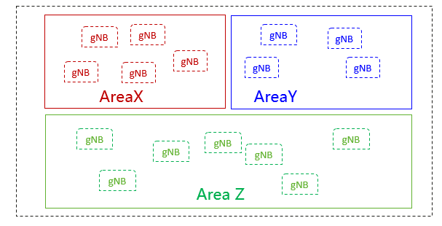
- An intent needs to be quantifiable from network data so that the fulfilment result can be measured and evaluated.

- Intent can be categorized based on different user types or different management scenario types.

4.1.2 Intent categorizes based on user types
Based on roles related to 5G networks and network slicing management defined in clause 4.8 in TS 28.530[X], different kinds of intents are applicable for different kinds of standardized reference interfaces.
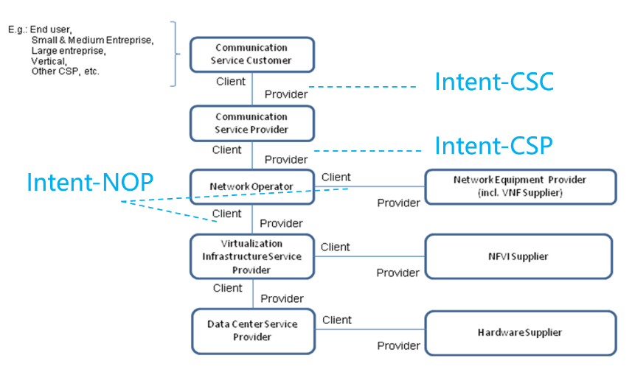
Figure 4.1.2-1: High-level model of different kind of intents expressed by different roles
- Intent from Communication Service Customer (Intent-CSC): Intent from Communication Service Customer enables Communication Service Customer (CSC) to express which properties of a communication service the CSC may request from CSP without knowing how to do the detailed management for communication service. For example, Intent-CSC can be 'Enable a V2X communication service for a group of vehicles in certain time'.
- Intent from Communication Service Provider (Intent-CSP): Intent from Communication Service Provider enables Communication Service Provider (CSP) to express an intent about what CSP would like to do for network without knowing how to do the detailed management for network. For example, Intent-CSP can be 'Provide a network service supporting V2X communications for highway-417 to support 500 vehicles simultaneously'.
- Intent from Network Operator (Intent-NOP): Intent from Network Operator enables Network Operator (NOP) to provide what NOP would like to do for group of network elements (i.e. subnetwork) management and control without knowing how to do the detailed management for the network elements. For example, Intent-NOP can be 'Provide a radio network service to satisfy the specified coverage requirements and UE throughput requirement in certain area'.

4.1.3 Intent categorizes based on management scenario types
Different types of intents are applicable for different types of management scenarios.
- Intent for network and service design/planning: Editor’s Note: The Intent for network and service design/planning is FFS.
- Intent for network and service deployment: enables a consumer to express the network or service instance to be deployed. Examples of intent for network and service deployment are “Provisioning radio network in the specified area with specified frequency information, transport information, and radio information (e.g. range of PCI, Cell Id), network capacity and performance information” or “provisioning radio service in the specified area with certain service characteristics (e.g. SLS)”.
- Intent for network and service assurance: enables a consumer to express intents for network and service assurance, and the following two sub-groups:
  - Intent for network and service maintenance: enables a consumer to express the network and service status (e.g. performance, alarm, issue) to be monitored or the network and service issues to be addressed. Examples of intent for network and service maintenance are “Monitoring coverage performance in the specified area by geographic grid granularity” or “Addressing the certain weak coverage issues in specified area”.
  - Intent for network and service optimization/assurance: enables a consumer to express the performance objectives of network and service to be improved. Examples of intent for network and service optimization are “Optimize radio network in the specified area with certain RAN UE throughput objectives (e.g. target average RAN UE DL throughput, target percentage of UE with the RAN UE DL throughout less than 5Mbps)” or “Optimize radio network in the specified area with certain coverage objectives (e.g. target coverage ratio, target average RSRP)”.

4.2 Framework for Intent Driven Management

4.2.1 Components in an Intent Driven Management System
In an Intent-driven Management System, the consumer provides its intent to the domain that is the producer of a set of management services that would otherwise be consumed. For example, the set provisioning MnSs to decommission a cell and instantiate the cell to a new Node B could be achieved by stating the intent to “rehome the cell”. The alternative management service produced by the domain is what may be referred to as the Intent-driven MnS.
The producer of an Intent-driven MnS shall allow the consumer to manage the service and /or network resources through the use of intents. The producer shall, as illustrated by Figure 4.2.1-1, support the capabilities for intent fulfilment, which include the following:
- The consumer states the intent as a job to be fulfilled and the producer receives and acknowledges the receipt of the intent job
- The producer decomposing the job to identify the required internal logic needed to fulfil the job
- The producer executing the compiled logic to fulfil the job using existing standardized services and interfaces.
- The producer may report about the fulfilment of the job
Figure 4.2.1-1: Framework for specification and fulfilment of intents

4.2.2 Intent driven MnS
Introduction of service-based architecture for 5G, in combination with functional model of business roles, exceeds the level of complexity for managing network in different scenarios (including scenarios for design/planning, deployment, maintenance and optimization) both in a single and multivendor network. New/simpler ways of managing are needed.
Actions of an intent driven MnS related to the lifecycle of intents may be categorized as intent fulfilment and intent assurance. Intent fulfilment refers to the steps taken in context of receiving a new intent or an update to an existing intent. The goal of intent fulfilment is to bring the network or service’s state to satisfy the new or updated intent. The lifecycle of some intents may end at the fulfilment case, if the intent’s goal simply describes the availability or presence of a service. In other cases, the intent’s goal describes the assurance requirements for a network or service (e.g., quality of service, end user experience, SLS, etc.) in addition to the need of existence of a service. Those intents have their lifecycle tied to the operation of the referred service or network function and may require frequent recurring actions to keep those assurance requirements achieved. This part of the intent lifecycle is referred to as intent assurance.
An Intent driven MnS allows its consumer to express intents for managing the network and services and obtain the feedback of intent evaluation result. The Intent-driven MnS producer have the following capabilities:
- Validate the intent, including at least
- Translate the received intent to executable actions as follows:
- Performing service or network management tasks
- Identifying, formulating and activating service or network management policies
- Evaluate the result/information about the intent fulfilment (e.g. the intent is initially satisfied or not) and intent assurance (e.g., the intent is continuously satisfied)..
The following figure 4.2-1 shows the model of Intent-driven MnS.
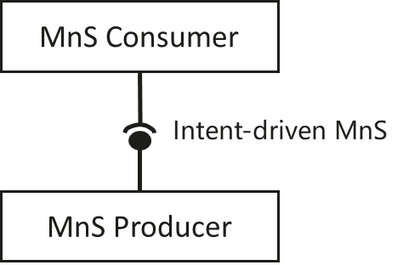
Figure 4.2-1: Intent-driven MnS
The MnS of various kinds are specified for deployment over many standardized reference interfaces. So, the Intent-driven MnS could in principle, be specified for deployment over the same set of standardized reference interfaces, as a replacement of or as an addition to the deployed non-Intent driven MnS. The intents may be fulfilled by utilizing multiple mechanisms including among others: Rule-based mechanisms that evaluate fixed rules to match the intent to internal logic that achieves the desired outcomes, closed loop mechanisms that continuously evaluate the degree to which the intent is satisfactorily achieved and AI/ML based systems that over time evaluates how to achieve the intents expected outcomes. If the intent is modelled, the intent may be accomplished using multiple services including the intent driven MnS. The internal implementation of the intent fulfilment will however not be standardized.

4.3 Example use of Intents: Intent driven closed-loop
Intent can be used for management and control of closed-loop automation (e.g. intent can be used to specify the goals for the closed-loop), which means the intent can be translated to policies and management tasks that the MnS producer needs to execute for the closed-loop automation. In the intent driven management approach, the mechanisms that the MnS producer uses for closed-loop automation to satisfy the intent is the implementation of the MnS producer and shall not be standardized. The relation of the Intent Driven MnS and the closed-loop automation within the Intent driven MnS producer is shown in the figure 4.3-1.
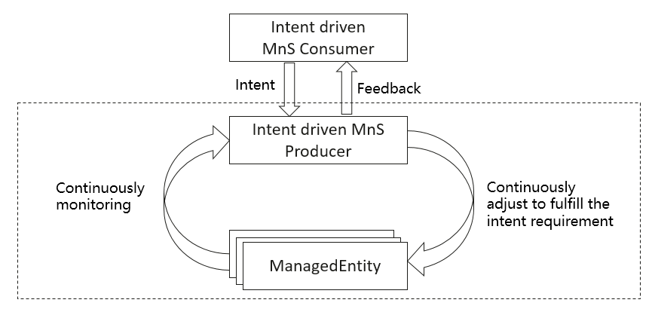
Figure 4.3-1 Intent driven closed-loop

4.4 Relation between the policy driven management and intent driven management
An intent specifies the expectations including requirements, goals, and constraints for a specific service or network management workflow, while a policy specifies the action(s) to be taken when given condition occurs. For certain scenarios, policies can be used in conjunction with intents to achieve the autonomous purposes. Figure 4.4-1 describes the relation between the policy and intent in the “what-how” view. As it now stands, the telecom systems are mainly focused on "how" and "less what". The current 5G networks brings more operational complexities, and the telecom system need to be able to adapt their operation to the business objectives of the operator as well as expectations of customer, which is driving customer to shift the focus from "how" to "what". The first step towards that shift, has been "Policy driven management", with more focus on "how" and less on "what" covering domain specific issues/aspects (an example for policy is when the average throughput is lower than certain threshold, take specified actions). As technologies are evolving and the level of complexity exceeds, the need for an abstraction level description (i.e. Intent) becomes more apparent (an example for intent is the target average throughput for certain area should be assured). An intent driven system will be able to learn the behaviour of networks and services and allows a customer to provide the desired state, without detailed knowledge of how to get to the desired state.

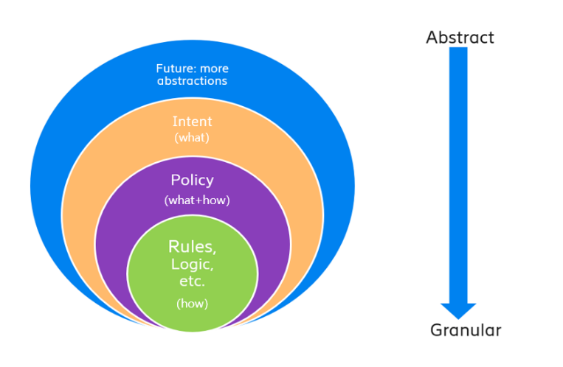
Figure 4.4-1: Relation between the policy and intent

End of changes

