3GPP TSG-SA5 Meeting #135-e S5-211209rev3

electronic meeting, online, 25 January - 3 February 2021

Source: CATT

Title: pCR Add possilbe solution for ProSe Direct Discovery

Document for: Approval

Agenda Item: 7.5.3

1 Decision/action requested
The group is asked to discuss and agree on the proposal.

2 References
[1] 3GPP TR 32.846: “Study on charging aspects of Proximity-based Services in 5GS”.

3 Rationale
SA2 study has concluded some apects for 5G ProSe Direct Discovery.
This contribution adds possible solutions for ProSe Direct Discovery.

4 Detailed proposal
1st Modified Section

2 References
The following documents contain provisions which, through reference in this text, constitute provisions of the present document.
- References are either specific (identified by date of publication, edition number, version number, etc.) or non-specific.
- For a specific reference, subsequent revisions do not apply.
- For a non-specific reference, the latest version applies. In the case of a reference to a 3GPP document (including a GSM document), a non-specific reference implicitly refers to the latest version of that document in the same Release as the present document.
[1] 3GPP TR 21.905: "Vocabulary for 3GPP Specifications".
[2] 3GPP TS 23.287: "Architecture enhancements for 5G System (5GS) to support Vehicle-to-Everything (V2X) services".
[3] 3GPP TR 23.752: “Study on system enhancement for Proximity based Services (ProSe) in the 5G System (5GS)”.
[4] 3GPP TS 32.277: "Proximity-based Services (ProSe) charging".
[5] 3GPP TS 32.240: "Telecommunication management; Charging management; Charging architecture and principles ".
[6] 3GPP TS 32.290: "Telecommunication management; Charging management; 5G system; Services, operations and procedures of charging using Service Based Interface (SBI)"
[7] 3GPP TS 23.501: "System Architecture for the 5G System; Stage 2".
[8] 3GPP TS 23.303: "Proximity-based services (ProSe); Stage 2".
[9] 3GPP TS 22.115: "Service aspects; Charging and billing".
[x] 3GPP TS 28.201: "Charging management; Network slice performance and analytics charging in the 5G System (5GS); Stage 2".
[y] 3GPP TS 23.304: "Proximity based Services (ProSe) in the 5G System (5GS)".

Next Modified Section

6.1.4.x Solution #1.1: ProSe Direct Discovery charging for Announce Request charging for Key issues #1.1

6.1.4.x.1 Consideration for ProSe Direct Discovery charging for Announce Request
5G DDNMF is defined to manage the dynamic ProSe Direct Discovery. Functionalities of the 5G DDNMF and the interactions with the UEs are similar to that of the DDNMF defined in TS 23.303 [8].
The Charging Enablement Function (CEF) is defined in TS 28.201 [x], for ProSe converged charging the CEF could be a consumer of NF service provider for ProSe (e.g.,5G DDNMF) and charging (Nchf) service provider.
ProSe Direct Discovery Announce Request allows a 5G ProSe-enabled UE to request a set of ProSe App Code from the 5G DDNMF, with associated validity timer and security materials, to announce over the air. Charging Data Request[Event] is triggered for Announcing UE after DDNMF responds to the Discovery Request or to the Announce Authorization message.
The 5GS shall collect the following minimum charging information:
Information Element | Description
UE identity | The identity of the ProSe UE
Serving PLMN ID | PLMN identity of the serving PLMN which signalled the carrier frequency
Announcing PLMN ID | This field holds PLMN identity of PLMN for UE to be monitored in monitor/match report procedure
Monitored PLMN ID | This field holds PLMN identity of PLMN for UE requested to be monitored in monitor/match report procedure
ProSe Application ID | The identities used for ProSe Direct Discovery, identifying application related information for the ProSe-enabled UE
Application ID | A globally unique identifier identifying a specific 3rd party application
Direct Discovery Model | Model of the Direct Discovery used by the UE, e.g. Model A, or Model B.
ProSe Event Type | This IE holds the event which triggers the charging message delivery, e.g. Announce, Monitor, Match Report
ProSe Request Timestamp | The time when ProSe Request is received from UE.
PC5 Radio Technology | The PC5 radio technology used by UE for ProSe Direct Discovery
Figure 6.1.4.x.1-1 Structure of the ProSe Discovery Information
Editor's note: Whether other information elements are needed is FFS.

6.1.4.x.2 Architecture Description
A set of trigger conditions are defined for the 5G DDNMF (CTF) or CEF to invoke a Charging Data Request [Event] towards the CHF.
The converged charging architecture is proposed for the event based charging for 5GS ProSe under the alternatives：
- Charging Trigger Function (CTF) based, as depicted in figure 6.1.4.1.2-1.
- Charging Enablement Function (CEF) based, depicted in figure 6.1.4.1.2-2.

Figure 6.1.4.x.2-1: The Converged Charging System (CTF)
Figure 6.1.4.x.2-2: The Converged Charging System (CEF)

6.1.4.x.3 Flow Description
6.1.4.x.3.1 Message flows with CTF
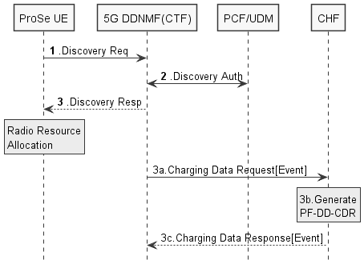
Figure 6.1.4.x.3.1: Message flow for ProSe Direct Discovery Announce Request - CTF (non-roaming)
The detailed description for the message flow will be defined in TS 23.304[y].
1-2. These steps are the same as the ProSe Direct Discovery will be defined in TS 23. 304 [y].
3. The 5G DDNMF responds with a Discovery Response with:
- (ProSe Application Code, validity timer, PC5_tech) for open discovery.
- (ProSe Application Code, ProSe Restricted Code/ ProSe Restricted Code Prefix[ProSe Restricted Code Suffix pool], validity timer, Discovery Entry ID, Announcing Enabled indicator, PC5_tech) for restricted discovery.
3a. The 5G DDNMF triggers Charging Data Request[Event] to CHF in HPLMN where event represents Announce. The PF-DD-CDR is generated by CHF for Announcing UE.
3b. The CHF creates a CDR for this Announcing UE.
3c. The CHF returns Charging Data Response corresponding to the received Charging Data Request[Event].

6.1.4.x.3.2 Message flows with CEF
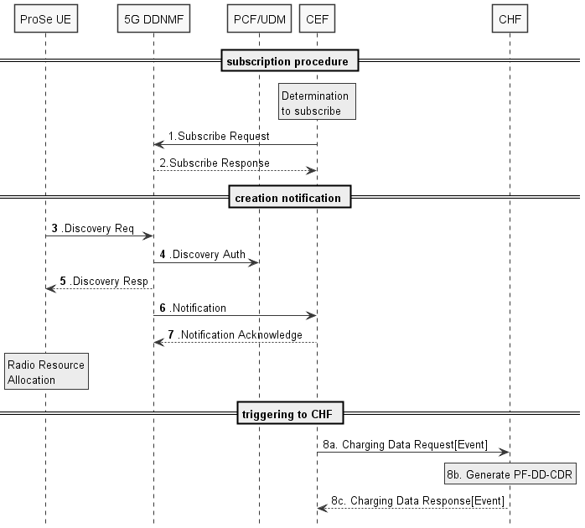
Figure 6.1.4.x.3.2: CEF-Message flow for ProSe Direct Discovery Announce Request (non-roaming)
1. Determination by CEF to subscribe to ProSe Direct Discovery Service.
2. Subscribe Request: the CEF subscribes to 5G DDNMF.
3-5. These steps are the same as the ProSe Direct Discovery will be defined in TS 23.304[y].
6. Notification: DDNMF notifies the CEF that ProSe Direct Discovery message has been processed.
7. Notification Acknowledge sent by the CEF.
8-a. The CEF sends Charging Data Request [Event] to CHF associated to the event represents Announce.
8-b. The CHF creates a CDR for this Announcing UE.
8-c. The CHF acknowledges by sending Charging Data Response to the CEF.
Editor’s Note: It is FFS for how 5G DDNMF works as ProSe Direct Discovery Service Provider.

6.1.4.x.4 Solution evaluation
TBD
Next Modified Section

6.1.4.y Solution #1.2: ProSe Direct Discovery charging for Public Safety for Key issues #1.1

6.1.4.y.1 Consideration for ProSe Direct Discovery charging for Public Safety
Regarding group discovery/management to support public safety, pre-configured or provisioned information can be used for the ProSe Direct Discovery procedure as specified in TS 23.303 [9] clause 5.3.7 (Direct Discovery for Public Safety use). When the UE decides that reporting criteria are met, according to the pre-configuration, the UE creates the corresponding usage information report to Network.
5G DDNMF is defined to manage the dynamic ProSe Direct Discovery. Functionalities of the 5G DDNMF and the interactions with the UEs are similar to that of the DDNMF defined in TS 23.303 [8].
The Charging Enablement Function (CEF) is defined in TS 28.201 [x], for ProSe converged charging the CEF could be a consumer of NF service provider for ProSe (e.g.,5G DDNMF) and charging (Nchf) service provider.
Besides the information list in Figure 6.1.4.x.1-1, the 5GS shall collect the following charging information:

Information Element | Description
User Location Information | The location of the UE
UE identity | The identity of the ProSe UE
Serving PLMN ID | PLMN identity of the PLMN which signalled the carrier frequency
ProSe Relay UE ID | A link layer identifier that uniquely represents the ProSe UE-to-Network Relay UE
ProSe Target Layer-2 ID | The identifier of target UE, uniquely represents a specific one-to-one or one-to-many discovery/communication
ProSe Group IP multicast address | The IP multicast address to be used for performing ProSe direct discovery/communication.
Coverage Info | This IE provides information on the coverage status (i.e., whether the UE is served by NG-RAN or not) and the time when the coverage status changed to its current state.
Radio Resources indicator | This IE identifies whether the operator-provided radio resources or the configured radio resources were used for ProSe direct discovery /communication
Usage Data Container | This field holds the container associated to a trigger conditions (e.g. go out of coverage, come back to coverage, etc.) on a specific ProSe communication
Figure 6.1.4.y.1-1 Structure of the ProSe Discovery Information for Public Safety
Editor's note: The information could also be used when Direct Communication, it is FFS for whether more information elements are needed.

6.1.4.y.2 Architecture Description
Regarding the PC5 usage reporting from the UE, the CTF is divided into two functional blocks as described in Annex D of TS 32.240 [1]. The Accounting Metrics Collection (AMC) function block is in the UE. The AMC sends usage information collected to the Accounting Data Forwarding (ADF) function block. Upon reception of the event, CTF(ADF) or CEF could generate Charging Data Request [Event] and forward them to CHF.
The converged charging architecture is proposed for the event based charging for 5GS ProSe under the alternatives：
- Charging Trigger Function (CTF) based, as depicted in figure 6.1.4.y.2-1.
- Charging Enablement Function (CEF) based, depicted in figure 6.1.4.y.2-2.

Figure 6.1.4.y.2-1: The Converged Charging System (CTF)
Figure 6.1.4.y.2-2: The Converged Charging System (CEF)

6.1.4.y.3 Flow Description
6.1.4.y.3.1 Message flows with CTF
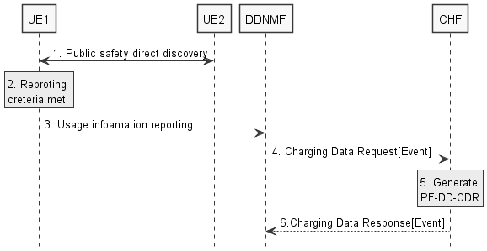
Figure 6.1.4.y.3.1: Message flow for ProSe Direct Discovery for Public Safety- CTF (non-roaming)
1. UE-1 sends announcement message with model A or solicitation message with model B. In the latter case, UE 2 sends a response message.
2. When the UE-1 decides that reporting criteria are met, according to the pre-configuration, the UE creates the corresponding usage information report.
3. UE-1 triggers the usage reporting procedure by sending the usage information report to the DDNMF.
4. The 5G DDNMF triggers Charging Data Request[Event] to CHF in HPLMN.
5. The CHF creates a CDR for this UE.
6. The CHF returns Charging Data Response.
6.1.4.y.3.2 Message flows with CEF
TBD

6.1.4.y.4 Solution evaluation
TBD

Next Modified Section

End of Modified Sections

