3GPP TSG SA WG5 Meeting 135-e TDoc S5-211206

electronic meeting, online, 25 January - 3 February 2021
CR-Form-v12.1
CHANGE REQUEST
 | 28.130 | CR | 0007 | rev | - | Current version: | 16.0.0
For HELP on using this form: comprehensive instructions can be found at
http://www.3gpp.org/Change-Requests.

Proposed change affects: | UICC apps |  | ME |  | Radio Access Network | X | Core Network | X

Title: | Add NG-RAN sharing deployment example
Source to WG: | ZTE Corporation
Source to TSG: | SA5
Work item code: | MANS |  |  |  |  |  | Date: |  |  | 2021-01-06
Category: | F |  |  |  |  |  | Release: |  |  | Rel-17
 | Use one of the following categories:  F (correction)  A (mirror corresponding to a change in an earlier release)  B (addition of feature),  C (functional modification of feature)  D (editorial modification)  Detailed explanations of the above categories can  be found in 3GPP TR 21.900. |  |  |  |  |  |  |  | Use one of the following releases:  Rel-8 (Release 8)  Rel-9 (Release 9)  Rel-10 (Release 10)  Rel-11 (Release 11)  …  Rel-15 (Release 15)  Rel-16 (Release 16)  Rel-17 (Release 17)  Rel-18 (Release 18)
Reason for change: |  | 5G MOCN supports NG-RAN Sharing with or without multiple Cell Identity broadcast, but it is not clear how NG-RAN Sharing with multiple Cell Identity broadcast can be deployed.
Summary of change: |  | - Add necessary references  - Add a NG-RAN sharing deployment example in the annex.
Consequences if not approved: |  | It will be still unclear how NG-RAN Sharing with multiple Cell Identity broadcast can be deployed..
Clauses affected: |  | 2, Annex X (new)
 |  | Y | N
Other specs |  |  | X | Other core specifications |  |  |  | TS/TR ... CR ...
affected: |  |  | X | Test specifications |  |  |  | TS/TR ... CR ...
(show related CRs) |  |  | X | O&M Specifications |  |  |  | TS/TR ... CR ...
Other comments:
This CR's revision history:

1st of Changes

2 References
The following documents contain provisions which, through reference in this text, constitute provisions of the present document.
- References are either specific (identified by date of publication, edition number, version number, etc.) or non-specific.
- For a specific reference, subsequent revisions do not apply.
- For a non-specific reference, the latest version applies. In the case of a reference to a 3GPP document (including a GSM document), a non-specific reference implicitly refers to the latest version of that document in the same Release as the present document.
[1] 3GPP TR 21.905: "Vocabulary for 3GPP Specifications".
[2] 3GPP TS 32.101: "Telecommunication management; Principles and high level requirements".
[3] 3GPP TS 32.102: "Telecommunication management; Architecture".
[4] 3GPP TS 36.300: "Evolved Universal Terrestrial Radio Access (E-UTRA) and Evolved Universal Terrestrial Radio Access Network (E-UTRAN); Overall description; Stage 2".
[5] 3GPP TS 23.251: "Network sharing; Architecture and functional description".
[6] 3GPP TS 36.314: "Evolved Universal Terrestrial Radio Access (E-UTRA); Layer 2 – Measurements"
[x] 3GPP TS 23.501: "System architecture for the 5G System (5GS)".
[y] 3GPP TS 38.331: “NR; Radio Resource Control (RRC); Protocol specification”
[z] 3GPP TS 38.401: “NG-RAN; Architecture description”

Next Change

Annex X (informative):
Network sharing deployment examples

X.1 Deployment examples of 5G MOCN NG-RAN sharing
In TS 23.501 [x], it is mentioned that “5G MOCN supports NG-RAN Sharing with or without multiple Cell Identity broadcast as described in TS 38.300.”
In TS 38.331 [y], multiple Cell Identity broadcast information is reflected in the definition of PLMN-IdentityInfoList. In the 5G MOCN NG-RAN Sharing without multiple Cell Identity broadcast scenario, there is only one PLMN-IdentityInfoList in the SIB1 broadcast, which only maps to one NCGI. The figure below depicts a deployment example for this scenario.
Note: In the following figures, the definitions of the entities (e.g. gNB, gNB-CU, gNB-DU) and the relationship of the entities can be found in TS 38.401 [z].
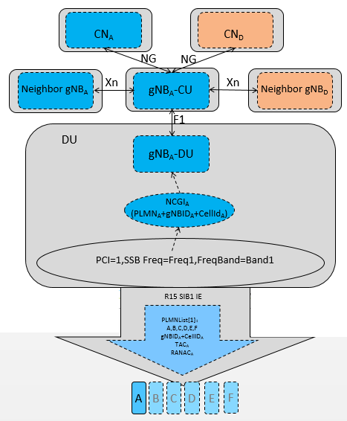
Figure X.1-1: Deployment example of NG-RAN Sharing without multiple Cell Identity broadcast
In the 5G MOCN NG-RAN Sharing with multiple Cell Identity broadcast scenario, there are more than one PLMN-IdentityInfoLists in the SIB1 broadcast, which map to more than one NCGIs. The figure below depicts a deployment example for this scenario.
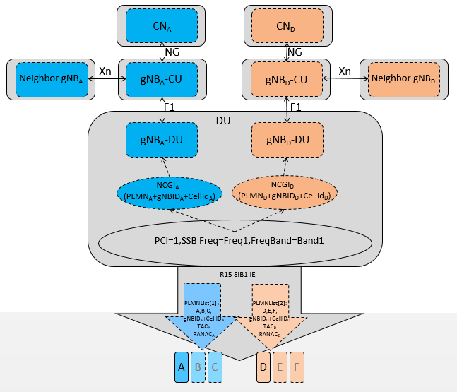
Figure X.1-2: Deployment example of NG-RAN Sharing with multiple Cell Identity broadcast

End of Change

