**3GPP TSG-SA5 Meeting #135e *S5-211190***

**e-meeting 25th January - 3rd February 2021**

|  |  |  |  |  |  |  |  |  |
| --- | --- | --- | --- | --- | --- | --- | --- | --- |
| *CR-Form-v12.0* | | | | | | | | |
| **CHANGE REQUEST** | | | | | | | | |
|  | | | | | | | | |
|  | **28.535** | **CR** | **0025** | **rev** | **-** | **Current version:** | **17.0.0** |  |
|  | | | | | | | | |
| *For* [***HE******LP***](http://www.3gpp.org/3G_Specs/CRs.htm#_blank)*on using this form: comprehensive instructions can be found at* [*http://www.3gpp.org/Change-Requests*](http://www.3gpp.org/Change-Requests)*.* | | | | | | | | |
|  | | | | | | | | |

|  |  |  |  |  |  |  |  |  |
| --- | --- | --- | --- | --- | --- | --- | --- | --- |
| ***Proposed change affects:*** | UICC apps |  | ME |  | Radio Access Network | **x** | Core Network | **x** |

|  |  |  |  |  |  |  |  |  |  |  |
| --- | --- | --- | --- | --- | --- | --- | --- | --- | --- | --- |
|  | | | | | | | | | | |
| ***Title:*** | Relation between Communication service LCM, Control loop LCM and NetworkSlice LCM | | | | | | | | | |
|  |  | | | | | | | | | |
| ***Source to WG:*** | Huawei | | | | | | | | | |
| ***Source to TSG:*** | S5 | | | | | | | | | |
|  |  | | | | | | | | | |
| ***Work item code:*** | eCOSLA | | | | |  | ***Date:*** | | | 2021-01-08 |
|  |  | | | |  | |  | | |  |
| ***Category:*** | **B** |  | | | | | ***Release:*** | | | Rel-17 |
|  | *Use one of the following categories:* ***F*** *(correction)* ***A*** *(mirror corresponding to a change in an earlier release)* ***B*** *(addition of feature),* ***C*** *(functional modification of feature)* ***D*** *(editorial modification)*  Detailed explanations of the above categories can be found in 3GPP [TR 21.900](http://www.3gpp.org/ftp/Specs/html-info/21900.htm). | | | | | | | | *Use one of the following releases: Rel-8 (Release 8) Rel-9 (Release 9) Rel-10 (Release 10) Rel-11 (Release 11) Rel-12 (Release 12)* *Rel-13 (Release 13) Rel-14 (Release 14) Rel-15 (Release 15) Rel-16 (Release 16)* | |
|  |  | | | | | | | | | |
| ***Reason for change:*** | | The relation of Communication service LCM, Control loop LCM and NetworkSlice LCMs need to be clear described in 28.535 | | | | | | | | |
|  | |  | | | | | | | | |
| ***Summary of change:*** | | Add description about the relation of Communication service LCM, Control loop LCM and NetworkSlice LCMs | | | | | | | | |
|  | |  | | | | | | | | |
| ***Consequences if not approved:*** | | The relation of Communication service LCM, Control loop LCM and NetworkSlice LCMs are not clear described in 28.535 | | | | | | | | |
|  | |  | | | | | | | | |
| ***Clauses affected:*** | | 4.2.x | | | | | | | | |
|  | |  | | | | | | | | |
|  | | **Y** | **N** |  | | | |  | | |
| ***Other specs*** | |  | **x** | Other core specifications | | | | TS/TR ... CR ... | | |
| ***affected:*** | |  | **x** | Test specifications | | | | TS/TR ... CR ... | | |
| ***(show related CRs)*** | |  | **x** | O&M Specifications | | | | TS/TR ... CR ... | | |
|  | |  | | | | | | | | |
| ***Other comments:*** | |  | | | | | | | | |
|  | |  | | | | | | | | |
| ***This CR's revision history:*** | |  | | | | | | | | |

|  |
| --- |
| **1st of changes** |

4.2.x

Relation of Communication service LCM, Control loop LCM and NetworkSlice LCM

The control loop lifecycle is dependent on the communincation service lifecycle, while the communication service and NetworkSlice lifecycles are independent. In the following figure, it describes an example about the relationship between those lifecycles in the shared NetworkSlice scenario, where each Communication Service is assured by its own specific Control loop.

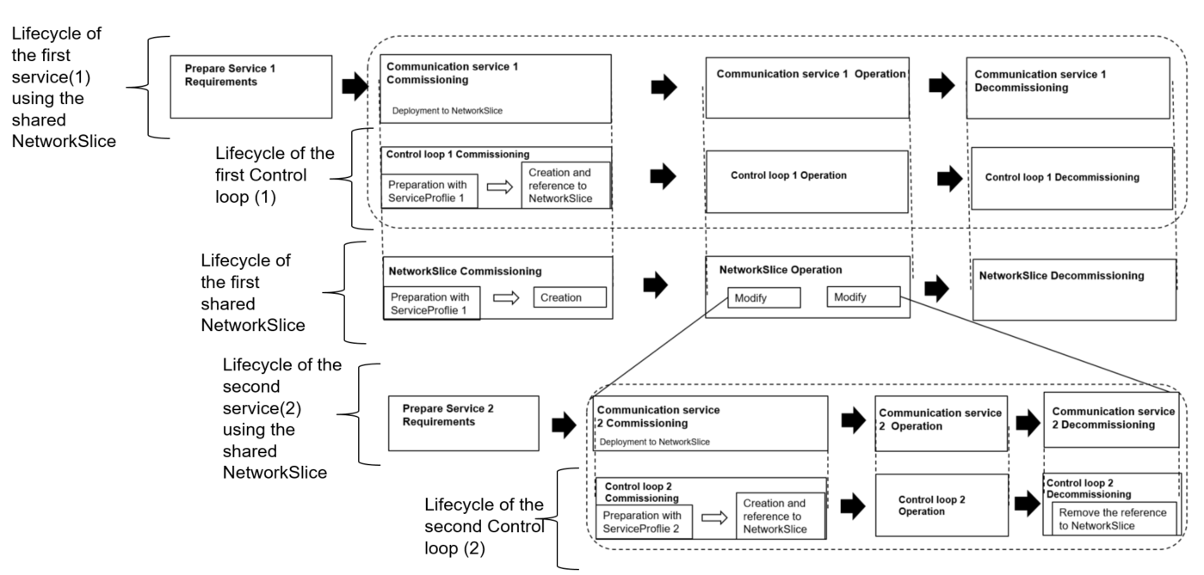

Figure: Relations of Communication service lifecycle, control loop lifecycle and NetworkSlice lifecycle in shared NetworkSlice senario

During the commissioning phase of ‘Communication service 1’, the Communication service, will trigger the NetworkSlice preparation during the commissioning phase. The control loop, ‘Control loop 1’, preparation will use the ServiceProfile of ‘Communication Service 1’ and will create a reference to the NetworkSlice during its commission phase.

In the shared NetworkSlice scenario, ‘Communication service 2’ will be deployed to the existing NetworkSlice. ‘Control loop 2’ preparation will use ServiceProfile of ‘Communication Service 2’ and create a reference to the NetworkSlice during its commissioning phase. During the decommissioning phase ‘Communication service 2’ will trigger the decommission phase of ‘Control loop 2’ which will remove the reference to the NetworkSlice.

|  |
| --- |
| **End of changes** |