3GPP TSG-SA5 Meeting #135-e S5-211156

Online, 25th Jan 2021 - 3rd Feb 2021
CR-Form-v12.1
CHANGE REQUEST
 | 32.130 | CR | 0003 | rev | 1 | Current version: | 16.0.0
For HELP on using this form: comprehensive instructions can be found at
http://www.3gpp.org/Change-Requests.

Proposed change affects: | UICC apps |  | ME |  | Radio Access Network | x | Core Network

Title: | Rel-17 CR TS 32.130 Update the scope and background of network sharing scenarios
Source to WG: | China Telecommunications, China Unicom, Huawei, ZTE
Source to TSG: | S5
Work item code: | MANS |  |  |  |  |  | Date: |  |  | 2021-01-15
Category: | B |  |  |  |  |  | Release: |  |  | Rel-17
 | Use one of the following categories:  F (correction)  A (mirror corresponding to a change in an earlier release)  B (addition of feature),  C (functional modification of feature)  D (editorial modification)  Detailed explanations of the above categories can  be found in 3GPP TR 21.900. |  |  |  |  |  |  |  | Use one of the following releases:  Rel-8 (Release 8)  Rel-9 (Release 9)  Rel-10 (Release 10)  Rel-11 (Release 11)  …  Rel-15 (Release 15)  Rel-16 (Release 16)  Rel-17 (Release 17)  Rel-18 (Release 18)
Reason for change: |  | As the approval of S5-206304 at last meeting, it is necessary to specify corresponding management features to support 5G network sharing scenarios in release 17. So, scope and background in TS 32.130 need to be updated for MOCN network sharing scenario.  The definition of MOCN should align with the definition in SA2 specifications. The second description of MOCN the clause 4.1 is redundant and does not fully align with SA2 specifications.
Summary of change: |  | - Updating the scope and background of network sharing scenaros.  - Remove the redundant description of MOCN.
Consequences if not approved:
Clauses affected: |  | 1, 2, 4.1
 |  | Y | N
Other specs |  |  | x | Other core specifications |  |  |  | TS/TR ... CR ...
affected: |  |  | x | Test specifications |  |  |  | TS/TR ... CR ...
(show related CRs) |  |  | x | O&M Specifications |  |  |  | TS/TR ... CR ...
Other comments:
This CR's revision history:

1st change

1 Scope
The present document describes concepts and high-level requirements for the Operations, Administration, Maintenance and Provisioning (OAM&P) of network sharing.
Network sharing scenarios considered in the present document are Multiple Operator Core Network (MOCN) and Gateway Core Network (GWCN) for GERAN, UTRAN and E-UTRAN, as defined in TS 23.251 [7], and Multiple Operator Core Network (MOCN) for NG-RAN as defined in TS 23.501[X].

Next change

2 References
The following documents contain provisions which, through reference in this text, constitute provisions of the present document.
- References are either specific (identified by date of publication, edition number, version number, etc.) or non-specific.
- For a specific reference, subsequent revisions do not apply.
- For a non-specific reference, the latest version applies. In the case of a reference to a 3GPP document (including a GSM document), a non-specific reference implicitly refers to the latest version of that document in the same Release as the present document.
[1] 3GPP TR 21.905: "Vocabulary for 3GPP Specifications".
[2] 3GPP TS 32.101: "Telecommunication management; Principles and high level requirements".
[3] 3GPP TS 32.102: "Telecommunication management; Architecture".
[4] 3GPP TS 36.300: "Evolved Universal Terrestrial Radio Access (E-UTRA) and Evolved Universal Terrestrial Radio Access Network (E-UTRAN); Overall description; Stage 2".
[5] 3GPP TS 23.251: "Network sharing; Architecture and functional description".
[6] 3GPP TS 36.314: "Evolved Universal Terrestrial Radio Access (E-UTRA); Layer 2 – Measurements"
[X] 3GPP TS 23.501: "System architecture for the 5G System (5GS); Stage2"

Next change

4 Concepts and background

4.1 RAN sharing scenarios
Various network sharing scenarios exist, amongst which one category is RAN sharing which can be divided into the following (non exhaustive) list of sub-categories:
- Passive RAN sharing, also known as infrastructure sharing (including site sharing).
- Active RAN sharing, where active network elements of the RAN are shared:
- RAN-only sharing (MOCN; see TS 23.251 [5] and TS 23.501 [X]), i.e. BTSs / BSCs (respectively NodeBs / RNCs and eNodeBs) in a 2G Radio Access Network (respectively a 3G Radio Access Network and an E-UTRA network), and gNBs in a 5G NR network;
- Gateway Core Network (GWCN; see TS 23.251 [5]), in which not only the Radio Access Network elements are shared but also part or all of the Core Network elements (there is no passive core network sharing).
.The following figures depict the MOCN scenarios.
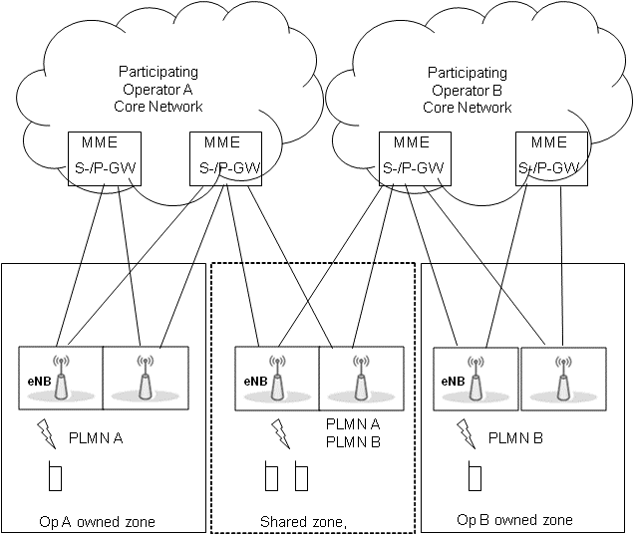
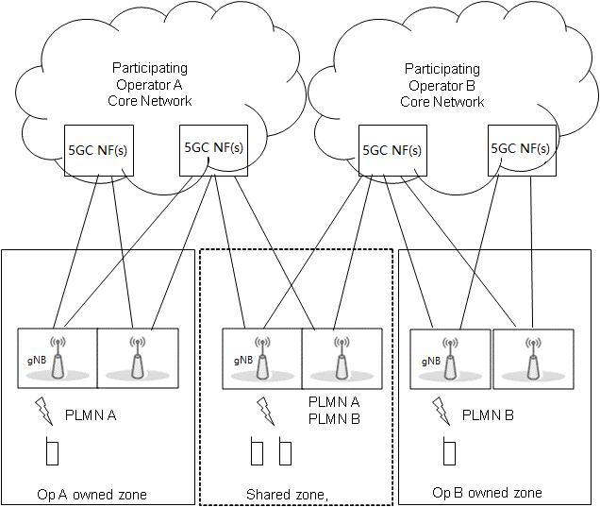
Figure 4.1-1: Multiple Operator Core Network (MOCN)
In GWCN, besides sharing Radio Access Network nodes, the POPs also share Core Network nodes (see TS 23.251 [5] – clause 4.1).
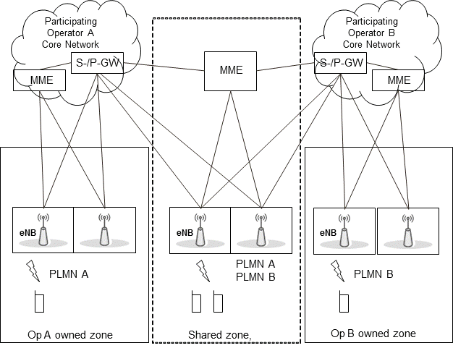
Figure 4.1-2: GateWay Core Network (GWCN)

End of changes

