3GPP TSG SA WG5 Meeting 134-e S5-206345

electronic meeting, online, 16th - 25th November 2020
CR-Form-v12.1
CHANGE REQUEST
 | 28.535 | CR |  | rev |  | Current version: | 16.1.0
For HELP on using this form: comprehensive instructions can be found at
http://www.3gpp.org/Change-Requests.

Proposed change affects: | UICC apps |  | ME |  | Radio Access Network | X | Core Network | X

Title: | eCOSLA
Source to WG: | Ericsson
Source to TSG: | S5
Work item code: | eCOSLA |  |  |  |  |  | Date: |  |  | 2020-11-06
Category: | B |  |  |  |  |  | Release: |  |  | Rel-17
 | Use one of the following categories:  F (correction)  A (mirror corresponding to a change in an earlier release)  B (addition of feature),  C (functional modification of feature)  D (editorial modification)  Detailed explanations of the above categories can  be found in 3GPP TR 21.900. |  |  |  |  |  |  |  | Use one of the following releases:  Rel-8 (Release 8)  Rel-9 (Release 9)  Rel-10 (Release 10)  Rel-11 (Release 11)  …  Rel-15 (Release 15)  Rel-16 (Release 16)  Rel-17 (Release 17)  Rel-18 (Release 18)
Reason for change: |  | This contribution is draft CR for:  S5-206326 Rel-17 draftCR TS 28.535 Coordination between control loops  S5-206366 Rel17 CR 28.535 Add use case and req for CL execution supe..  S5-206350 Rel-17 CR TS 28.535 Add concept of closed control loop governing and monitoring  S5-206367 Add use case of network resource usage and performance prediction assisted SLS communication service Assurance  S5-206368 Rel17 CR 28.535 Add use case for limiting actions of an assurance loop  S5-206369 Rel17 CR 28.535 Add use case for triggering assurance loop state change
Summary of change:
Consequences if not approved:
Clauses affected: |  | 4.2.x (new), 6.1.X(new), 6.2
 |  | Y | N
Other specs |  |  | X | Other core specifications |  |  |  | TS/TR ... CR ...
affected: |  |  | X | Test specifications |  |  |  | TS/TR ... CR ...
(show related CRs) |  |  | X | O&M Specifications |  |  |  | TS/TR ... CR ...
Other comments:
This CR's revision history: |  | This draft CR includes:  S5-206326  S5-206366  S5-206350  S5-206367  S5-206368  S5-206369

1st Change

4.2.x Coordination between control loops
Different control loops reside in management domains or network function to support the overall autonomous networks. Different domains may be deployed for the same or different coverage areas. The purposes and results of different control loops may have impacts on one another. Coordination between control loops are needed in the management, 5GC and NG-RAN domains, to improve the performance in order to achieve the goal(s) of the control loops or conflict resolution, as shown in the figure 4.2.x-1.
A control loop may coordinate with other control loops in the same domain or in a different domain. Control loops in domain management are responsible for local optimization. Control loops in cross domain management may need to coordinate with control loops in multiple domains for the end to end optimizations.
The relationships between control loops can be hierarchical and peer-to peer. Coordination in management domains include the following categories:
- Coordination between Cross Management Domain and the 5GC Management Domain
- Coordination between Cross Management Domain and the NG-RAN Management Domain
- Coordination between 5GC Management Domain and the NG-RAN Management Domain
- Coordination within Cross Management Domain, 5GC Management Domain or NG-RAN Management Domain
Coordination in management domains provides the SLS assurance from the overall management perspective. It also provides governace and objective to the 5GC NFs and gNBs.
Editor’s NOTE: This will be revisited.

2nd Change

4.2.y Closed control loop governance and monitoring

4.2.y.1 Overview
The closed control loop can be viewed as an entity to be managed, which means the implementation of the internal capabilities and internal interactions between the steps couldn’t be externally visible. However, some management capabilities (e.g. closed control loop governance and closed control loop monitoring) will exposed by the MnS producer, implementing the closed control loops, to enable the MnS consumer to manage the closed control loops.
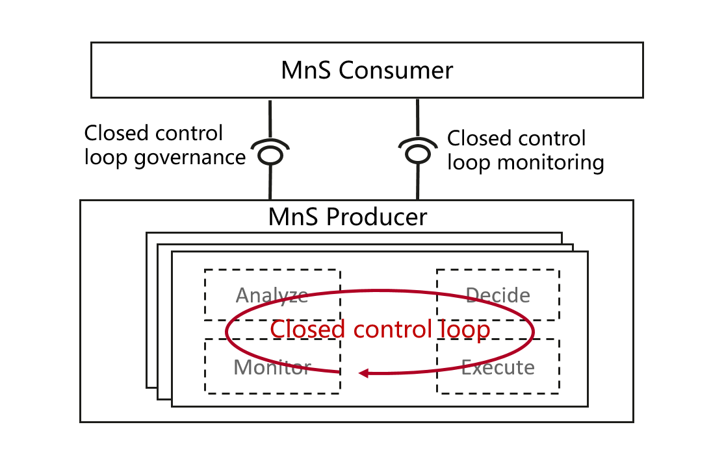
Figure 4.2.X.1 Closed control loop governance and monitoring

4.2.y.2 Closed control loop governance
Closed control loop governance describes a set of capabilities to allow MnS consumer to govern closed control loop, including:
- Lifecycle management of closed control loop, including create, modify,activate/deactivate,delete closed control loop.
- Configure goals for closed control loop.

4.2.y.3 Closed control loop monitoring
Closed control loop monitoring describes a set of capabilities to allow MnS consumer to monitoring the progress and result of closed control loop, including:
- Monitor the goal fulfillment of the closed control loop.
Editor’s Note: the content needs to be checked when R16 COSLA work is finished.

2nd Change

6.1.X Assurance closed loop execution supervision
Assurance closed loops have a defined goal related to a communication service SLS may execute various actions in the deployed operator network. To fully understand and trust the execution of such an assurance closed loop in the system, The MnS consumer of the assurance closed loop may want to supervise the execution of the assurance closed loop at “pause point” during the Execute step of the closed loop. At this pause point the consumer is enabled to review the available information. MnS consumer can set the pause point before the closed loop is running or when the closed loop is de-activated.
The 3GPP management system provides the ability to enable or disable such “pause point” during the Execute step of the assurance closed loop. At a pause point, when notification is sent to the MnS consumer, the consumer of the control loop can enable pausing the execution of the control.
The assurance closed loop pause point can be defined by the assurance closed loop and set for “Execute” step only.
The MnS consumer obtain the pause point capabilities for assurance closed loop(s) from the MnS producer. For example, for NR coverage optimization closed loop, the pause point can be coverage adjustment action execution.
Based on the pause capabilities, MnS consumer requests the MnS producer to enable pause point for an assurance closed loop.
When a pause point is reached, the flow of the assurance closed loop is paused and the authorized MnS consumer is informed with the pause information. When the notified MnS consumer sends a resume request, the assurance closed loop flow will continue to execute to the next step of the assurance closed loop. For example, when a pause point at coverage adjustment execute step is enabled, the MnS producer will not execute coverage adjustment action and instead inform the authorized MnS consumer that coverage adjustment action is determined and wait for approval.
- If the coverage adjustment action is approved by the MnS consumer, the MnS consumer will request the MnS producer to resume. Then MnS producer can continue to execute the coverage adjustment action.
- If the coverage adjustment action is not approved by the MnS consumer, the MnS consumer requests MnS producer to reject execution of the coverage adjustment action.

6.1.Y Network prediction assisted SLS communication service Assurance
The goal of this use case is to identify the management of network prediction assisted SLS communication service assurance. The SLS related to a particular communication service can be assured by considering the predicted network resource usage and performance within a certain time frame.
The 3GPP management system will have the most comprehensive network operating data, such as network resource utilization, network performance parameters in different periods. By introducing MDAS and NWDAF into both the management system and core network, it is possible that the network operating data can be the input of the closeloop to fulfil SLS requirements from CSP or NOP.
In a certain period of time, the current network condition is good enough to satisfy the SLS requirements. By introducing the prediction results from the analysis of MDAF and NWDAF, the historical data shows that the network will experience a traffic burst in certain area and certain time which can cause network resource shortage and performance degradation. This predictional results can directly trigger network actions such as reconfiguration and resource reallocation before the predicted traffic burst time. Similarly, in office area, the network will not active during holiday but will have network surges on working day, the network prediction can also trigger resource release and network function reconfiguration. This can not only save network operating costs on holiday but also achieve the goal of network service assurance on working day.

6.1.Z Limiting the actions of an assurance closed loop
The goal of this use case is to provide the consumer of an assurance closed loop the ability to limit actions the assurance closed loop can execute. This renders the assurance closed loop taking action (configuration of MoI attributes) that are within the limits of the scope as defined by the consumer.
Assurance closed loops have a defined assurance goal related to a communication service SLS may execute various actions in the deployed operator network. There may be cases in which two or more assurance closed loops can execute the same or related set of actions on a managed entity. For example, assurance closed loops ACCL1 and ACCL2 for coverage optimization running in neighbouring RAN domains may take independent decision on the radio signal strength and azimuth to optimize the coverage. These assurance closed loops therefore may have the capability to cause a conflict with both simultaneously changing the azimuth to address a coverage-hole thereby causing an unnecessary coverage-overlap instead.
An authorized coordinating entity (authorized common consumer of the two ACCLs), should be able to configure the closed loops in a way that such occurrences are minimized. To coordinate the execution of multiple such assurance closed loops in the system the common authorized consumer of the assurance closed loop limits the set of actions of the assurance closed loops to avoid possible conflicts between the two or more assurance closed loops. In the example above: The authorized consumer of an assurance closed loops may limit the coverage optimization configurations signal strength and azimuth configurations to be done only by ACCL1.
The 3GPP management system shall therefore provide the ability to limit action capabilities (possible configurations of an MoI attributes) that an assurance closed loop can take, this can be for example via operational policy configurations.
The MnS consumer obtains the allowed action capabilities (configurations that assurance closed loops could execute on an managed entitiy) from the MnS producer. The MnS consumer may then internally compare the action capabilities allowed that can be taken by a set of assurance closed loops to determine if possible conflicts exist. If conflicts are found, and the MnS consumer determines a possible resolution by limiting the action capabilities of a set of assurance closed loops, then it requests the MnS producer to limit the set of action capabilities, for example: by configuring new operational policies.

6.1.A Trigger based Assurance Closed Control Loop (ACCL) state change
The goal of this use case is to provide the consumer of an assurance closed loop the ability to set conditions (example threshold crossings) in the 3GPP management system that when met, trigger changes in ACCL state (enable or diable an ACCL). This implies that an ACCL may be activated or deactivated if the set condition in the 3GPP network is met (example: the threshold is crossed).
Assurance closed loops may be required to run at different times and network conditions in the 3GPP network. For example, an ACCL related to handover optimization may only execute when the handover failure crosses a certain threshold. Similarly, an ACCL managing energy efficiency may be disabled when the network is overloaded beyond a certain threshold. These conditions (network overload, handover failure threshold crossing) can therefore be associated with a change in state (enable/disable) of an ACCL to further support autonomy of the 3GPP management domain.
An authorized entity (authorized consumer of the ACCL), for example, another closed loop or operator, should be able to configure the condition and its association with an ACCL state transition (enable/disable) in the 3GPP management domain.
The 3GPP management system shall therefore provide the ability to configure conditions and associate them with the state transition of an ACCL. The 3GPP management system then configure appropriate listeners to monitor the configured threshold crossing and once triggered execute a state transition (enable/disable) of the associated ACCL.
The MnS consumer obtains the possible conditions as well as the possible ACCL state transitions they can be associated with. The MnS consumer may then configure condition in the 3GPP network. When the threshold crossing notification is received the MnS producer it executes the associated state transition (enable/disable) of the ACCL.

3rd Change

6.2 Requirements
REQ-CSA-CON-01 The 3GPP management system shall have the capability to take actions for a set of communication services serving certain group of UEs based on the target SLS.
REQ-CSA-CON-02 The 3GPP management system shall have the capability to collect service experience information.
REQ-CSA-CON-03 The 3GPP management system shall have the capability to analyse the performance information related to the set of communication services serving certain group of UEs.
REQ-CSA-CON-04 The 3GPP management system shall have the capability to modify the configuration parameters related to the set of communication services serving certain group of UEs.
REQ-CSA-CON-05 The 3GPP management system shall have the capability to collect NSI related data from one or more 5GC NF(s).
NOTE 1: An example for NSI related data may be Quek data.
REQ-CSA-CON-06 The 3GPP management system shall have the capability to derive which communication service is associated to the QoE data from the collected NSI related QoE data.
REQ-CSA-CON-07 The 3GPP management system shall have the capability to ascertain SLS breach.
REQ-CSA-CON-08 The 3GPP management system shall have the capability to perform the root cause analysis (e.g., identifying the underlying reason) for an SLS breach.
REQ-CSA-CON-09 The 3GPP management system shall have the capability to take corrective actions against the root cause identified.
REQ-CSA-CON-10 The 3GPP management system shall have the capability to translate communicate service requirements to cross domain SLS goal and single domain SLS goal.
REQ-CSA-CON-11 The 3GPP management system shall have the capability to collect single domain SLS analysis as input to cross domain SLS analysis.
REQ-CSA-CON-12 The 3GPP management system shall have the capability to allow its authorized consumer to control the SLS assurance (e.g. specify the SLS to be assured, enable/disable, specify the assurance time and update the SLS assurance requirements).
REQ-CSA-CON-13 The 3GPP management system shall have the capability to allow its authorized consumer to obtain the SLS assurance progress information and fulfil information.
NOTE 2: The management system refers to the producer of management service for SLS assurance.
REQ-CSA-CON-xx1 The 3GPP management system shall have the capability to allow Cross Management Domain to configure SLS assurance goals for 5GC Management Domain and NG-RAN Management Domain.
REQ-CSA-CON-xx2 The 3GPP management system shall have the capability to allow control loops in Cross Management Domain to collect SLS assurance goal status of control loops in 5GC Management Domain and NG-RAN Management Domain.
REQ-CSA-CON-X The 3GPP management system shall have the capability to allow an authorized consumer to enable or disable pause point(s) connected to actions on managed entities during the ACCL’s execution phase and prior to the actions’ execution.”
REQ-CSA-CON-Y1 The 3GPP management system shall have the capability to do network prediction (e.g. network resource usage and network performance) by analysing the network operation information in special scenarios.
REQ-CSA-CON-Y2 The 3GPP management system shall have the capability to take actions such asnetwork configuration and perform network resource reallocation according to the network prediction results.
REQ-CSA-CON-Z The 3GPP management system shall have the capability to allow its authorized consumer to limit the set of action capabilities executable by an assurance closed loop.
REQ-CSA-CON-A The 3GPP management system shall allow an authorized consumer to set a condition to enable/disable an ACCL.

End of Change

