**3GPP TSG SA WG5 Meeting 134-eTDoc S5-206344**

**electronic meeting, online, 16th - 25th November 2020**

|  |  |  |  |  |  |  |  |  |
| --- | --- | --- | --- | --- | --- | --- | --- | --- |
| *CR-Form-v12.0* | | | | | | | | |
| **CHANGE REQUEST** | | | | | | | | |
|  | | | | | | | | |
|  | **28.533** | **CR** |  | **rev** | **-** | **Current version:** | **16.5.1** |  |
|  | | | | | | | | |
| *For* [***HE******LP***](http://www.3gpp.org/3G_Specs/CRs.htm#_blank)*on using this form: comprehensive instructions can be found at* [*http://www.3gpp.org/Change-Requests*](http://www.3gpp.org/Change-Requests)*.* | | | | | | | | |
|  | | | | | | | | |

|  |  |  |  |  |  |  |  |  |
| --- | --- | --- | --- | --- | --- | --- | --- | --- |
| ***Proposed change affects:*** | UICC apps |  | ME |  | Radio Access Network |  | Core Network |  |

|  |  |  |  |  |  |  |  |  |  |  |
| --- | --- | --- | --- | --- | --- | --- | --- | --- | --- | --- |
|  | | | | | | | | | | |
| ***Title:*** | Correct inconsistent terminology | | | | | | | | | |
|  |  | | | | | | | | | |
| ***Source to WG:*** | Huawei | | | | | | | | | |
| ***Source to TSG:*** | SA5 | | | | | | | | | |
|  |  | | | | | | | | | |
| ***Work item code:*** | 5GDMS | | | | |  | ***Date:*** | | | 2020-11-23 |
|  |  | | | |  | |  | | |  |
| ***Category:*** | **F** |  | | | | | ***Release:*** | | | Rel-16 |
|  | *Use one of the following categories:* ***F*** *(correction)* ***A*** *(mirror corresponding to a change in an earlier release)* ***B*** *(addition of feature),* ***C*** *(functional modification of feature)* ***D*** *(editorial modification)*  Detailed explanations of the above categories can be found in 3GPP [TR 21.900](http://www.3gpp.org/ftp/Specs/html-info/21900.htm). | | | | | | | | *Use one of the following releases: Rel-8 (Release 8) Rel-9 (Release 9) Rel-10 (Release 10) Rel-11 (Release 11) Rel-12 (Release 12)* *Rel-13 (Release 13) Rel-14 (Release 14) Rel-15 (Release 15) Rel-16 (Release 16)* | |
|  |  | | | | | | | | | |
| ***Reason for change:*** | | Inconsistent usage of the terms “service provider” and “service producer”. | | | | | | | | |
|  | |  | | | | | | | | |
| ***Summary of change:*** | | 28.533 has several descriptions of the relationship between a service producer and a service consumer. But in some cases, the service producer is incorrectly referred to as service provider. | | | | | | | | |
|  | |  | | | | | | | | |
| ***Consequences if not approved:*** | | Inconsistent terminology may cause confusion. | | | | | | | | |
|  | |  | | | | | | | | |
| ***Clauses affected:*** | | 4.7.1, 4.7.3, 5.1.1, 6.1.1, A.2, A.4, A.9.2 | | | | | | | | |
|  | |  | | | | | | | | |
|  | | **Y** | **N** |  | | | |  | | |
| ***Other specs*** | |  | **X** | Other core specifications | | | | TS/TR ... CR ... | | |
| ***affected:*** | |  | **X** | Test specifications | | | | TS/TR ... CR ... | | |
| ***(show related CRs)*** | |  | **X** | O&M Specifications | | | | TS/TR ... CR ... | | |
|  | |  | | | | | | | | |
| ***Other comments:*** | |  | | | | | | | | |
|  | |  | | | | | | | | |
| ***This CR's revision history:*** | |  | | | | | | | | |

|  |
| --- |
| **1st Change** |

### 4.7.1 Introduction

The MnS consumer in an operator’s management system need to discover the availability of MnS instances provided by other MnS producer(s). In order to enable the MnS instances to be discovered by MnS consumer, the MnS needs to be discoverable to the operator’s management system when the MnS instance become operative.

### 4.7.2 MnS data

The MnS data includes the information of MnS instance used for MnS discovery.

### 4.7.3 MnS discovery service

The MnS discovery service enables MnS consumer to discover management capabilities of MnS instances provided by MnS producer(s). The MnS consumer sends a MnS query request to MnS discover service producer to discover MnS instances and receives response with the MnS data of MnS instances which satisfy the request.

The MnS discovery service is illustrated in Table 4.7.3-1.

Table 4.7.3-1: MnS discovery service

|  |  |  |
| --- | --- | --- |
| MnS name | MnS component type A (operations and notifications) | MnS component type B (information model) |
| MnS discovery service | Operations:  - MnSQuery operation | MnS data |

|  |
| --- |
| **2nd change** |

### 5.1.1 Management service producers, consumers and exposure

The management services for a mobile network with or without network slicing may be produced by any entity. For example, it can be a Network Functions (NF), or network management functions. The entity may provide (produce) such management services as, for example, the performance management services, configuration management services and fault supervision services.

The management services can be consumed by another entity, which may in turn produce (expose) the service to other entities. Figure 5.1.1-1 shows an example of the management service X which is initially produced by the entity A which is an NF , then consumed by another entity B which is a network management function. Then entity B in turn exposes it to the entity C.



Figure 5.1.1-1. Example of producers and consumers of the management service

Figure 5.1.1-2 shows another example of the management service X which is produced by the entity A which is a NF, then entity B processes the information and produce management service Y and exposes it to the entity C.



Figure 5.1.1-2. Example of producers and consumers of management services

|  |
| --- |
| **3rd change** |

### 6.1.1 MnS query

| Use case stage | Evolution/Specification | <<Uses>> Related use |
| --- | --- | --- |
| **Goal** | Enable MnS discovery service consumer to obtain the available MnS instance(s). |  |
| **Actors and Roles** | MnS discovery service consumer |  |
| **Telecom resources** | MnS discovery service producer |  |
| **Assumptions** | MnS discovery service consumer is authorized to obtain the available MnS instance(s) from MnS discovery service producer. |  |
| **Pre-conditions** | Information of MnS instance(s) is existed in MnS discovery service producer. |  |
| **Begins when** | MnS discovery service consumer wants to obtain the available MnS instance(s). |  |
| **Step 1 (M)** | MnS discovery service consumer sends a request to MnS discovery service producer to obatin the available MnS instances with MnS requirements (e.g. MnS type (e.g. provisioning MnS, fault supervision MnS, performance assurance MnS), requirement description for MnS components (e.g. class name and/or instance information of the managedObject)). |  |
| **Step 2 (M)** | MnS discovery service producer decides the available MnS instance(s) to satisfy the received MnS requirements. |  |
| **Step 3 (M)** | MnS discovery service producer sends the available MnS instance with some information (e.g. MnS Id, MnS component information, MnS producer information) to MnS discovery service consumer. |  |
| **Ends when** | All the steps identified above are successfully completed. |  |
| **Exceptions** | One of the mandatory steps fails. |  |
| **Post-conditions** | MnS discovey service consumer has obtained the the available MnS instance(s) and be ready to use this MnS instance. |  |
| **Traceability** | REQ-MnSD-FUN-X |  |

|  |
| --- |
| **4th change** |

# A.2 Utilization of management services in network function management.

This subclause describes the network function management model in the example of management services deployment. In case that a deployment requires management service in NF management model, management services in NF management model can provide specific management capability for NFs to authorized management service consumer through service based interface.

NF management function is an execution entity to provide NF Management services in NF management model. NF Management function (NFMF) may manage more than one network functions.

NF management function for multiple managed network functions as shown in Figure A.2.1 provides:

- Management services exposure; and

- Data governance for management service exposure.

NOTE 1: One example of a management object with multiple management services is NF pooling design. Another example of a management object with this multiple NF management services is 5G Core control plane.

NOTE 2: NF management function can behave as consumer to ETSI ISG NFV MANO interfaces (e.g. Ve-Vnfm-em interface exposed by VNFM).

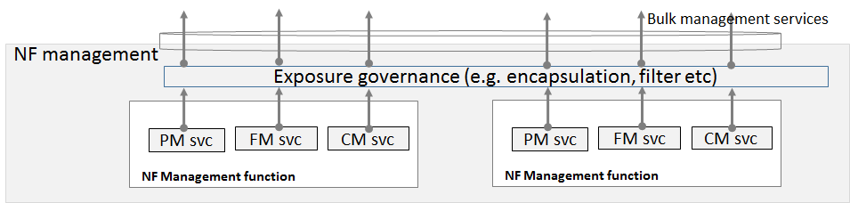

Figure A.2.1: Example NF management function layer structure

As shown in Figure A.2.1, an example of NF management function model structure is given. Exposure governance management function (EGMF) shown in Figure A.2.1 is management function in network function model with the role of management service exposure governance (i.e. abstraction, simplification, filtering, etc.). When multiple NF management services are exposed to network management, the particular group of multiple NF management services can be represented by a set of NF management services. This set of NF management services are exposed as a bulk NF management service, by NF management function. Additional management service abstraction may be needed based on NF management services because of lack of trust relationship between management service producer/consumer cannot address management services to build a global view of subnet or meaningful management purposes.

|  |
| --- |
| **5th change** |

# A.4 Utilization of interface to NFV-MANO by the producer of management services

In this deployment scenario the producers of the NSS related management services and NF related management services are also consuming the management interfaces provided by the NFV-MANO:

- -VNF PM, FM and LCM

- NS PM, FM and LCM

These interfaces are provided via the Os-Ma-nfvo and the Ve-Vnfm-em reference points as specified in the following specifications:

- Configuration Management (CM): TS 28.510 [11], TS 28.511 [12], TS 28.512 [13], TS 28.513 [14],

- Fault Management (FM): TS 28.515 [15], TS 28.516 [16], TS 28.517 [17], TS 28.518 [18],

- Performance Management (PM): TS 28.520[19], TS 28.521 [21], TS 28.522 [22], TS 28.523 [23],

- Life Cycle Management (LCM): TS 28.525[24], TS 28.526 [25], TS 28.527 [26], TS 28.528 [27].

In this deployment scenario:

- the entity denoted as NSSMF (NSS Management Function), is capable of consuming the VNF LCM and NS LCM related services provided by the NFV-MANO (NFVO). Same entity is also a producer of the NSS related management services.

- the entity denoted as NFMF (NF Management Function), is capable of application level management of VNFs and PNFs and is a producer of the NF Provisioning service that includes Configuration Management (CM), Fault Management (FM) and Performance Management. Same entity is consumer of the NF Provisioning service produced by VNFs and PNFs.



Figure A.4.1 The deployment scenario for NSSI management with interface to NFV-MANO

The use case Network slice subnet instance creation in the clause 5.1.2 of the TS 28.531 [8] shows example of interaction between:

- the consumer of the NSS related management services (e.g. NSS provisioning service) and the NSSMF as the producer of the NSS related management services.

- the NSSMF and the NFMF.

and also, the interaction between:

- the NSSMF and the NFV-MANO,

- the NFMF and the NFV-MANO.

NOTE: Figure A.4.1 shows an example of a deployment scenario, not all scenarios are captured by this figure.

|  |
| --- |
| **6th change** |

### A.9.2 Integration with ONAP controller utilizing 3GPP MnS(s)

Figure A.9.2 shows an example of integration with ONAP Controller (e.g. APPC) utilizing provisioning management services provided by 3GPP Management Service Producer. In this example, the 3GPP MnS(s) Consumer which uses ONAP Controller may utilize the provisioning management services (e.g. configuration management related provisioning management service components) as follows provided by 3GPP Management Service Producer.

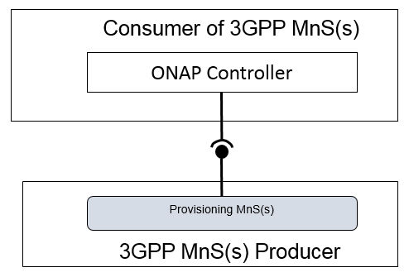

Figure A.9.2: An example of integration with ONAP Controller utilizing the management services provided by 3GPP MnS(s) Producer

|  |
| --- |
| **End of changes** |