3GPP TSG-SA5 Meeting #134e S5-206181

e-meeting 16th - 25th November 2020
CR-Form-v12.0
CHANGE REQUEST
 | 28.535 | CR | 0017 | rev | - | Current version: | 16.1.0
For HELP on using this form: comprehensive instructions can be found at
http://www.3gpp.org/Change-Requests.

Proposed change affects: | UICC apps |  | ME |  | Radio Access Network | x | Core Network | x

Title: | Update open control loops
Source to WG: | Huawei
Source to TSG: | S5
Work item code: | COSLA |  |  |  |  |  | Date: |  |  | 2020-11-2
Category: | F |  |  |  |  |  | Release: |  |  | Rel-16
 | Use one of the following categories:  F (correction)  A (mirror corresponding to a change in an earlier release)  B (addition of feature),  C (functional modification of feature)  D (editorial modification)  Detailed explanations of the above categories can  be found in 3GPP TR 21.900. |  |  |  |  |  |  |  | Use one of the following releases:  Rel-8 (Release 8)  Rel-9 (Release 9)  Rel-10 (Release 10)  Rel-11 (Release 11)  Rel-12 (Release 12)  Rel-13 (Release 13)  Rel-14 (Release 14)  Rel-15 (Release 15)  Rel-16 (Release 16)
Reason for change: |  | Human operators or external management entity may intervene with one or more steps in the open control loop.
Summary of change: |  | 1. Update descriptions on human operator or external management entity intervene with open control loop steps.  2. Update Figure 4.2.3.1 for embodiment of interactions between external entity or human operator with the open control loop steps.
Consequences if not approved: |  | The operation of open control loop is not clear.
Clauses affected: |  | 4.2.3 , 6.2
 |  | Y | N
Other specs |  |  | x | Other core specifications |  |  |  | TS/TR ... CR ...
affected: |  |  | x | Test specifications |  |  |  | TS/TR ... CR ...
(show related CRs) |  |  | x | O&M Specifications |  |  |  | TS/TR ... CR ...
Other comments:
This CR's revision history:

1st of changes

4.2.3 Open control loops
In an open control loop, the human operator intervenes in one or more of the process steps inside the loop, see Figure 4.2.3.1. The human operator is in control of the steps in the control loop, including decisions taken in the loop. The management system collects, analyses and presents the data to the operator, but the operator can interact with each step during control loop runtime, e.g. specify the monitor data sources, select the suitable analytic reports and decides which action to take. In this case, the completion time for control loop is dependent on availability and reaction time of a human operator or other management entity.

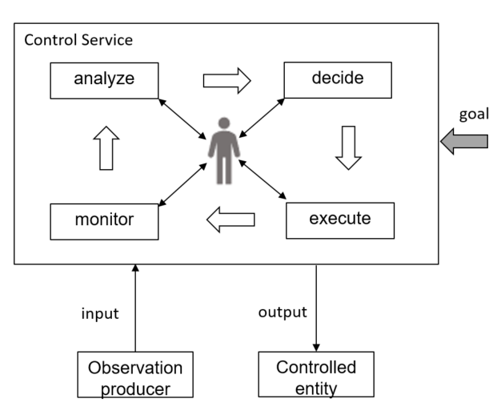
Figure 4.2.3.1: Open control loop entities

2nd of changes

6.2 Requirements
REQ-CSA-CON-01 The 3GPP management system shall have the capability to take actions for a set of communication services serving certain group of UEs based on the target SLS.
REQ-CSA-CON-02 The 3GPP management system shall have the capability to collect service experience information.
REQ-CSA-CON-03 The 3GPP management system shall have the capability to analyse the performance information related to the set of communication services serving certain group of UEs.
REQ-CSA-CON-04 The 3GPP management system shall have the capability to modify the configuration parameters related to the set of communication services serving certain group of UEs.
REQ-CSA-CON-05 The 3GPP management system shall have the capability to collect NSI related data from one or more 5GC NF(s).
NOTE 1: An example for NSI related data may be QoE data.
REQ-CSA-CON-06 The 3GPP management system shall have the capability to derive which communication service is associated to the QoE data from the collected NSI related QoE data.
REQ-CSA-CON-07 The 3GPP management system shall have the capability to ascertain SLS breach.
REQ-CSA-CON-08 The 3GPP management system shall have the capability to perform the root cause analysis (e.g., identifying the underlying reason) for an SLS breach.
REQ-CSA-CON-09 The 3GPP management system shall have the capability to take corrective actions against the root cause identified.
REQ-CSA-CON-10 The 3GPP management system shall have the capability to translate communicate service requirements to cross domain SLS goal and single domain SLS goal.
REQ-CSA-CON-11 The 3GPP management system shall have the capability to collect single domain SLS analysis as input to cross domain SLS analysis.
REQ-CSA-CON-12 The 3GPP management system shall have the capability to allow its authorized consumer to control the SLS assurance (e.g. specify the SLS to be assured, enable/disable, specify the assurance time and update the SLS assurance requirements).
REQ-CSA-CON-13 The 3GPP management system shall have the capability to allow its authorized consumer to obtain the SLS assurance progress information and fulfil information.
NOTE 2: The management system refers to the producer of management service for SLS assurance.
REQ-CSA-CON-xx The 3GPP management system shall have the capability to allow authorized external entity or human operator to interact and influence one or more of the process steps inside an open control loop.
end of changes

