3GPP TSG SA WG5 Meeting 134-e S5-206173

electronic meeting, online, 16th - 25th November 2020
CR-Form-v12.0
CHANGE REQUEST
 | 28.535 | CR | draftCR | rev | - | Current version: | 16.1.0
For HELP on using this form: comprehensive instructions can be found at
http://www.3gpp.org/Change-Requests.

Proposed change affects: | UICC apps |  | ME |  | Radio Access Network | X | Core Network | X

Title: | Add concept of closed control loop governing and monitoring
Source to WG: | Huawei
Source to TSG: | S5
Work item code: | eCOSLA |  |  |  |  |  | Date: |  |  | 2020-08-04
Category: | B |  |  |  |  |  | Release: |  |  | Rel-17
 | Use one of the following categories:  F (correction)  A (mirror corresponding to a change in an earlier release)  B (addition of feature),  C (functional modification of feature)  D (editorial modification)  Detailed explanations of the above categories can  be found in 3GPP TR 21.900. |  |  |  |  |  |  |  | Use one of the following releases:  Rel-8 (Release 8)  Rel-9 (Release 9)  Rel-10 (Release 10)  Rel-11 (Release 11)  Rel-12 (Release 12)  Rel-13 (Release 13)  Rel-14 (Release 14)  Rel-15 (Release 15)  Rel-16 (Release 16)
Reason for change: |  | In Clause 4.2 Management control loops the concept of control loops, open control loops and closed cotnrol loops are described, however, the closed loop governance and monitoring is missing, which is important for management of the closed control loops.
Summary of change: |  | Add concept of closed control loop governance and closed control loop monitoring.
Consequences if not approved:
Clauses affected: |  | 4.2.X
 |  | Y | N
Other specs |  |  | X | Other core specifications |  |  |  | TS/TR ... CR ...
affected: |  |  | X | Test specifications |  |  |  | TS/TR ... CR ...
(show related CRs) |  |  | X | O&M Specifications |  |  |  | TS/TR ... CR ...
Other comments:
This CR's revision history:

1st Change

4.2.X Closed control loop governance and monitoring

4.2.X.1 Overview
The closed cotrol loop can be viewed as an entity to be managed, which means the implementation of the internal capabilities and internal interactions between the steps are not externally visible. However, two management capabilities will exposed by the MnS producer, implementing the closed control loops, to enable the MnS consumer to manage the closed control loops, including closed control loop governance and closed control loop monitoring.

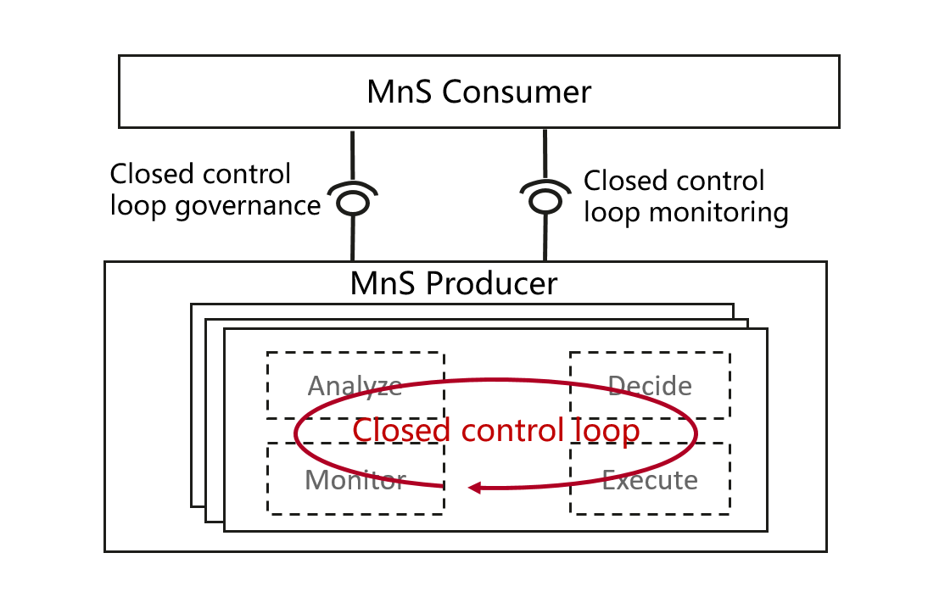
Figure 4.2.X.1 Closed control loop governance and monitoring

4.2.X.2 Closed control loop governance
Closed control loop governance describes a set of capabilities to allow MnS consumer to govern closed control loop, including:
- Lifecycle management of closed control loop, including create, modify,activate/deactivate,delete closed control loop.
- Configure goals and/or policies for closed control loop.

4.2.X.3 Closed control loop monitoring
Closed control loop monitoring describes a set of capabilities to allow MnS consumer to monitoring the progress and result of closed control loop, including:
- Monitor the status and goal fulfillment information of the closed control loop.

End of Change

