3GPP TSG-SA5 Meeting #134e S5-206051

e-meeting 16th - 25st November 2020
CR-Form-v12.1
CHANGE REQUEST
 | 28.535 | CR | 0014 | rev | - | Current version: | 16.1.0
For HELP on using this form: comprehensive instructions can be found at
http://www.3gpp.org/Change-Requests.

Proposed change affects: | UICC apps |  | ME |  | Radio Access Network | X | Core Network | X

Title: | Update figure and description of Communication service assurance service
Source to WG: | Ericsson, Deutsche Telekom, NEC
Source to TSG: | SA5
Work item code: | COSLA |  |  |  |  |  | Date: |  |  | 2020-11-04
Category: | F |  |  |  |  |  | Release: |  |  | Rel-16
 | Use one of the following categories:  F (correction)  A (mirror corresponding to a change in an earlier release)  B (addition of feature),  C (functional modification of feature)  D (editorial modification)  Detailed explanations of the above categories can  be found in 3GPP TR 21.900. |  |  |  |  |  |  |  | Use one of the following releases:  Rel-8 (Release 8)  Rel-9 (Release 9)  Rel-10 (Release 10)  Rel-11 (Release 11)  …  Rel-15 (Release 15)  Rel-16 (Release 16)  Rel-17 (Release 17)  Rel-18 (Release 18)
Reason for change: |  | The reference to ETSI ZSM has to be updated to the work on closed loop automation.  The figure and text is to be updated to replace the control step Monitor with control step Collection and add further descriptive text in the MnF box.  The two given examples are better described bullited.
Summary of change: |  | Figure 4.3.1 and text is updated, examples are clearer and Editor’s Note added to references
Consequences if not approved: |  | Potentially misunderstanding on main functions of the closed control loop potentially leading to implementation issues
Clauses affected: |  | 2, 4.3
 |  | Y | N
Other specs |  |  | X | Other core specifications |  |  |  | TS/TR ... CR ...
affected: |  |  | X | Test specifications |  |  |  | TS/TR ... CR ...
(show related CRs) |  | X |  | O&M Specifications |  |  |  | TS/TR 28.536 CR 206032
Other comments: |  | The updates are made on top of the S5-2060032 (move text from 28.536 to 28.535). The change marks are still kept to show the difference. The changed text is shown with “ericsson user 3”. If both S5-206032 and this CR are approved only this CR has to be implemented.
This CR's revision history:

First change

2 References
The following documents contain provisions which, through reference in this text, constitute provisions of the present document.
- References are either specific (identified by date of publication, edition number, version number, etc.) or non-specific.
- For a specific reference, subsequent revisions do not apply.
- For a non-specific reference, the latest version applies. In the case of a reference to a 3GPP document (including a GSM document), a non-specific reference implicitly refers to the latest version of that document in the same Release as the present document.
[1] 3GPP TR 21.905: "Vocabulary for 3GPP Specifications".
[2] 3GPP TS 22.261: "Service requirements for the 5G system".
[3] 3GPP TS 28.550: "Management and orchestration; Performance assurance".
[4] 3GPP TS 28.531: "Management and orchestration; Provisioning".
[v] ETSI GS ZSM 002 (V1.1.1) (2019-08): "Zero-touch network and Service Management (ZSM); Reference Architecture".
[w] 3GPP TS 28.545: "Management and orchestration; Fault Supervision (FS)".
[x] 3GPP TS 28.552: "Management and orchestration; 5G performance measurements".
[y] 3GPP TS 28.554: "Management and orchestration; 5G end to end Key Performance Indicators (KPI)".
[z] 3GPP TS 28.532: "Management and orchestration; Generic management services".

Second change

4.X Communication service assurance service
Communication service assurance relies on a set of management services that together provide the CSP with the capability to assure the communication service as per agreement (for example an SLS) with a CSC (e.g. enterprise). The overall solution and information flows between management services and the closed control loop steps [v] are shown in Figure 4.3.1.

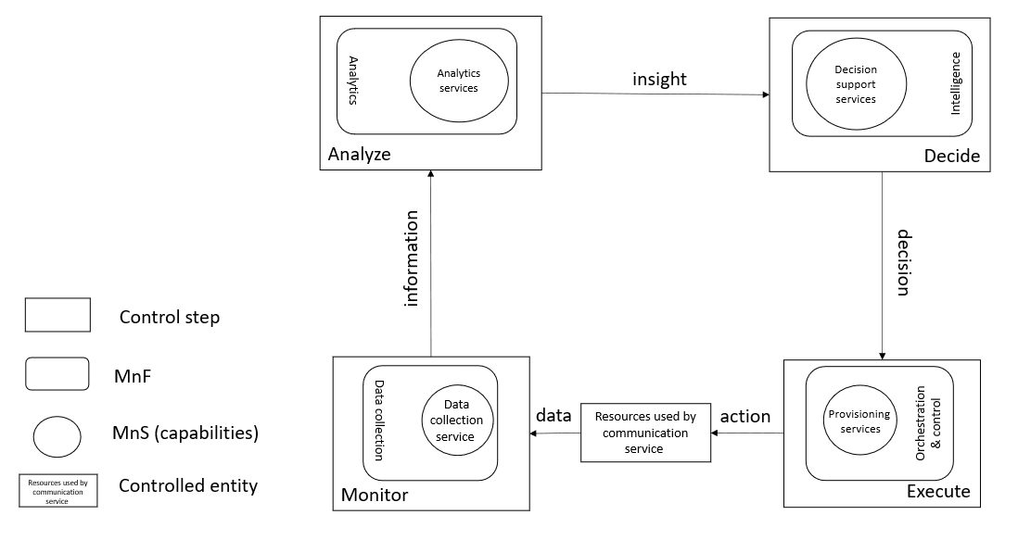
Figure 4.3.1: Overview of closed control loop information flows
In Figure 4.3.1 the controlled entity represents the resources used by a communication service and the assurance of this communication service is provided by the closed control loop between the different management services provided by the management system.
The input to the closed control loop is the data concerning the resources used by the communication service and corrresponding service KPIs which is monitored by the closed control loop and step "Monitor", analyzed by the closed control loop step “Analyze”, a decision on potential solution by the closed control loop step "Decide" which may be a possible action for the closed control loop step "Execute", The role of the decision support services is to provide variable degrees of automated decision making and human oversight support. The following two examples demonstrate how a closed control loop can be used:
- when a service experience degradation is detected (for example due to resource shortage or faults in the network), the resources used by a communication service may be adjusted automatically to improve the service experience
- the data associated with the communication service is monitored by the management services for data collection, this management service provides information to an assurance root cause analysis management service (example of an analytics service) and based on that information the assurance root cause analysis takes place, followed by proposing activities, mitigation or suggestions to solve the problem. The proposed activities, for example mitigation or problem-solving suggestion(s) are executed through provisioning services to bring the behaviour of the communication service within the requested boundaries of the metrics (SLS goals) that are controlled by the closed control loop.
The management services available for the closed control loop steps for "Monitor", "Analyze" and "Decide" are based on file transfer described in TS 28.550 [3], or data streaming described in TS 28.550 [3] and notifications described in TS 28.545 [w].
The information provided from the "Monitor" step to the "Analyze" step includes performance measurements (see TS 28.552 [x]), KPI’s (see TS 28.554 [y]), performance threshold monitoring events and fault supervision events (see TS 28.532 [z]).
The insights provided from the "Analyze" step to the "Decide" step includes analytics outcomes that are not specified in the present document.
The decision support services provided from the "Decide" step to the "Execute" step are not specified in the present document.

End of changes

