3GPP TSG-SA5 Meeting #134e S5-206032

e-meeting 16th - 25st November 2020
CR-Form-v12.1
CHANGE REQUEST
 | 28.535 | CR | 0013 | rev | - | Current version: | 16.1.0
For HELP on using this form: comprehensive instructions can be found at
http://www.3gpp.org/Change-Requests.

Proposed change affects: | UICC apps |  | ME |  | Radio Access Network | X | Core Network | X

Title: | Add description of Communication service assurance service coming from 28.536
Source to WG: | Ericsson, Deutsche Telekom, NEC
Source to TSG: | SA5
Work item code: | COSLA |  |  |  |  |  | Date: |  |  | 2020-11-04
Category: | F |  |  |  |  |  | Release: |  |  | Rel-16
 | Use one of the following categories:  F (correction)  A (mirror corresponding to a change in an earlier release)  B (addition of feature),  C (functional modification of feature)  D (editorial modification)  Detailed explanations of the above categories can  be found in 3GPP TR 21.900. |  |  |  |  |  |  |  | Use one of the following releases:  Rel-8 (Release 8)  Rel-9 (Release 9)  Rel-10 (Release 10)  Rel-11 (Release 11)  …  Rel-15 (Release 15)  Rel-16 (Release 16)  Rel-17 (Release 17)  Rel-18 (Release 18)
Reason for change: |  | The description of a closed control loop for communication service assurance is documented in 28.536, it is however not a stage 2 nor stage 3 description, but more like a concept description of a closed control loop which should be documented in 28.535. This CR takes the applicable text from 28.536, updates and adds it to 28.535 clause 4.
Summary of change: |  | New clause 4.3 has been added.
Consequences if not approved: |  | - Missing description of closed control loop for commnication service assurance from stage 1 specifications  - If the corresponding CR for 28.536 has been approved the description of closed control loop will completely dissappear from the specifications.  - If the CR for 28.536 S5-206031 has not been approved the text will be located in the wrong specification (all be it an Annex).
Clauses affected: |  | 2, 4.3 (New)
 |  | Y | N
Other specs |  |  | X | Other core specifications |  |  |  | TS/TR ... CR ...
affected: |  |  | X | Test specifications |  |  |  | TS/TR ... CR ...
(show related CRs) |  | X |  | O&M Specifications |  |  |  | TS/TR 28.536 CR 206031
Other comments:
This CR's revision history:

First change

2 References
The following documents contain provisions which, through reference in this text, constitute provisions of the present document.
- References are either specific (identified by date of publication, edition number, version number, etc.) or non-specific.
- For a specific reference, subsequent revisions do not apply.
- For a non-specific reference, the latest version applies. In the case of a reference to a 3GPP document (including a GSM document), a non-specific reference implicitly refers to the latest version of that document in the same Release as the present document.
[1] 3GPP TR 21.905: "Vocabulary for 3GPP Specifications".
[2] 3GPP TS 22.261: "Service requirements for the 5G system".
[3] 3GPP TS 28.550: "Management and orchestration; Performance assurance".
[4] 3GPP TS 28.531: "Management and orchestration; Provisioning".
[v] ETSI GS ZSM 002 (V1.1.1) (2019-08): "Zero-touch network and Service Management (ZSM); Reference Architecture".
[w] 3GPP TS 28.545: "Management and orchestration; Fault Supervision (FS)".
[x] 3GPP TS 28.552: "Management and orchestration; 5G performance measurements".
[y] 3GPP TS 28.554: "Management and orchestration; 5G end to end Key Performance Indicators (KPI)".
[z] 3GPP TS 28.532: "Management and orchestration; Generic management services".

Second change

4.X Communication service assurance service
Communication service assurance relies on a set of management services that together provide the CSP with the capability to assure the communication service as per agreement with a CSC (e.g. enterprise). The overall solution and information flows between management services and the closed control loop steps [v] are shown in Figure C.1.

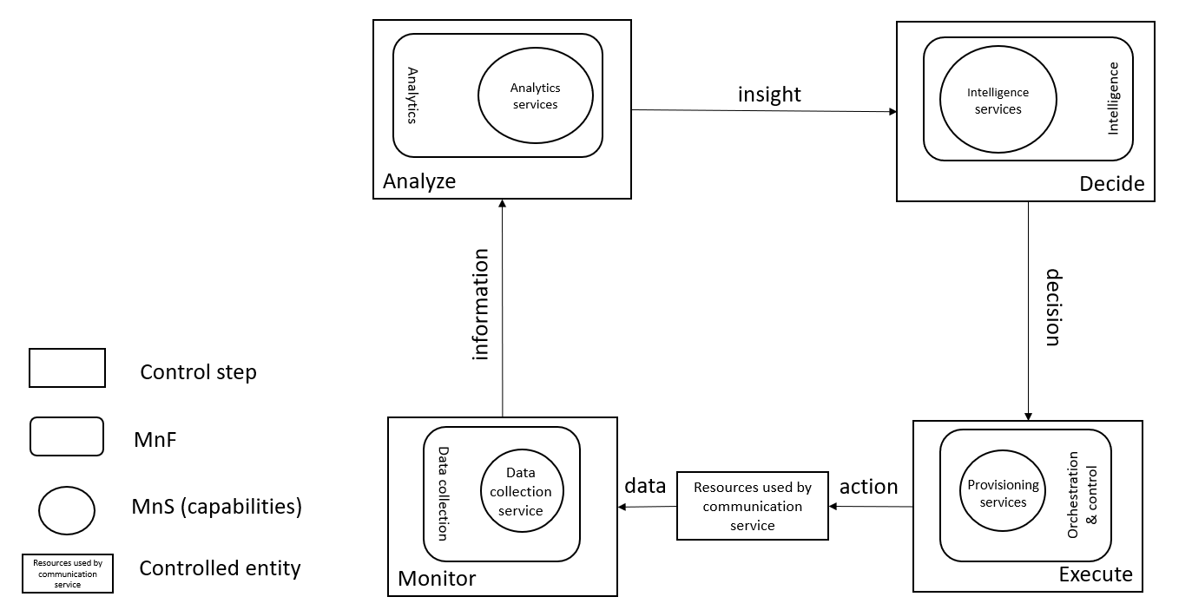
Figure 4.3.1: Overview of closed control loop information flows
In Figure 4.3.1 the controlled entity represents the resources used by a communication service and the assurance of this communication service is provided by the closed control loop between the different management services provided by the management system.
The input to the closed control loop is the data concerning the resources used by the communication service which is monitored by the closed control loop step "Monitor", analysed by the closed control loop step “Analyze”, decision on potential solution by the closed control loop step "Decide" which may be a possible action for the closed control loop step "Execute", for example when the service experience degrades, the resources used by a communication service have to be adjusted. The role of the intelligence services is to provide variable degrees of automated decision making and human oversight support. For example the data associated with the communication service is monitored by the management services for data collection, this management service provides information to the analytics management service and based on that information the assurance analysis takes place followed by proposing activities, mitigation or suggestion to solve the problem. The proposed activities, for example mitigation or problem-solving suggestion(s) are executed through provisioning services to bring the behaviour of the communication service within the requested boundaries of the metrics (SLS goals) that are controlled by the closed control loop.
The management services available for the closed control loop steps for "Monitor", "Analyse" and "Decide" are based on file transfer described in TS 28.550 [3], or data streaming described in TS 28.550 [3] and notifications described in TS 28.545 [w].
The information provided from the "Monitor" step to the "Analyse" step includes performance measurements (see TS 28.552 [x]), KPI’s (see TS 28.554 [y]), performance threshold monitoring events and fault supervision events (see TS 28.532 [z]).
The insights provided from the "Analyse" step to the "Intelligence" step includes analytics outcomes that are not specified in the present document.
End of changes

