3GPP TSG-SA5 Meeting #132e S5-204312

e-meeting 17th 28th August 2020
CR-Form-v12.0
CHANGE REQUEST
 | 28.535 | CR | 0003 | rev | - | Current version: | 16.0.0
For HELP on using this form: comprehensive instructions can be found at
http://www.3gpp.org/Change-Requests.

Proposed change affects: | UICC apps |  | ME |  | Radio Access Network | x | Core Network | x

Title: | Update overview of management control loops
Source to WG: | Huawei
Source to TSG: | S5
Work item code: | eCOSLA |  |  |  |  |  | Date: |  |  | 2020-08-05
Category: | B |  |  |  |  |  | Release: |  |  | Rel-17
 | Use one of the following categories:  F (correction)  A (mirror corresponding to a change in an earlier release)  B (addition of feature),  C (functional modification of feature)  D (editorial modification)  Detailed explanations of the above categories can  be found in 3GPP TR 21.900. |  |  |  |  |  |  |  | Use one of the following releases:  Rel-8 (Release 8)  Rel-9 (Release 9)  Rel-10 (Release 10)  Rel-11 (Release 11)  Rel-12 (Release 12)  Rel-13 (Release 13)  Rel-14 (Release 14)  Rel-15 (Release 15)  Rel-16 (Release 16)
Reason for change: |  | The management control loop for Communication Service Assurance, CSA, consists of the steps Monitoring, Analysis, Decision and Execution. In the process of the management control loop, each step may need to provide information for other steps. For open control loops, each step may provide MnS services for other steps and may consume MnS services provided by other steps, e.g. the Decision step provides MnS to the Execution step, and consumes MnS provided by the Analysis step.
Summary of change: |  | Update overview of management control loops to add stage 2 description for information exchange between steps.
Consequences if not approved: |  | The operation of management control loop is not clear.
Clauses affected: |  | 4.2.1
 |  | Y | N
Other specs |  |  | x | Other core specifications |  |  |  | TS/TR ... CR ...
affected: |  |  | x | Test specifications |  |  |  | TS/TR ... CR ...
(show related CRs) |  |  | x | O&M Specifications |  |  |  | TS/TR ... CR ...
Other comments:
This CR's revision history:

1st of changes

4.2.1 Overview
For communication service assurance one can identify two interactions of management control loops:
1) Between the CSC and the CSP: In this case, the CSC provides the requirements for an assured communication service to the CSP, the CSP provides the corresponding communication service, the CSP also provides feedback to the CSC. The CSP adjusts the resources used by a communication service or the CSC adjusts the SLS continuously to achieve the assured requirements.
2) Between the CSP and the NSP: the communication service provided by CSP requires the network capabilities. For example, the CSP requires a certain network latency. The NSP management system adjusts the network or CSP adjusts the latency requirement continuously to satisfy the latency requirement.
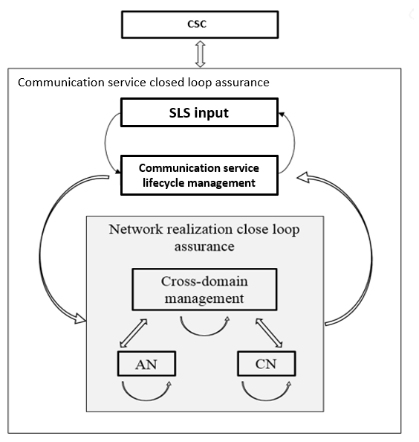
Figure 4.2.1.1: Communication service closed loop assurance
Generally, the management control loop for Communication Service Assurance, CSA, consists of the steps Monitoring, Analysis, Decision and Execution. The management control loops reside in domain layer and cross domain layer. Management services support the steps of the control loop. In a management control loop, a step uses information provided by other steps and provides necessary information for other steps. The “Analysis” step uses performance and fault information from the “Monitor” step and provides analytical report to the “Decision” step. The “Decision” step provides actions information to “Execution” step. The adjustment of the resources used for the communication service is completed by the continuous iteration of the steps in a management control loop. As described in clause 4.1, the management control loop for the resources used for the communication service is deployed in the preparation phase and takes effect during the preparation phase and operation phase.

Figure 4.2.1.2 shows the overall process of communication service assurance using a management control loop.
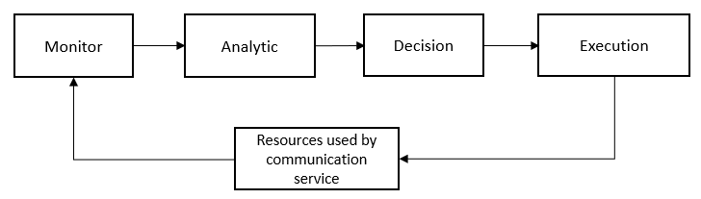
Figure 4.2.1.2: Management Control Loop

4.2.2 Control loops
A control loop is a building block for management of networks and services. The basic principle of any control loop is to adjust the value of a measured or observed variable (expressed as for example an attribute) to equal the value of a desired goal (expressed as for example an attribute). The producer of the measurements or observations, the control service, and the controlled entity are all required to create a control loop.
For the control loop to act on input in the context of the set goal, the control loop provided through following four steps that continuously consume and produce information from each other in a loop in the following sequence monitor, analyse, decide and execute.
A control loop can be an open control loop in which case a human operator or other management entity intervenes inside the loop A control loop can be closed and operates without human operator or other management entity involvement inside the loop other than possibly the initial configuration of the measurement producer and configuration of control loop.

4.2.3 Open control loops
In an open control loop, the human operator intervenes in one or more of the process steps inside the loop, see Figure 4.2.3.1. The human operator is in control of the steps in the control loop, including decisions taken in the loop. The management system collects, analyses and presents the data to the operator, but the operator decides which action to take. In this case, the completion time for control loop is dependent on availability and reaction time of a human operator or other management entity. In open control loops, each step provides corresponding management services which can be consumed by other relevant steps. E.g. the “Analysis” step may provide analytical management service. The “Decision” step may provide decision management service.
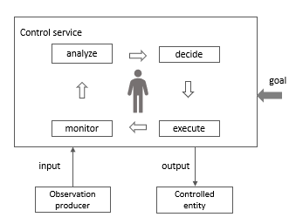
Figure 4.2.3.1: Open control loop entities

4.2.4 Closed control loops
In a closed control loop, there is no direct involvement of a human operator or other management entity in the control loop, the control loop is fully automated. As shown in Figure 4.2.4.1 the human operator or management entity is not directly controlling the details inside the process steps but provides control outside the loop. For example, configuring goals for the control loop to make autonomous decisions within the boundaries of the set goal. Once the control loop is configured with the goal, the controlled entity is adjusted according to the set goals.
In a closed loop the input to the control loop provided by human operator or other management entity may include the goal or policies. The output of the control loop may include closed loop status to a human operator or other management entity.
Typically, the goal is set within certain parameter boundaries, the control loop can automatically adjust the output based on the input within the parameter boundaries. Once a control loop cannot automatically adjust, the human operator or other management entity needs to be informed. The human operator or other management entity may decide to change the management of closed control loop becomes to an open control loop, where decisions are made by the human operator or other management entity and not by the closed control loop.
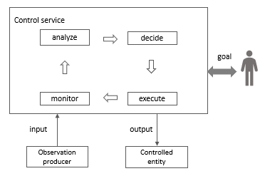
Figure 4.2.4.1: Closed control loop entities
end of changes

