3GPP TSG-SA5 Meeting #132e S5-204282rev3

e-meeting 17th 28th August 2020

Source: Huawei

Title: Key Issue: Area based energy saving

Document for: Approval
Agenda Item: 6.6.5

1 Decision/action requested
The group is asked to discuss and agree on the proposal.

2 References
[1] Draft TS 28.813 0.1.0: Study on new aspects of Energy Efficiency (EE) for 5G
[2] 3GPP TS 28.310: Management and orchestration; Energy efficiency of 5G

3 Rationale
Traditional energy saving (ES) solutions include centralized energy saving solution and distributed energy saving solution. TS 28.310 [2] clause 6.2.1 gives an overview about the ES solutions for the scenarios where the capacity booster cell is fully or partially overlaid by the candidate cell(s). The cell activation/deactivation decision is typically based on the load information of the related cells and the energy saving policies (like the allowed ES time period, ES candidate cell relations) without special considering for the case of area based ES.
It is proposed to introduce a new KI for the draft TS 28.813 [1].

4 Detailed proposal
This document proposes the following changes in TS 28.813 [1].
1st Change

2 References
The following documents contain provisions which, through reference in this text, constitute provisions of the present document.
- References are either specific (identified by date of publication, edition number, version number, etc.) or non-specific.
- For a specific reference, subsequent revisions do not apply.
- For a non-specific reference, the latest version applies. In the case of a reference to a 3GPP document (including a GSM document), a non-specific reference implicitly refers to the latest version of that document in the same Release as the present document.
[1] 3GPP TR 21.905: "Vocabulary for 3GPP Specifications".
[2] 3GPP TS 23.501: "5G; System Architecture for the 5G System".
[3] 3GPP TS 32.130: "Telecommunication management; Network sharing; Concepts and requirements".
[4] 3GPP TS 28.552: "Management and orchestration; 5G performance measurements".
[5] 3GPP TS 28.554: "Management and orchestration; 5G end to end Key Performance Indicators (KPI)".
[6] ETSI ES 203 228 v1.2.1: "Environmental Engineering (EE);Assessment of mobile network energy efficiency".
[7] S5-201169/S2-1912770: LS on analytics support for energy saving
[XX] 3GPP TS 28.310: "Management and orchestration; Energy efficiency of 5G".

Next Change

4.X Key Issue #Y: Area based energy saving

4.X.1 Description
Traditional energy saving (ES) solutions include centralized energy saving solution and distributed energy saving solution. These solutions are mainly targeting for the scenarios illustrated as Figure 5.1.3.2.1-1 NR capacity booster cell partially overlaid by candidate cells and Figure 5.1.3.3-1 gNB capacity booster cell fully overlaid by candidate cell(s), see TS 28.310 [XX]. No specific consideration for the case of area based ES which means there are multiple capacity booster cells in the area to consider ES at the same time as a whole so far.
Considering ES from an area aspect would be beneficial for improving ES efficiency and effect. For example, see figure 4.X.1-1, separate cell activation/deactivation decisions for capacity cell B1, B2 and B3 may lead to Ping-Pong activation/deactivation effect on the related cells (i.e. some capacity cells and coverage cells) in an area in some special cases.

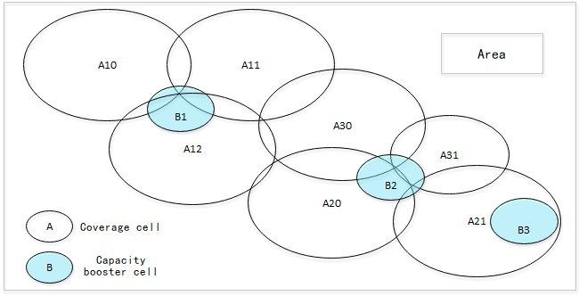
Figure 4.X.1-1: example of area based energy saving

This key issue studies whether and how to support an area based ES which means there are multiple capacity booster cells in the geographical area to consider ES as a whole. In particular, this KI addresses:
- How does 3GPP management system divide the managed network into appropriate areas? For example, suppose there are 1000 capacity booster cells in the whole managed network, the 3GPP management system needs to divide the 1000 capacity booster cells into different geographical areas, and in each of the allocated ES area there are corresponding capacity booster cells and coverage cells to improve ES efficiency and effect.
- How does 3GPP management system decide the activation/deactivation on the related cells inside each ES area?

4.X.2 Potential solutions

4.X.2.1 Potential solution #Y-1: <Potential Solution Title>

4.X.2.1.1 Introduction
Editor's Note: This clause describes briefly the potential solution at a high level.

4.X.2.1.2 Description
Editor's Note: This clause further details the potential solution and any assumptions made.

End of change

