3GPP TSG-SA5 Meeting #132e S5-204149

e-meeting 17th-28th August 2020
CR-Form-v12.0
CHANGE REQUEST
 | 28.658 | CR | 0326 | rev | 1 | Current version: | 15.5.0
For HELP on using this form: comprehensive instructions can be found at
http://www.3gpp.org/Change-Requests.

Proposed change affects: | UICC apps |  | ME |  | Radio Access Network | X | Core Network

Title: | Add missing inheritance diagram for EUtranFrequency and EUtranFreqRelation
Source to WG: | Huawei
Source to TSG: | S5
Work item code: | NETSLICE-5GNRM |  |  |  |  |  | Date: |  |  | 2020-08-05
Category: | F |  |  |  |  |  | Release: |  |  | Rel-15
 | Use one of the following categories:  F (correction)  A (mirror corresponding to a change in an earlier release)  B (addition of feature),  C (functional modification of feature)  D (editorial modification)  Detailed explanations of the above categories can  be found in 3GPP TR 21.900. |  |  |  |  |  |  |  | Use one of the following releases:  Rel-8 (Release 8)  Rel-9 (Release 9)  Rel-10 (Release 10)  Rel-11 (Release 11)  Rel-12 (Release 12)  Rel-13 (Release 13)  Rel-14 (Release 14)  Rel-15 (Release 15)  Rel-16 (Release 16)
Reason for change: |  | The EUtranFrequency IOC and EUtranFreqRelation IOC are introduced in TS 28.658 for NSA deployment scenario, however, the inheritance diagram for EUtranFrequency IOC and EUtranFreqRelation IOC is missing.
Summary of change: |  | Add inheritance diagram for EUtranFrequency IOC and EUtranFreqRelation IOC
Consequences if not approved: |  | No inheritance diagram for EUtranFrequency IOC and EUtranFreqRelation IOC.
Clauses affected: |  | 4.2.2
 |  | Y | N
Other specs |  |  | X | Other core specifications |  |  |  | TS/TR ... CR ...
affected: |  |  | X | Test specifications |  |  |  | TS/TR ... CR ...
(show related CRs) |  |  | X | O&M Specifications |  |  |  | TS/TR ... CR ...
Other comments:
This CR's revision history: |  | Revision of S5-204149

1st Change

4.2.2 Inheritance

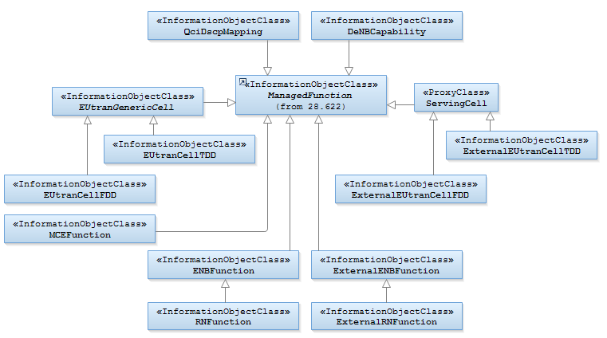

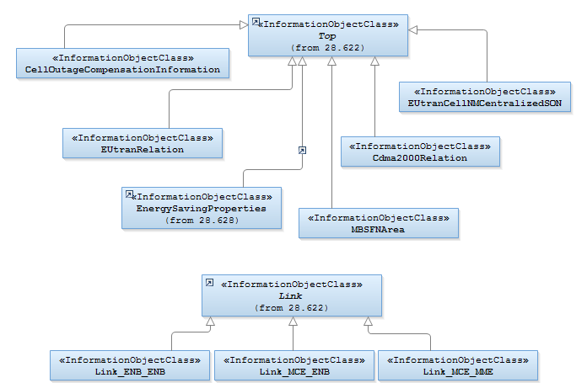
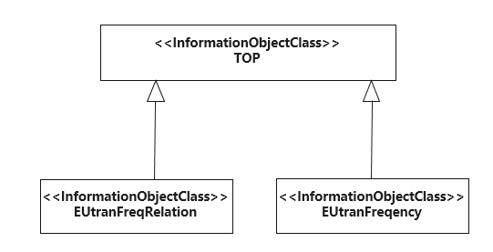

Figure 4.2.2-1: E-UTRAN NRM Inheritance Hierarchy

End of Change

