3GPP TSG-SA5 Meeting #131-e S5-203247rev4

Online, , 25th May 2020 - 3rd Jun 2020
CR-Form-v12.0
CHANGE REQUEST
 | 28.622 | CR | 0084 | rev | - | Current version: | 16.3.0
For HELP on using this form: comprehensive instructions can be found at
http://www.3gpp.org/Change-Requests.

Proposed change affects: | UICC apps |  | ME |  | Radio Access Network | X | Core Network | X

Title: | Rel-16 CR 28.622 Update PM control fragment (stage 2)
Source to WG: | Nokia, Nokia Shanghai Bell
Source to TSG: | SA5
Work item code: | eNRM |  |  |  |  |  | Date: |  |  | 2020-05-15
Category: | F |  |  |  |  |  | Release: |  |  | Rel-16
 | Use one of the following categories:  F (correction)  A (mirror corresponding to a change in an earlier release)  B (addition of feature),  C (functional modification of feature)  D (editorial modification)  Detailed explanations of the above categories can  be found in 3GPP TR 21.900. |  |  |  |  |  |  |  | Use one of the following releases:  Rel-8 (Release 8)  Rel-9 (Release 9)  Rel-10 (Release 10)  Rel-11 (Release 11)  Rel-12 (Release 12)  Rel-13 (Release 13)  Rel-14 (Release 14)  Rel-15 (Release 15)  Rel-16 (Release 16)
Reason for change: |  | The PM control fragment is convoluted, difficult to understand and function wise ambiguous. It is also not clear why two IOCs are needed.
Summary of change: |  | The PM control fragment is basically rewritten completely. All functions are morged into a single IOC.
Consequences if not approved: |  | The PM control fragment is ambiguous and will result in different implementations impairing interoperability.
Clauses affected: |  | 4.2.1, 4.2.2, 4.3.3.2, 4.3.4.2, 4.3.7.2, 4.3.11.1, 4.3.11.2, 4.3.12 (void), 4.3.13, 4.3.13.1, 4.3.13.2, 4.3.13.3, 4.3.14.4, 4.3.14, 4.3.14.1, 4.3.14.2, 4.3.28 (void), 4.3.W, 4.3.W.1, 4.3.W.2, 4.3.W.3, 4.3.W.4, 4.3.X, 4.3.X.1, 4.3.X.2, 4.3.X.3, 4.3.X.4, 4.4.1
 |  | Y | N
Other specs |  |  | X | Other core specifications |  |  |  | TS/TR ... CR ...
affected: |  |  | X | Test specifications |  |  |  | TS/TR ... CR ...
(show related CRs) |  | X |  | O&M Specifications |  |  |  | TS 28.623 CR 0087
Other comments: |  | TS 28.623 CR 87 is in S5-203249
This CR's revision history:

Changes in rev1
- Moved back to one streamTarget
- Condensed definition of ReportingCtrl
First modification

4.2 Class diagrams

4.2.1 Relationships
This clause depicts the set of classes (e.g. IOCs) that encapsulates the information relevant for this IRP. This clause provides the overview of the relationships of relevant classes in UML. Subsequent clauses provide more detailed specification of various aspects of these classes.
The following figure shows the containment/naming hierarchy and the associations of the classes defined in the present document. See Annex A of a class diagram that combines this figure with Figure 1 of [2], the class diagram of UIM.
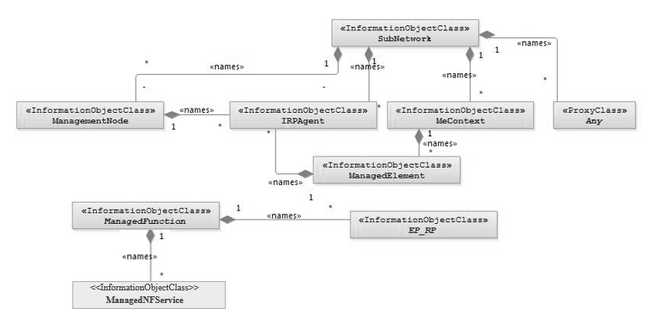
NOTE 1: ManagedElement may be contained either
- in a SubNetwork (since SubNetwork inherits from Domain_ and ManagedElement inherits from ManagedElement_ and Domain_ name-contained ManagedElement_ as observed in the figure of Annex A) or
- in a MeContext instance as observed by the above figure or in the figure of Annex A.
This either-or relation cannot be shown by using an {xor} constraint in the above figure.
ManagedElement may also have no parent instance at all.
NOTE 2: Each instance of the VsDataContainer shall only be contained under one IOC. The VsDataContainer can be contained under IOCs defined in other NRMs.
NOTE 3: If the configuration contains several instances of SubNetwork, exactly one SubNetwork instance shall directly or indirectly contain all the other SubNetwork instances.
NOTE 4: The SubNetwork instance not contained in any other instance of SubNetwork is referred to as "the root SubNetwork instance".
NOTE 5: ManagementNode shall be contained in the root SubNetwork instance.
NOTE 6: If contained in a SubNetwork instance, IRPAgent shall be contained in the root SubNetwork instance.
NOTE 7: For a clarification on the choice of containment of the IRPAgent (since it has three possible parents), see the def. of IRPAgent.
NOTE 8: Cardinality * is identical to multiplicity 0..*.

Figure 4.2.1-1: Containment/Naming and Association NRM fragment
Each Managed Object is identified with a Distinguished Name (DN) according to 3GPP TS 32.300 [13] that expresses its containment hierarchy. As an example, the DN of a ManagedElement instance could have a format like:
SubNetwork=Sweden,MeContext =MEC-Gbg-1, ManagedElement=RNC-Gbg-1.
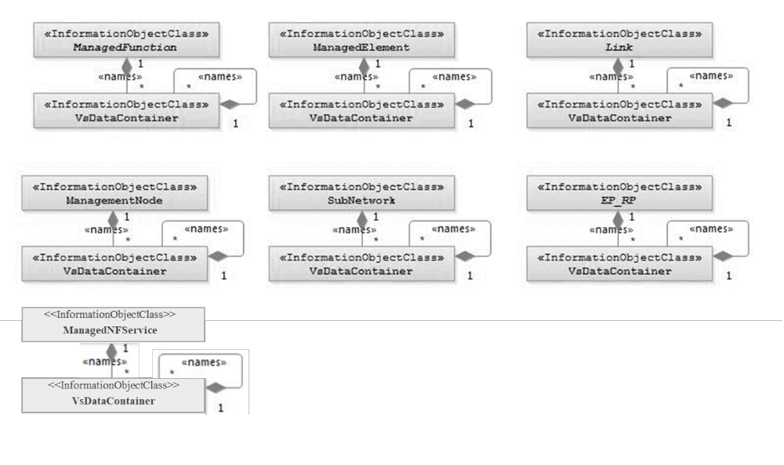
NOTE 8: Each instance of the VsDataContainer shall only be contained under one IOC. The VsDataContainer can be contained under IOCs defined in other NRMs by virtue of inheritance from the GENERIC NRM.
NOTE 9: The VsDataContainer is only used for the Bulk CM IRP.

Figure 4.2.1-2: VsDataContainer Containment/Naming and Association in NRM fragment

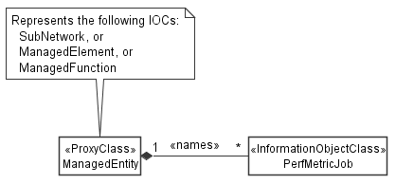
Figure 4.2.1-3: PM control NRM fragment
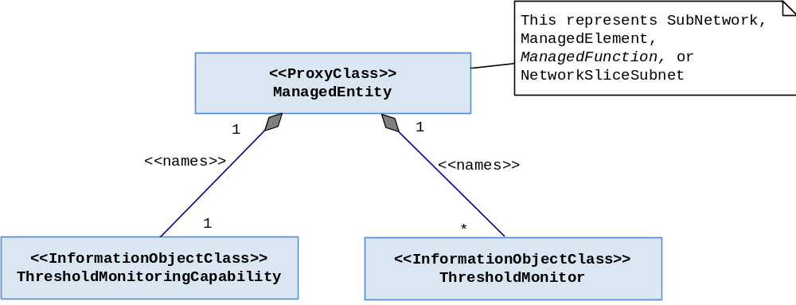
Figure 4.2.1-4: Measurement threshold monitoring control fragment
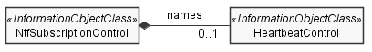
Figure 4.2.1-5: Heartbeat notification control fragment
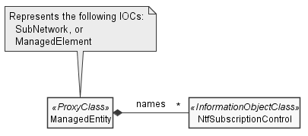
Figure 4.2.1-6: Notification subscription control fragment

4.2.2 Inheritance

This clause depicts the inheritance relationships.

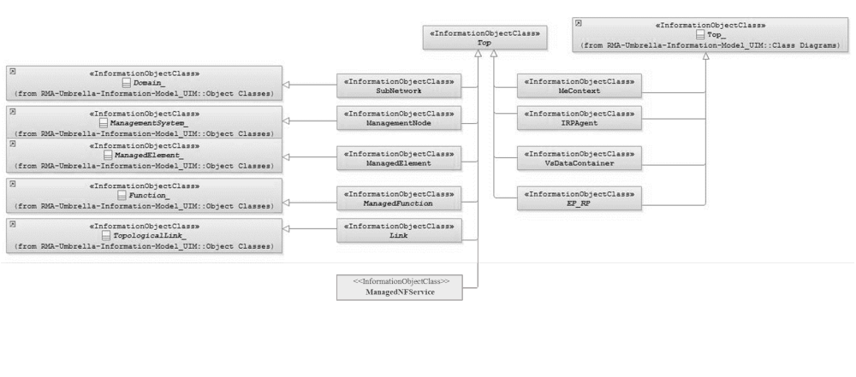

Figure 4.2.2-1: Inheritance Hierarchy NRM fragment
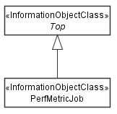

Figure 4.2.2-2: Performance measurement control NRM fragment

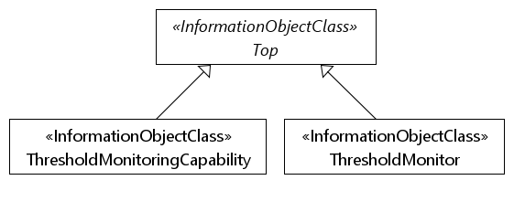

Figure 4.2.2-3: Measurement threshold monitoring NRM fragment
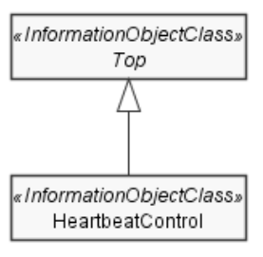

Figure 4.2.2-4: Heartbeat notification control fragment

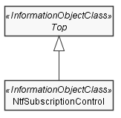
Figure 4.2.2-5: Notification subscription fragment
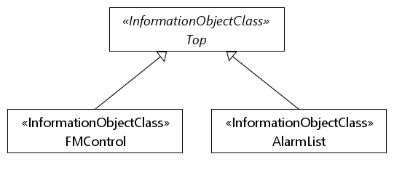
Figure 4.2.2-6: FM control NRM fragment

Next modification

4.3.3 ManagedElement

4.3.3.1 Definition
This IOC represents telecommunications equipment or TMN entities within the telecommunications network providing support and/or service to the subscriber.
An ME communicates with a manager (directly or indirectly) over one or more management interfaces for the purpose of being monitored and/or controlled. MEs may or may not additionally perform element management functionality.
An ME contains equipment that may or may not be geographically distributed. An ME is often referred to as a "Network Element".
A telecommunication equipment has software and hardware components. The IOC described above represents the case when the software component is designed to run on dedicated hardware component. In the case when the software is designed to run on ETSI NFV defined NFVI [15], the IOC description would exclude the NFVI component supporting the above mentioned subject software. A ManagedElement may be contained in either a SubNetwork or in a MeContext instance. A single ManagedElement may also exist stand-alone with no parent at all.
The ManagedElement IOC may be used to represent combined ME functionality (as indicated by the managedElementType attribute and the contained instances of different functional IOCs).
Single function ManagedElement IOC instances will have a 1..1 containment relationship to a function IOC instance (in this context a function IOC instance is an instance of an IOC derived from the ManagedFunction IOC). Multiple function ManagedElement instances will have a 1..N containment relationship to function IOC instances.
NOTE: For some specific functional IOCs a 1..N containment relationship is permitted. The specific functional entities are identified in the NRMs that define subclasses of ManagedFunction.

4.3.3.2 Attributes
The ManagedElement IOC includes the attributes inherited from ManagedElement_ IOC (defined in TS 28.620 [9]), attributes inherited from Top IOC (defined in clause 4.3.8) and the following attributes:
Attribute Name | S | isReadable | isWritable | isInvariant | isNotifyable
vendorName | M | T | F | F | T
userDefinedState | M | T | T | F | T
swVersion | M | T | F | F | T
priorityLabel | O | T | F | T | F
supportedPerfMetricGroups | O | T | F | F | T

4.3.3.3 Attribute constraints
Attribute constrains for dnPrefix: The attribute dnPrefix shall be supported if an instance of ManagedElement is the local root instance of the MIB. Otherwise the attribute shall be absent or carry no information.

4.3.3.4 Notifications
The common notifications defined in clause 4.5 are valid for this IOC. In addition, the following set of notifications is also valid.
Name | Qualifier | Notes
notifyDownloadNESwStatusChanged | See Software Management IRP (3GPP TS 32.532 [6])
notifyInstallNESwStatusChanged | See Software Management IRP (3GPP TS 32.532 [6])
notifyActivateNESwStatusChanged | See Software Management IRP (3GPP TS 32.532 [6])

Next modification

4.3.4 ManagedFunction

4.3.4.1 Definition
This IOC is provided for sub-classing only. It provides attribute(s) that are common to functional IOCs. Note that a ManagedElement may contain several managed functions. The ManagedFunction may be extended in the future if more common characteristics to functional objects are identified.
This IOC can represent a telecommunication function either realized by software running on dedicated hardware or realized by software running on NFVI. Each ManagedFunction instance communicates with a manager (directly or indirectly) over one or more management interfaces exposed via its containing ME instance.

4.3.4.2 Attributes
The ManagedFunction IOC includes the attributes inherited from Function_ IOC (defined in TS 28.620 [9]), attributes inherited from Top IOC (defined in clause 4.3.8) and the following attributes:
Attribute Name | S | isReadable | isWritable | isInvariant | isNotifyable
vnfParametersList | CM | T | T | F | T
peeParametersList | CM | T | T | F | T
priorityLabel | O | T | F | T | F
supportedPerfMetricGroups | O | T | F | T | F

4.3.4.3 Attribute constraints

Name | Definition
vnfParametersList Support Qualifier | Condition: The ManagedFunction instance is realized by one or more VNF instance(s). Otherwise this attribute shall be absent.
peeParametersList Support Qualifier | Condition: The control and monitoring of PEE parameters is supported by the ManagedFunction or sub-class instance.

4.3.4.4 Notifications
There is no notification defined.

Next modification

4.3.7 SubNetwork

4.3.7.1 Definition
This IOC represents a set of managed entities. There may be zero or more instances of a SubNetwork. It shall be present if either a ManagementNode or multiple ManagedElements are present (i.e. ManagementNode and multiple ManagedElement instances shall have SubNetwork as parent).
The SubNetwork instance not contained in any other instance of SubNetwork is referred to as the "root" SubNetwork instance.

4.3.7.2 Attributes
The SubNetwork IOC includes the attributes inherited from Domain_ IOC (defined in TS 28.620 [9]), attributes inherited from Top IOC (defined in clause 4.3.8) and the following attributes:
Attribute Name | S | isReadable | isWritable | isInvariant | isNotifyable
setOfMcc | CM | T | F | F | T
priorityLabel | O | T | F | T | F
supportedPerfMetricGroups | O | T | F | T | F

4.3.7.3 Attribute constraints
Name | Definition
dnPrefix (inherited from Domain_) Support Qualifier | Condition: The instance of SubNetwork is the local root instance of the MIB. Otherwise the attribute shall be absent or carry no information.
setOfMcc Support Qualifier | Condition: There is more than one value in setOfMcc of the SubNetwork ; otherwise the support is optional.

4.3.7.4 Notifications
The common notifications defined in clause 4.5 are valid for this IOC, without exceptions or additions

Next modification

4.3.11 EP_RP

4.3.11.1 Definition
This IOC is provided for sub-classing only. This IOC represents an end point of a link used across a reference point between two network entities.

For naming the subclasses of EP_RP, the following rules shall apply:
- The name of the subclassed IOC shall have the form “EP_<rp>”, where <rp> is a string that represents the name of the reference point.
Thus, two valid examples of EP_RP subclassed IOC names would be: EP_S1 and EP_X2.

4.3.11.2 Attributes
The EP_RP IOC includes the attributes inherited from Top_ (defined in TS 28.620 [9]), attributes inherited from Top IOC (defined in clause 4.3.8) and the following attributes:
Attribute Name | S | isReadable | isWritable | isInvariant | isNotifyable
farEndEntity | O | T | - | - | T
userLabel | O | T | T | - | T
supportedPerfMetricGroups | O | T | F | T | F

4.3.11.3 Attribute constraints
None

4.3.11.4 Notifications
This class does not support any notification.

Next modification

4.3.12 Void

Next modification

4.3.13 PerfMetricJob

4.3.13.1 Definition

This IOC represents a performance metric production job. It can be name-contained by SubNetwork, ManagedElement, or ManagedFunction.
To activate the production of the specified performance metrics, a MnS consumer needs to create a PerfMetricJob instance on the MnS producer. For ultimate deactivation of metric production, the MnS consumer should delete the job to free up resources on the MnS producer.
For temporary suspension of metric production, the MnS consumer can manipulate the value of the administrative state attribute. The MnS producer may disable metric production as well, for example in overload situations. This situation is indicated by the MnS producer with setting the operational state attribute to disabled. When production is resumed the operational state is set again to enabled.
The perfMetricJobGroupId is a common reference across all members of a PerfMetricJob group. A group contains related PerfMetricJob instances.
The attribute performanceMetrics defines the performance metrics to be produced and the attribute granularityPeriod defines the granularity period to be applied.
All object instances below and including the instance name-containing the PerfMetricJob (base object instance) are scoped for performance metric production. Performance metrics are produced only on those object instances whose object class matches the object class associated to the performance metrics to be produced.
The attributes objectInstances and rootObjectInstances allow to restrict the scope. When the attribute objectInstances is present, only the object instances identified by this attribute are scoped. When the attribute rootObjectInstances is present, then the subtrees whose root objects are identified by this attribute are scoped. Both attributes may be present at the same time meaning the total scope is equal to the sum of both scopes. Object instances may be scoped by both the objectInstances and rootObjectInstances attributes. This shall not be considered as an error by the MnS producer.
When the performance metric requires performance metric production on multiple managed objects, which is for example the case for KPIs, the MnS consumer needs to ensure all required objects are scoped. Otherwise a PerfMetricJob creation request shall fail.
The attribute reportingCtrl specifies the method and associated control parameters for reporting the produced measurements to MnS consumers. Three methods are available: file-based reporting with selection of the file location by the MnS producer, file-based reporting with selection of the file location by the MnS consumer and stream-based reporting.
A PerfMetricJob creation request shall fail, when the requested performance metrics, the requested granularity period, the requested repoting method, or the requested combination thereof is not supported by the MnS producer.
Creation and deletion of PerfMetricJob instances by MnS consumers is optional; when not supported, PerfMetricJob instances may be created and deleted by the system or be pre-installed.

4.3.13.2 Attributes
The PerfMetricJob IOC includes attributes inherited from Top IOC (defined in clause 4.3.8) and the following attributes:
Attribute name | S | isReadable | isWritable | isInvariant | isNotifyable
administrativeState | M | T | T | F | T
operationalState | M | T | F | F | T
perfMetricJobGroupId | M | T | T | T | F
performanceMetrics | M | T | T | F | F
granularityPeriod | M | T | T | F | F
objectInstances | O | T | T | F | T
rootObjectInstances | O | T | T | F | T
reportingCtrl | M | T | T | F | F

4.3.13.3 Attribute constraints
None.

4.3.13.4 Notifications
The common notifications defined in clause 4.5 are valid for this IOCceptions or n, the following set of notifications is also valid.
Name | S | Notes
notifyFileReady | M | --
notifyFilePreparationError | M | --

Next modification

4.3.14 SupportedPerfMetricGroup <<dataType>>

4.3.14.1 Definition
This <<dataType>> captures a group of supported performance metrics and associated granularity periods and reporting methods that are supported for the specified performance metric group.
4.3.14.2 Attributes
Attribute name | S | isReadable | isWritable | isInvariant | isNotifyable
performanceMetrics | M | T | F | F | F
granularityPeriods | M | T | F | F | F
reportingMethods | M | T | F | F | F

4.3.14.3 Attribute constraints
None

4.3.14.4 Notifications
Not applicable.

Next modification

4.3.28 Void

Next modification

4.3.X ReportingCtrl <<choice>>

4.3.X.1 Definition
This <<choice>> defines the method for reporting collected performance metrics to MnS consumers as well as the parameters for configuring the reporting function. It is a choice between the control parameter required for the reporting methods, whose presence selects the reporting method as follows:
When only the fileReportingPeriod attribute is present, the MnS producer shall store files on the MnS producer at a location selected by the MnS producer and inform the MnS consumer about the availability of new files and the file location using the notifyFileReady notification.
When only the fileReportingPeriod and fileLocation attributes are present, the MnS producer shall store the files on the MnS consumer at the loaction specified by fileLocation. No notification is emitted by the MnS producer.
When only the streamTarget attribute is present, the MnS producer shall stream the data to the location specified by streamTarget.
For the file-based reporting methods the fileReportingPeriod attribute specifies the time window during which collected measurements are stored into the same file before the file is closed and a new file is opened.

4.3.X.2 Attributes
Attribute name | S | isReadable | isWritable | isInvariant | isNotifyable
CHOICE_1.1 fileReportingPeriod | CM | T | T | F | T
CHOICE_2.1 fileReportingPeriod | CM | T | T | F | T
CHOICE_2.2 fileLocation | CM | T | T | F | T
CHOICE_3.1 streamTarget | CM | T | T | F | T

4.3.X.3 Attribute constraints
Name | Definition
CHOICE_1.1 fileReportingPeriod | This attribute shall be supported, when the file-based reporting method is supported, and the files are stored on the MnS producer.
CHOICE_2.1 fileReportingPeriod  CHOICE_2.2 fileLocation | These attributes shall be supported, when the file-based reporting method is supported, and the files are stored on the MnS consumer.
CHOICE_3.1 streamTarget | This attribute shall be supported, when the stream-based reporting method is supported

4.3.X.4 Notifications
The subclause 4.5 of the <<IOC>> using this <<dataType>> as one of its attributes, shall be applicable.

Next modification

4.4 Attribute definitions

4.4.1 Attribute properties
The following table defines the properties of attributes specified in the present document.
Attribute Name |  | Documentation and Allowed Values |  | Properties
heartbeatNtfPeriod |  | This attribute specifies the periodicity of heartbeat notification emission. The value of zero has the special meaning of stopping the heartbeat notification emission.  Unit is in minutes.  AllowedValues: non-negative integers |  | type: Integer  multiplicity: 1  isOrdered: N/A  isUnique: N/A  defaultValue: 0  isNullable: False
triggerHeartbeatNtf |  | Setting this attribute to TRUE triggers an immediate additional heartbeat notification emission. Setting the value to FALSE has no observable result.  The periodicity of notifyHeartbeat emission is not changed.  AllowedValues: TRUE, FALSE |  | type: ENUM  multiplicity: 1  isOrdered: N/A  isUnique: N/A  defaultValue: FALSE  isNullable: False
notificationRecipientAddress |  | This attribute defines the address of the notification recipient. |  | type: String  multiplicity: 1  isOrdered: N/A  isUnique: N/A  defaultValue: None  isNullable: False
notificationTypes |  | This attribute defines the types of notifications that are candidates for being forwarding to the notification recipient  If the notificationFilter attribute is not supported all candidate notifications are forwarded to the notification recipient, otherwise the candidate notifications are discriminated by the filter specified by the notificationFilter attribute.  AllowedValues:  - notifyMOICreation  - notifyMOIDeletion  - notifyMOIAttributeValueChanges  - notifyEvent  - notifyNewAlarm  - notifyChangedAlarm  - notifyAckStateChanged  - notifyComments  - notifyCorrelatedNotificationChanged  - notifyChangedAlarmGeneral  - notifyAlarmListRebuilt  - notifyPotentialFaultyAlarmList  - notifyFileReady  - notifyFilePreparationError  - notifyThresholdCrossing |  | type: string  multiplicity: 1..*  isOrdered: N/A  isUnique: N/A  defaultValue: NOne  isNullable: False
notificationFilter |  | This attribute defines a filter to be applied to candidate notifications identified by the notificationTypes attribute. Only notifications that pass the filter criteria are forwarded to the notification recipient. All other notifications are discarded.  The filter can be applied to any field of a notification. |  | type: String  multiplicity: 1  isOrdered: N/A  isUnique: N/A  defaultValue: None  isNullable: False
scope |  | This attribute defines the scope. It is a structured parameter with the data type Scope. |  | type: Scope  multiplicity: 1  isOrdered: N/A  isUnique: N/A  defaultValue: None  isNullable: False
scopeType |  | If the optional scopeLevel parameter is not supported or absent, allowed values of scopeType are BASE_ONLY and BASE_ALL.  The value BASE_ONLY indicates only the base object is selected.  The value BASE_ALL indicates the base object and all of its subordinate objects (incl. the leaf objects) are selected.  If the scopeLevel parameter is supported and present, allowed values of scopeType are BASE_ALL, BASE_ONLY, BASE_NTH_LEVEL and BASE_SUBTREE.  The value BASE_NTH_LEVEL indicates all objects on the level, which is specified by the scopeLevel parameter, below the base object are selected. The base object is at scopeLevel zero.  The value BASE_SUBTREE indicates the base object and all of its subordinate objects down to and including the objects on the level, which is specified by the scopeLevel parameter, are selected. The base object is at scopeLevel zero. |  | type: ENUM  multiplicity: 1  isOrdered: N/A  isUnique: N/A  defaultValue: None  isNullable: False
scopeLevel |  | See definition of scopeType parameter. |  | type: Integer  multiplicity: 1  isOrdered: N/A  isUnique: N/A  defaultValue: None  isNullable: False
farEndEntity |  | The value of this attribute shall be the Distinguished Name of the far end network entity to which the reference point is related.  As an example, with EP_Iucs, if the instance of EP_Iucs is contained by one RncFunction instance, the farEndEntity is the Distinguished Name of the MscServerFunction instance to which this Iucs reference point is related.  allowedValues: N/A |  | type: DN  multiplicity: 0..1  isOrdered: N/A  isUnique: N/A  defaultValue: No  isNullable: False
linkType |  | This attribute defines the type of the link.  allowedValues: Signalling, Bearer, OAM&P, Other or multiple combinations of this type. |  | type: String  multiplicity: 0..*  isOrdered: False  isUnique: True  defaultValue: No  isNullable: False
locationName |  | The physical location of this entity (e.g. an address).  allowedValues: N/A |  | type: String  multiplicity: 0..1  isOrdered: N/A  isUnique: N/A  defaultValue: No  isNullable: False
monitoringGP |  | This attribute defines the monitoring granularity period (in seconds).  allowedValues: see NOTE 5 |  | type: Integer  multiplicity: 1  isOrdered: False  isUnique: True  defaultValue: No  isNullable: False
monitoredIOCName |  | It specifies one object class name for which the threshold monitor is created. When this attribute take effective, the threshold monitor is created for all of its instances in the name-containment tree whose top (tree) node is the IOC instance name-containing the subject <<IOC>>ThresholdMonitor instance containing this attribute.  This attribute takes effective when the monitoredObjectDNs contained by the same <<IOC>>ThresholdMonitor instance is empty.  allowedValues: The IOC names defined in the NRMs specifications. |  | type: String  multiplicity: 1  isOrdered: False  isUnique: True  defaultValue: No  isNullable: False
monitoringNotifTarget |  | This identifies the target of the notifications when the monitored measurement crosses or reaches the threshold set by the subject threshold monitor.  allowedValues: N/A |  | type: String  multiplicity: 1  isOrdered: N/A  isUnique: N/A  defaultValue: None  isNullable: True
monitoredObjectDNs |  | It specifies the object instance(s) for threshold monitoring.  This attribute monitoredIOCName contained by the same <<IOC>>ThresholdMonitor instance does not take effective when this attribute is not empty.  allowedValues: list of DN |  | type: dataType  multiplicity: 1  isOrdered: False  isUnique: True  defaultValue: No default value  isNullable: False
objectClass |  | An attribute which captures the name of the class from which the object instance is an occurrence of.  allowedValues: N/A |  | type: String  multiplicity: 1  isOrdered: N/A  isUnique: N/A  defaultValue: No default value  isNullable: False
objectInstance |  | Managed object instance identified by its DN.  allowedValues: N/A |  | type: String  multiplicity: 1  isOrdered: N/A  isUnique: N/A  defaultValue: No default value  isNullable: False
objectInstances |  | List of managed object instances. Each object instance is identified by its DN.  allowedValues: N/A |  | type: Dn  multiplicity: *  isOrdered: N/A  isUnique: N/A  defaultValue: None  isNullable: False
peeParametersList |  | This attribute contains the parameter list for the control and monitoring of power, energy and environmental parameters of ManagedFunction instance(s). This list contains the following parameters:  - siteIdentification  - siteLatitude (optional)  - siteLongitude (optional)  - siteDescription  - equipmentType  - environmentType  - powerInterface  siteIdentification: The identification of the site where the ManagedFunction resides.  allowedValues: N/A  siteLatitude: The latitude of the site where the ManagedFunction instance resides, based on World Geodetic System (1984 version) global reference frame (WGS 84). Positive values correspond to the northern hemisphere. This attribute is optional in case of BTSFunction and RNCFunction instance(s).  allowedValues: -90.0000 to +90.0000  siteLongitude: The longitude of the site where the ManagedFunction instance resides, based on World Geodetic System (1984 version) global reference frame (WGS 84). Positive values correspond to degrees east of 0 degrees longitude. This attribute is optional in case of BTSFunction and RNCFunction instance(s).  allowedValues: -180.0000 to +180.0000  siteDescription: An operator defined description of the site where the ManagedFunction instance resides.  allowedValues: N/A  equipmentType: The type of equipment where the managedFunction instance resides.  allowedValues: see clause 4.4.1 of ETSI ES 202 336-12 [18].  environmentType: The type of environment where the managedFunction instance resides.  allowedValues: see clause 4.4.1 of ETSI ES 202 336-12 [18].  powerInterface: The type of power.  allowedValues: see clause 4.4.1 of ETSI ES 202 336-12 [18]. |  | type: String  multiplicity: 0..*  isOrdered: N/A  isUnique: True  defaultValue: No default value  isNullable: True
priorityLabel | This is a label that consumer would assign a value on a concrete instance of the managed object. The management system takes the value of this attribute into account. The effect of this attribute value to the subject managed entity is not standardized |  | type: Integer  multiplicity: 1  isOrdered: N/A  isUnique: N/A  defaultValue: No default value  isNullable: False
protocolVersion |  | Versions(s) and additional descriptive information for the protocol(s) used for the associated communication link. Syntax and semantic is not specified.  allowedValues: N/A |  | type: String  multiplicity: *  isOrdered: False  isUnique: True  defaultValue: no default value  isNullable: False
setOfMcc |  | Set of Mobile Country Code (MCC). The MCC uniquely identifies the country of domicile of the mobile subscriber. MCC is part of the IMSI (TS 23.003 [5])  This list contains all the MCC values in subordinate object instances to this SubNetwork instance.  allowedValues: See clause 2.3 of TS 23.003 [5] for MCC allocation principles. |  | type: Integer  multiplicity: 1..*  isOrdered: False  isUnique: True  defaultValue: No default value  isNullable: False
swVersion |  | The software version of the ManagementNode or ManagedElement (this is used for determining which version of the vendor specific information is valid for the ManagementNode or ManagedElement).  allowedValues: N/A |  | type: String  multiplicity: 0..1  isOrdered: N/A  isUnique: N/A  defaultValue: No default value  isNullable: False
systemDN |  | The Distinguished Name (DN) of IRPAgent (or consumer). Defined in 3GPP TS 32.300.  allowedValues: N/A |  | type: DN  multiplicity: 0..1  isOrdered: N/A  isUnique: N/A  defaultValue: No default value  isNullable: False
supportedMonitoringGPs |  | The monitoring granularity periods (in seconds) supported by the producer for the monitored entities.  AllowedValues: see NOTE 5. |  | type: integer  multiplicity: 1..*  isOrdered: N/A  isUnique: N/A  defaultValue: No default value  isNullable: False
thresholdInfoList |  | It specifies the list of threshold information.  It is list of  <  measurementType,  direction,  thresholdPack  >,  where thresholdPack is list of  <  thresholdLevel,  thresholdValue,  hysteresis (optional)  >  The measurementType shall be in one of the following form:  - "family.measurementName.subcounter" for monitoring the measurement types with subcounters defined.  - "family.measurementName" for monitoring the measurement types without subcounters defined.  The direction can be 'Increasing' or ‘Decreasing' of the measurement values.  - If it is "Increasing", the threshold crossing notification is triggered when the measurement value equals or exceeds a thresholdValue.  - If it is "Decreasing", the threshold crossing notification is triggered when the measurement value equals or below a thresholdValue.  The thresholdLevel indicates the level for the threshold. See NOTE 6 for the supported threshold levels.  The hysteresis has a threshold-high and a threshold-low value that are different from the threshold value.  A hysteresis, therefore, defines the threshold-high and threshold-low levels within which the measurementType value is allowed to oscillate without triggering the threshold crossing notification.  AllowedValues: N/A |  | type: dataType  multiplicity: 1s..*  isOrdered: N/A  isUnique: N/A  defaultValue: No default value  isNullable: False
userDefinedState |  | An operator defined state for operator specific usage.  allowedValues: N/A |  | type: String  multiplicity: 0..1  isOrdered: N/A  isUnique: N/A  defaultValue: No default value  isNullable: False
userLabel |  | A user-friendly (and user assignable) name of this object.  allowedValues: N/A |  | type: String  multiplicity: 0..1  isOrdered: N/A  isUnique: N/A  defaultValue: No default value  isNullable: False
vendorName |  | The name of the vendor.  allowedValues: N/A |  | type: String  multiplicity: 0..1  isOrdered: N/A  isUnique: N/A  defaultValue: None  isNullable: False
vnfParametersList |  | This attribute contains the parameter set of the VNF instance(s) corresponding to an NE. Each entry in the list contains:  - vnfInstanceId  - vnfdId (optional)  - flavourId (optional)  - autoScalable  vnfInstanceId: VNF instance identifier (vnfInstanceId, see section 9.4.2 of [16] and section B2.4.2.1.2.3 of [17]).  See Note 1.  vnfdId: Identifier of the VNFD on which the VNF instance is based, see section 9.4.2 of [16]. This attribute is optional.  Note: the value of this attribute is identical to that of the same attribute in clause 9.4.2 of ETSI GS NFV-IFA 008 [16].  flavourId: Identifier of the VNF Deployment Flavour applied to this VNF instance, see section 9.4.3 of [16]. This attribute is optional.  Note: the value of this attribute is identical to that of the same attribute in clause 9.4.3 of ETSI GS NFV-IFA 008 [16].  autoScalable: Indicator of whether the auto-scaling of this VNF instance is enabled or disabled. The type is Boolean.  See Note2.  The presence of this attribute indicates that the ManagedFunction represented by the MOI is a virtualized function.  See Note 3.  allowedValues: N/A  A string length of zero for vnfInstanceId means the VNF instance(s) corresponding to the MOI does not exist (e.g. has not been instantiated yet, has already been terminated). |  | type: String  multiplicity: *  isOrdered: N/A  isUnique: True  defaultValue: None  isNullable: True
vsData |  | Vendor specific attributes of the type vsDataType. The attribute definitions including constraints (value ranges, data types, etc.) are specified in a vendor specific data format file.  allowedValues: -- |  | type: --  multiplicity: --  isOrdered: --  isUnique: --  defaultValue: --  isNullable: False
vsDataFormatVersion |  | Name of the data format file, including version.  allowedValues: N/A |  | type: String  multiplicity: 1  isOrdered: N/A  isUnique: N/A  defaultValue: No  isNullable: False
vsDataType |  | Type of vendor specific data contained by this instance, e.g. relation specific algorithm parameters, cell specific parameters for power control or re-selection or a timer. The type itself is also vendor specific.  allowedValues: N/A |  | type: String  multiplicity: 1  isOrdered: N/A  isUnique: N/A  defaultValue: No  isNullable: False
supportedPerfMetricGroups |  | A set of performance metric groups. When this attribute is contained in a managed object it may define performance metrics for this object and all descendant objects.  allowedValues: N/A |  | type: SupportedPerfMetricGroup  multiplicity: *  isOrdered: N/A  isUnique: N/A  defaultValue: None  allowedValues: N/A  isNullable: False
performanceMetrics |  | List of performance metrics.  Performance metrics include measurements defined in TS 28.552 [20] and KPIs defined in TS 28.554 [28]. Performance metrics can also be those specified by other SDOs or vendor specific metrics. Performance metrics are identified with their names. A name can als identify a vendor specific group of performance metrics.  For measurements defined in TS 28.552 [20] the name is constructed as follow:  - "family.measurementName.subcounter" for measurement types with subcounters  - "family.measurementName" for measurement types without subcounters  - "family" for measurement families  For KPIs defined in TS 28.554 [28] the name is defined in the KPI definitions template as the component designated with e).  allowedValues: N/A |  | type: String  multiplicity: *  isOrdered: N/A  isUnique: True  defaultValue: None  isNullable: False
rootObjectInstances |  | List of object instances. Each object instance is identified by its DN and designates the root of a subtree that contains the root object and all descendant objects. |  | Type: Dn  multiplicity: *  isOrdered: N/A  isUnique: True  defaultValue: None  isNullable: False
reportingMethods |  | List of reporting methods for performance metrics  allowedValues:  - "FILE_BASED_LOC_SET_BY_PRODUCER",  - "FILE_BASED_LOC_SET_BY_CONSUMER",  - "STREAM_BASED" |  | Type: ENUM  multiplicity: *  isOrdered: N/A  isUnique: True  defaultValue: None  isNullable: False
nFServiceType |  | The parameter defines the type of the managed NF service instance  allowedValues: See clause 7.2 of TS 23.501[22] |  | type: ENUM  multiplicity: 1  isOrdered: N/A  isUnique: True  defaultValue: No default value  isNullable: False
operations |  | This parameter defines set of operations supported by the managed NF service instance.  allowedValues: See TS 23.502[23] for supporting operations |  | type: Operation  multiplicity: 1..*  isOrdered: False  isUnique: False  defaultValue: No default value  isNullable: False
Operation.name |  | This parameter defines the name of the operation of the managed NF service instance.  allowedValues: N/A |  | type: String  multiplicity: 1  isOrdered: False  isUnique: False  defaultValue: no default value  isNullable: True
allowedNFTypes |  | This parameter identifies the type of network functions allowed to access the operation of the managed NF service instance.  allowedValues: See TS 23.501[22] for NF types |  | type: ENUM  multiplicity: 1..*  isOrdered: N/A  isUnique: N/A  defaultValue: None  isNullable: False
operationSemantics |  | This paramerter identifies the semantics type of the operation. See TS 23.502[23]  allowedValues: “Request/Response”, “Subscribe/Notify”. |  | type: ENUM  multiplicity: 1  isOrdered: N/A  isUnique: N/A  defaultValue: None  isNullable: False
sAP |  | This parameter specifies the service access point of the managed NF service instance.  allowedValues: N/A |  | type: SAP  multiplicity: 1  isOrdered: N/A  isUnique: N/A  defaultValue: No default value  isNullable: False
host |  | This parameter specifies the host address of the managed NF service instance. It can be FQDN (See TS 23.003 [5]) or an IPv4 address (See RFC 791 [24]) or an IPv6 address (See RFC 2373 [25]).  allowedValues: N/A |  | type: String  multiplicity: 1  isOrdered: False  isUnique: N/A  defaultValue: None  isNullable: False
port |  | This parameter specifies the transport port of the managed NF service instance.  allowedValues: 1 - 65535 |  | type: Integer  multiplicity: 1  isOrdered: False  isUnique: False  defaultValue: None  isNullable: False
ManagedNFService.operationalState |  | This parameter indicates the operational state of the managed NF service instance. It describes whether the resource is physically installed and working.  allowedValues: "ENABLED", "DISABLED".  The meaning of these values is as defined in 3GPP TS 28.625 [21] and ITU-T X.731 [19]. |  | type: ENUM  multiplicity: 1  isOrdered: N/A  isUnique: N/A  defaultValue: None  isNullable: False
ManagedNFService.administrativeState |  | This parameter indicates the administrative state of the manaed object instance. It describes the permission to use or prohibition against using the instance, imposed through the management services.  allowedValues: “LOCKED”, “UNLOCKED”, SHUTTINGDOWN”  The meaning of these values is as defined in 3GPP TS 28.625 [21] and ITU-T X.731 [19]. |  | type: ENUM  multiplicity: 1  isOrdered: N/A  isUnique: N/A  defaultValue: None  isNullable: False
ManagedNFService.usageStae |  | This parameter indicates the usage state of the object instance. It describes whether the resource is actively in use at a specific instant, and if so, whether or not it has spare capacity for additional users at that instant.  allowedValues: "IDLE", "ACTIVE", "BUSY".  The meaning of these values is as defined in 3GPP TS 28.625 [21] and ITU-T X.731 [19]. |  | type: ENUM  multiplicity: 1  isOrdered: N/A  isUnique: N/A  defaultValue: None  isNullable: False
registrationState |  | This parameter defines the registration status of the managed NF service instance.  allowedValues: "Registered", "Deregistered". |  | type: ENUM  multiplicity: 1  isOrdered: N/A  isUnique: N/A  defaultValue: Deregistered  isNullable: False
perfMetricJobGroupId |  | Identifies members of a PerfMetricJob group. For the stream based reporting method this reference shall be present. |  | type: String  multiplicity: 0..1  isOrdered: N/A  isUnique: N/A  defaultValue: None  isNullable: False
granularityPeriod |  | Granularity period used to produce measurements. The period is defined in seconds.  For measurements of type counter this is the period at which samples of the internal counter value, that is incremented with every event occurance, are taken.  For measurements of type gauge, this is period, over which the mean value of the measured variable is calculated. The mean value is then taken as sample.  See Note 4.  allowedValues: Integer with a minimum value of 1 |  | type: Integer  multiplicity: 1  isOrdered: N/A  isUnique: N/A  defaultValue: None  isNullable: False
granularityPeriods |  | Granularity periods supported for the production of associated measurement types. The period is defined in seconds.  allowedValues: Integer with a minimum value of 1 |  | type: Integer  multiplicity: *  isOrdered: N/A  isUnique: N/A  defaultValue: None  isNullable: False
reportingCtrl |  | Selecting the reporting method and defining associated control parameters. |  | type: ReportingCtrl  multiplicity: 1  isOrdered: N/A  isUnique: N/A  defaultValue: None  isNullable: False
fileReportingPeriod |  | For the file-based reporting method this is the time window during which collected measurements are stored into the same file before the file is closed and a new file is opened. The period is defined in minutes.  allowedValues: Multiples of granularityPeriod |  | type: Integer  multiplicity: 1  isOrdered: N/A  isUnique: N/A  defaultValue: None  isNullable: False
fileLocation |  | File location  allowedValues: Not applicable. |  | type: String  multiplicity: 1  isOrdered: N/A  isUnique: N/A  defaultValue: No  isNullable: True
streamTarget |  | The stream target for the stream-based reporting method.  allowedValues: N/A |  | type: String  multiplicity: 1  isOrdered: N/A  isUnique: N/A  defaultValue: None  isNullable: True
FMControl.administrativeState |  | The consumer sets this attribute to UNLOCKED instructing the producer to report and record alarm information. The consumer sets the attribute to LOCKED indicating detection, reporting and recording of alarm information are no longer needed.  allowedValues: LOCKED, UNLOCKED. |  | type: ENUM  multiplicity: 1  isOrdered: N/A  isUnique: N/A  defaultValue: LOCKED  isNullable: False
FMControl.operationalState |  | The producer sets this attribute to ENABLED, indicating that it has the resource and ability to record alarm in AlarmList and sending alarm notification to faultReportTarget (an attribute of NtfSubscriptionControl IOC); else, it sets the attribute to DISABLED.  allowedValues: ENABLED, DISABLED. |  | type: ENUM  multiplicity: 1  isOrdered: N/A  isUnique: N/A  defaultValue: DISABLED  isNullable: False
alarmRecordList |  | It contains a list of alarm information. It has the attributes defined at clause 11.2.2.1.3.1 AlarmInformation of TS 28.532 [x].  allowedValues: not applicable |  | type: AlarmRecord  multiplicity: *  isOrdered: N/A  isUnique: True  default value: NULL  isNullable: True
numOfAlarmRecords |  | It indicates the number of alarm records in the AlarmList.  allowedValues: 0 to x where x is vendor specific. |  | type: integer  multiplicity: 1  isOrdered: N/A  isUnique: N/A  defaultValue: 0  isNullable: False
NOTE 1: The value of this attribute is identical to that of the same attribute in clause 9.4.2 of ETSI GS NFV-IFA 008 [16].
NOTE 2: The value of this attribute is identical to that of the same attribute included in vnfConfigurableProperty in clause 9.4.2 of ETSI GS NFV-IFA 008 [16].
NOTE 3:The presence of the attribute vnfParametersList, whose vnfInstanceId with a string length of zero, in createMO operation can trigger the instantiation of the related VNF/VNFC instances.
NOTE 4: The GP defines the measurement data production rate. The supported rates are dependent on the capacity of the producer involved (e.g. the processing power of the producer, the complexity of the measurement type involved etc) and therefore, it cannot be standardized for all producers involved. The supported GPs reflects the agreement between producer and the consumer involved.
NOTE 5: The monitoring granularity period defines the measurements monitoring period. The supported monitoring periods are dependent on the capacity of the producer involved (e.g. the processing power of the producer, the complexity of the measurement type involved etc) and therefore, it cannot be standardized for all producers involved. The supported monitoring GPs reflect the agreement between producer and the consumer involved.
NOTE 6: The supported threshold levels are dependent on the capacity of the producer involved (e.g. the processing power of the producer, number of measurements being measured by the producer at the time, the complexity of the measurement type involved etc) and therefore, it cannot be standardized for all producers involved. The supported levels can only reflect the negotiated agreement between producer and the consumer involved.

4.4.2 Constraints
None

End of last modification

