3GPP TSG-SA5 Meeting #131e S5-203214

e-meeting 25th May-3rd June 2020
CR-Form-v12.0
CHANGE REQUEST
 | 32.103 | CR | 0018 | rev |  | Current version: | 15.0.0
For HELP on using this form: comprehensive instructions can be found at
http://www.3gpp.org/Change-Requests.

Proposed change affects: | UICC apps |  | ME |  | Radio Access Network | X | Core Network | X

Title: | Add 5G specification information
Source to WG: | Huawei
Source to TSG: | S5
Work item code: | TEI15 |  |  |  |  |  | Date: |  |  | May.15,2020
Category: | F |  |  |  |  |  | Release: |  |  | Rel-16
 | Use one of the following categories:  F (correction)  A (mirror corresponding to a change in an earlier release)  B (addition of feature),  C (functional modification of feature)  D (editorial modification)  Detailed explanations of the above categories can  be found in 3GPP TR 21.900. |  |  |  |  |  |  |  | Use one of the following releases:  Rel-8 (Release 8)  Rel-9 (Release 9)  Rel-10 (Release 10)  Rel-11 (Release 11)  Rel-12 (Release 12)  Rel-13 (Release 13)  Rel-14 (Release 14)  Rel-15 (Release 15)  Rel-16 (Release 16)
Reason for change: |  | The collection of 5G specification information is missing in the specification.
Summary of change: |  | Add the 5G specification information
Consequences if not approved: |  | The collection of 5G specification information is missing
Clauses affected: |  | X (new),1,2
 |  | Y | N
Other specs |  |  | X | Other core specifications |  |  |  | TS/TR ... CR ...
affected: |  |  | X | Test specifications |  |  |  | TS/TR ... CR ...
(show related CRs) |  |  | X | O&M Specifications |  |  |  | TS/TR ... CR ...
Other comments:
This CR's revision history:

X 5G Specifications

X.1 5G Specification overviw
The following figure and table show the overview information of 5G specifications which capture corresponding management features:

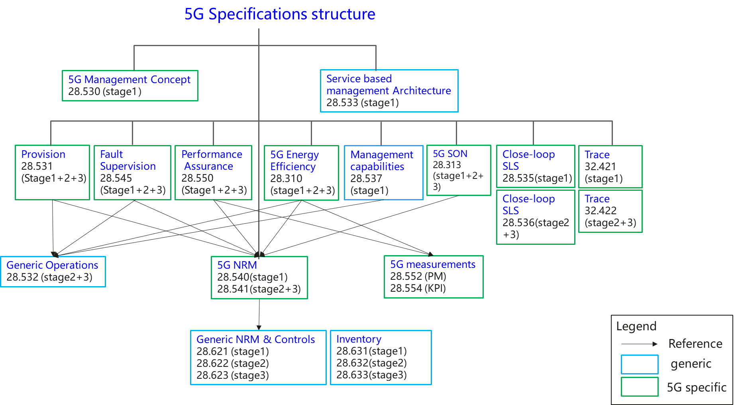
Figure X.1-1: Overview of 5G management specifications
In the figure, some features are generic management features which are applied to management of different network technologies, and some features are 5G specific management features. The following table provides the overall 5G management features and the related specification information.
 | 5G related management features | Related specifications
1 | Network and service management concept specification | TS 28.530[39]
2 | Network management service based management architecture specifications | TS 28.533[40]
3 | Network and Network slicing management related specifications
3.1 | Network and Network slicing provisioning | TS 28.531[41],TS 28.532[42],TS 28.540[43],TS 28.541[44]
3.2 | Network and Network slicing fault supervision | TS 28.545[45],TS 28.532[42]
3.3 | Network and Network slicing performance assurance | TS 28.550[46],TS 28.532[42],TS 28.540[43],TS 28.541[44],TS 28.552[47], TS 28.554[48]
3.4 | NRM | TS 28.540[43],TS 28.541[44]
4 | Energy efficiency related specifications | TS 28.310[49],TS 28.532[42],TS 28.552[47],TS 28.554[48]
5 | ONAP-3GPP integration | TS 28.532[42]
6 | Trace and MDT management | TS 32.421[37],TS 32.422[54]
7 | 5G SON management | TS 28.313[50],TS 28.541[44]
8 | SLA management | TS 28.540[43],TS 28.541[44]
9 | 5G management capabilities (Heart beat) | TS 28.537[51],TS 28.532[42]
10 | Close-loop SLS | TS 28.535[52], TS 28.536[53]
11 | Management service discovery | TS 28.530[39],TS 28.533[40]
12 | Management of tenant information | TS 28.530[39], TS 28.531[41],TS 28.533[40],TS 28.550[46],TS 28.552[47],TS 28.541[44]

2nd Change

1 Scope
The present document gives an overview about 3GPP's management capabilities and related functionality.
This document is intended to be a guide into the world of 3GPP management specifications, enabling also non-subject matter experts to gain an understanding about 3GPP's management solutions.

3rd Change

2 References
The following documents contain provisions which, through reference in this text, constitute provisions of the present document.
- References are either specific (identified by date of publication, edition number, version number, etc.) or non-specific.
- For a specific reference, subsequent revisions do not apply.
- For a non-specific reference, the latest version applies. In the case of a reference to a 3GPP document (including a GSM document), a non-specific reference implicitly refers to the latest version of that document in the same Release as the present document.
[1] 3GPP TR 21.905: "Vocabulary for 3GPP Specifications".
[2] 3GPP TS 32.150: "Telecommunication management; Integration Reference Point (IRP) Concept and definitions".
[3] 3GPP TS 32.101: "Telecommunication management; Principles and high level requirements".
[4] 3GPP TS 28.624: "Telecommunication management; State management data definition Integration Reference Point (IRP); Requirements".
[5] 3GPP TS 28.625: "Telecommunication management; State management data definition Integration Reference Point (IRP); Information Service (IS)".
[6] 3GPP TS 28.626: "Telecommunication management; State management data definition Integration Reference Point (IRP); Solution Set (SS) definitions".
[7] 3GPP TS 32.601: "Telecommunication management; Configuration Management (CM); Basic CM Integration Reference Point (IRP); Requirements".
[8] 3GPP TS 32.602: "Telecommunication management; Configuration Management (CM); Basic CM Integration Reference Point (IRP); Information Service (IS)".
[9] 3GPP TS 32.603: "Telecommunication management; Configuration Management (CM); Basic CM Integration Reference Point (IRP); Common Object Request Broker Architecture (CORBA) Solution Set (SS)".
[10] 3GPP TS 28.621: "Telecommunication management; Generic Network Resource Model (NRM) Integration Reference Point (IRP); Requirements".
[11] 3GPP TS 28.622: "Telecommunication management; Generic Network Resource Model (NRM) Integration Reference Point (IRP); Information Service (IS)".
[12] 3GPP TS 28.623: "Telecommunication management; Generic Network Resource Model (NRM) Integration Reference Point (IRP); Solution Set (SS) definitions".
[13] Void
[14] Void
[15] 3GPP TS 32.153: "Telecommunication management; Integration Reference Point (IRP) technology specific templates, rules and guidelines".
[16] 3GPP TS 32.154: "Telecommunication management; Backward and Forward Compatibility (BFC); Concept and definitions".
[17] 3GPP TS 32.155: "Telecommunication management; Requirements template".
[18] 3GPP TS 32.156: "Telecommunication management; Fixed Mobile Convergence (FMC) model repertoire".
[19] 3GPP TS 32.157: "Telecommunication management; Integration Reference Point (IRP) Information Service (IS) template".
[20] 3GPP TS 32.102: "Telecommunication management; Architecture".
[21] 3GPP TS 32.107: "Telecommunication management; Fixed Mobile Convergence (FMC) Federated Network Information Model (FNIM)".
[22] 3GPP TS 32.111-1: "Telecommunication management; Fault Management; Part 1: 3G fault management requirements".
[23] 3GPP TS 32.140: "Telecommunication management; Subscription Management (SuM) requirements".
[24] 3GPP TS 32.141: "Telecommunication management; Subscription Management (SuM) architecture".
[25] 3GPP TS 32.300: "Telecommunication management; Configuration Management (CM); Name convention for Managed Objects".
[26] 3GPP TS 32.401: "Telecommunication management; Performance Management (PM); Concept and requirements".
[27] 3GPP TS 32.500: "Telecommunication management; Self-Organizing Networks (SON); Concepts and requirements".
[28] 3GPP TS 32.511: "Telecommunication management; Automatic Neighbour Relation (ANR) management; Concepts and requirements".
[29] 3GPP TS 32.521: "Telecommunication management; Self-Organizing Networks (SON) Policy Network Resource Model (NRM) Integration Reference Point (IRP); Requirements".
[30] 3GPP TS 32.541: "Telecommunication management; Self-Organizing Networks (SON); Self-healing concepts and requirements".
[31] 3GPP TS 32.551: "Telecommunication management; Energy Saving Management (ESM); Concepts and requirements".
[32] 3GPP TS 32.600: "Telecommunication management; Configuration Management (CM); Concept and high-level requirements".
[33] 3GPP TR 32.854: "Telecommunication management; Fixed Mobile Convergence (FMC) 3GPP / TM Forum concrete model relationships and use cases".
[34] 3GPP TS 28.620: "Telecommunication management; Fixed Mobile Convergence (FMC) Federated Network Information Model (FNIM) Umbrella Information Model (UIM)".
[35] 3GPP TS 28.627: "Telecommunication management; Self-Organizing Networks (SON) Policy Network Resource Model (NRM) Integration Reference Point (IRP); Requirements".
[36] 3GPP TS 32.501: "Telecommunication management; Self-configuration of network elements; Concepts and requirements".
[37] 3GPP TS 32.421: "Telecommunication management; Subscriber and equipment trace; Trace concepts and requirements".
[38] 3GPP TS 32.441: "Telecommunication management; Trace Management Integration Reference Point (IRP); Requirements".
[39] 3GPP TS 28.530: "Management and orchestration; Concepts, use cases and requirements"
[40] 3GPP TS 28.533: "Management and orchestration; Architecture framework"
[41] 3GPP TS28.531: "Management and orchestration; Provisioning"
[42] 3GPP TS 28.532: "Management and orchestration; Generic management services"
[43] 3GPP TS 28.540: "Management and orchestration; 5G Network Resource Model (NRM); Stage 1"
[44] 3GPP TS 28.541: "Management and orchestration; 5G Network Resource Model (NRM); Stage 2 and stage 3"
[45] 3GPP TS28.545: "Management and orchestration; Fault Supervision (FS)"
[46] 3GPP TS 28.550: "Management and orchestration; Performance assurance"
[47] 3GPP TS 28.552: "Management and orchestration; 5G performance measurements"
[48] 3GPP TS 28.554: "Management and orchestration; 5G end to end Key Performance Indicators (KPI)"
[49] 3GPP TS 28.310: "Management and orchestration; Energy efficiency of 5G"
[50] 3GPP TS 28.313: "Self-Organizing Networks (SON) for 5G networks"
[51] 3GPP TS 28.537: "Management and orchestration; Management capabilities"
[52] 3GPP TS 28.535: "Management services for communication service assurance; Requirements "
[53] 3GPP TS 28.536: "Management services for communication service assurance; Stage 2 and stage 3"
[54] 3GPP TS 32.422: "Telecommunication management; Subscriber and equipment trace; Trace control and configuration management "

