3GPP TSG-SA5 Meeting #131e S5-203093

e-meeting 25th May-3rd June 2020

Title: LS for SON management
Response to:
Release: Rel-16
Work Item: SON_5G

Source: SA5
To: RAN3
Cc:

Contact Person:

Name: Shi Xiaoli
Tel. Number:

E-mail Address: shixiaoli@huawei.com

Send any reply LS to: 3GPP Liaisons Coordinator, mailto:3GPPLiaison@etsi.org

Attachments: None

1. Overall Description:
SA5 has captured SON concept and Self-establishment of new RAN NE in network in clause 4.1 and clause 4.2 in TS 28.313 including the definition of centralized SON, Distributed SON and Hybrid SON.
The overview of SON concept in clause 4.1.1 in TS 28.313 is shown as below:
============================= clause 4.1.1 in TS 28.313 ============================
4.1.1 Overview
Based on the location of the SON algorithm, SON is categorized into four different solutions that are possible for implementing various SON use cases, the solution is selected depending on the needs of the SON use cases.
a) Centralized SON:
1) Cross Domain-Centralized SON
2) Domain-Centralized SON
b) Distributed SON
c) Hybrid SON.
The SON algorithm is not standardized by 3GPP.
The following figure illustrates the overview of SON Framework.
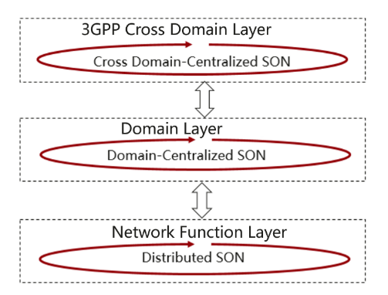
Figure 4.1.1-1 Overview of SON Framework
===========================================================================
SA5 considers that the use case of SON discussed in RAN3 is Distributed SON (D-SON). SA5 provides management services for D-SON management and management services for C-SON including RACH optimization, MRO (Mobility Robustness Optimisation), PCI configuration and ANR management in clause 7.1 and clause 7.2 in TS 28.313, where D-SON use case including RACH optimization, MRO (Mobility Robustness Optimisation), PCI configuration and ANR management, and C-SON use case including PCI configuration. For D-SON, the NFs monitors the network events, analyses the network data, makes decisions on the SON actions and executes the SON actions in the network nodes as described in clause 4.1.3 in TS 28.313.
The introduction of Self-establishment of new RAN NE in network in clause 4.2.1 in TS 28.313 is shown as below:
============================= clause 4.2.1 in TS 28.313 ============================
4.2.1 Introduction
Self-establishment of new RAN NE in network describes the procedure of a new NG-RAN NE can automatically establish when it is powered up and connect to the IP network in multi-vendor scenario, which includes:
- Network Configuration data handling
- Plug and connect to management system
- Self-Configuration
===========================================================================

SA5 considers that the Self-configuration discussed in RAN3 is related with Self-establishment of new RAN NE in network. SA5 provides Network configuration data handling including network configuration data preparation, network configuration data transfer and network configuration data validation as described in clause 4.2.2, Plug and connect to management system as described in clause 4.2.3 and Self-configuration in cluse 4.2.4 in TS 28.313 to support self-configuration process.
SA5 respectfully ask RAN3 to confirm that:
- The SON use cases and solutions of Self-optimization defined in RAN3 are used to implement the D-SON function.
- The Self-configuration defined in RAN3 is related with the Self-establishment of new RAN NE in network defined in SA5
2. Actions:
To RAN3.
ACTION:
SA5 would like to respectfully request RAN3 to confirm the following and provide feedback to SA5 if needed
- The SON use cases and solutions of Self-optimization defined in RAN3 are used to implement the D-SON function.
- The Self-configuration defined in RAN3 is related with the Self-establishment of new RAN NE in network defined in SA5.

3. Date of Next TSG-SA WG5 Meetings:
SA5#132e 24 – 28 August 2020 e-meeting
SA5#133 12 – 16 October 2020 US

