3GPP TSG-SA5 Meeting #130e S5-202271

e-meeting 20-28 April 2020
CR-Form-v11.4
CHANGE REQUEST
 | 28.541 | CR | 0281 | rev | 1 | Current version: | 16.4.1
For HELP on using this form: comprehensive instructions can be found at
http://www.3gpp.org/Change-Requests.

Proposed change affects: | UICC apps |  | ME |  | Radio Access Network | X | Core Network

Title: | Update Clause 4.2.1.2 Inheritance UML diagram
Source to WG: | Huawei
Source to TSG: | S5
Work item code: | NETSLICE-5GNRM |  |  |  |  |  | Date: |  |  | 2020-04-10
Category: | A |  |  |  |  |  | Release: |  |  | Rel-16
 | Use one of the following categories:  F (correction)  A (mirror corresponding to a change in an earlier release)  B (addition of feature),  C (functional modification of feature)  D (editorial modification)  Detailed explanations of the above categories can  be found in 3GPP TR 21.900. |  |  |  |  |  |  |  | Use one of the following releases:  Rel-8 (Release 8)  Rel-9 (Release 9)  Rel-10 (Release 10)  Rel-11 (Release 11)  Rel-12 (Release 12)  Rel-13 (Release 13)  Rel-14 (Release 14)  Rel-15 (Release 15)  Rel-16 (Release 16)
Reason for change: |  | Following issues are observed for the first inheritance UML diagram in clause 4.2.1.2:  - <<ProxyClass>> inherited from concrete <<IOC>>, e.g. CellRelation<<ProxyClass>> inherit from ManagedFunction<<IOC>>;  - As defined in TS 28.622, ManagedFunction represent a telecommunication function, it is confuse that CellRelation and FrequencyRelation inherited from ManagedFunction. Also in TS 28.658, the EutranRelation is inherited from TOP IOC.  - There is no definition for CellRelation<<ProxyClass>> and FrequencyRelation<<ProxyClass>>
Summary of change: |  | Update the inheritance UML diagram in Class 4.2.1.2
Consequences if not approved: |  | The inheritance UML diagram is wrong
Clauses affected: |  | 4.2.1.2
 |  | Y | N
Other specs |  |  | X | Other core specifications |  |  |  | TS/TR ... CR ...
affected: |  |  | X | Test specifications |  |  |  | TS/TR ... CR ...
(show related CRs) |  |  | X | O&M Specifications |  |  |  | TS/TR ... CR ...
Other comments:

This CR's revision history:

1st Change

4.2.1.2 Inheritance

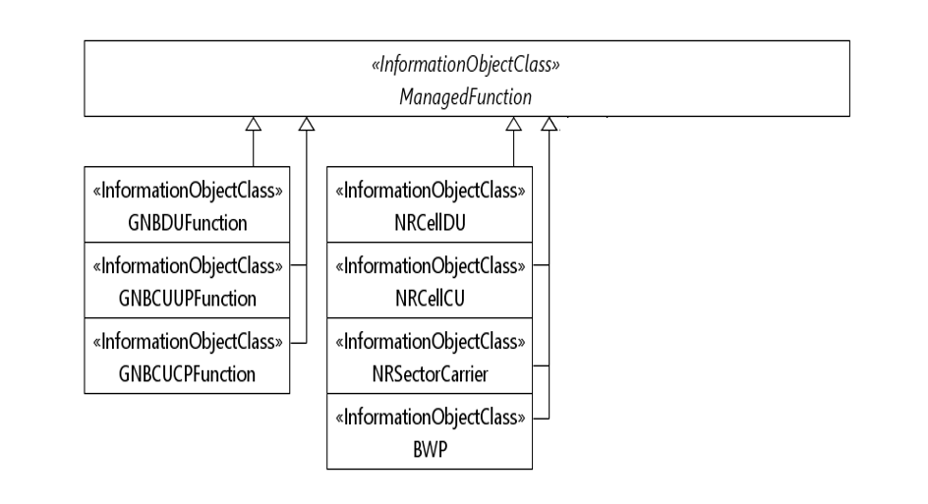
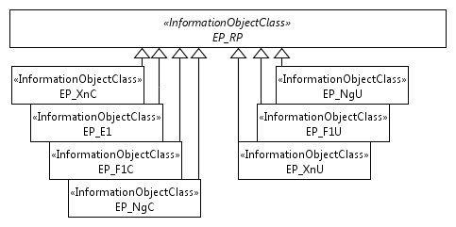
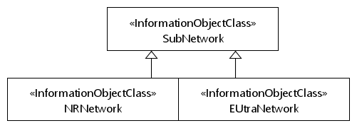
Figure 4.2.1.2-1: Inheritance Hierarchy
End of Change

