Invitation to 3GPP SA5 #119 Ad-hoc
26th – 28th June 2018
Stockholm, Sweden

Dear Colleagues,

On behalf of Ericsson, we are pleased to invite you to the 3GPP SA5 #119 Ad-hoc meeting in Stockholm, Sweden.

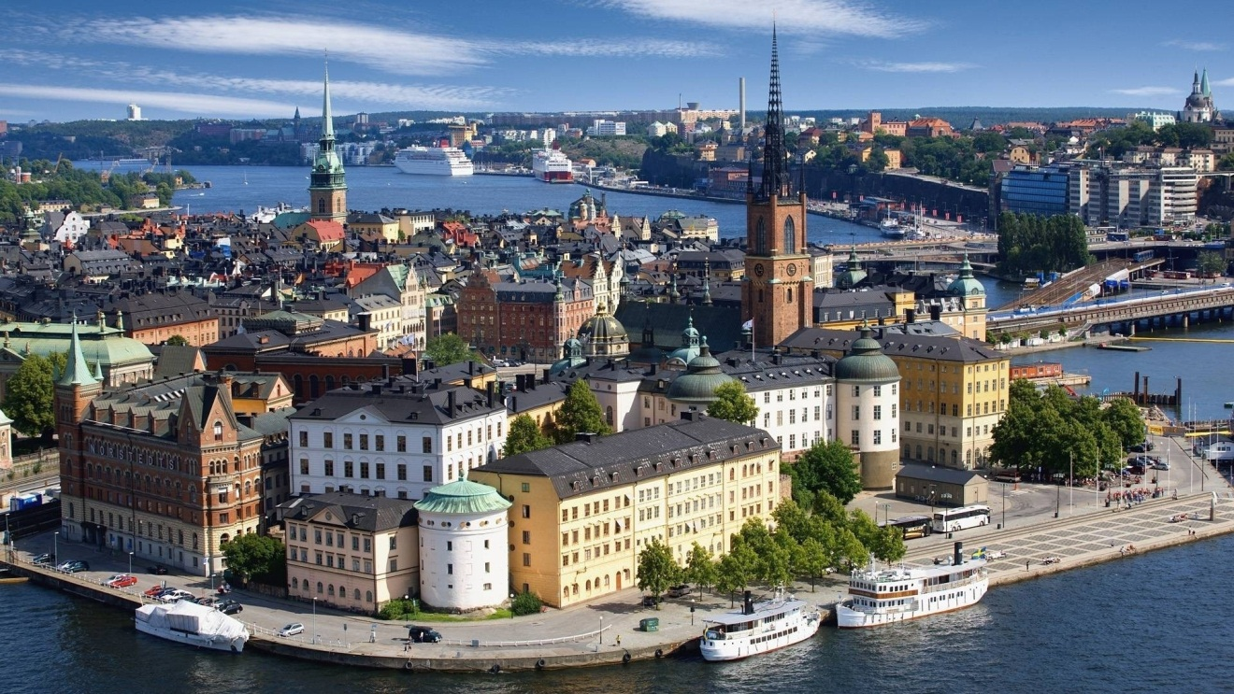

The meetings will be held at Ericsson office, Torshamnsgatan 23, Kista. Conference rooms Lars Magnus (OAM) and Carl-Henric (Charging) are booked for the occasion. These rooms are very near the reception when you arrive and you can ask the receptionist if help is needed.
The registration form can be found on the 3GPP website. Please visit https://webapp.etsi.org/3GPPRegistration/fMain.asp?mid=33662 to register for the meeting online.
For your stay a block of rooms has been reserved at Scandic Victoria Tower hotel, which is conveniently close to meeting venue and the subway and commuter train for visiting Stockholm city (downtown). Information about room rate and cut-off date is provided in following pages.
Links to a couple of hotels in Stockholm City are also included but Scandic Victoria Tower is the hotel for which we have a negotiated price.

Meeting directions and general information are provided in the following pages.
We are looking forward to seeing you in Stockholm!

Sincerely,
Zhulia Ayani on behalf of Ericsson
General Meeting Information

Meeting and Dates:

TITLE | TYPE | DATES | LOCATION | CTRY
3GPPSA5#119-Ad Hoc | AH | 26 - 28 Jun 2018 | Stockholm | SE

Location:
Torshamnsgatan 23, 164 40 Kista, Sweden
Conference room Lars Magnus (OAM)
Carl-Henric (Charging)
Both rooms are very near the reception where you can get help if needed.

Contact from the host:

General meeting information:
Zhulia Ayani
zhulia.ayani@ericsson.com

Thomas Tovinger
thomas.tovinger@ericsson.com

For letter of invitation:
Ulrika Nordlund
ulrika.nordlund@ericsson.com

Meeting Start and End Time:
The meeting will start on 26th and will end on the 28th of June 2018. Specific start and end time for each day will be communicated later together with meeting agenda.

Wireless LAN:
This will be a paperless meeting.

Hotel Address and Contact Information

Scandic Victoria Tower hotel
Arne Beurlings Torg 3
164 40 Kista, Sweden
Tel: +46 8 517 533 00
https://www.scandichotels.com/hotels/sweden/stockholm/scandic-victoria-tower

Room Rate:
Monday-Thursday: 1450 SEK per night per single occupancy
Friday-Sunday: 850 SEK per night per single occupancy
All rates include VAT and breakfast (12% VAT)

Cut-off Date: 25th May 2018 - Group Code is BERI230618

Please be sure to make your reservations before the cut-off date with the group rate code BERI230618 (email/phone) to ensure the lower group rate. A certain number of rooms have been reserved and are guaranteed at reduced rates for the attendees of this meeting. Reservations made beyond cut-off date may be more expensive and subject to availability. The lower rate is negotiated from 23rd to 30th of June.
Please observe that the group code can only be used for email or telephone reservations (i.e. the group code cannot be used in the internet booking form provided by the hotel).

Check-in/Check-out Times:

Check in – 2:00 pm

Check out – 12:00 pm

Telephone Reservations:
To make your reservation by phone, please call +46 8 517 533 00.
Please make sure you make the reservation by referring to the group rate code BERI230618

Cancellations:
Rooms booked through group code can be changed and cancelled until the 23 June 2018 06:00 pm. without any extra charging.
Please note that Ericsson is not responsible for reservation confirmations, cancelled or changed reservations, or no-shows. Please contact the hotel directly to make any changes.

Phone charges:
Each delegate is responsible for verifying any toll charges that may be incurred by placing local, long distance and toll-free calls from a guest room.

Shipping Packages:
Receiving, handling and storage charges may apply for packages sent to a guest’s attention at the hotel. Please contact the hotel directly to check these charges prior to having anything shipped to the hotel.

Airport:
Stockholm Arlanda airport (ARN).
The airport is located approximately 45 km north of Stockholm city center.

Airport Transportation:
Taxi
Taxi - ~400 SEK (one way) from Arlanda airport to Scandic Victoria Tower hotel.
Please note: This is an average price depending on TAXI supplier and current traffic situation. Please always ask the driver before you start your trip about what price is in effect.

Please look for either one of the following Taxi companies:

Arlanda Express
As an alternative you can take the Arlanda express train departing from Arlanda airport to Stockholm city center. From the city center you can either take the subway (from T-Centralen) or the commuter train to Kista. The name of the commuter train station in Kista is “Helenelund”.

https://www.arlandaexpress.se/
http://sl.se/

Commuter train
The most price-friendly and quick ways to reach the hotel is by commuter train (Pendeltåg). The trip takes around 25 minutes from Arlanda airport to Helenelund station.
http://sl.se/

The Scandic Victoria Tower hotel is located within walking distance from both the subway and the commuter train station in Kista, see map of Kista area below.

Directions from the Airport:
The Scandic Victoria Tower hotel is located ca 30 km south of Arlanda airport.
Maps and transport options can be found here:
http://www.scandichotels.com/Hotels/Sweden/Stockholm/Victoria-Tower/?hotelpage=location&location=detailedmap

Transport to and from Stockholm city center:
The Scandic Victoria Tower hotel is located close to the commuter train station and the subway station in Kista which will take you to Stockholm city center (T-centralen) within less than 20 minutes.

Time Zone:
Central European Summer Time (CEST)

Voltage:
230 volts
Please be sure you have the correct adapter. Voltage converters will not be provided at the meeting.

Kista Map:

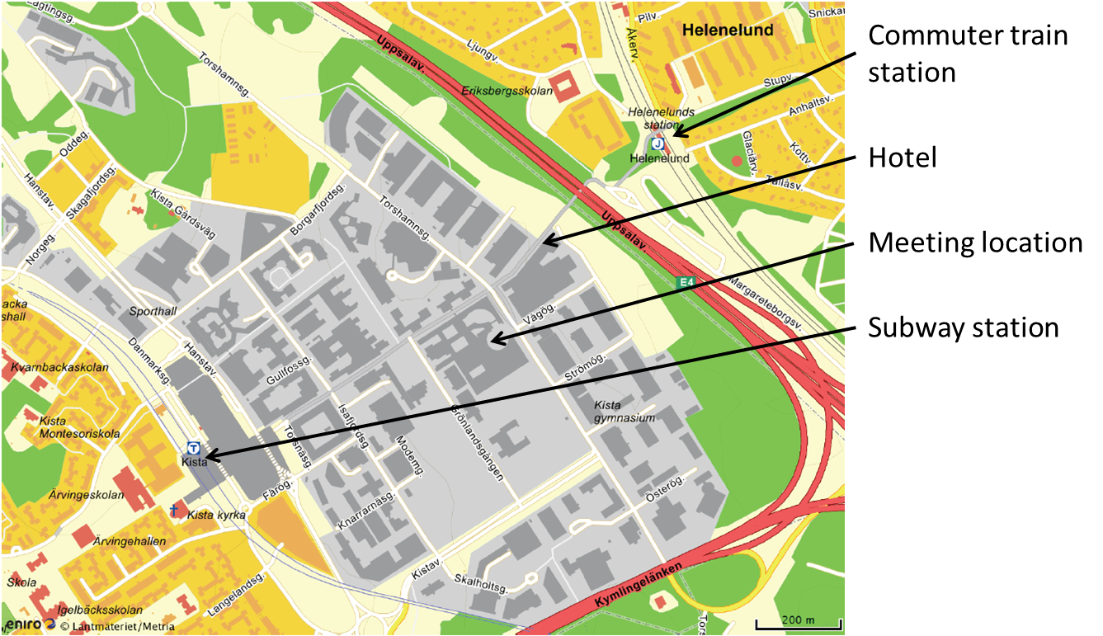

Link to other hotels located in Stockholm City:

Hilton Stockholm Slussen
Radisson Blu Royal Viking Hotel

Visa Information

To obtain a Visa to enter Sweden for the meeting you may need a letter of invitation from Ericsson to present to the Swedish Embassy/Consulate in your home country. A template can be found on the following pages of this invitation. Please add your personal information and send the completed letter to Ulrika Nordlund: ulrika.nordlund@ericsson.com .
Signed letters will be returned via email.

PLEASE VERIFY THAT ALL INFORMATION IS ACCURATE AND WILL BE VALID AT THE TIME OF THE MEETING.

Please direct any questions regarding the logistical arrangements of this meeting to the Meeting Coordinator:
Zhulia Ayani
zhulia.ayani@ericsson.com

Have a great meeting and enjoy your stay in Stockholm!

Dear Sir/Madam,

We would like to invite Mr./Mrs. …………. to visit Sweden for business meetings.

Mr./Mrs.……………… is an employee of …………………………………
He/ She is scheduled to visit Sweden to attend a 3GPP meeting in Kista, Stockholm, from June 26 – July 29nd, 2015. These activities will be held in Ericsson´s premises in Kista/Stockholm.

His/her personal data is as follows:

First name:
Last name:
Gender:
Date of birth:
Place of birth:
Passport number:
Date of issue:
Expiry date:

Company address:

Contact details:

Tel:
Mobile:
Mail:

The company ………………………… will bear all the costs involved his/her stay in Sweden including the costs of medical insurance and guarantees his/her return to country ……….

We are writing here requesting you to kindly grant him/her the entry visa to Sweden.

Yours sincerely,

Ulrika Nordlund
Assistant, Systems & Technology

Mobile: +46 72 574 66 54
Mail: ulrika.nordlund@ericsson.com

