Invitation to
3GPP SA5#112
March 27 - 31, 2017
Guilin, P. R. China

Dear 3GPP colleagues,

On behalf of Huawei Technologies, we are pleased to invite you to the 3GPP SA5#112 meeting in Guilin, P. R. China.

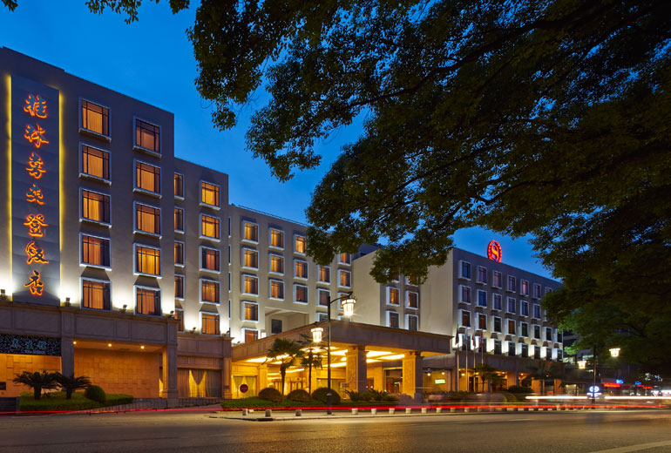

The meeting will be held at the Sheraton Guilin Hotel. A block of rooms has been reserved at the hotel under the block code SZHW. The group rate is ￥608 CNY per night for premium room (including one buffet breakfast, service charge and VAT). Broadband Internet access is free in guest rooms. Please read the hotel reservation information in the following pages for more on group rates. Delegates are responsible for their own hotel reservations. Please book your room before the cutoff date, 24 February 2017. Note that reservation beyond this point may be subject to availability.

In addition to making your hotel reservation, it is also very important to register for the meeting on the 3GPP website. This provides the MCC and meeting planners with important planning information. Please visit the Registration Page to register on line. Please be sure to print your name badge prior to the meeting. Name badges will no longer be provided at meetings.

Should you require a personal letter of invitation for your business visa application, please contact the host listed in Appendix A via email. Your email should attach the form in Appendix A filled with all necessary information and be sent out before 28 February 2017. For Chinese Embassy or Consulate information, please visit website http://www.fmprc.gov.cn/eng/.

Travel and general information is provided in the following pages.

We are looking forward to seeing you in Guilin, China.

Sincerely yours,
Christian Toche
On behalf of Huawei Technologies Co., Ltd.

General Meeting Information

Meeting & Date:
SA5#112 March 27 - 31, 2017

Location:
Guilin, Guangxi, P. R. China

Contact from the host:
Ms. Katherine Wu Ms. Cici Xie
Tel: +86 10 82829060 Tel: +86 18506836066
Email: kathy.wu@huawei.com Email: xiewei.xie.xiewei@huawei.com

Hotel Information:
Sheraton Guilin Hotel
Address: 15 Bin Jiang Road, Guilin, Guangxi 541001, P. R. China
Phone: +86 773 282 5588
Website: http://www.starwoodhotels.com/sheraton/property/overview/index.html?propertyID=483&language=en_US&localeCode=en_US

Wireless LAN:
This will be a paperless meeting.
MCC will provide and administer WLAN during the meeting.

Hotel Reservation Information

The Sheraton Guilin Hotel will be providing the accommodations for the meeting.

Group Rate:
Premium room (king/twin) ￥608 CNY per room per night
Executive club (king/twin) ￥900 CNY per room per night

The above rate includes one buffet breakfast, 10% service charge and 6% VAT. Broadband Internet access is complimentary in guest rooms.

Cut-off Date: 24 February 2017
Please make your reservation before the cutoff date to ensure the reduced group rate. Reservation beyond this point may be subject to availability.

Check-in/Check-out Time:
Check in after 03:00 PM
Check out before 12:00 PM

Reservations:
All reservations are subject to confirmation by the hotel.
A personalized web site for meeting has been created for you. Please access the site: https://www.starwoodmeeting.com/Book/NGMNNWMOMeeting3GPPSA5112Meeting to complete booking before 24 February 2017. If you have any question, please send an email to daisy.zhai@sheraton.com or call us by + (86) 0773 282 5588 ex 8881.

Cancellation Policy:
- Reservation must be guaranteed by credit card
- Please offer your own credit card to guarantee your booking
- Please note that cancellation fee will be assessed if you cancel the booking :
- Any cancellation on guest room prior to Feb 27, 2017 will be free of charge.
- Any cancellation on guest room prior to Mar 6, 2017 will be subject to 50% charge.
- Any cancellation on guest room prior to Mar 20, 2017 will be subject to 100% charge.

Please Note:
The host is not responsible for reservation confirmations, cancelled or changed reservations, or no-shows. Please contact the hotel directly to make any changes.

Transportation Information

Guilin is located in the northeast of Guangxi Zhuang Autonomous Region, an hour’s flight from Hong Kong. The Sheraton Guilin hotel is on the banks of the Li River located in Guilin city center and adjacent to the Zhengyang Pedestrian Street, City Center Square, Elephant Trunk Hill, etc.

Local Attractions:
- Li River 0.0 km/0.0 miles
- Center Plaza 0.1 km/0.1 miles
- Fu Bo Mountain 1.0 km/0.6 miles
- Elephant Trunk Hill 1.0 km/0.6 miles
- Folded Brocade Hill 1.0 km/0.6 miles
- Solitary Beauty Peak 1.0 km/0.6 miles
- Seven Star Park 1.0 km/0.6 miles
- Dreamland of Li River Show 2.0 km/1.2 miles
- West Hill Park 3.0 km/1.9 miles
- Guilin Museum 3.0 km/1.9 miles
- Reed Flute Cave 5.0 km/3.1 miles
- Yaoshan Scenic Spot 7.0 km/4.3 miles
- Crown Cave Scenic Spot 40.0 km/24.9 miles
- Impression of Liu Sanjie 65.0 km/40.4 miles

Airport:
Guilin Liangjiang International Airport
IATA: KWL
ICAO: ZGKL
Travel Distance: approximately 30 km
Travel time: 1 hour
Taxi fee: approximately ￥ 150 CNY

Railway:
Guilin Train Station
Travel Distance: approximately 5 km
Travel time: 15 minutes
Taxi fee: approximately ￥ 20 CNY
Please Note: Most taxi drivers do not speak English, so make sure you have the name of your hotel or address written in Chinese. The following is the name, address and phone number of the Sheraton Guilin Hotel in Chinese:
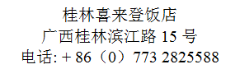

General Information for Stay in Guilin

Mobile Network Coverage:
There is GSM/UMTS/LTE coverage in Guilin.

Currency:
In December 2016, 1 U.S. dollar was worth ￥ 6.95 CNY and 1 Euro was worth ￥ 7.26 CNY. Most foreign currencies are easily changed at banks or hotels. Local banks are typically open from 9am to 5pm from Monday to Friday, while weekend working hours may vary by institution. You will be required to present your identification card or passport in order to access foreign exchange services.
Several ATMs are conveniently located in the vicinity of the hotel.

Time Zone:
GMT +8 hours

Voltage:
Commercial power in China is 220V. Please be sure you have the correct adapter. Voltage converters will not be provided at the meeting.

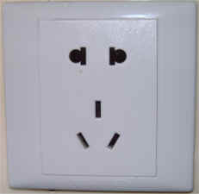

City Profile/ Area Attractions:
http://www.guilintourist.com
Please don’t hesitate to direct any questions regarding the logistical arrangements of this meeting to the Meeting Coordinators:

Ms. Katherine Wu
Or
Ms. Cici Xie

Have a successful meeting and enjoy your stay in Guilin!
Appendix A
3GPP SA5#112
Guilin, China
March 27-31, 2017
INVITATION LETTER REQUEST FORM

To enter China for the meetings indicated above, you may need a letter of invitation from the Chinese host, which you will need to present to the Chinese Embassy/Consulate in your area in order to obtain your visa. In order to obtain the invitation letter, please:
- fill out the form below
- a scanned copy of your passport (the name, date of birth, nationality, passport number, passport validity date, etc. must be seen clearly; to ensure readability; a scanned photograph page is preferred.)
- a scanned copy of the latest Chinese visa (one or two records) if your entry is not the first time
- send all of the above via email to visa_guilin@huawei.com before 28 February 2017

NOTE: please send your application form in WORD file.

Full name of Company
Surname |  | Given name
Gender | □ Male □ Female
Birthday (YYYY-MM-DD) |  | Nationality
Tel No. |  | Job Title
Passport No. |  | Place of Issue Passport
Expired Date of Passport (YYYY-MM-DD)
Destination Country/Area & City/ Places to visit after entry (In this case, it is Guilin by default; if you want to visit other places than Guilin, please indicate here)
Country |  | City
Visa Issued Country/Area & City (If the country in which you'll obtain your visa is different from your nationality, please indicate it here:[ Country to obtain your visa])
Country |  | City
Duration (YYYY-MM-DD)
From |  | To
Purpose
Address
Fax No.
E-mail
End of form
(Please do not forget to attach a copy of your passport photograph page before sending.)

