**Invitation to 3GPP SA5#102**

**August 24 - 28, 2015**

**Beijing, P. R. China**

Dear Colleagues,

On behalf of Huawei Technologies, we are pleased to invite you to the **3GPP SA5#102** meeting in Beijing, P. R. China.

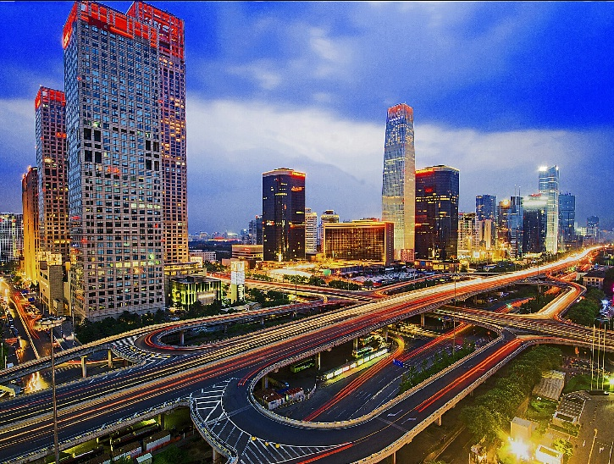

The meeting will be held at the **Traders Hotel, Beijing** and the **China World Hotel,** **Beijing** will provide the accommodation. A block of rooms has been reserved under the name ***3GPP***. The reduced rate for deluxe room (single) is ￥1200 CNY (~USD 196) per night (including one breakfast, 15% surcharge). Broadband Internet access is free in guest rooms. Delegates are responsible for their own hotel reservations. Please send the completed *China World Hotel Accommodation Form* on Page 9 to the hotel by fax or email before the **cutoff date**, **24 July 2015** (**Note that reservation beyond this point may be more expensive and subject to availability**).

In addition to hotel reservation, it is important to perform the online meeting registration at the following website: [3GPP Online Registration](http://webapp.etsi.org/3GPPRegistration/fMain.asp?mid=31372) before **12 August 2015**. This provides the meeting planner better vision to the meeting organization.

For entering China, it is required to hold either tourism or business visa. Should you require a letter of invitation for your business visa application, please contact the host. Your email should attach the *INVITATION LETTER REQUEST FORM* on Page 8 filled with all necessary information and be sent out before **24 July 2015**. For Chinese Embassy or Consulate information, please visit website <http://www.fmprc.gov.cn/eng/>.

The meeting will start on Monday 24 and end on Friday 28 August. More detailed information on the meeting itself will be found in the corresponding official documents. Meeting directions and general information are provided in the following pages.

We are looking forward to seeing you in Beijing, China.

Sincerely yours,

Christian Toche

On behalf of Huawei Technologies

General Meeting Information

**Meeting & Location & Dates:**

|  |  |  |  |  |
| --- | --- | --- | --- | --- |
| **TITLE** | **TYPE** | **DATES** | **LOCATION** | **CTRY** |
| [Add to my calendar](http://webapp.etsi.org/MeetingCalendar/ical.asp?qMTG_ID=31372)[3GPPSA5#102](http://webapp.etsi.org/MeetingCalendar/MeetingDetails.asp?mid=31372) | OR | 24 - 28 Aug 2015 | Beijing | CN |

**Contact from the host:**

Ms. Katherine Wu Mr. Quentin Zhang

Tel: +86 10 82829060 Tel: +86 10 81035945

Fax: +86 10 82882144 Mobile: +86 18612987681

Email: [kathy.wu@huawei.com](mailto:kathy.wu@huawei.com) Email: [quentin.zhangqiang@huawei.com](mailto:quentin.zhangqiang@huawei.com)

**Hotel Information:**

**The China World Hotel, Beijing** (Accommodations)

Address: No. 1 Jianguomenwai Avenue, Beijing 100004, P. R. China

Tel: + 86 10 6505 2266

Website: <http://www.shangri-la.com/beijing/chinaworld/>

**Traders Hotel, Beijing** (Meeting rooms)

Address: No. 1 Jianguomenwai Avenue, Beijing 100004, P. R. China

Tel: + 86 10 6505 2277

Website: <http://www.shangri-la.com/beijing/traders/>

**Wireless LAN:**

This will be a paperless meeting.

MCC will provide and administer WLAN during the meeting.

Reservation Information

The China World Hotel, Beijing will provide the accommodation.

**Group Rates:**

Deluxe Room:

CNY1200 net per room per night with one daily breakfast for single occupancy

CNY1400 net per room per night with two daily breakfasts for double occupancy

The above rate includes 15% surcharge. Broadband Internet access is complimentary in guest rooms.

**Cut-off Date: 24 July 2015**

**Check-in/Check-out Time:**

Check in after 02:00 PM

Check out before 12:00 PM

**Reservations:**

Please fill out the *China World Hotel Accommodation Form* on Page 9 and return it to the hotel by fax or email.

**Cancellation Policy:**

Please refer to the *China World Hotel Accommodation Form*.

**Please Note:**

Huawei Technologies Co., Ltd is not responsible for reservation confirmations, cancelled or changed reservations, or no-shows. Please contact the hotel directly to make any changes.

**Transportation Information**

The China World Hotel, Beijing is located in the heart of the Central Business District, only 5 minutes from the Forbidden City. The hotel is part of the prominent China World Trade Center complex: the exhibition hall, offices, shopping mall and upscale residential towers, which also houses the Guomao subway station.

**Airport:**

**Beijing Capital International Airport (**<http://en.bcia.com.cn/>**)**

**There are numerous options to reach China World Hotel, Beijing. Guests can choose among airport express, airport bus and taxi.**

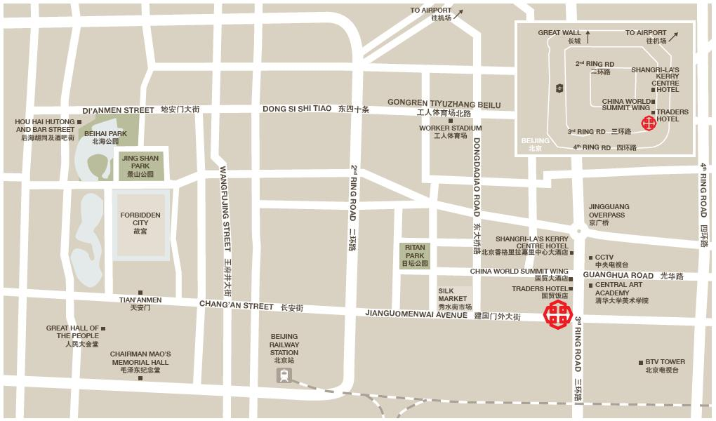

* **Airport Express**

**The airport train departs from the Arrival Hall of the Airport’s Terminal 3 every 15 minutes and stops at the Airport’s Terminal 2 before proceeding to the city.**

**To reach the Guomao station located within the China World Trade Centre complex from the Airport, disembark at Sanyuanqiao station and transfer to Line 10. It will not be necessary to exit the Sanyuanqiao station in order to transfer to Line 10.**

**On Line 10, disembark at Guomao station for China World Hotel, Beijing, which is an easy stroll away within the China World Trade Centre complex.**

**The entire one-way trip will take approximately 45 minutes and will cost around RMB 27 (~ USD 4.5).**

* **Airport Bus**

**Airport buses**, which can be found on the ground floor of the domestic and international arrival halls, **stop at China World Trade Centre complex and each journey typically costs ￥** 16CNY (~USD 2.6).

* **Taxi**

**Many metered taxis are available at Beijing Capital International Airport. The fare between the airport and China World Hotel, Beijing, generally costs around ￥** 120CNY (~US $ 19) **per journey**, depending on the traffic condition. **This is inclusive of toll fees.**

**Please Note**: Taxi drivers may not speak English, so make sure you have the name of your hotel or address written in Chinese. The following is the name, address and phone number of the China World Hotel, Beijing in Chinese; please print it for your convenience:

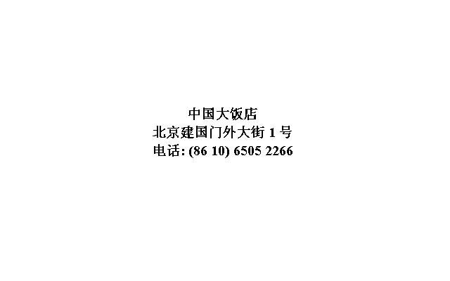

* **Valet Parking**

**Complimentary valet parking and use of the hotel garage is available to hotel guests.**

****General Information for Stay in Beijing****

**GSM/WCDMA/CDMA2000/TD-SCDMA/TD-LTE Coverage:**

There is GSM/WCDMA/CDMA2000/TD-SCDMA/ TD-LTE coverage in Beijing.

**Currency:**

Until April 2015, 1 USD is worth about ￥6.12 CNY and 1 Euro is worth about ￥6.73 CNY. Most foreign currencies are easily changed at banks or hotels.

**Time Zone:**

GMT +8 hours

**Voltage:**

The electricity in China is **220V**. Please be sure you have the correct adapter. Voltage converters will **not** be provided at the meeting.

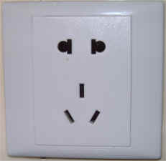

**About Beijing**

General Information, **Area Attractions, Weather & Clothing, Shopping**

<http://english.visitbeijing.com.cn/>

Please don’t hesitate to direct any questions regarding the logistical arrangements of this meeting to the Meeting Coordinators:

[Ms. Katherine Woo](mailto:kathywoo@huawei.com)

&

[Mr. Quentin Zhang](mailto:quentin.zhangqiang@huawei.com)

***Have a great meeting and enjoy your stay in Beijing!***

**3GPP SA5#102**

**August 24-28, 2015**

**Beijing, China**

**INVITATION LETTER REQUEST FORM**

To enter China for the meetings indicated above, you may need a letter of invitation from the Chinese host, which you will need to present to the Chinese Embassy/Consulate in your area in order to obtain your visa. In order to obtain the invitation letter, please:

1. fill out the form below;
2. a copy of your passport (the name, date of birth, nationality, passport number, valid date of passport, etc. must be seen clearly; to ensure readability, a scanned photograph page is preferred.);
3. a copy of previous Chinese visa and records if your entry is not the first time;
4. send all of the above to [visa_sa5@huawei.com](mailto:visa_sa5@huawei.com) before **24 July 2015**.

NOTE: please send your application form in WORD file.

|  |  |  |  |  |  |
| --- | --- | --- | --- | --- | --- |
| **Company** |  | | | | |
| **Applicant Information** |  | | | **❒Mr ❒Dr ❒Ms ❒Mrs** | |
|  |  | | |  | |
|  | **Date of birth :** | | |  | |
|  | **If the country in which you'll obtain your visa is different from your nationality, please indicate it here:** | | | | |
| **Address** | **Telephone Number:**  **Fax Number:**  **E-mail:** | | | | |
| **Places to visit after entry** | **(In this case, it is Beijing by default; if you want to visit other places than Beijing, please indicate here.)** | | | | |
| **Date of arrive at China** | |  | **Date of departure from China** | |  |

End of form

*(Please do not forget to attach a copy of your passport photograph page before sending.)*

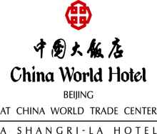**China World Hotel Accommodation Form For**

**Huawei Company Meeting Group / 23 Aug - 28 Aug, 2015**

Please fax or e-mail this form directly to Reservation Department of China World Hotel, Beijing

Reservation Fax:86-10-6505-4323 / Telephone: 86-10-6505-8885 / Email Adress:reservations.cwh@shangri-la.com

**Please Revert on or before July 24, 2015**

Surname: _____________________________ First Name:_______ ___________________________________

Company/ Title: ___________________________________________

Address: ___________________________________________

City:__ _____________Zip Code:_______________________ Country:_ ________________

Telephone: ____ Fax:_____________________ E-mail:_ ____________

**Accommodations for the participants –** *Please tick your preferred choice*

Deluxe Room ○ CNY1200 per night, single occupancy ○ CNY1400 per night, double occupancy

* *The above room rates are inclusive of 15% surcharge.*
* *The above room rates are inclusive of daily breakfast.*
* *Complimentary in-room wired and wireless internet access.*

Special Request: _____________________________________________________________________________

**Accommodations Person sharing the room (**If any**)**

Surname:_______________________________ First Name:__________________________________________

**Travel information**

Arrival Date ________________ Flight No. ________________ Arrival Time________________

Departure Date________________ Flight No. ________________ Departure Time________________

**Transportation**

Arrival Airport Transfer: ○YES ○No Departure Airport Transfer: ○YES ○No

If yes, please tick: ○Audi:CNY690net per car per way ○Mercedes350:CNY1000net per car per way

**In order to guarantee your reservation, please supply your Credit card details below:**

**(This section is mandatory to confirm your booking)**

○Visa ○Master Card ○American Express ○Dinners Club

Card Number________________________________ Expiration Date _______________________________

Card Holder Name__________________________________________________________________________

Card Holder Signature__________________________________________________________________________

**Terms and conditions**

1. Please note that any changes or cancellations made to your reservation have to be notified in writing to the hotel. Any cancellation made within **7** days prior to the expected arrival, will result in a late cancellation charge equivalent to a full length of stay based on the relevant room rate outlined above.
2. Any no show on the expected arrival day, will be charged at an amount equivalent to a full length of stay based on the relevant room rate outlined above.
3. All reservations must be guaranteed by one night room rate advance deposit or by use of a major credit card.
4. The deadline for making reservations is **24th July 2015** after which accommodation is subject to availability at prevailing rates. The confirmed room category and numbers of rooms based on first come and first served basis.
5. Any balance charges, room and incidentals must be settled upon departure.
6. Accommodation at the rates quoted is available only to registered delegates of the above meeting and can only be made using this form.
7. Check in time is at 14:00. Check out is at 12:00 noon. To guarantee early check-in or late check out, please book one night before or after. The room charge will be based on the daily room rate quoted above.
8. The above room rates will be valid for **2** days prior to and 2 days after the main conference date. All reservation is subject to Hotel availability.