3GPP TSG-SA5 (Telecom Management) S5eHNB---
3GPPSA5-Virtual Meeting on HeNB

Source: Verizon

Title: DLNA parameter categories and justification for HeNB

Document for: Discussion and Approval
Agenda Item:

1 Decision/action requested
The group is asked to discuss the proposed DLNA high level parameter category, and introduce the agreed part into the draft TS 32.592.

2 References
[1] 3GPP TS 32.582
[2] 3GPP TS 32.592
[3] TR-196
[4] DLNA http://www.dlna.org

3 Rationale
The Home ENodeB is a home networked device. This device is connected to the subscriber’s home network and as such is part of the home network.

In today’s home networking environment typical subscribers have multiple networked devices in their homes that are networked together in an attempt to share content between these devices. In other words, users want to have a home that is not only connected but also have the ability for content being distributed at home across consumer devices bough off the shelf. To achieve this goal of a connected home wherein media is shared and distributed across devices is addressed by the organization known as DLNA. (Digital Living Network Alliance).

Among the home networking media standards for consumer devices, the DLNA Alliance is a highly successful guidelines body that provides guidelines for interoperability of content in the home.As of this writing, over 5000 conusmer devices have been certifies as DLNA compliant.

The Femto device is also expected to take part in the DLNA ecosystem and allow for the sharing and distribution of content in the home. As such, the Femto device can host or proxy DLNA based applications and take part in the home DLNA ecosystem. As a result, managing the DLNA objects on the Home ENodeB is important to a service provider in understanding the DLNA object level interactions that occur in a home between the Home eNodeB and the rest of the DLNA capable devices in the home..

This document proposes a high level parameter category to include DLNA object management for the Home eNodeB. This level of management is important to service providers who have multiple managed entities in a subscriber home (such as a managed home router/DSL modem/Set Top Box/ DVR etc).

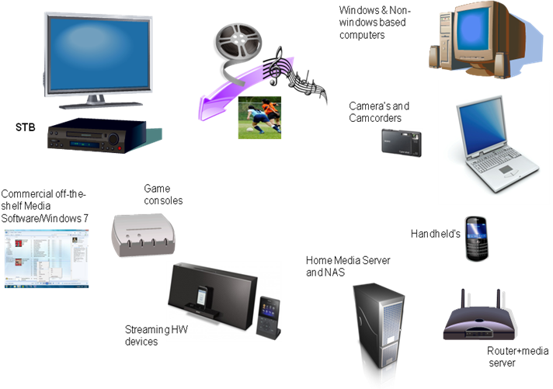

Fig 1: DLNA based networked home

4 High level parameter categories

The following additional high level parameter category is proposed (i.e DLNA object management)

End of Section

