**Invitation to 3GPP SA5#98bis Ad Hoc Meeting**

**on Management of Virtualized Network**

**January 27-29, 2015**

**NFV Workshop**

**January 30, 2015**

**Beijing, P. R. China**

Dear Colleagues,

On behalf of China Mobile and Huawei Technologies, we are pleased to invite you to the **3GPP SA5#98bis ad hoc meeting on management of virtualized network** January 27-29, 2015 in Beijing, P. R. China.

Following the ad hoc meeting, you are welcome to attend the **NFV workshop** hosted by China Mobile in the same location on Friday 30 January.

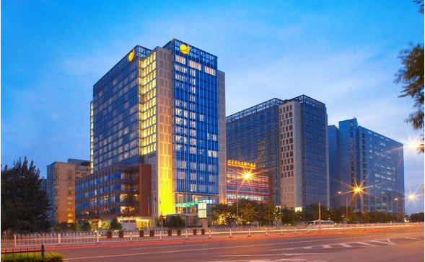

The SA5 ad hoc meeting and the NFV workshop will be held at the New Century Grand Hotel Beijing. A block of rooms has been reserved at the hotel under the name ***3GPP SA5 or NFV workshop***. The reduced rate for superior room is ￥ 600 CNY per night (including breakfast buffet, service charge and taxes). Broadband Internet access is free in guest rooms. Please refer to the reservation information in the following pages. Delegates are responsible for their own hotel reservations. Please refer to the hotel information (**Appendix B**) and make reservation before the cut-off date, **20 December 2014.**

In addition to hotel reservation, it is important to perform the online meeting registration at the following website: [3GPP Online Registration](http://webapp.etsi.org/meetingcalendar/MeetingDetails.asp?mid=31736) before **15 January 2015**. **This provides the meeting host better visibility for the meeting organization.**

For entering China, it is required to hold either tourism or business visa. Should you require a letter of invitation for your business visa application, please contact the host. Your email should attach the form in **Appendix A** filled with all necessary information and be sent out before **14 December 2014.** For Chinese Embassy or Consulate information, please visit website <http://www.fmprc.gov.cn/eng/>.

The ad hoc meeting will start on Tuesday 27 January 9am Beijing time and end on Thursday 29 January 5pm Beijing time. More detailed information on the meeting itself will be found in the corresponding official documents.

Meeting directions and general information are provided in the following pages.

We are looking forward to seeing you in Beijing, China.

Sincerely yours,

Deng Hui, China Mobile

Christian Toche, Huawei

On behalf of China Mobile and Huawei Technologies

General Meeting Information

**Meeting & Date:**

3GPP SA5#98bis Ad hoc meeting January 27 ~ 29, 2015

NFV workshop January 30, 2015

**Location:**

Beijing, P. R. China

**Contact from the host:**

**Ad hoc meeting**

Mr. Liu Jinglei, Mr. Wang Lu

Tel: +86-13911271674, +86-13910768174

Email: liujinglei@chinamobile.com , wanglu@chinamobile.com

**Workshop**

Mr. Han Xiaoyong

Tel: +86-15810497093

Email: [hanxiaoyong@chinamobile.com](mailto:hanxiaoyong@chinamobile.com)

**Hotel Information**

Hotel name: New Century Grand Hotel Beijing

Address: Buiding2, No.1, Cai Shi Kou Street, Xicheng District, 100052 Beijing, China

Tel: + 86 (10) 83537777-8815; +86-18701687206

Email: [bjmd@kaiyuanhotels.com](mailto:bjmd@kaiyuanhotels.com)

Fax: + 86(10)-63563737

Website: <http://www.kaiyuanhotels.com/branch/showBranchIndexByCode.htm?code=KYBJMD&lan=2>

**EDH requirements:**

This will be a paperless meeting. Participants are requested to bring a wireless LAN card for their laptops.

In meeting rooms, the host will provide power extensions as illustrated in the following picture.

|  |  |
| --- | --- |
| http://www.panelcomponents.com/pcc/images/N_NAmerica.jpg | X_China |

Hotel Reservation Information

The meeting will be held at the **New Century Grand Hotel Beijing**.

**Group Rate:**

Superior room (Single / Double) ￥ 600 CNY per room per night

The above rate includes one buffet breakfast (for single occupancy) or two buffet breakfasts (for double occupancy), service charge and taxes. Broadband Internet access is complimentary in guest rooms.

**Cut-off Date: 20 December 2014**

Please send your reservation form to Mr. Niu Wei Guo ([Niuweiguo@huawei.com](mailto:Niuweiguo@huawei.com)) before the cut off date to insure the reduced group rate. Reservation beyond this point may be considerably more expensive and subject to availability.

**Check-in/Check-out Time:**

Check in after 02:00 PM

Check out before 12:00 PM

**Reservations:**

Please refer to Appendix B and make the hotel reservation in time.

**Cancellation Policy:**

Please refer to Appendix B.

**Transportation Information**

The **New Century Grand Hotel Beijing** is located in Buiding2, No.1, Cai Shi Kou Street, Xicheng District, 100052 Beijing.

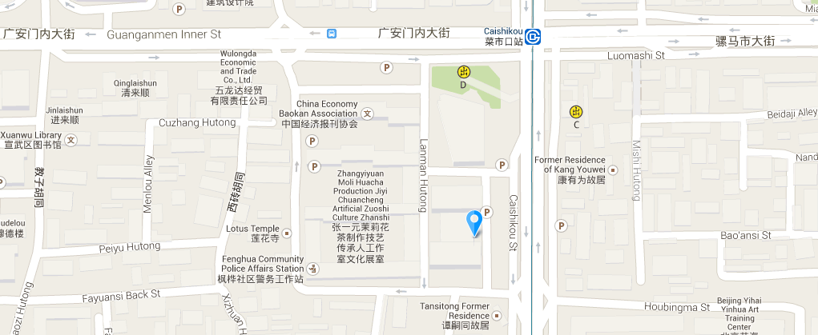

**Airport:**

* Beijing Capital International Airport

Website: <http://en.bcia.com.cn/>

Hotel direction: 35 Kms SW, 1hour and 20 minutes by car and taxi fare about ￥130 CNY (one way)

**Please Note**: Taxi drivers may not speak English, so make sure you have the name of your hotel or address written in Chinese. The following is the name, address and phone number of the **New Century Grand Hotel Beijing** in Chinese; please print it for your convenience:

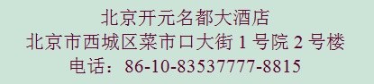

****General Information for Stay in Beijing****

**Mobile phones:**

CMCC -- GSM (GPRS, EDGE), TD-SCDMA and TD-LTE services

China Unicom -- GSM (GPRS, EDGE) and WCDMA services

China Telecom -- CDMA, CDMA1X and CDMA2000 services

**Currency:**

Until December 2014, 1 U.S. dollar was worth ￥6.14 CNY and 1 Euro is worth ￥7.63 CNY. Most foreign currencies are easily changed at banks or hotels.

**Time Zone:**

GMT +8 hours

**Voltage:**

Commercial power in China is **220V**. Please be sure you have the correct adapter. Voltage converters will **not** be provided at the meeting.

Please don’t hesitate to direct any questions regarding the logistical arrangements of this meeting to the Meeting Coordinator:

Mr. [Liu Jinglei](mailto:liujinglei@chinamobile.com) , Mr. Wang Lu

&

Mr. [Han Xiaoyong](mailto:hanxiaoyong@chinamobile.com)

Appendix A

**3GPP SA5#98bis Ad Hoc Meeting**

**January 27-29, 2015**

**NFV Workshop**

**January 30, 2015**

**Beijing, P. R. China**

**INVITATION LETTER REQUEST FORM**

To enter China for the meetings indicated above, you may need a letter of invitation from the Chinese host, which you will need to present to the Chinese Embassy/Consulate in your area in order to obtain your visa. In order to obtain the invitation letter, please:

1. fill out the form below
2. a scanned copy of your passport (the name, date of birth, nationality, passport number, valid date of passport, etc. must be seen clearly; to ensure readability; a scanned photograph page is preferred.)
3. a scanned copy of the latest Chinese visa (one or two records) if your entry is not the first time
4. send all of the above via email to

[niuweiguo@huawei.com](mailto:niuweiguo@huawei.com)

|  |  |  |  |  |  |
| --- | --- | --- | --- | --- | --- |
| **Company** |  | | | | |
| **Applicant Information** |  | | | **❒Mr ❒Dr ❒Ms ❒Mrs** | |
|  |  | | |  | |
|  | **Date of birth :** | | |  | |
|  | **If the country in which you'll obtain your visa is different from your nationality, please indicate it here:** | | | | |
| **Address** | **Telephone Number:**  **Fax Number:**  **E-mail:** | | | | |
| **Places to visit after entry** | **(In this case, it is Beijing by default; if you want to visit other places than Beijing, please indicate here.)** | | | | |
| **Date of arrive at China** | |  | **Date of departure from China** | |  |

End of form

*(Please do not forget to attach a copy of your passport photograph page before sending.)*

Appendix B

Hotel Information

Please fill out the form below and send email to Mr. Niu Wei Guo ([Niuweiguo@huawei.com](mailto:Niuweiguo@huawei.com)). We will arrange the hotel reservation for you.

|  |  |
| --- | --- |
| ***Your name and first name:*** | |
| ***Name and address of your Company:*** | |
| ***Phone #:*** | ***Fax #:*** |
| ***E-mail address:*** | |
| **RESERVATION:**   |  |  |  |  |  |  | | --- | --- | --- | --- | --- | --- | | ***Single room*** |  | ***Double room*** |  | ***Smoking room*** |  | | |
| **ARRIVAL and DEPARTURE** |  |
| ***Date of your arrival:*** | ***Date of your departure:*** |
| ***Time of your arrival:*** | ***Time of your departure:*** |
| ***Date:*** | ***Signature:*** |

**Cancellation Policy:**

For hotel cancellation, please contact Mr. Niu Wei Guo ([Niuweiguo@huawei.com](mailto:Niuweiguo@huawei.com)) 72 hours before date of arrival.