3GPP TSG-S4 Meeting #135 S4-260249

Goa, India, 9th February – 13th February 2026
CR-Form-v12.0
CHANGE REQUEST
 | 26.958 | CR | Pseudo | rev |  | Current version: | 0.1.1
For HELP on using this form: comprehensive instructions can be found at
http://www.3gpp.org/Change-Requests.

Proposed change affects: | UICC apps |  | ME | X | Radio Access Network |  | Core Network | X

Title: | [FS_3DGS_MED] Mapping 3DGS to 3GPP services with All in UE configuration
Source to WG: | Samsung Electronics Co. Ltd., Nokia
Source to TSG: | S4
Work item code: | FS_3DGS_MED |  |  |  |  |  | Date: |  |  | 2026-01-23
Category: | B |  |  |  |  |  | Release: |  |  | Rel-20
 | Use one of the following categories:  F (correction)  A (mirror corresponding to a change in an earlier release)  B (addition of feature),  C (functional modification of feature)  D (editorial modification)  Detailed explanations of the above categories can  be found in 3GPP TR 21.900. |  |  |  |  |  |  |  | Use one of the following releases:  Rel-8 (Release 8)  Rel-9 (Release 9)  Rel-10 (Release 10)  Rel-11 (Release 11)  …  Rel-15 (Release 15)  Rel-16 (Release 16)  Rel-17 (Release 17)  Rel-18 (Release 18)
Reason for change: |  | The SA4 Video SWG is working on specifying how 3DGS maps to different 3GPP services
Summary of change: |  | Describes mapping of 3DGS services to different 3GPP services/ specifications for the All-in-UE configuration
Consequences if not approved: |  | Study is incomplete
Q
Clauses affected: |  | 10
 |  | Y | N
Other specs |  |  | X | Other core specifications
affected: |  |  | X | Test specifications
(show related CRs) |  |  | X | O&M Specifications
Other comments:
This CR's revision history: |  | S4-260249: Initial proposal on mapping 3DGS to 3GPP services with All in UE configuration
CHANGE 1

10 Mapping to the 3GPP services/specifications

This clause maps the high-level media data workflows described in clause 9 of the present document to different 3GPP Services. Steps of those media workflows are mapped to 3GPP services/specifications in this clause for the two configurations described in clause 9.

10.1 3GPP Media Service Architectures
SA4 media service architectures are either based on the generalized 5G Media Delivery architecture (TS 26.501 clause 4.1.2.2, TS 26.510) and IP Multimedia System (TS 23.228, TS 26.114). In releases 18 and 19, SA4 studied or specified media services such as split rendering, avatar communications, media messaging and spatial computing which involve network based processing. The 5G Media Service Enabler framework studied in TR 26.857 and IMS with Data Channel (IMS DC), specified in TS 23.228 annex AC ,have been either specified or mapped for these services. For example, a split rendering media service enabler is specified in TS 26.565 and a spatial computing media service enabler is studied and documented in TR 26.819, both use RTC architecture specified in TS 26.506 which is based on the generalized 5G media delivery architecture. Split rendering for IMS and Augmented Reality and avatar calls over IMS are specified in TS 26.567 and TS 26.264 and both are based on the IMS DC architecture.

10.1.1 Media Service Enabler
The media service enabler framework provides an Application Provider (AP) with a set of well defined client and network side functions which simplifies operation and service deployment. This framework may be appropriate for 3DGS content generation and sharing workflows.

Figure 10.1.1-1 Media Service Enablers in 5G Systems (Figure 6.2.2-1 of TR 26.857)
TR 26.857 provides a reference MSE architecture, shown in Figure .
The defined functions are:
- Application : a UE resident function leveraging MSE for services or user experiences
- MSE Client : a logical internal UE function for specific a MSE, which may include new and existing subfunctions.
- MSE Application Function: an application function dedicated to an MSE, and
- MSE Application Server: an application server dedicated to an MSE.

The defined interfaces and APIs include:
MSE-1 :provisioning API for Application Providers
MSE-2 :optional ingest/egest API for content processing
MSE-3 :may be used for inter MSE AF -MSE AS communication.
MSE-4 :user plane interface between MSE Client and Server
MSE-5 :control API for configuration and management,
MSE-6 :client APIs for internal application communication
MSE-7 :external device APIs for accessing device functions
MSE-8 :application APIs for information exchange between Application and Provider.

For 3DGS content generation and sharing an AP provisions the service through MSE-1. The session MSE AF and MSE client exchange session handling related control plane information over MSE-5, while media communication takes place over MSE-4.
For capture portion of the 3DGS generation workflow, the application may use device functions such as cameras to capture images and video. The captured media is transmitted over MSE-4 to MSE application server which performs the SfM and training portions of the 3DGS generation. The generated 3DGS or rendered views of the 3DGS may be shared back to UE over MSE-4.

10.1.1.2 IMS DC Architecture

IMS is the backbone of conversational media communication, especially voice calling, in 3GPP networks. New applications and services have been made possible with the augmentation of IMS with Data Channel functionalities.
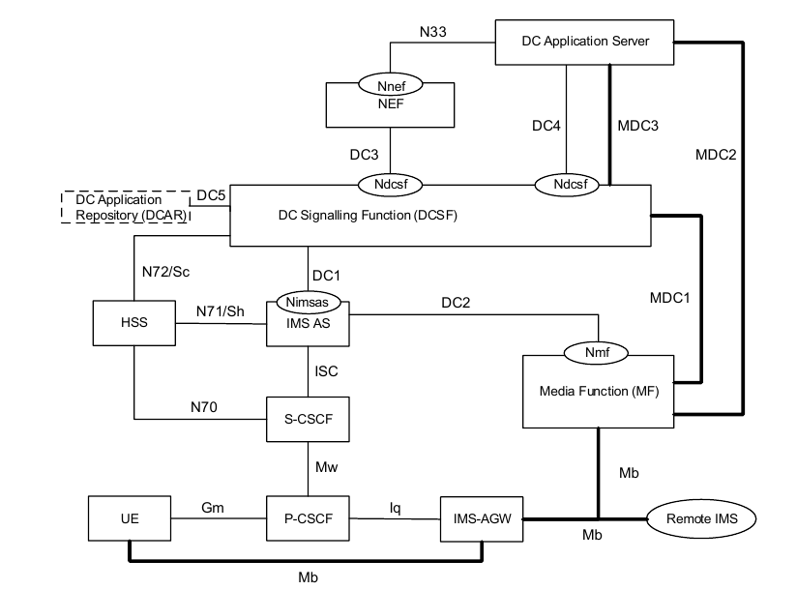
Figure 10.1.1.2-1 IMS supporting DC usage with MF (from Figure AC.2.1-1, TS 23.228)

The IMS DC architecture is shown in Figure 2. The new functional entities added to support the DC functionality are:
Data Channel Signalling Function (DCSF): a signaling control function responsible for managing data channel control logic. It determines whether data channel services can be provided during IMS sessions, manages bootstrap and application data channel resources at the Media Function (MF) via IMS AS, and handles interworking between application data channel media and audio/video media.
Media Function (MF): provides media resource management and forwarding of data channel media traffic. It manages bootstrap and application data channel resources, anchors application data channels in P2P scenarios, relays traffic between UEs and the DC Application Server, and handles transcoding of data channel media based on instructions from the DCSF. From a compute perspective, SA2 specifies that MF supports rendering (S4-251420) but not any AIML functionality (S4-260022).
DC Application Repository (DC-AR): stores verified data channel applications. These applications are retrieved by the DCSF when required, enabling the download of data channel applications to the UE.
Data Channel Application Server (DC-AS): interacts with the DCSF for resource control and traffic forwarding. It serves as the endpoint for application data channels and communicates with the UE through the Media Function (MF) for sending and receiving traffic. DC-AS functionalities are not specified by 3GPP and it is envisioned to support disparate application scenarios.
The DC relevant reference points are:
DC1: Reference point between the DCSF and the IMS AS.
DC2: Reference point between the IMS AS and MF.
DC3: Reference point between the DCSF and NEF.
DC4: Reference point between the DCSF and DC Application Server.
DC5: Reference point between the DCSF and DCAR.
The following reference points are updated to support data channel signalling control in IMS:
N70/Cx/Dx: Reference point between the CSCF and HSS.
N71/Sh: Reference point between the IMS AS and HSS.
The following reference points are defined for data channel media handling:
MDC1: Reference point for transport of data channel media between data channel media function MF and
DCSF.
MDC2: Reference point for transport of data channel media between data channel media function MF and DC
Application Server, between BAR and DC Application Server and between MF and BAR.
MDC3: Reference point for transport of data channel media between DCSF and DC Application Server.
IMS DC may be appropriate for mapping 3DGS workflows over IMS. For 3DGS generation, a service provider may provide an IMS DC application to DCAR and provisions and configures resources for the service via NEF and DC4. The UE downloads the IMS DC app. The IMS DC app sets up an application data channel with a DC AS to configure the service, uses device camera(s) to capture images or video, transmits the captured media to the DC-AS for SfM and 3DGS training. The generated 3DGS may be shared back to the UE. Or may be sent to the MF for view based rendering. A service provider may also share interactive scenes from a DC-AS to UEs together with an mmtel session in guided exploration use cases.

10.2 All in UE configuration
The functions of different workflows for this configuration are described in clause 9.1 of the present document. Below is a potential mapping of those functions to 3GPP services. In this configuration, 3DGS content is treated as downloadable or message-based asset.
Function | Potential 3GPP Service Mapping
Content generation  - Scene capture  - Static 3DGS model generation | 3DGS/XR Application on the UE  - 3GPP reference mapping: Media-Aware Application of Media Delivery architecture specified in TS 26.501 [26.501]
3DGS File Delivery | MMS [26.140][26.143], RCS messaging, HTTP file transfer (NOTE 1)  - 3GPP reference mapping: Media Access Function of Media Delivery architecture specified in TS 26.501 [26.501]  - Provides upload/download function for sending and receiving 3DGS content
Storage | UE Local storage (NOTE 2)
Rendering and playback | 3DGS/XR Application on the UE  - 3GPP reference mapping: Media-Aware Application specified in TS 26.501 [26.501]
NOTE 1: For file-based delivery with this configuration:
- 5G latency or jitter requirements do not apply (Strict 5G QoS is not necessary)
- Low Packet Error Rate and reliable delivery required.
- Standard 5G bearers specified in TS 23.501 [23501] are adequate to carry 3DGS content.
NOTE 2: No 3GPP specific mapping

end of CHANGEs

