3GPP TSG-S4 Meeting #135 S4-260192

Goa, India, 9-13 Feburary 2026

Source: Nokia
Title: [FS_Avatar_Ph2_MED] Authentication for avatar data
Agenda item: 9.8
Document for: Discussion and Agreement

1. Introduction
  - Background
The Rel-20 SID FS_Avatar_Ph2_MED was approved at last SA#110 (Dec 2025). This subsequent study phase aims to address the gaps identified by previous work, and resolve where possible, a number of open points identified in TS 26.264 Rel-19.
Security related aspects including e.g. authentication schemes have been identified as part of the gaps and included in the objectives of FS_Avatar_Ph2_MED:
6. In collaboration with SA3, study security implications, focusing on identification, authentication (including schemes for Avatar related APIs), privacy preservation, content protection (e.g. watermarking and DRM), and secure distribution mechanisms for Avatar data

  - Status in current TSs and TRs
In TR 26.813 and TS 33.328, the above aspects have not been addressed.
It is proposed to add a new sub-clause 8.3.4 with the text as below:
ALL NEW CHANGE

8.3.4 Security Considerations for IMS-based Avatar calls

8.3.4.1 Overview
Editor’s note: to be added.

8.3.4.X Authentication
It is necessary to provide suitable authentication methods for avatar management during an IMS-based avatar call, to ensure that a base avatar is representing the user of the avatar. In this clause, a Digital Credential based solution is provided to address the security implications. It provides a potential solution for maintaining the integrity of the avatar. The Digital Credential, referred to as Base Avatar Assertion (BAA), cryptograpically binds the Base Avatar Representation to the avatar owner.
In order to address the authentication requirements, an authenticator and an issuer can provide a set of corresponding functions. From implementation perspective, the authenticators can be deployed on UEs, and the issuer may be either part of the operator network which is operating the IMS for the avatar calls, or it could be a trusted entity out of the operator network.
The authenticator receives the Base Avatar Assertion from the issuer and securely store them for authentication. The authenticator ensures that the same user is present by verifying the BAA for avatar authentication. As mentioned, the BAA is a Digital Credential which is used to prove that a certain Base Avatar represents a user owning a certain private/public key pair. The generic structure of the Base Avatar Assertion is shown in Figure 8.3.4.X-1.
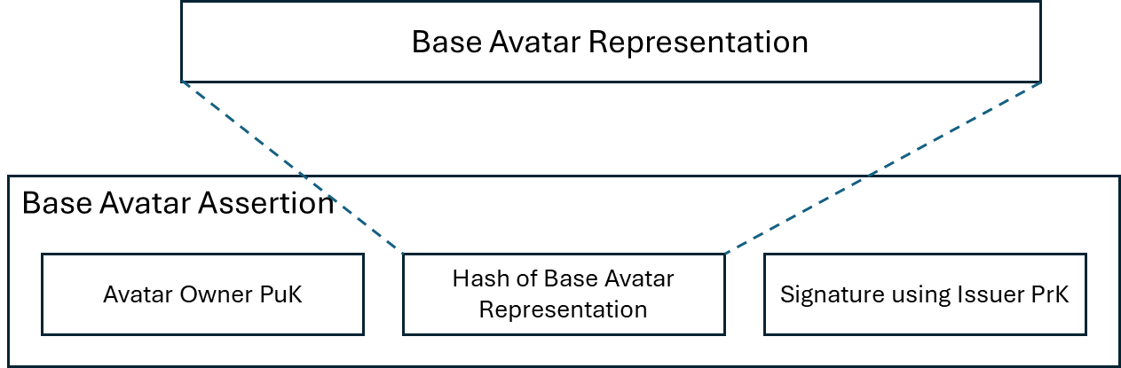
Figure 8.3.4.X-1 Structure of the Base Avatar Assertion

The issuer is responsible to verify that a Base Avatar represents its avatar owner and to provide a corresponding Digital Credential, such as Base Avatar Assertion, to the UE of the avatar owner. Furthermore, the issuer verifies that the authenticator on the avatar owner’s UE is in possession of the private/public key pair. The issuer provides functions including authorization functions and provisioning server.
During an avatar call, the avatar user can prove avatar authenticity to a peer by providing the BAA and by proving possession of the private key corresponding to the public key in the BAA, by the authenticator on the UE. An example to implement the authenticator and the issuer in the current system is shown in Figure 8.3.4.X-2.
Figure 8.3.4.X-2 An example of avatar authentication

BAA issuance procedure is illustrated in step 1-7:
1. The application on the UE1 triggers to generate an authorization request for a selected avatar representation and send the request to the Issuer.
2. The Issuer verify the request and authorize the user (UE1) if the verification succeed.
3. The Issuer sends the response to the UE1 which indicate the user authorization succeed. The response includes the Issuer ID.
4. The Authenticator on the UE1 creates a public/private key pair associated with the selected avatar presentation.
5. The Authenticator sends the enrolment request to the Issuer (including the public key).
6. The Issuer verifies the enrolment request (including verify if the user and the avatar are match, verify the public key is from a valid authenticator) and creates a BAA including its signature.
7. The Issuer sends enrolment response to the UE1 including the BAA. The authenticator stores the received BAA for further authentication.
Avatar authentication procedures:
8. When UE1 initiate an avatar call with UE2 and decided to use the selected avatar. UE2 further obtain the BAA from UE1 or Issuer of the selected avatar. The application and/or authenticator on UE2 verifies the validity of the BAA, e.g. by verifying the validity of the signature of the Issuer that the BAA is issued by a trusted issuer.
The avatar authentication procedures are usually at the beginning of the avatar calls, also can be at e.g. when a session is resumed or re-started.
END OF CHANGE

2. Proposal
It is proposed to add above content in the base CR.

