3GPP TR 26.836 V0.1.0 (2026-02)
Technical Report

3rd Generation Partnership Project;
Technical Specification Group Services and System Aspects;
Study on QUIC-based media delivery solutions for real-time communication
(Release 20)

The present document has been developed within the 3rd Generation Partnership Project (3GPP TM) and may be further elaborated for the purposes of 3GPP.
The present document has not been subject to any approval process by the 3GPP Organizational Partners and shall not be implemented.
This Specification is provided for future development work within 3GPP only. The Organizational Partners accept no liability for any use of this Specification.
Specifications and Reports for implementation of the 3GPP TM system should be obtained via the 3GPP Organizational Partners' Publications Offices.

3GPP
Postal address

3GPP support office address
650 Route des Lucioles - Sophia Antipolis
Valbonne - FRANCE
Tel.: +33 4 92 94 42 00 Fax: +33 4 93 65 47 16
Internet
https://www.3gpp.org

Copyright Notification
No part may be reproduced except as authorized by written permission.
The copyright and the foregoing restriction extend to reproduction in all media.

© 2025, 3GPP Organizational Partners (ARIB, ATIS, CCSA, ETSI, TSDSI, TTA, TTC).
All rights reserved.

UMTS™ is a Trade Mark of ETSI registered for the benefit of its members
3GPP™ is a Trade Mark of ETSI registered for the benefit of its Members and of the 3GPP Organizational Partners
LTE™ is a Trade Mark of ETSI registered for the benefit of its Members and of the 3GPP Organizational Partners
GSM® and the GSM logo are registered and owned by the GSM Association

Contents
Foreword 5
Introduction 6
1 Scope 8
2 References 8
3 Definitions of terms, symbols and abbreviations 9
3.1 Terms 9
3.2 Symbols 10
3.3 Abbreviations 10
4 QUIC-based media delivery protocols 10
4.1 General 10
4.2 Considered protocols 10
4.2.1 Protocol#1: <protocol name> 10
4.2.1.1 Introduction 10
4.2.1.2 Features 11
4.2.1.2.1 Introduction 11
4.2.1.2.2 Object-based data model 11
4.2.1.2.3 Publish/Subscribe workflow 11
4.2.1.2.4 Data transport over streams and datagrams 12
4.2.1.2.5 Relay behaviour and scalability 12
4.2.1.3 Benefits and limitations 13
4.2.1.4 Related Internet Drafts in the IETF MOQ WG 13
4.2.1.5 Current applications 14
4.2.2 RTP over QUIC (RoQ) 14
4.2.2.1 Introduction 14
4.2.2.2 Features 15
4.2.2.2.1 Security and encapsulation 15
4.2.2.2.2 Multiplexing 15
4.2.2.2.3 RTCP considerations 15
4.2.2.3 Benefits and limitations 16
4.2.2.4 Current applications 16
4.2.3 WebTransport 16
4.2.3.1 Introduction 16
4.2.3.2 Features 17
4.2.3.3 Benefits and limitations 18
4.2.3.4 Current applications 18
4.3 Summary 19
5 Evaluation of QUIC-based media delivery protocols for RTC 19
5.1 General 19
5.2 Application scenarios 19
5.2.1 Introduction 19
5.2.x Scenario#x: <scenario name> 19
5.3 Architectural and functional evaluation 19
5.3.1 Protocol#1: <protocol name> 19
5.3.1.1 Potential architectural enhancements 19
5.3.1.2 Advantages and disadvantages for application scenarios 19
5.3.2 Summary 20
5.4 Performance evaluation 20
5.4.1 Performance metrics 20
5.4.2 Evaluated protocols 20
5.4.2.1 Protocol#1: <protocol name> 20
5.4.2.1.1 General 20
5.4.2.1.2 Evaluation conditions 20
5.4.2.1.3 Evaluation results 20
5.5 Evaluation summary 20
6 Integration of the QUIC-based media delivery protocols into the RTC System 20
6.1 General 20
6.2 Candidate solutions 20
6.3 Summary of the solutions 20
7 Conclusions and recommendations 21
Annex A (informative): Change history 23

For definitive guidance on drafting 3GPP TSs and TRs, see 3GPP TS 21.801.
Ensure all blue guidance text is removed before submitting the TS/TR to the TSG for approval.

Foreword
This clause is mandatory; do not alter the text in any way other than to choose between "Specification" and "Report".
This Technical Report has been produced by the 3rd Generation Partnership Project (3GPP).
The contents of the present document are subject to continuing work within the TSG and may change following formal TSG approval. Should the TSG modify the contents of the present document, it will be re-released by the TSG with an identifying change of release date and an increase in version number as follows:
Version x.y.z
where:
x the first digit:
1 presented to TSG for information;
2 presented to TSG for approval;
3 or greater indicates TSG approved document under change control.
y the second digit is incremented for all changes of substance, i.e. technical enhancements, corrections, updates, etc.
z the third digit is incremented when editorial only changes have been incorporated in the document.
In drafting the TS/TR, pay particular attention to the use of modal auxiliary verbs! TRs shall not contain any normative provisions.
In the present document, modal verbs have the following meanings:
shall indicates a mandatory requirement to do something
shall not indicates an interdiction (prohibition) to do something
The constructions "shall" and "shall not" are confined to the context of normative provisions, and do not appear in Technical Reports.
The constructions "must" and "must not" are not used as substitutes for "shall" and "shall not". Their use is avoided insofar as possible, and they are not used in a normative context except in a direct citation from an external, referenced, non-3GPP document, or so as to maintain continuity of style when extending or modifying the provisions of such a referenced document.
should indicates a recommendation to do something
should not indicates a recommendation not to do something
may indicates permission to do something
need not indicates permission not to do something
The construction "may not" is ambiguous and is not used in normative elements. The unambiguous constructions "might not" or "shall not" are used instead, depending upon the meaning intended.
can indicates that something is possible
cannot indicates that something is impossible
The constructions "can" and "cannot" are not substitutes for "may" and "need not".
will indicates that something is certain or expected to happen as a result of action taken by an agency the behaviour of which is outside the scope of the present document
will not indicates that something is certain or expected not to happen as a result of action taken by an agency the behaviour of which is outside the scope of the present document
might indicates a likelihood that something will happen as a result of action taken by some agency the behaviour of which is outside the scope of the present document
might not indicates a likelihood that something will not happen as a result of action taken by some agency the behaviour of which is outside the scope of the present document
In addition:
is (or any other verb in the indicative mood) indicates a statement of fact
is not (or any other negative verb in the indicative mood) indicates a statement of fact
The constructions "is" and "is not" do not indicate requirements.

Introduction
QUIC is a user space UDP-based transport protocol developed by IETF with built‑in encryption, connection migration, stream multiplexing, pluggable congestion control, and optional unreliable datagrams defined in an extension to the core protocol.
The core QUIC specifications are:
- IETF RFC 9000 (QUIC: A UDP-Based Multiplexed and Secure Transport) ]: The foundational document defining QUIC's core mechanisms.
- IETF RFC 9001 (Using TLS to Secure QUIC) [10] specifies how TLS v1.3 [6] is integrated for security.
- IETF RFC 9002 (QUIC Loss Detection and Congestion Control) [11] specifies how QUIC handles packet loss and manages network congestion.
- IETF RFC 8999 (Version-Independent Properties of QUIC) [8] describes properties that don't change between QUIC versions.
Beyond the core specifications, IETF has specified multiple extensions such as HTTP/3 [13] and datagram [14] support, as well as operational specifications relating to the QUIC protocol’s applicability [15] and manageability [16].
As QUIC has seen broader adoption in recent years, its role in improving media transport compared to earlier TCP and UDP-based methods has become increasingly significant. QUIC-based media transport protocols can benefit from QUIC’s security, multiplexing, low-latency features to deliver media with finer control over reliability and ordering. Some key motivations to use QUIC for media transport are:
- Lower latency and faster start-up: 1-RTT handshake with optional 0-RTT resumption shortens join time for live/interactive sessions. User-space pacing algorithms can be applied to space packets over a round-trip time (RTT) rather than sending them at once, minimizing burstiness and thus potentially reducing jitter.
- Independent stream processing and prioritization: Independent streams prevent one stalled media flow (e.g. a large video frame) from blocking others (e.g. audio, timed metadata), ensuring no head‑of‑line (HoL) blocking across different streams. QUIC stream prioritization allows applications to signal the importance of different data flows, enabling the transport layer to allocate resources effectively.
- Selective reliability: Datagrams as defined in IETF RFC 9221 [14] allow best‑effort delivery (no retransmission) and are better suited for latency-critical applications that require unordered, unreliable packet delivery. On the other hand, streams are preferable in scenarios that require reliable, ordered delivery and allow explicit prioritization. Selecting between streams and datagrams, as well as determining the number of streams, depends on application needs and expected impact of HoL blocking. Applications can mix reliable streams carrying critical data with datagrams for unreliable delivery of non-critical and delay-sensitive data.
- Always-on security: Thanks to built-in support for encryption and authentication according to TLS 1.3 [6], no separate DTLS layer is needed. Connection IDs (CIDs) and encrypted headers improve privacy and robustness to protocol ossification by restricting middlebox inspection and reliance on transport-layer header semantics.
- Better mobility and robustness: Connection migration enables IP/port changes (e.g. Wi‑Fi to cellular) without call drops that lead to renegotiations and disrupt audio/video continuity.
- Flexibility, evolvability and extensibility: QUIC user-space implementation prevents traditional ossification experienced by other transport protocols, such as TCP and UDP. This makes QUIC more flexible with higher potential for protocol evolution and extensibility. The latter is not only limited to QUIC protocol extensions but also includes enabling applications ship portable and optimized congestion control, packet pacing, loss recovery mechanisms without reliance on customized kernel modules or workarounds.
As of 2026, three QUIC-based application protocols are under standardization in the IETF to support application scenarios including real‑time and interactive communication:
- Media over QUIC Transport (MOQT) [18].
- RTP over QUIC (ROQ) [19].
- WebTransport [20].

1 Scope
This clause shall start on a new page.
The present document …

2 References
The following documents contain provisions which, through reference in this text, constitute provisions of the present document.
- References are either specific (identified by date of publication, edition number, version number, etc.) or non-specific.
- For a specific reference, subsequent revisions do not apply.
- For a non-specific reference, the latest version applies. In the case of a reference to a 3GPP document (including a GSM document), a non-specific reference implicitly refers to the latest version of that document in the same Release as the present document.
[1] 3GPP TR 21.905: "Vocabulary for 3GPP Specifications".
[2] 3GPP TS 23.501: "System architecture for the 5G System (5GS)".
[3] IETF RFC 3550: "RTP: A Transport Protocol for Real-Time Applications", July 2003.
[4] IETF RFC 3711: “The Secure Real-time Transport Protocol (SRTP)”, March 2004.
[5] IETF RFC 8298: "Self-Clocked Rate Adaptation for Multimedia", December 2017.
[6] IETF RFC 8446: "The Transport Layer Security (TLS) Protocol Version 1.3", August 2018.
[7] IETF RFC 8866, “SDP: Session Description Protocol”, January 2021.
[8] IETF RFC 8999: "Version-Independent Properties of QUIC", May 2021.
[9] IETF RFC 9000: "QUIC: A UDP-Based Multiplexed and Secure Transport", May 2021.
[10] IETF RFC 9001: "Using TLS to Secure QUIC", May 2021.
[11] IETF RFC 9002: "QUIC Loss Detection and Congestion Control", May 2021.
[12] IETF RFC 9113: "HTTP/2", June 2022.
[13] IETF RFC 9114: "HTTP/3", June 2022.
[14] IETF RFC 9221: "An Unreliable Datagram Extension to QUIC", March 2022.
[15] IETF RFC 9309: "Applicability of the QUIC Transport Protocol", September 2022.
[16] IETF RFC 9312: "Manageability of the QUIC Transport Protocol", September 2022.
[17] IETF RFC 9576: "The Privacy Pass Architecture", June 2024.
[18] S. Nandakumar, V. Vasiliev, I. Swett, A. Frindell; draft-ietf-moq-transport-16, "Media over QUIC Transport", Work in Progress, Internet-Draft, 13 January 2026.
https://datatracker.ietf.org/doc/draft-ietf-moq-transport/
[19] M. Engelbart, J. Ott and S. Dawkins, draft-ietf-avtcore-rtp-over-quic-14, "RTP over QUIC (RoQ)", Work in Progress, Internet-Draft, 20 March 2025.
https://datatracker.ietf.org/doc/draft-ietf-avtcore-rtp-over-quic/
[20] E. Kinnear and V. Vasiliev; draft-ietf-webtrans-overview-11, "The WebTransport Protocol Framework", Work in Progress, Internet-Draft, 20 October 2025.
https://datatracker.ietf.org/doc/draft-ietf-webtrans-overview/
[21] M. Zanaty, S. Nandakumar and P. Thatcher, draft-ietf-moq-loc-01, "Low Overhead Media Container", Work in Progress, Internet-Draft, 8 January 2026.
[22] W. Law, draft-ietf-moq-msf-00, "MOQT Streaming Format", Work in Progress, Internet-Draft, 19 January 2026.
[23] S. Dawkins and V.Pascual, draft-ietf-avtcore-sdp-roq-00, “SDP Offer/Answer for RTP over QUIC (RoQ)”, Work in Progress, Internet-Draft, 11 October 2025.
[24] S. Holmer et al., draft-ietf-rmcat-gcc-02, "A Google Congestion Control Algorithm for Real-Time Communication", Internet-Draft, 8 July 2016.
[25] L. Navarre and O. Bonaventure, draft-navarre-quic-flexicast-01, "Flexicast QUIC: combining unicast and multicast in a single QUIC connection", 7 July 2025.
[26] A. Frindell et al., draft-ietf-webtrans-http2-07, "WebTransport over HTTP/2", Work in Progress, Internet-Draft, 20 October 2025.
[27] A. Frindell, E. Kinnear and V. Vasiliev, draft-ietf-webtrans-http3-14, "WebTransport over HTTP/3", Work in Progress, Internet-Draft, 20 October 2025.
[28] W. Law et al., draft-ietf-moq-c4m-00, "Authentication scheme for MOQT using Common Access Tokens", Work in Progress, Internet-Draft, 19 September 2025.
[29] S. Nandakumar, C. Jennings and T. Meunier, draft-ietf-moq-privacy-pass-auth-01, "Privacy Pass Authentication for Media over QUIC (MoQ)", Work in Progress, Internet-Draft, 20 October 2025.
[30] charter-ietf-moq-01, “Media Over QUIC”, https://datatracker.ietf.org/doc/charter-ietf-moq/
[31] charter-ietf-avtcore-03, “Audio/Video Transport Core Maintenance”, https://datatracker.ietf.org/doc/charter-ietf-avtcore/
[32] charter-ietf-webtrans-01, “WebTransport”, https://datatracker.ietf.org/doc/charter-ietf-webtrans/
[33] N. Jaju, V. Vasiliev and J. Bruaroey, "WebTransport", W3C Working Draft, 17 December 2025.
https://www.w3.org/TR/webtransport
[34] “WebRTC: Real-Time Communication in Browsers “, W3C Recommendation, 13 March 2025. https://www.w3.org/TR/webrtc/
[35] P. Adenot and E. Zemtsov, "WebCodecs", W3C Working Draft, 29 January 2026.
https://www.w3.org/TR/webcodecs
[36] Ericsson Research, "SCReAM (Self-Clocked Rate Adaptation for Multimedia)", https://github.com/EricssonResearch/scream

3 Definitions of terms, symbols and abbreviations
This clause and its three (sub) clauses are mandatory. The contents shall be shown as "void" if the TS/TR does not define any terms, symbols, or abbreviations.

3.1 Terms
For the purposes of the present document, the terms given in TR 21.905 [1] and the following apply. A term defined in the present document takes precedence over the definition of the same term, if any, in TR 21.905 [1].
Definition format (Normal)
<defined term>: <definition>.
example: text used to clarify abstract rules by applying them literally.

3.2 Symbols
For the purposes of the present document, the following symbols apply:
Symbol format (EW)
<symbol> <Explanation>

3.3 Abbreviations
For the purposes of the present document, the abbreviations given in TR 21.905 [1] and the following apply. An abbreviation defined in the present document takes precedence over the definition of the same abbreviation, if any, in TR 21.905 [1].
Abbreviation format (EW)
<ABBREVIATION> <Expansion>

4 QUIC-based media delivery protocols

4.1 General
IETF has been working on the standardization of several QUIC-based application protocols. This clause documents the ones that are considered relevant to real‑time and interactive communication.

4.2 Considered protocols
Editor’s note: Each subsequent clause describes an individual protocol.

4.2.1 Protocol#1: <protocol name>

4.2.1.1 Introduction
Media over QUIC Transport (MOQT) [18] is a publish/subscribe-based binary data transport protocol that is under development by the IETF MOQ Working Group [30] since 2023, designed to run either directly over QUIC [9] or via WebTransport [20]. Although the protocol was originally created for media applications as its name suggests, its flexible design also allows it to transmit various other types of data.
The MOQT protocol stack is shown in Figure 4.2.1.1-1.
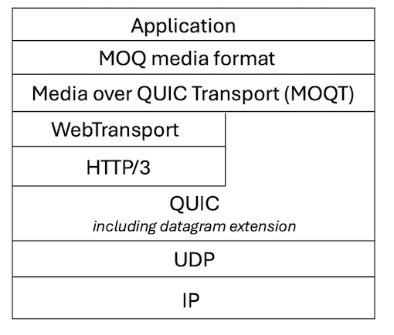
Figure 4.2.1.1-1: MOQT protocol stack

4.2.1.2 Features

4.2.1.2.1 Introduction
Below is a non-exhaustive summary of MOQT's key features. For further details, refer to draft-ietf-moq-transport [18].

4.2.1.2.2 Object-based data model
MOQT’s data model represents each MOQT schedulable unit of content as an Object within a named Track, organized into Groups and Subgroups. Objects are identified by an Object ID within a Group/Subgroup and carry metadata including Track Alias, Group ID, Object IDs, Publisher Priority, and optional extension headers.
A Track is a named content stream published under a specific Track Namespace. Tracks are referenced on the wire by a numeric Track Alias, which is assigned when a subscription is established. Publishers may provide multiple tracks for identical content, offering alternatives such as varying quality levels.
A Track is a collection of Groups that are temporal sequences of Objects. Groups are typically aligned with a codec’s synchronization point, e.g., a MOQT Group can be a Group of Pictures (GOP) defined in the H.264/AVC and H.265/HEVC video specifications. So, Group boundaries act as random access points in the stream of Objects such that subscribers can join and begin decoding without requiring information from earlier Groups.

4.2.1.2.3 Publish/Subscribe workflow
MOQT’s publish/subscribe workflow enables publishers to make media Tracks available within designated namespaces, allowing subscribers to select only the namespaces and Tracks they need.
Publishers are endpoints that handle subscriptions by sending requested Objects from the requested Track; the initial publisher of a given track is called the Original Publisher. Subscribers are endpoints that subscribe to and receive tracks. Relays are protocol entities that efficiently cache and route content, acting as intermediaries that handle subscription requests, retrieve data from upstream sources, and distribute it to downstream subscribers.
Publishers and subscribers are decoupled, enabling relays to fan out to large audiences; the Original Publisher (i.e. the initial publisher of a given track) need not push to every endpoint. Publishers generate Tracks carrying different media content (e.g. audio, video or metadata) and transmit them to subscribers/relays either by responding to SUBSCRIBE and FETCH messages from subscribers/relays or by initiating subscriptions themselves using PUBLISH messages. SUBSCRIBE only requests newly published or received Objects while Objects from the past are retrieved using FETCH.
MOQT relies on out-of-band mechanisms for discovery of MOQT servers. However, an in-band means of discovery of publishers for a given namespace is provided by SUBSCRIBE_NAMESPACE, PUBLISH and PUBLISH_NAMESPACE messages. A subscriber can send a SUBSCRIBE_NAMESPACE message to a publisher to request the current set of matching published namespaces and/or subscriptions, as well as future updates to the set. A publisher can send a PUBLISH_NAMESPACE message to advertise that it has tracks available within a given Track Namespace.
Subscribers can also specify subscription filters indicating to the publisher which Objects to send, such as defining a starting point or choosing an exact range of Objects.

4.2.1.2.4 Data transport over streams and datagrams
Objects are transmitted either on QUIC streams (reliable, ordered) or as QUIC DATAGRAM frames (unreliable, unordered) as defined in IETF RFC 9221 [14].
Grouping mutually dependent Objects together in a QUIC stream can provide operational advantages, such as improved prioritization. This is achieved by using Subgroups that are distinct segments within a Group, with each Subgroup delivered over a single QUIC stream. Each Object has an associated Forwarding Preference, specifying whether it is sent in a Subgroup (reliable stream) or datagram (unreliable); this is a property of an individual Object and can vary among the Objects in the same Track.
When Objects are sent in datagrams, each is encapsulated within a variable-length OBJECT_DATAGRAM message containing a single Object. When QUIC streams are used, Objects are sent on unidirectional streams that start with a variable-length integer indicating the stream type (SUBGROUP_HEADER or FETCH_HEADER). Bidirectional streams are applicable only to the control stream which is opened for transmitting control messages.
Figure 4.2.1.2.4-1 illustrates how MOQT Objects and control messages are encapsulated within QUIC packets when MOQT is layered over WebTransport. A QUIC STREAM frame can carry several control messages or Objects, but a DATAGRAM frame carries exactly one Object. STREAM frames cannot mix control messages and Objects.
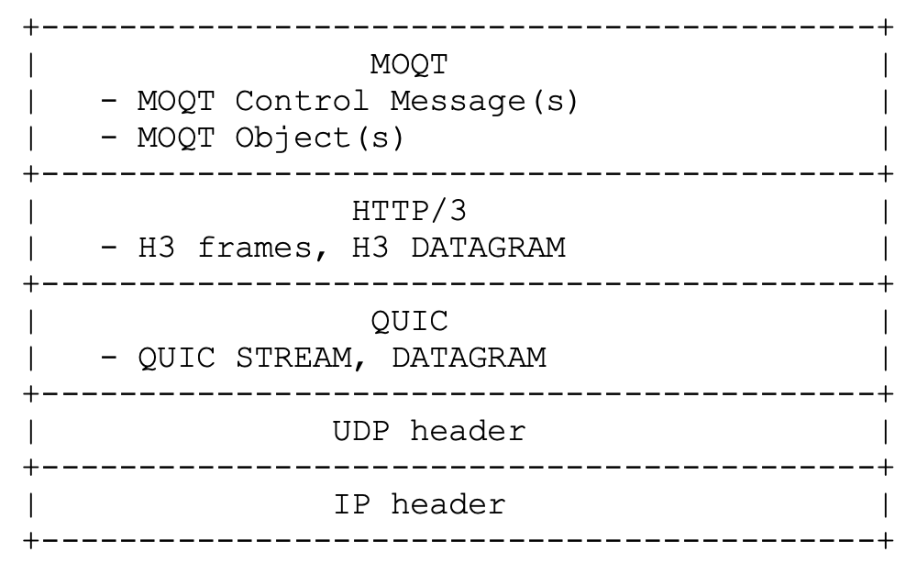
NOTE: A UDP datagram can carry multiple QUIC packets, and each QUIC packet can carry multiple QUIC frames.
Figure 4.2.1.2.4-1: Encapsulation of MOQT data within QUIC packets

4.2.1.2.5 Relay behaviour and scalability
MOQT Relays support both fan-in and fan-out: they can ingest tracks from multiple publishers (fan-in), acquire Tracks once and serve many subscribers (fan-out), thereby facilitating scalable distribution in a manner analogous to Content Delivery Networks (CDNs). Furthermore, relays function as policy enforcement points by validating both subscription and publication requests at the network edge.
[NOTE: Out-of-Band discovery: Initial discovery of servers and specific Track Namespaces is typically handled outside the protocol (out-of-band), although mechanisms exist to discover tracks once a session is established.]
Objects and Tracks can have relay-visible fields by means of Extension Headers that allow publishers to inform relays about publisher preferences/settings (e.g. delivery timeout, max cache duration) and Object metadata (e.g. publisher priority). As endpoints, relays terminate QUIC transport sessions, providing visibility into Object metadata including data carried in optional Extension Headers that might be necessary for distribution. However, Object payload may be additionally encrypted and not available to relays, such that relays are required by draft-ietf-moq-transport [18] to treat the Object payload as opaque; they are not allowed to modify, split or combine payloads.
Relays may cache recent Objects to reduce load of the Original Publisher, enable quicker late joins and recovery from loss.

4.2.1.3 Benefits and limitations
Benefits:
- Leverage the features of QUIC for real-time media delivery (e.g., multiple streams, prioritization) and provides means for integration to a CDN infrastructure.
- Convergence to a single media delivery protocol suitable from ingest to distribution simplifies workflows for service providers and enables a unified infrastructure for real-time and streamed media in the long run.
- Scalable publish-subscribe architecture that uses relays to fan out Objects to many subscribers, with the aim of enabling independent scaling of producers and consumers as well as efficient content distribution.
- Potentially reduced session setup delay compared to WebRTC [34], as WebRTC commonly incurs multiple RTTs for operations such as ICE gathering, DTLS, SCTP/data channel setup, etc.
- MOQT relays can examine metadata in Object Extension Headers and perform network optimizations, such as the 5G User Plane Function (UPF) integrating a MOQT relay and parsing the PDU Set information from an extension header, as defined in 3GPP TS 23.501 [2].
- Web compatibility: The option to use MOQT over WebTransport enables it to run natively in web browsers without requiring custom plug-ins. This facilitates future browser support and convergence between real-time media communication and web-based service platforms.
Limitations:
- MOQT is still evolving (the IETF specification draft-ietf-moq-transport [18] is not yet finalized), meaning limited production implementations, and operational experience.
- Initial deployment costs for the new architecture and protocol implementation
- Additional testing and operational experience are needed to validate scalability.
Editor’s note: Further verification of these benefits and limitations for specific RTC relevant application scenarios is FFS.

4.2.1.4 Related Internet Drafts in the IETF MOQ WG
The MOQ WG also develops container formats that specify encapsulation of MOQT data and media streaming formats operating over MOQT that specify media packaging as well as signalling mechanisms for negotiation between MOQT endpoints. These formats include:
- Low Overhead Media Container (LOC) [21]. LOC is a low-overhead container format for encoded audio and video data. "Low-overhead" refers to minimal extra encapsulation as well as minimal application overhead when interfacing with WebCodecs [35].
- MOQT Streaming Format (MSF, formerly known as WARP) [22]. MSF enables producers to describe their content using a Catalog, a specialized track containing metadata about available tracks, codecs, and initialization data. A Catalog track allow subscribers to discover and select content. Other formats may be defined to address specific media or non-media delivery requirements.
In addition to formats, authentication schemes are being developed in two drafts.
- Authentication scheme for MOQT using Common Access Tokens [28]: Introduces a token-based authentication scheme for use with MOQT. The scheme protects access to the relay during session establishment and constrains the actions which the client may take once connected.
- Privacy Pass Authentication for Media over QUIC [29]: Specifies how Privacy Pass [17] tokens can be integrated with MOQT to provide privacy-preserving authentication for subscriber, publisher and relay operations while supporting fine-grained access control.

4.2.1.5 Current applications
- Several open-source implementations of the IETF draft exist. A non-exhaustive list is given below:
- Google’s production-ready implementation supports MOQT: https://github.com/google/quiche
- Meta provides an experimental MOQT Relay and live encoder/player designed to work with it:
- Relay: https://github.com/facebookexperimental/moxygen
- Encoder/player: https://github.com/facebookexperimental/moq-encoder-player
- Ozyegin University provides a MOQT library with publisher, subscriber and relay components, featuring various live and on-demand demo applications using the LOC and CMAF formats: https://moqtail.dev/
- Cloudflare provides an implementation of the MOQT protocol for live media delivery over QUIC: https://github.com/cloudflare/moq-rs
- Cloudflare relay network implementation – Deployed on Cloudflare datacenter servers. https://blog.cloudflare.com/moq/
- Bitmovin web player– Integrated MOQT playback, bringing sub-second latency to modern web browsers. Leverages WebTransport and the WebCodecs API. https://bitmovin.com/blog/sub-second-streaming-bitmovin-player-web-x-moq-playback/
- Vindral live streaming solution – Integrated MOQT into their low-latency live streaming platform. https://vindral.com/live/features/moq/
- Red5 announced upcoming support for MOQT-based live streaming in their cloud-based live video streaming and real-time communications solutions in early 2026. https://www.red5.net/media-over-quic-moq/

4.2.2 RTP over QUIC (RoQ)

4.2.2.1 Introduction
RTP over QUIC (RoQ) [19] is a protocol that has been under development by the IETF AVTCORE (Audio/Video Transport Core Maintenance) WG [31] since 2022. The RoQ draft defines a minimal and flexible mapping that allows existing RTP-based real-time media applications to operate over QUIC instead of the traditional UDP. By doing so, real-time media applications can leverage QUIC’s built-in features, such as mandatory encryption, connection migration, multiplexing, and pluggable congestion control, while preserving the core semantics of RTP [3] for transport real-time audio and video data.
RoQ aims to provide a modern transport alternative for real-time media that simplifies deployment (single encrypted connection, easier NAT traversal) while raising important design considerations around latency, Head-of-Line (HoL) blocking, congestion control interaction, and interoperability.
RTP applications often rely on the Session Description Protocol (SDP) [7] as their signalling protocol to establish connections and media negotiation. For RoQ [23] describes how SDP Offer/Answer can be used to set up an RTP connection using QUIC.

4.2.2.2 Features

4.2.2.2.1 Security and encapsulation
QUIC includes built-in encryption (TLS v1.3 [6]) for all traffic, so RTP media packets benefit from confidentiality and integrity without a separate DTLS layer as in the case of SRTP [4]. RoQ [19] supports QUIC streams and QUIC datagrams [14] as primary encapsulation models for carrying RTP/RTCP packets over QUIC, allowing applications to choose between reliable, ordered delivery and unreliable, low-latency delivery depending on their requirements.
RoQ offers two ways to map RTP/RTCP packets onto QUIC:
1. Use QUIC stream: Multiple RTP/RTCP packets are sent within the same QUIC stream using RoQ’s in-stream framing (each packet is length-prefixed for delineation). When carried in STREAM frames, RTP packets can be queued and segmented by QUIC as required for stream reliability. Standard QUIC signalling mechanisms, such as STOP_SENDING and RESET_STREAM, may be utilized to terminate in-flight frames when, for instance, media data become obsolete.
NOTE: Transmitting each RTP/RTCP packet in a separate QUIC stream is possible but not recommended, as creating thousands of short‑lived streams (one per RTP packet) leads to excessive per-packet overhead and state due to additional stream metadata and lifecycle management (creation, flow control accounting).
2. Use QUIC datagrams: Each QUIC DATAGRAM frame carries one RTP/RTCP packet—only the flow ID is needed, no additional length field is required. In this case, there is no internal fragmentation of the RTP packet payload; the size of every DATAGRAM frame must respect the max_datagram_frame_size connection parameter negotiated by the peers as well as the underlying Path MTU in order to accommodate the RTP packet, flow identifier, QUIC headers, and IP headers.

4.2.2.2.2 Multiplexing
RoQ allows multiplexing multiple RTP and RTCP streams over a single QUIC connection using flow identifiers, simplifying NAT/firewall traversal and reducing port usage. Instead of using separate UDP ports per flow, an application-level flow identifier is inserted as part of the QUIC payload for both STREAM frames and DATAGRAM frames. For example, one flow ID can be assigned to audio-related RTP/RTCP packets and another to video stream packets. Flow identifiers enable demultiplexing at the receiver without additional QUIC connections.
Figure 4.2.2.2.2-1 illustrates how RoQ encapsulates RTP/RTCP packets within QUIC packets.
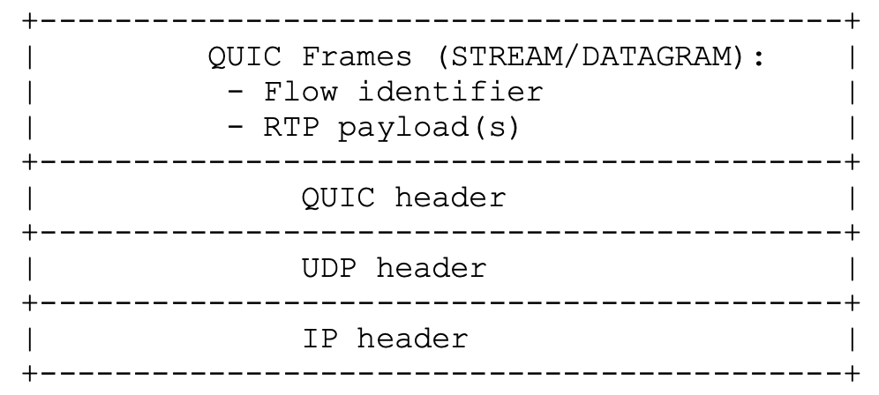
NOTE 1: A UDP datagram can carry multiple QUIC packets, and each QUIC packet can carry multiple QUIC frames.
NOTE 2: Each RTP payload begins with a length field indicating the length of the RTP packet, followed by the RTP packet itself.
Figure 4.2.2.2.2-1: RoQ encapsulation of RTP packets within QUIC packets

4.2.2.2.3 RTCP considerations
RoQ aims to minimize RTCP traffic by utilizing data already accessible in the QUIC layer. QUIC’s transport-level feedback can be used to complement or partially replace traditional RTCP features, potentially reducing control overhead.
- QUIC acknowledgments can be used to compute the lost packet statistics, which are typically derived from RTCP reports in RTP applications. A mapping, as per Section 10.4 of draft-ietf-avtcore-rtp-over-quic [19], defines how QUIC loss events map to Negative Acknowledgment (NACK) semantics at RTP layer.
- QUIC’s support for Explicit Congestion Notification (ECN) can be used instead of RTCP ECN feedback reports.
- Other RTCP semantics, such as BYE, can be replaced using QUIC feedback by transmitting the reason for leaving in the Reason Phrase field of the QUIC frame CONNECTION_CLOSE.
Section 10 of draft-ietf-avtcore-rtp-over-quic [19] explains in greater detail how the information provided by the QUIC layer can be used to replace RTCP messages whenever possible.

4.2.2.3 Benefits and limitations
Benefits:
- Reuse established RTP payload formats, media semantics and timing, A/V lip-sync across multiple streams, etc.
- Built-in authentication and encryption via QUIC/TLS 1.3 (no need for separate DTLS-SRTP [4]).
- Multiple media, control, and other application flows can be multiplexed over one QUIC connection, simplifying NAT/firewall traversal and reducing port usage.
- By leveraging QUIC’s internal metrics such as Round-Trip-Time, loss, delivery rates, RoQ can reduce or avoid some RTCP feedback that is traditionally needed to infer network conditions.
Limitations:
- Flow identifiers introduce some overhead in addition to the header overhead of RTP and QUIC. They are encoded as QUIC variable-length integers, adding 1–8 bytes per packet. So, in typical deployments with ≤63 flows, the overhead would be 1 byte per RTP/RTCP packet.
- When RTP packets are placed on a reliable QUIC stream, QUIC’s reliable delivery can introduce head-of-line blocking, which is undesirable for real-time traffic. This issue can be avoided using QUIC DATAGRAM frames or stream segmentation techniques, but requires careful design.
- RTP applications often implement application-layer rate control (e.g. Google Congestion Control [24], SCReAM [5],[36]) while QUIC enforces transport-level congestion control (e.g. CUBIC, BBR). Coordination between the two is necessary to prevent conflicts and performance degradation. Currently, there is no API defined for communication between app-layer rate control and transport-layer congestion control algorithms.
- Not suitable for point-to-multipoint topologies, as QUIC is not yet defined for multicast operation, although several draft proposals exist, including Flexicast QUIC [25].
- Limited ecosystem and adoption in the industry so far.
Editor’s note: Further verification of these benefits and limitations for specific RTC relevant application scenarios is FFS.

4.2.2.4 Current applications
Open-source implementations exist:
- Go implementation by TUM: https://github.com/mengelbart/roq
- Gstreamer plugin by BBC: https://github.com/bbc/gst-roq
- Meetecho C library imquic implements RoQ in addition to MOQT: https://github.com/meetecho/imquic/
No commercial deployments have been identified, further exploration is for further study.

4.2.3 WebTransport

4.2.3.1 Introduction
WebTransport is a modern web API and protocol framework that enables secure, low‑latency, bidirectional communication between browsers or web apps and servers. WebTransport is designed to cover use cases where the WebSocket API is too limited (single, ordered, reliable byte stream over TCP) and where the WebRTC Data Channel is too complex or too peer-to-peer-oriented.
The IETF WebTransport Working Group [32], formed in 2019, defines the WebTransport protocol framework [20], including the mappings to HTTP/2 [12] and HTTP/3 [13] found in draft-ietf-webtrans-http2 [26] and draft-ietf-webtrans-http3 [27], respectively, while the W3C specifies the web API [33] that allows data to be exchanged between a browser and server through a QUIC-like API (secure, multiplexed real-time transport of streams and datagrams). When layered over HTTP/3, a WebTransport session runs over an underlying HTTP/3 connection.
The protocol and API are designed to work within the Web security model (origin verification, TLS), and are aimed at real-time scenarios such as gaming, interactive streaming, collaboration, and IoT telemetry. Non-browser clients, such as native apps, might instead benefit from using QUIC directly for greater control and efficiency.
The WebTransport protocol stack is shown in Figure 4.2.3.1-1.
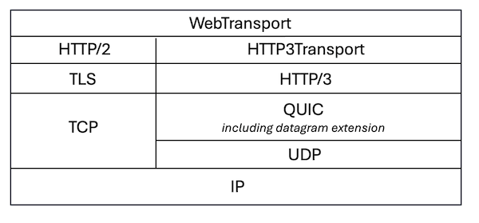
Figure 4.2.3.1-1: WebTransport protocol stack
In this stack, HTTP3Transport represents a protocol mapping, including:
- HTTP/3 feature negotiation
- Extended CONNECT to initiate the connection
- Mapping WebTransport datagrams and streams to HTTP/3 datagrams and streams.
Figure 4.2.3.1-2 illustrates the encapsulation of WebTransport payload when it is layered over HTTP/3.
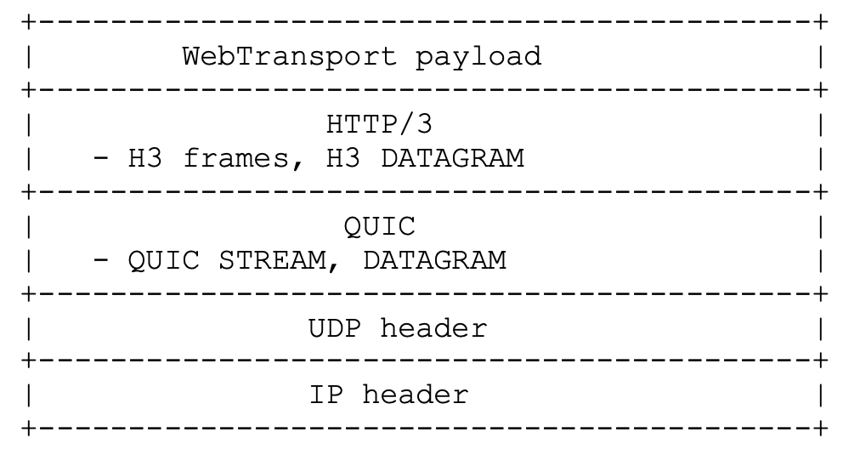
Figure 4.2.3.1-2: Encapsulation of WebTransport payload
NOTE 1: A UDP datagram can carry multiple QUIC packets, and each QUIC packet can carry multiple QUIC frames.

4.2.3.2 Features
WebTransport provides a session-based communication model supporting multiple independent unidirectional and bidirectional streams, ensuring reliable and ordered delivery of byte streams. It also allows for unreliable delivery using QUIC datagrams. The API exposes readable/writable streams and datagrams to developers, all multiplexed within the same connection when running over HTTP/3 [27].
When layered over HTTP/3, a WebTransport session is established via an HTTP/3 CONNECT with :protocol=webtransport and negotiated SETTINGS. All data then flows over QUIC streams/datagrams. Applications gain high-level access to QUIC’s capabilities through the WebTransport API. However, arbitrary crafting of QUIC packets or frames is not allowed; the developers interact with QUIC through the WebTransport API’s streams and datagrams mapped onto QUIC.
Congestion control is hinted via an API preference ("throughput" or "low-latency") but not directly selectable or configurable; actual algorithms are defined by the user agent.

4.2.3.3 Benefits and limitations
Benefits:
- Leverage benefits of QUIC within the standard web security model (origin-based access control, secure contexts) providing browser support. The W3C WebTransport API [33] exposes the capabilities of QUIC through a high-level, stream-oriented JavaScript interface aligned with the Web Streams paradigm, offering a modern alternative to WebSockets with native support for multiplexing and unreliable datagrams.
- Simpler deployment compared to WebRTC Data Channel [34] (no ICE/STUN/TURN).
- WebTransport adds only minimal overhead on top of QUIC: a one-time HTTP/3 CONNECT for session setup, after which MOQT messages use normal QUIC streams/datagrams with typically just a one-byte session ID per stream and no additional cryptographic overhead since it reuses the existing QUIC connection and encryption.
- Integrates with HTTP semantics and deployment models, specifying mappings over HTTP/3 [27] and HTTP/2 [26] so that the same application-level API can operate in environments where QUIC/UDP is not available, easing incremental deployment.
Limitations:
- Browser support is evolving; no support in Safari as of early 2026.
- Primarily designed for client–server interactions initiated by web clients and does not provide a standardized NAT traversal model like WebRTC [34].
- An application-layer protocol is required to deliver media, utilizing either a custom frame format with message boundaries and headers or MOQT [18]. Same for per-stream prioritization.
- Intentionally exposes only a high-level subset of QUIC features considered safe within the web security model, not allowing full control over QUIC configuration. WebTransport is available only in secure contexts (HTTPS) and is intentionally “safe to expose to untrusted applications,” which limits low-level transport control compared to native (non-browser) networking.
- Adoption can be limited by specification and implementation maturity: the browser API is still a W3C Working Draft and support can vary across user agents [33].
Editor’s note: Further verification of these benefits and limitations for specific RTC relevant application scenarios is FFS.

4.2.3.4 Current applications
MOQT can be layered on top of WebTransport.
WebTransport implementations over QUIC (HTTP/3) are available both for clients and servers:
- Google Chrome and Microsoft Edge browsers implement client-side W3C WebTransport API [33] over QUIC.
- Many open-source server-side implementations exist. Some examples:
- Google’s QUICHE supports WebTransport: https://github.com/google/quiche
- Cloudflare’s Rust implementation quiche: https://github.com/cloudflare/quiche
- Python library aioquic https://github.com/aiortc/aioquic

4.3 Summary
Editor’s note: Provide a summary and comparison of the protocols described in the previous clause.

5 Evaluation of QUIC-based media delivery protocols for RTC

5.1 General
Editor’s note: This clause documents the evaluation of QUIC-based media delivery protocols against existing architectures and protocols defined in the RTC System. The evaluation is conducted in terms of architectural aspects including supported functional features as well as performance aspects, based on the application scenarios defined in clause 5.2.

5.2 Application scenarios
Editor’s note: This clause describes potential application scenarios for RTC using QUIC-based media delivery protocols.

5.2.1 Introduction

5.2.x Scenario#x: <scenario name>
Editor’s note: Each individual subsequent clause describes possible RTC service scenarios.

5.3 Architectural and functional evaluation
Editor’s note: Documentation of potential impacts, advantages and disadvantages of integrating QUIC-based technologies into the RTC media delivery architecture (as defined in TS 26.506), 5G Core Network architecture (as defined in TS 23.501), as well as on UE implementations. This includes an analysis of the advantages and disadvantages of applying the protocols.

5.3.1 Protocol#1: <protocol name>

5.3.1.1 Potential architectural enhancements
Editor’s note: Documents how each identified QUIC-based media delivery protocol is applicable to the application scenarios. Then identify the potential architectural enhancements to implement the QUIC-based media delivery protocol into RTC system.

5.3.1.2 Advantages and disadvantages for application scenarios
Editor’s note: Documents advantages and disadvantages of integrating QUIC-based media delivery protocols into the RTC System for each application scenario.

5.3.2 Summary

5.4 Performance evaluation
Editor’s note: The performance evaluation utilizes the test framework described in TR 26.934 ("Test platform for media delivery technologies").

5.4.1 Performance metrics
Editor’s note: Definition of appropriate performance metrics for evaluation of QUIC-based media delivery protocols.

5.4.2 Evaluated protocols

5.4.2.1 Protocol#1: <protocol name>

5.4.2.1.1 General

5.4.2.1.2 Evaluation conditions

5.4.2.1.3 Evaluation results
Editor’s note: Documentation of the results obtained using the test framework defined in TR 26.934.

5.5 Evaluation summary
Editor’s note: Documents the overall evaluation as the summary. This includes advantages and disadvantages on RTC system, benefits for application scenarios, and performance evaluation result.

6 Integration of the QUIC-based media delivery protocols into the RTC System

6.1 General
Editor’s note: This clause documents potential integration scenarios. This clause is expected to be addressed if any of the QUIC-based media delivery protocols documented in clause 4 are found to be beneficial for RTC, based on the evaluation in clause 5.

6.2 Candidate solutions
Editor’s note: This clause documents potential solutions.

6.3 Summary of the solutions
Editor’s note: This clause summarizes the proposed solutions and potential normative work related to the solutions. This can include evaluation / comparison of solutions.

7 Conclusions and recommendations
Editor’s note: This clause provides the conclusions of this study and recommendations.

Annex A (informative):
Change history
Change history
Date | Meeting | TDoc | CR | Rev | Cat | Subject/Comment | New version
2026-02 | SA4#135 | S4-260076 |  |  |  | Initial version, technical report skeleton | 0.0.1
2026-02 | SA4#135 | S4-260384 |  |  |  | Incorporate S4-260358 and S4-260359 | 0.1.0

