3GPP TSG-SA WG4 Meeting #135 S4-260261r01

Goa, India, 09 – 13 February, 2026

Source: InterDigital Pennsylvania
Title: [FS_Q4RTC_MED] Application scenario: Conference using QUIC-based media protocols for RTC
Spec: 3GPP TR 26.836 v0.0.1
Agenda item: 10.7
Document for: Discussion and Agreement

1. Introduction
The Study on QUIC-based media delivery for real-time communication and services focuses on identifying relevant application scenarios for which the evaluation of QUIC-based media delivery protocols is carried out, in particular including existing 3GPP services or service enablers such as split rendering.
This contribution focuses on Conference application scenario for real-time communication services.
2. Reason for Change
This contribution documents the description of Conference application scenario using QUIC-based media delivery protocols in real-time communication services.
3. Proposal
It is proposed to agree the following changes to current version of 3GPP TR 26.836.
* * * First Change * * *

2 References
The following documents contain provisions which, through reference in this text, constitute provisions of the present document.
- References are either specific (identified by date of publication, edition number, version number, etc.) or non specific.
- For a specific reference, subsequent revisions do not apply.
- For a non-specific reference, the latest version applies. In the case of a reference to a 3GPP document (including a GSM document), a non-specific reference implicitly refers to the latest version of that document in the same Release as the present document.
[1] 3GPP TR 21.905: "Vocabulary for 3GPP Specifications".
[2] 3GPP TS 26.522: "5G Real-time Media Transport Protocol Configurations".
[3] 3GPP TS 23.501: "System architecture for the 5G System (5GS)".
[22870] 3GPP TR 22.870: "Study on 6G Use Cases and Service Requirements".
* * * Second Change * * * all new

5.2 Application Scenarios

5.2.X Scenario#3: Conference application

5.2.X.1 Description
A conference application enables multiple user equipments (UEs) like smartphones, tablets or smart glasses to participate in a real-time interactive session from web-based or native clients. Participants may use different browsers or dedicated applications. The application supports audio, video, haptic media and data sharing (e.g., chat, presence, screen-sharing metadata). Control signalling and non-media data must be reliable, while media delivery prioritizes low latency and continuity.
For this conference application, two architectures can be considered:
1. Single output scenario from all feeds with a centralized mixing.
2. Multiple feeds transmitted separately to other UEs.

5.2.X.2 Single output scenario from all feeds with a centralized mixing
In this scenario as illustrated in figure 5.2.X.2-1, the media streams (audio and/or video and/or haptics) of each participant are sent to a central conferencing server. This server comprises a composition function or media mixer which mixes and/or composites the different input streams into a composite output stream per session. Each UE (UE1, UE2, UE3 and UE4) receives the same combined or mixed streams. Although not represented in this figure 5.2.X.2-1, each UE sends control and signalling messages to the conferencing server to enable the media session establishment. The conferencing server is associated with a media mixer to apply a composition of the different media. To this end, all parties exchange their capabilities but also their state. In case of changes, e.g. new video resolution or new video source, the media mixer reacts quickly and accordingly. This dynamic adaptation is essential for all the participants to get the best experience. The conferencing server is also in charge of the admission of new participants.
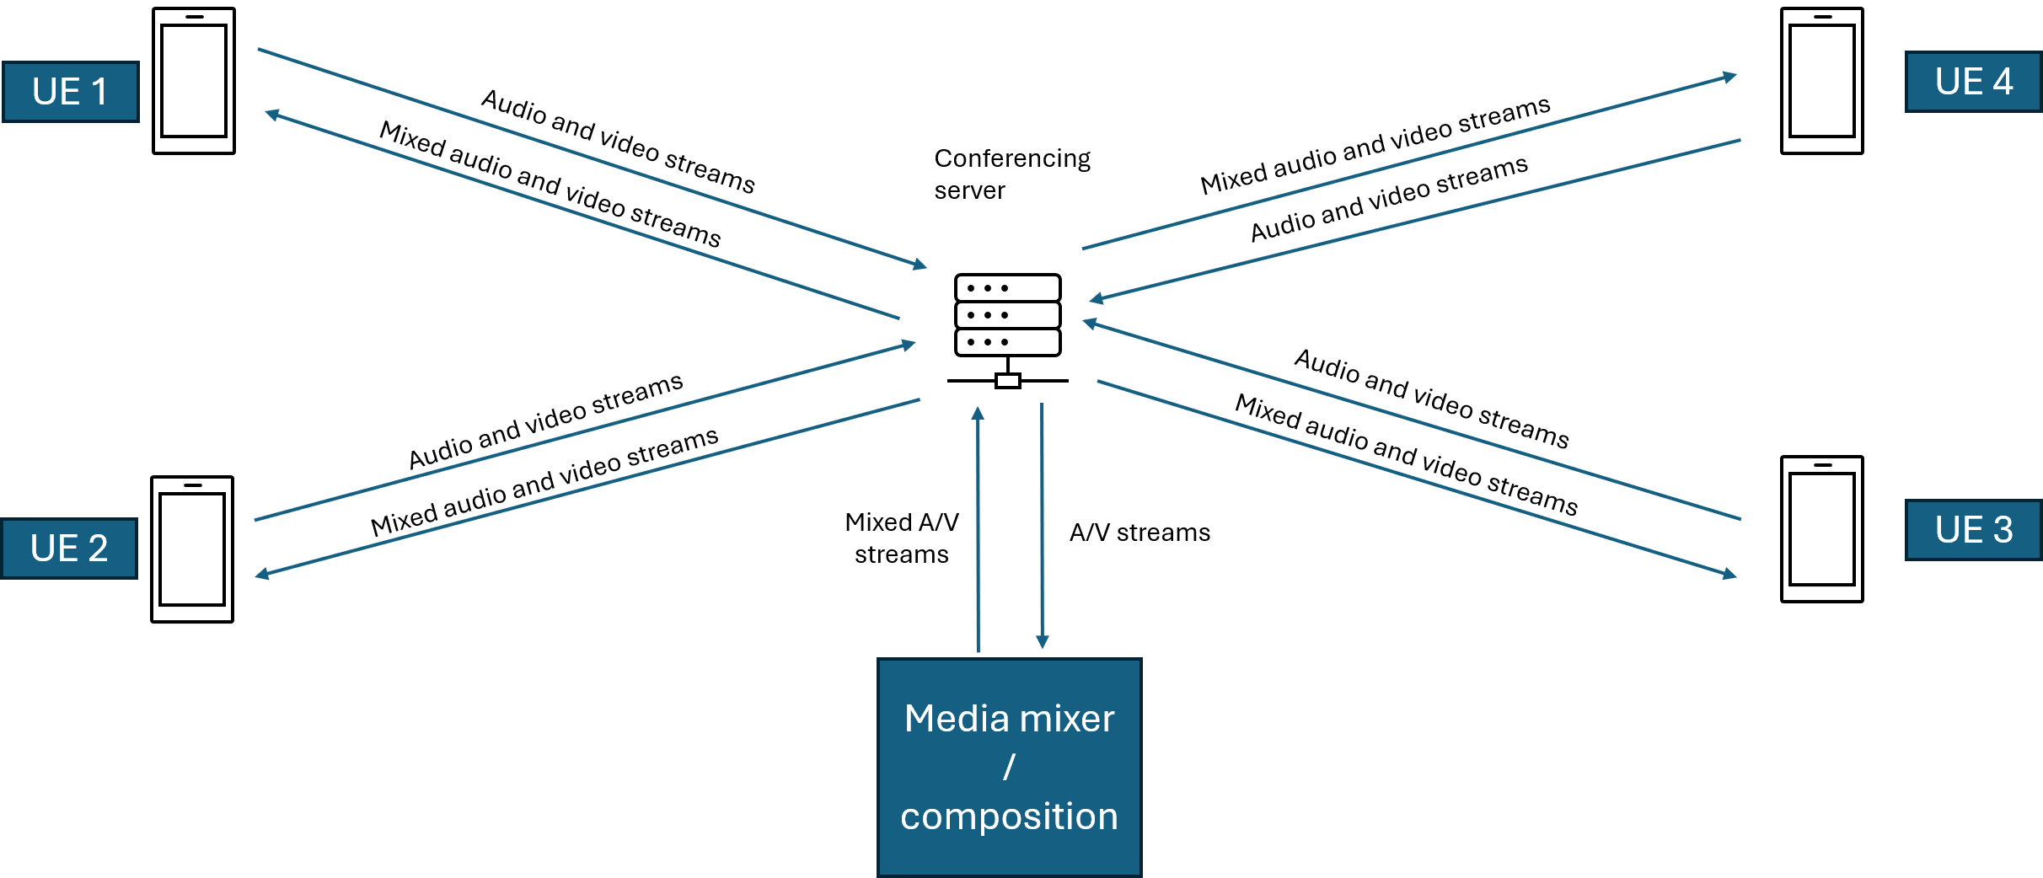
Figure 5.2.X.2-1: Centralized composition architecture

5.2.X.3 Multi-stream scenario: multiple streams are transmitted separately to other UEs
In this scenario, participants (UE 1, UE 2, UE 3 and UE4) have established an RTC session. To enable communication between them, each UE subscribes to the audio and video streams published by the remote participants. The subscription and publish mechanisms are managed by a central conferencing server. The conferencing server is in charge to handle the subscription messages. Thus, one UE can subscribe to one or more streams at the same time, and this may change over the time. UE1 can subscribe to audio and video streams of all other UEs, and UE2 can subscribe to the video stream of UE1 and audio streams of UE1, UE3 and UE4 only. After some time, UE2 may decides to stream UE4 video, it then subscribes to UE4 video stream.
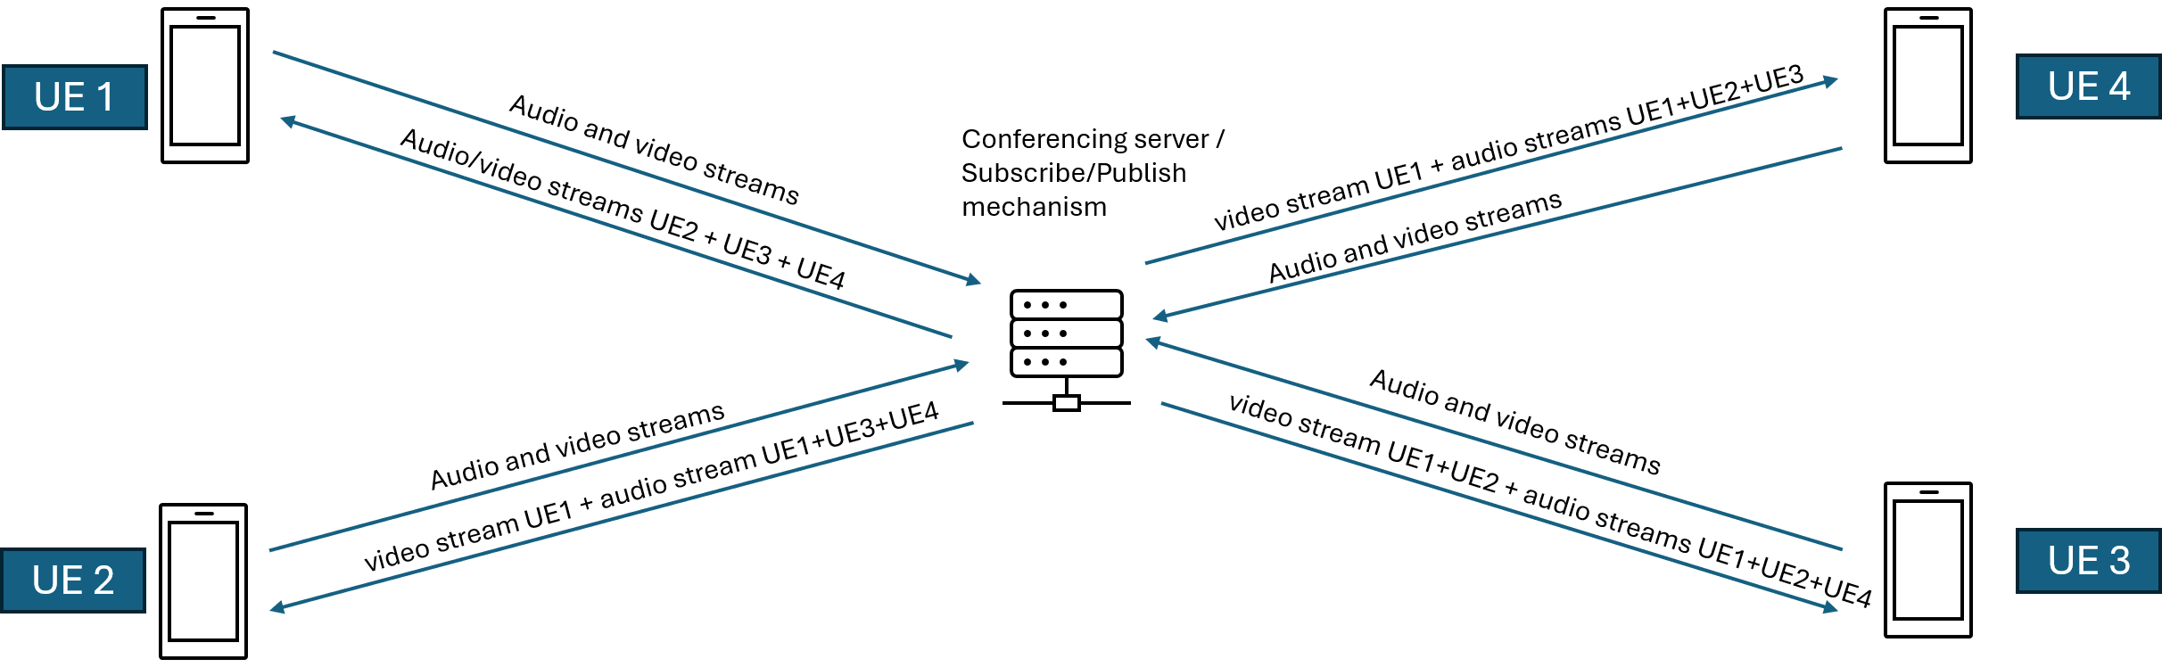
Figure 5.2.X.2-1: Multi-stream composition on UE
5.2.X.4 Use Cases
These two RTC application scenarios can be mapped to use cases described in TR 22.870 [22870]. The holographic telepresence in healthcare use case (clause 9.8 of TR 22.870) fits better to the multi-stream application scenario as it comprises separate streams for audio, hologram (avatar) and haptics, and it requires a tight inter-stream synchronization. On the other hand, the multi-site immersive communication use case (clause 9.6 of TR 22.870) fits better to the single output scenario with a centralized mixing. Indeed, this use case comprises multi camera capture with a central rendering of a global scene. Composed data is distributed to on-site audiences and remote viewers.
- Immersive gaming (clause 9.2 of TR 22.870): This use case has a strong real-time communication component combining conversational media, interactive XR, haptics, and synchronized shared state, not just high-resolution streaming.
- Seamless immersive reality in education (clause 9.5 of TR 22.870): This use case is a real-time immersive telepresence and collaboration scenario, requiring conversational latency, tight media synchronization, and interactive shared-state communication.
- Collaborative service in multi-site involved immersive communication (clause 9.6 of TR 22.870): This use case is a real-time, multi-site immersive communication and collaborative media production scenario with stringent latency, synchronization, and uplink performance requirements.
- Multiple application media synchronisation (clause 9.7 of TR 22.870): This use case represents ultra tight real-time, multi modal communication requiring cross flow and cross device media synchronisation with millisecond level bounds. This is ultra reliable, ultra-low latency, interactive real-time communication with multi modal synchronization, far beyond best effort media delivery.
- Holographic telepresence in healthcare (clause 9.8 of TR 22.870): This use case represents mission critical real-time holographic communication with stringent latency, synchronization, reliability, and security requirements, especially suited to healthcare scenarios. This is mission-critical, conversational, immersive real-time communication with ultra-low latency and high reliability.
- Mixed reality gaming (clause 9.9 of TR 22.870): This use case represents interactive real-time mixed reality communication requiring low latency, bidirectional data exchange, and consistent shared state across users. This is an interactive real-time XR communication use case, combining conversational and interactive traffic, though not mission critical.
- Personalised interactive immersive guided tour (clause 9.12 of TR 22.870): This use case represents interactive, multi user real-time immersive communication with personalised content, heterogeneous devices, and tight multi modal synchronisation requirements. This is an interactive, conversational, multi-modal real-time immersive communication use case, with strong synchronization requirements but less strict than tele-surgery or tele-operation.

5.2.X.2 Application of QUIC
The conference application scenario and the immersive use cases identified in TR 22.870 [22870] are characterized by requirements including low latency, bidirectional communication, high reliability, multi-modal traffic support, and strong security. These requirements align well with the QUIC-based transport protocol, which provides encrypted-by-default communication, stream multiplexing without head-of-line blocking, and robustness to packet loss and network variability using in-built standardized congestion control and loss recovery mechanisms, making it suitable for interactive and immersive communication application scenarios.
Editor’s NOTE: The benefits of using QUIC based protocols for this application scenario is FFS.

5.2.X.3 Media stream and control signalling characteristics
Editor’s NOTE: The characteristics of the media streams and control signalling for this application scenario is FFS.

* * * End of Changes* * * *

