3GPP TSG-SA WG4 Meeting #135 S4-260259r01

Goa, India, 09 – 13 February, 2026

Source: InterDigital Pennsylvania
Title: [FS_Q4RTC_MED] Application scenario: Peer to Application (P2A) with split rendering
Spec: 3GPP TR 26.836 v0.0.1
Agenda item: 10.7
Document for: Discussion and Agreement

1. Introduction
The Study on QUIC-based media delivery for real-time communication (RTC) and services focuses on identifying relevant application scenarios for which the evaluation of QUIC-based media delivery protocols is carried out, in particular including existing 3GPP services or service enablers such as split rendering.
This contribution focuses on P2A application scenario with split rendering service described in TS 26.506, and TS 26.565 for real-time communication services.
2. Reason for Change
This contribution document provides the description of Peer to Application use case scenario with split rendering in real-time communication services.
3. Proposal
It is proposed to agree the following changes to current version of 3GPP TR 26.836.
* * * First Change * * *

2 References
The following documents contain provisions which, through reference in this text, constitute provisions of the present document.
- References are either specific (identified by date of publication, edition number, version number, etc.) or non specific.
- For a specific reference, subsequent revisions do not apply.
- For a non-specific reference, the latest version applies. In the case of a reference to a 3GPP document (including a GSM document), a non-specific reference implicitly refers to the latest version of that document in the same Release as the present document.
[1] 3GPP TR 21.905: "Vocabulary for 3GPP Specifications".
[2] 3GPP TS 26.522: "5G Real-time Media Transport Protocol Configurations".
[3] 3GPP TS 23.501: "System architecture for the 5G System (5GS)".
[22870] 3GPP TR 22.870: "Study on 6G Use Cases and Service Requirements".
* * * Second Change * * * all new

5.2 Application scenarios

5.2.X Scenario#2: Real-time interactive applications with split rendering

5.2.X.1 Description
Split rendering is a real-time service for an interactive application jointly executed by a peer device (e.g., user equipment, XR/MR device) and a remote application instance (e.g., running on an application server located at the edge or in the cloud).
The peer device performs user interaction capture, local sensing, and final presentation functions. This includes acquisition of user inputs and contextual information such as motion, pose, audio, video, spatial/environmental data, and other sensor information. The peer device transmits this information in real-time to the application server.
The application server updates the XR or gaming scene by processing the received inputs, executing application logic, performing physics simulations and AI-based processing. Once updated, the application server renders the XR or gaming scene and transmits the rendered frame as 2D video and additional media (such as audio and haptics) to the peer device for the display.
A bidirectional communication path between the peer and the Application Server is maintained throughout the session. End-to-end latency, jitter, and reliability are critical to ensure responsiveness and to meet human perception and interaction requirements. Secure connections and encryption are required to guarantee privacy of sensitive data transmitted to the application server.
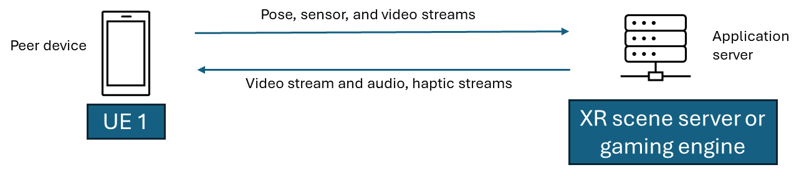
Figure 5.2.X.1-1: peer device to application server bidirectional communication
In single-user scenario, illustrated in Figure 5.2.X.1-1, the Application Server receives pose and sensor updates as well as video stream captured from the device’s camera, updates the XR or gaming scene in real-time and sends 2D video and additional media data back to the peer device. In multi-user scenario, a shared application state (e.g. virtual scene, digital objects, or avatars) is maintained at the Application Server and consistently synchronized between the Application Server and each peer in real time, thanks to bidirectional communication between peer and Application Server.
Due to constraints related to device form factors, energy consumption, and rendering capabilities, the peer device relies on dynamic offloading of compute-intensive functions and rendering functions to the Application Server. The network is expected to support this interactive service by providing differentiated connectivity, supporting secure, low-latency and high-reliability communication for multi-modal streams, and enabling coordination between communication, computing and rendering resources.
This use case supports multi-modal interactions and outputs, including audio, video, 2D/3D graphics, and haptic feedback, and is applicable to a range of real-time interactive services such as those described in TR 22.870 [22870], including:
- Immersive gaming (clause 9.2 of TR 22.870 [22870]): This use case involves real-time immersive gaming and XR applications where users interact with high-fidelity virtual environments, avatars, or holograms using multi-modal inputs such as audio, video, motion, and spatial data. Compute-intensive rendering and AI-based processing are performed remotely, requiring secured, low-latency, bidirectional media delivery to ensure privacy, responsive and consistent user experience.
- XR rendering offload support (clause 9.4 of TR 22.870 [22870]): This use case considers lightweight XR devices that offload rendering and application processing to an edge or cloud application server due to limited local compute capabilities. Real-time exchange of user inputs and rendered media streams is required, with tight latency and network-assisted optimization to maintain application performance.
- Mixed reality gaming (clause 9.9 of TR 22.870 [22870]): This use case addresses a multiplayer mixed reality gaming scenario where multiple users share a synchronized virtual scene based on a common spatial map of the environment. Users continuously upload environmental data to a cloud server, which generates and distributes consistent real-time scene updates to all participants under varying mobility and network conditions.

5.2.X.2 Application of QUIC
Editor’s NOTE: The benefits of using QUIC based protocols for this application scenario is FFS.

5.2.X.3 Media stream and control signalling characteristics
Editor’s NOTE: The characteristics of the media streams and control signalling for this application scenario is FFS.

* * * End of Changes* * * *

