3GPP TSG-SA WG4 Meeting #135 S4-260246

Goa, India, 09 – 13 February, 2026

Source: InterDigital Pennsylvania
Title: [FS_Q4RTC_MED] Media over QUIC media delivery protocol for real-time communication
Spec: 3GPP TR 26.836 v0.0.1
Agenda item: 10.7
Document for: Discussion and Agreement

1. Introduction
The Study on QUIC-based media delivery for real-time communication and services focuses on identifying various existing and emerging QUIC-based media delivery protocols suitable for real-time communication services, and documenting the features, benefits and limitations of those protocols for various applications and identified use-case scenarios.
This contribution focuses on the Media over QUIC (MoQ) transport protocol for real-time communication services.
2. Reason for Change
This contribution documents the description of Media over QUIC transport protocol, its features, benefits, and limitations with respect to real-time communication services.
3. Proposal
It is proposed to agree the following changes to the current version of 3GPP TR 26.836.
* * * First Change * * *

2 References
The following documents contain provisions which, through reference in this text, constitute provisions of the present document.
- References are either specific (identified by date of publication, edition number, version number, etc.) or non-specific.
- For a specific reference, subsequent revisions do not apply.
- For a non-specific reference, the latest version applies. In the case of a reference to a 3GPP document (including a GSM document), a non-specific reference implicitly refers to the latest version of that document in the same Release as the present document.
[1] 3GPP TR 21.905: "Vocabulary for 3GPP Specifications".
[2] 3GPP TS 26.522: "5G Real-time Media Transport Protocol Configurations".
[3] 3GPP TS 23.501: "System architecture for the 5G System (5GS)".
…
[draft-ietf-moq-transport] S. Nandakumar, V. Vasiliev, I. Swett, A. Frindell; draft-ietf-moq-transport-16, "Media over QUIC Transport", Work in Progress, Internet-Draft, 13 January 2026.
https://datatracker.ietf.org/doc/draft-ietf-moq-transport/
[draft-ietf-moq-msf] W. Law, draft-ietf-moq-msf-00, "MOQT Streaming Format", Work in Progress, Internet-Draft, 19 January 2026.
[draft-ietf-moq-loc] M. Zanaty, S. Nandakumar and P. Thatcher, draft-ietf-moq-loc-01, "Low Overhead Media Container", Work in Progress, Internet-Draft, 8 January 2026.
[RFC8446] IETF RFC 8446: "The Transport Layer Security (TLS) Protocol Version 1.3", August 2018.
* * * Second Change * * * (all new)

4.2.X Media over QUIC

4.2.X.1 Introduction
Media over QUIC (MoQ) refers to a family of protocols under development in IETF that addresses the transport of real-time media (including audio, video, and synchronized data) over QUIC transport protocol. The IETF specification [draft-ietf-moq-transport] defines Media over QUIC Transport (MOQT) protocol and builds upon the following technologies:
- QUIC or WebTransport as the underlying transport protocol.
- Publish/subscribe interaction pattern.
- Optional relay-based distribution mechanisms.
MOQT is being developed to support low-latency media delivery and scalable real-time communication scenarios.
In addition to the transport protocol, streaming formats may be defined on top of MOQT to specify mappings between media data and transport objects. One such format is the MOQT Streaming Format (MSF), previously referred to as WARP, as specified in [draft-ietf-moq-msf]. Other formats may be defined to address specific media or non-media delivery requirements.
Figure 4.2.X.1-1 illustrates the MOQT protocol stack.
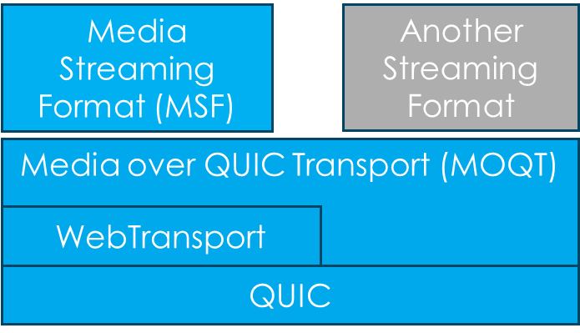
Figure 42.X.1-1: MOQT protocol stack.

4.2.X.2 Features
MOQ Transport (MOQT) protocol relies on the following core features:
- QUIC underlying protocol: MOQT protocol is designed to operate interchangeably over native QUIC or WebTransport over QUIC. It leverages QUIC streams for reliable, ordered delivery (avoiding head-of-line blocking) and datagrams for cases where data loss is acceptable.
- Publish/Subscribe interaction pattern: MOQT utilizes a model where producers publish media data and consumers (clients or relays) subscribe to specific content "Tracks".
Additional streaming formats are defined on top of MOQT for media delivery, they define specific mappings of media to the transport:
- MOQT Streaming Format (MSF) [draft-ietf-moq-msf]: a segment-based format targeting interoperable and low latency streaming.
- LOC (Low Overhead Media Container) [draft-ietf-moq-loc]: a container format aligned with WebCodecs for minimal overhead.
The MOQT Streaming Format relies on the following features:
- Hierarchical data model: Media content is organized into Tracks (a sequence of groups), Groups (temporal sequences acting as independent join points), and Objects (the basic addressable units). Objects can be further organized into Subgroups to manage decoding dependencies on a single stream.
- Catalogs: Producers describe their content using a Catalog, a specialized track containing metadata about available tracks, codecs, and initialization data. Specific formats like the Common Catalog Format allow subscribers to discover and select content.
- Prioritization and fetching: MOQT allows fine-grained control over object transmission, including subscriber and publisher priorities to manage resource contention such as reliable bidirectional/unidirectional streams and unreliable datagrams modes, object prioritization, cancellation of obsolete objects (e.g. late video frames).
- Scalability with MoQ Relays: Relays are integral to the protocol, enabling functionality similar to Content Delivery Networks (CDNs). They cache, deduplicate, and route content based on track names while keeping the actual media payload opaque and potentially encrypted.

4.2.X.3 Benefits
Based on the protocol design, the following potential benefits of MOQT for real-time communication services are identified:
1. Low latency and congestion control: MOQT aims to deliver media content with minimal latency by leveraging QUIC's ability to rapidly detect and respond to network congestion, avoiding the delays common in TCP-based protocols. MOQT benefits from the following QUIC features that make it suitable for low-latency and real-time communication: reduced connection establishment latency (0-RTT / 1-RTT), no head-of-line blocking across independent streams, discarding of outdated media objects.
2. Scalability: The architecture allows for massive scaling through MOQ Relays which aggregate multiple subscriptions for the same content into a single upstream request, reducing the load on the original publisher.
3. Convergence of media ingest and distribution: MOQT supports the use of a single transport protocol for both media contribution and media distribution, which may reduce the need for protocol conversion or media repackaging at intermediate nodes.
4. Web compatibility: The option to use MOQT over WebTransport enables it to run natively in web browsers without requiring custom plug-ins. This facilitates future browser support and convergence between real-time media communication and web-based service platforms.
5. Delivery flexibility: Applications can choose between reliable stream-based delivery or unreliable datagram-based delivery within the same session, depending on the nature of the content and latency requirements.
6. QoS configuration: Applications can benefit from different QoS configurations such as QUIC stream priorities applied, for example to an I-Frame versus a B-frame.
7. Built-in security: QUIC provides mandatory encryption based on TLS version 1.3 [RFC8446], no support for unsecured modes, simplified security model compared to RTP/SRTP-based solutions.

4.2.X.4 Limitations
1. Out-of-Band discovery: Initial discovery of servers and specific Track Namespaces is typically handled outside the protocol (out-of-band), although mechanisms exist to discover tracks once a session is established.
2. Congestion control complexity: Latency performance of MOQT depends on the congestion control algorithm used. Certain congestion control behaviours may introduce latency under specific network conditions, requiring careful selection or tuning for real-time services.

4.2.X.5 Current applications
- MOQtail implementation in Rust and TypeScript, https://github.com/moqtail/moqtail, provides libraries for publisher, subscriber and relay components, featuring media applications demos using the LOC and CMSF formats.
- moq-encoder-player: https://github.com/facebookexperimental/moq-encoder-player
- CloudFare MoQ service, https://blog.cloudflare.com/moq/, is a Cloudfare’s implementation of MoQ protocol for real-time and scalable media communication. Cloudflare has deployed a MoQ Relay Network (MRN) on its infrastructure and provides media streaming on a scale using MoQ.
* * * End of Changes * * *

