3GPP TSG-SA4 #135 Meeting S4-260112R1
Goa, India, 9-13 Feb, 2026 rev of S4aR260006

Source: Nokia
Title: [AI_IMS-MED] AI/ML media processing and task updating
Agenda item: 10.5
Document for: Discussion and Agreement

1. Introduction
In this contribution we propose to provide task updating call flows based on the work done by SA4 in TR 26.927 and IMS DC procedures in TS 23.228 Annex AC, and taking into account the high level call flow agreed in SA4#134 (S4-252075), as well as to add the detailed task control messages.
Updates in S4aR260006: this revision considers the discussion and comments received on SA4 RTC SWG telco (17th December 2025):
- Clarified the scenarios of task re-select and task update.
- Added impacts on remote UE.
- Addressed aspects in the reply LS from SA2 on AIML for Media (S4aR250214).
Updates in S4-260112: this revision considers the common call flows in S4aR260014 agreed SA4 RTC SWG telco (28th Jan 2026):
- Updated step 1-15 accordingly.

2. Discussion
TR 26.927, clause 5.5 defines a mapping of the AI/ML architecture to IMS using DC applications. According to the mapping, the supported media processing may be discovered as part of the DC application discovery process over the bootstrap data channel. The process and descriptions from TR 26.927 as shown below:
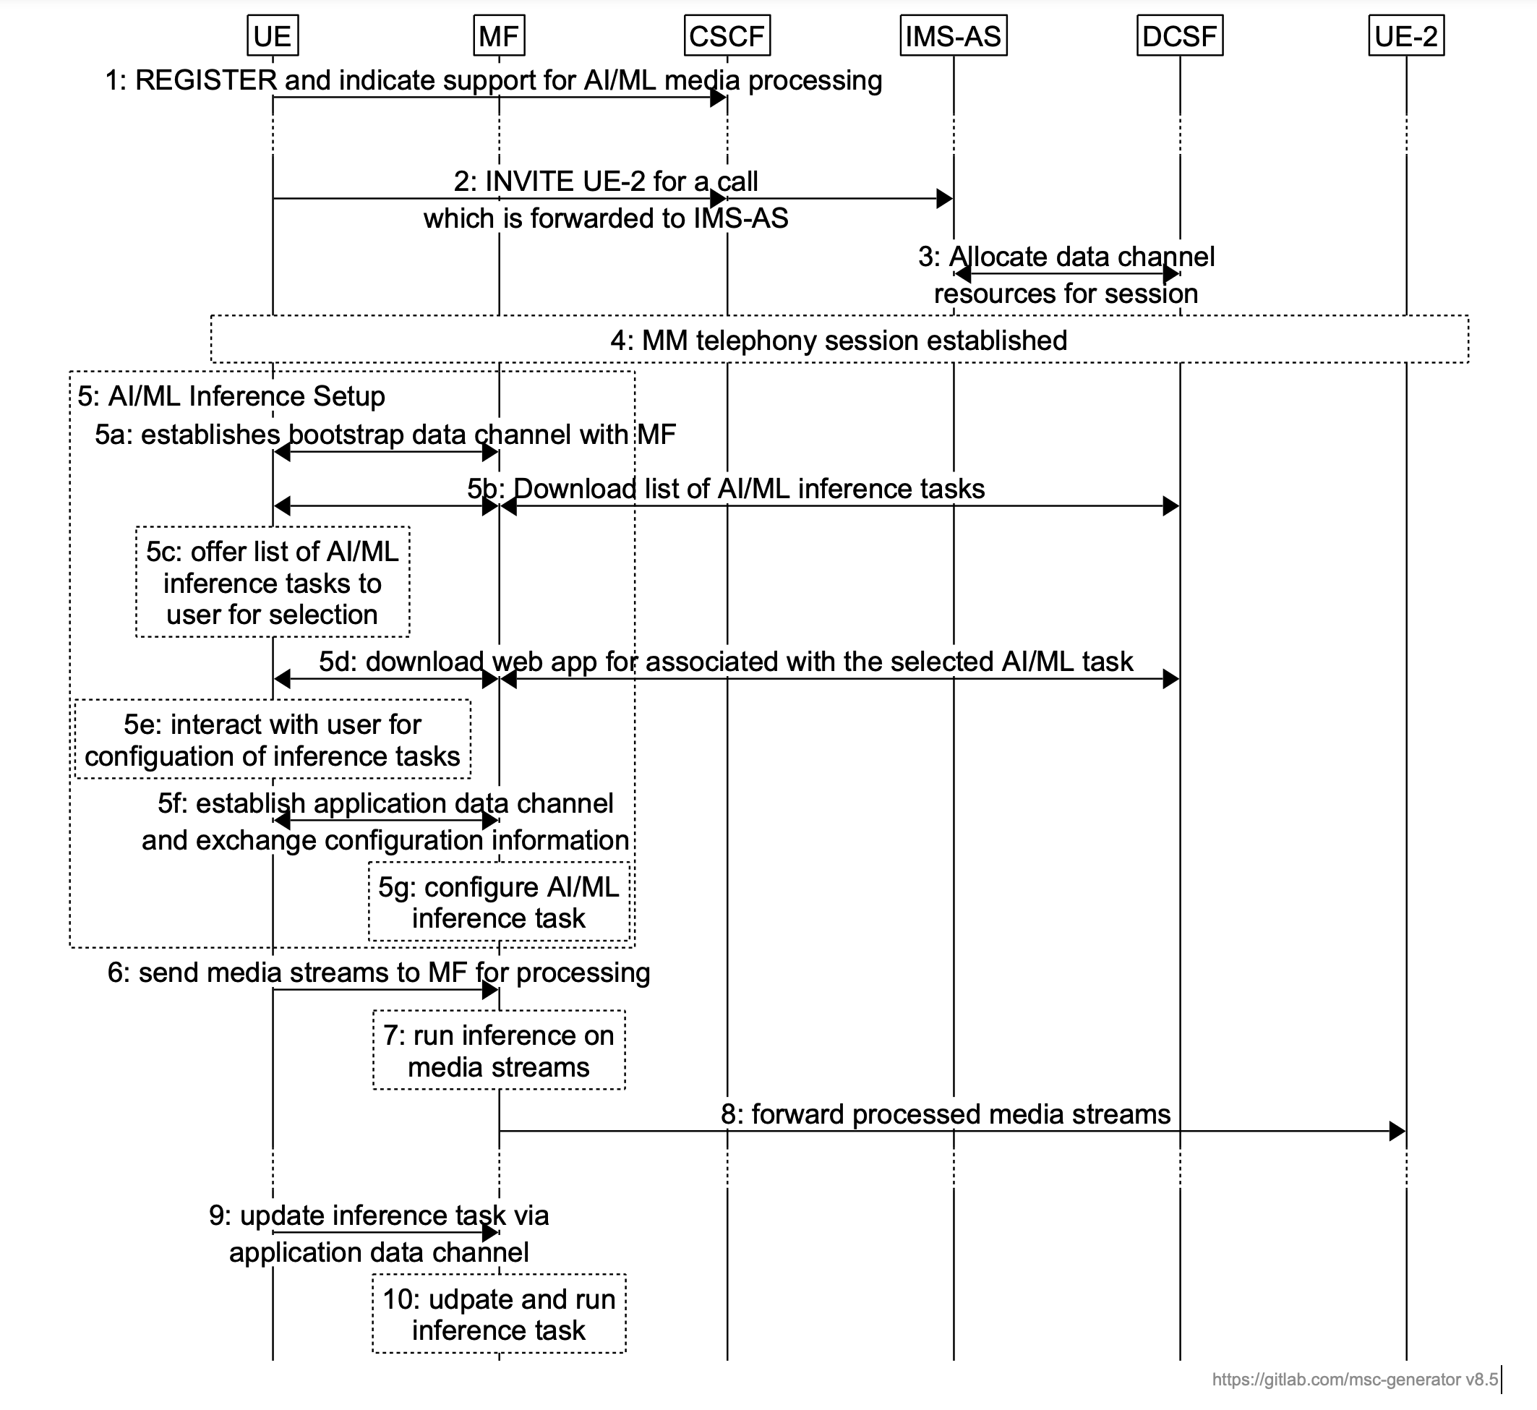
Figure 1: Process to trigger AI/ML media processing using IMS DC (from TR 26.927)
Regarding the text in TR 26.927, one major concern is that split media processing might be in the UE or network (instead of MF). Furthermore, DC AS is not introduced after ADC establishment. Also, the numbering of above steps causes confusion, e.g. 5a, 5b etc. looks like parallel options.
Also in step 9, it is indicated that “the user may update or change the AI/ML inference task. The updates are sent to the MF/MRF via the application data channel”, without further details. Furthermore, in step 10, it is indicated that “the MF/MRF updates the AI/ML inference task accordingly and continues the inference”.
We identified that there’re several open issues here to be resolved before adopting it in the normative work. Firstly, the procedures between UE1 and IMS functional entities (e.g. MF) are unclear. Also, as clarified in SA2 specs that MRF does not a play role for Data Channel, it was removed from 23.228 a while ago. The MRF from text should be removed.
In S4-252075, it was agreed to work based on the common call flows, shown as below:
- An MMTel service is established
- BDC is established between UE and MF
- DCSF creates a DC application list based on 1) subscription list filter (how?) 2) UE static capabilities (What level of support? How?)
  - Application list also contains information related to the AI service provided by the AI application e.g. an intelligent translation service
  - Example UE static capabilities: AI capable/WebNN?
  - There are 1) app requirements 2) UE capabilities. DCSF may use these somehow to create/annotate the app list
- UE downloads the app list
- User selects an app based on the AI service
- MF fetches the AI application
- App is downloaded via BDC
  - We should define specific task related information (e.g. what the task is, model variants/split for the task) [we need to define tasks/sub-tasks]
  - UE gets the task related information, checks its capability then presents the selected options/variants to the user
  - Example of task: speech recognition and translates it into the required language using AI
NOTE: Tasks may be reselected/updated
- User selects the AI tasks and the UE selects the model variants /configuration
- ADC is established
Local inferencing
- AI model is downloaded either from 1) DCAR (BDC) or 2) DC AS (ADC)
- Inferencing happens in UE

Remote inferencing
- App negotiation (including inference configuration, MF configuration)
- MF may fetch the required model from 1) DCAR (BDC) or 2) DC AS (ADC)
- Inferencing happens in MF

Split inferencing
- App negotiation (including inference configuration, MF configuration)
- UE and MF may fetch the required sub-models from 1) DCAR (BDC) or 2) DC AS (ADC)
- Split inferencing happens

Thus, we propose to provide the call flows for AI task updating based on the clause 5.5 in TR 26.927 as well as the call flows in S4-252075, to keep the alignment with TS 23.228, as shown in first change.
Additionally, we propose to add the task control messages as well as examples, as shown in second change. Further details on message formats will be provided in the future.

3. Proposal
We propose to add the following changes to the main CR, or base CR to TS 26.264.

* * * First change * * *

A.X AIML Call Flows

A.X.X AI/ML Task Updating

Figure A.X.2-1 Call flows to trigger and update AI/ML media processing using IMS DC
Steps are as follows:
Step 1-13 are same with the common call flows.

14. Media session runs over MMTEL session after initiation procedures.
- UE1 may execute the selected task and/or transmit the input media streams to network (e.g. DC AS) for which inference is to be applied. The network may run inference on the media streams and forward to the remote UE (UE2). In some applications, the processed media streams can be sent to UE1 or to both UE1 and UE2.
NOTE: step 15 can further include different alternatives depending on the locations for running inference tasks.
For the situation e.g. due to new actions in applications or other triggers, the UE1 may reselect AI task(s) during the session using the AI task metadata received in above steps, specifically, go to step 10.
- UE1 reselects one or more of the tasks listed in the app manifest. Then go to step 10 and following steps.
For the situations e.g. when UE has new requirements to be addressed during a running IMS session which are not fulfilled by the downloaded tasks, for example, a new callee (e.g. UE3 speaks a new language) joined the call and for UE1 and UE2, a new language needs to be processed (e.g. language translation), step 17 to step 22 are provided for updating the task:
- UE1 updates a previously selected task by sending a task UPDATE Task request over ADC, i.e., request the network to run the task with updated task parameters.
NOTE: The UPDATE Task request may include, Task ID, New parameters, start time (when to start to apply the new parameters), and optionally other parameters. Tasks parameters may be updated based on certain criteria.
- DC AS checks the request and reconfigures the task with the new parameters. DC AS may reject the request if it is not valid.
- According to the new parameters received in step 18, new or updated models can be obtained from DCAR via DCSF, or. alternatively, from DC AS.
After step 19, there are two alternatives depending on the different locations for running inference tasks:
Alt a: Local inference:
20.a. DC AS sends the response of the UPDATE Task request (e.g. including new or updated models) to UE1 via MF.
21.a. UE1 runs the updated inference task locally.
Alt b: Network inference:
20.b. DC AS sends the response of the UPDATE Task request to UE1 via MF.
21.b. UE1 transmits the media streams to the network (e.g. DC AS) for which inference is to be applied.
22.b. Network runs inference on the media streams.
23. Furthermore, remote UE (UE2) might be informed when the task updates would impact. Network may also forward processed media streams to UE2.

* * * Second change * * *

8.X.X Task Control Messages
The following messages are defined on the Application Data channel to be exchanged between the UE and the MF to manage AI/ML Tasks.

8.X.X.1 START Task
The START task message is sent as a request from one endpoint to the other. Typically, a UE sends this request to the MF to start an inference task. It can be used for both split inference and remote inference tasks.
The sender may include in the Start_Task message an identifier of a media stream that carries the input stream for the task or the output stream after inference and postprocessing. An (S)RTP media stream shall be identified with “mid” identifier (defined in RFC 8843) as included in the SDP offer/answer for establishing the said media streams. If more than one RTP media streams are used, a list of mid values separated by commas is included. An example of START Task message is shown below.
List 8.X.X.1-1: An example of START Task Message
“id”: “0”
“type”: “urn:3gpp:aiml:start-task”
“task_id”: “speech-to-speech-translation”
“parameters”: {
“inputLanguage”: “languageA”,
“outputLanguage”: “languageB”
}
“input”: {
“protocol”: “RTP”,
“mid”: <mid as shared in the SDP for establishing the stream>
}
“output”: {
“protocol”: “RTP”,
“mid”: <mid as shared in the SDP for establishing the stream>
}
“timestamp”: 1767300896

In response to a START Task, a Response is sent to indicate if the request was accepted or not. The Response includes task_session_id which is a unique identifier in the context of the session for the specific task and the associated input, output and parameters. An example is shown below.
List 8.X.X.1-2: An example of START Task Response Message
“id”: “0”
“type”: “urn:3gpp:aiml:start-task-response”
“task_id”: “speech-to-speech-translation”
“task_session_id”: 007
“response_code”: “OK”
“parameters”: {
“inputLanguage”: “languageA”,
“outputLanguage”: “languageB”
}

8.X.X.2 UPDATE Task
The UPDATE Task message is sent by DCMTSI Client in terminal as a new ADC message for a task that has already been started using the START Task message. The UPDATE Task message can only be sent if a 200 OK has been received in response to a START Task.
The UPDATE Task message may be used to update the model, parameters or input and output of an existing task. The task_session_id shall be set to the same value as indicated in START Task Response to identify the task. It can also be sent to indicate a new input or output stream, e.g., if a new UE is added to a call the UPDATE Task may indicate it. An example of UPDATE Task message is shown below.:
List 8.X.X.2-1: An example of UPDATE Task Message
“id”: “0”
“type”: “urn:3gpp:aiml:update-task”
“task_id”: “speech-to-speech-translation”
“task_session_id”: 007
“parameters”: {
“inputLanguage”: “languageA”,
“outputLanguage”: “languageC”
}
“output”: {
“protocol”: “RTP”,
“mid”: <mid as shared in the SDP for establishing the stream>
}
“timestamp”: 1767300896

In response to a UPDATE Task, a Response is sent to indicate if the request was accepted or not. An example is shown below.
List 8.X.X.2-2: An example of UPDATE Task Response Message
“id”: “0”
“type”: “urn:3gpp:aiml:update-task-response”
“task_id”: “speech-to-speech-translation”
“task_session_id”: 007
“response_code”: “OK”
}

* * * End of Changes * * * *

