3GPP TSG-WG SA4 Meeting #135 S4-260100
Goa, IN, 9th Feb – 13th Feb, 2026

Source: Huawei, HiSilicon
Title: Network, QoS and UE Considerations for client side inferencing AIML/IMS
Document for: Discussion and Agreement
Agenda Item: 10.5
Work Item / Release: AI_IMS-MED
Abstract: we raise the issue of network requirements for UE based AI inferencing and possible ways forward to address this concern.

Introduction
In S4aR260004a call flow for client/UE side inferencing was discussed.
In this paper we raise network related issues that need to be addressed to make such a call flow feasible in practical mobile networks.
The main problems are in steps 12 to 16 and are detailed in clause 2.
Figure 1-1 draft call flow for UE inferencing from S4aR260004a

Network related issues

Model Size.
TR 26.927 states that models are about 40 MB in Table 6.6.2-1.
Consulting current publicly available models shows that for current use cases much bigger in the range of 100 GB plus.
See the example Hunyuan Image generation model set in figure 2-1 which is 169 GB available on hugging face.
Simple language models for translation of 1 language we have observed to be about 100 MB (e.g. google translate).
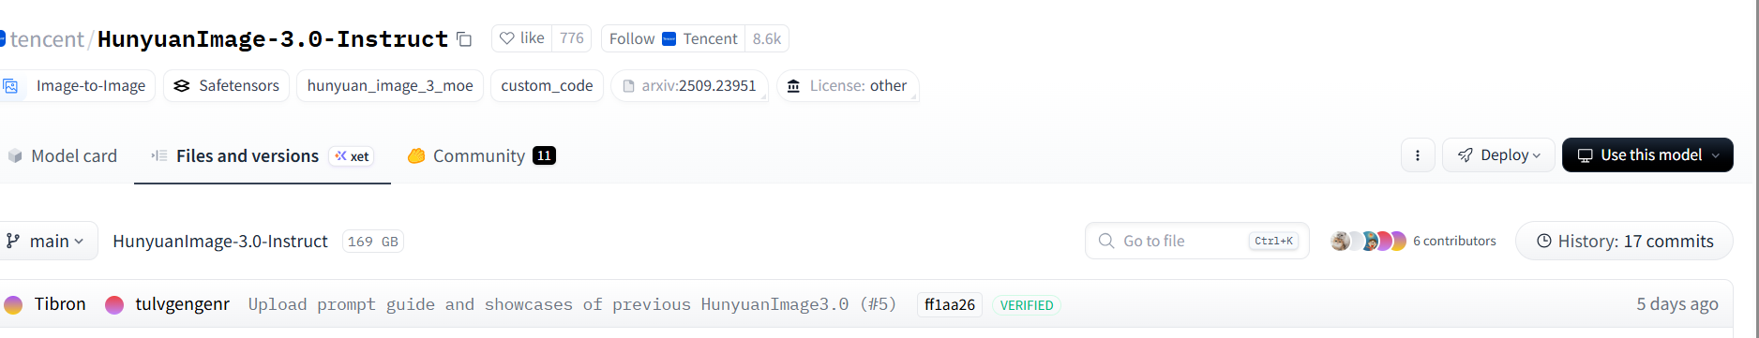
Figure 2-1 Example model for image reconstruction from hugging face

Network QoS support
For a real-time request response times, or responses in a reasonable time, current mobile network cannot support such bit-rates (e.g. 500 ms or even under 1000 ms). For a response in 1000 ms for a 100 GB we would be talking about 800 Gbps which is not a realistic bit-rate achievable in current mobile networks.
Details on the supported model sizes and required response times should be defined.
Once a supported model size and transfer time requirement, the appropriate QoS profile (5QI) should be identified, otherwise SA2 should be asked to update their 5QI specifications to support this use case.

Lacking Compression and UE support
TR 26.927 details NN compression, this may compression reports 2-20 percent of original size, this would still not result in feasible bit-rates that can be supported in mobile network. Also, no capabilities for UE support of NN codec have been defined so making use of such capability cannot be assumed.
Therefore it should be clarified if NNC is required for client side inferencing or not and the related requirements should be documented.

Protocol Support Issue
S4aR260004a mentions HTTP for download, but HTTP combined with TCP is less than ideal for large quick data download due to TCP slow start and congestion control introducing additional latency and tail latency (increasing overall latency due to head of line blocking). 3GPP burst QoS can be used using RTP protocol, otherwise even QUIC could be considered which also has bindings to the 5G XRM framework for improved QoS support for bursty data transfer.
Limitations should be clarified in the technical specication and ideal.

Caching Issue and Bandwidth Wastage issue
To make things even worse the diagram indicates that the model is downloaded every-time without explicitly caching or updating the model. This would lead to huge bandwidth wastage and possibly impossible network bit-rates in current mobile networks.
The call flow should include model updates and caching and not every time request a new model from the network.

3. Suggested Way Forward
Our intention is not to exclude UE inferencing as was agreed for this work item, but the limitations and requirements should be clear and these concerns should be addressed before agreeing to a CR detailing such a call flow.
Understanding that the intention is to use this in current 5G networks these network related requirements should be addressed.
Therefore we propose the following actions:
- Add a note that this can only work for smaller models (up to approximately 100 MB, bigger of larger response latency is tolerated). Larger models may benefit from distributed inferencing.
- Add a note that use cases and end-end latency requirements and derive required bit-rate/latency and loss profiles are FFS
.
.
- Clarify the required support of neural network codec if any for the UE and the related requirements
- Consider adding caching and model updates in the call flow to avoid downloading a model for each task, or making it implicit by making the model download step optional.

