3GPP TR 26.940 V0.6.1 (2026-02)
Technical Report

3rd Generation Partnership Project;
Technical Specification Group Services and System Aspects;
Study on Ultra Low Bit rate Speech Codecs
(Release 20)
The present document has been developed within the 3rd Generation Partnership Project (3GPP TM) and may be further elaborated for the purposes of 3GPP.
The present document has not been subject to any approval process by the 3GPP Organizational Partners and shall not be implemented.
This Specification is provided for future development work within 3GPP only. The Organizational Partners accept no liability for any use of this Specification.
Specifications and Reports for implementation of the 3GPP TM system should be obtained via the 3GPP Organizational Partners' Publications Offices.

3GPP
Postal address

3GPP support office address
650 Route des Lucioles - Sophia Antipolis
Valbonne - FRANCE
Tel.: +33 4 92 94 42 00 Fax: +33 4 93 65 47 16
Internet
https://www.3gpp.org

Copyright Notification
No part may be reproduced except as authorized by written permission.
The copyright and the foregoing restriction extend to reproduction in all media.

© 2025, 3GPP Organizational Partners (ARIB, ATIS, CCSA, ETSI, TSDSI, TTA, TTC).
All rights reserved.

UMTS™ is a Trade Mark of ETSI registered for the benefit of its members
3GPP™ is a Trade Mark of ETSI registered for the benefit of its Members and of the 3GPP Organizational Partners
LTE™ is a Trade Mark of ETSI registered for the benefit of its Members and of the 3GPP Organizational Partners
GSM® and the GSM logo are registered and owned by the GSM Association

Contents

Foreword 6
Introduction 7
1 Scope 8
2 References 9
3 Definitions of terms, symbols and abbreviations 12
3.1 Terms 12
3.2 Symbols 12
3.3 Abbreviations 12
4 Application scenarios for ultra-low bit rate communication services 12
4.1 Introduction 13
4.2 Scenario 1: IMS Voice Call over GEO 13
4.2.0 General 13
4.2.1 Background 13
4.2.2 Scenario Description 13
4.2.2.1 General 13
4.2.2.2 [Main] Scenario: One UE connects via GEO-satellite access only 13
4.2.2.3 [Sub-] Scenario: Both UEs connect via GEO-satellite access 14
4.2.3 Derived high-level prerequisites 14
4.2.3.1 General 14
4.3 Scenario 2: Multi-Party Voice Communication 15
4.3.0 General 15
4.3.1 Background 15
4.3.2 Scenario Description 15
4.3.2.1 General 15
4.3.3 Derived high-level prerequisites from SA4 15
4.3.3.1 General 15
4.4 Scenario 3: IMS Voice Call with ULBC over other access types than GEO 15
4.4.0 General 15
4.4.1 Scenario Description 16
4.4.1.1 General 16
4.4.1.2 Scenario 3: Both UEs support ULBC and connect via a 3GPP access other than GEO satellite access 16
4.4.2 Derived high-level prerequisites 16
4.4.2.1 General 16
4.5 Scenario 4: Vehicle Emergency Call Communication 16
4.5.0 General 16
4.5.1 Background 16
4.5.2 Scenario Description 17
4.5.2.1 General 17
4.5.3 Derived high-level prerequisites from SA4 17
4.5.3.1 General 17
5 Channel characteristics and service-related dependencies 17
5.1 Estimation of mouth to ear delay for GEO scenarios 18
5.1.1 Overview 18
5.1.2 Delay components 18
5.1.2.1 Overview 18
5.1.2.2 UE Delay considering IMS codecs 18
5.1.2.3 Core network delay 19
5.1.2.4 Propagation delay UE – GEO - Ground station 20
5.1.2.5 ULBC Delay components 20
5.1.3 Estimation of Mouth-to-ear delay 20
5.2 NB-IoT NTN system in 3GPP and design parameters 21
5.2.1 System architecture 21
5.2.2 RAN parameters 22
5.2.3 QoS characteristics 23
5.2.4 UE radio capabilities 23
5.2.5 Multi-user consideration 24
6 Design constraints 25
6.1 General 25
6.2 Design Constraint Parameter 26
6.2.1 Considerations on DC: Complexity and Memory 26
6.2.1.1 Current Evaluation Analysis 26
6.2.1.2 Memory and Power Considerations 26
6.2.1.3 Codec Deliverables and Performance Metrics 27
6.2.1.4 Complexity metric for AI based codecs 27
6.2.1.5 Complexity target estimation for AI based codecs 27
6.2.1.5.1 Target devices for ULBC 28
6.2.1.5.2 Computational complexity and power consumption limits for ULBC 28
6.2.1.6 Observations and conclusions 28
6.3 Design Constraint Verification 29
6.4 Additional Design Considerations 29
6.4.1 Codec Parameters and Configuration 29
7 Existing technologies and feasibility evidence 29
[7.1 Existing codec technologies for GEO scenarios 29
7.1.1 Overview 29
7.1.2 Observations regarding codec parameter 32
7.1.3 Complexity Considerations 32
7.1.4 Performance Evaluation 33
7.1.5 PLC with existing technology 35
7.1.5.1 PLC experiment with DAC 35
7.1.5.1.1 Introduction 35
7.1.5.1.2 Introducing loss in quantized blocks 35
7.1.5.1.3 Consecutive 4 blocks drop and repeat 35
7.1.5.1.4 Interleaved drop and repeat 35
7.1.5.1.5 Results 36
7.1.5.1.6 Observations 37
7.1.5.2 PLC experiment with DAC and DAC-IBM 37
7.1.5.2.2 Packet loss simulation 38
7.1.5.2.3 Results 38
7.1.6 Conclusion on existing technology 39
[7.2 Very low bitrate listening test results 39
7.2.1 Overview 39
7.2.2 Listening test results 40
7.2.3 Extended ACR5 listening test results 41
7.2.4 DCR listening test results 42
[7.3 Test results on clean speech and music/mixed content 43
7.3.1 Overview 43
7.3.2 DCR test results on clean speech 43
7.3.3 ACR test results on clean speech 44
7.3.4 DCR test results on music and mixed content 44
7.4 Impact of noise suppression on AI based codecs 45
7.4.1 Existing systems using noise suppression 45
7.4.1.1 General 45
7.4.1.2 Classical speech coding 45
7.4.1.3 Neural speech coding 45
7.4.2 Impact of noise suppression on AI based coded speech 46
7.4.2.1 General 46
7.4.2.2 Test design and mixing procedure 46
7.4.2.3 Conditions under test 46
7.4.2.4 High SNR test results 46
7.4.2.5 Low SNR test results 48
7.4.3 Conclusions 50
7.5 Analysis of an existing AI codec: Lyra V2 50
7.5.1 Code-Level analysis 50
7.5.2 Conclusion 51
7.6 Complexity Analysis of an existing AI Codec: DAC 51
7.6.1 Methodology for Complexity Analysis 51
7.6.2 Theoretical Complexity Analysis 51
7.6.3 Real-World Inference Performance Analysis 52
7.6.4 Key Findings 52
8 Performance requirements 55
8.1 General 55
8.1.1 A List of Reference Codecs and Operating Points 56
9 Test methodologies 56
9.1 General 56
9.1.1 Typical quality impairments of ultra-low bit rate speech coding 56
9.1.2 Challenges of quality assessment of ultra-low bit rate speech codecs 56
9.1.3 Subjective Testing Considerations 57
9.1.3.1 Robustness related to source material 57
9.1.3.2 Simulation of Real-world Acoustic Conditions 57
9.1.3.3 Tandeming and Compatibility Testing 57
9.1.3.4 Conclusion 58
9.1.4 Objective Testing Considerations 58
9.1.4.1 Correlation analysis results 58
9.1.4.2 Discussion 59
9.1.4.3 Conclusion 59
9.1.5 ULBC Codec Testing Considerations in Noise 59
9.1.5.1 Background 59
9.1.5.2 Recommendations for ULBC Codec Testing 60
10 Considered work plan for potential normative work 60
11 Conclusions and recommendations 60
Annex A (informative): Change history 61

For definitive guidance on drafting 3GPP TSs and TRs, see 3GPP TS 21.801.
Ensure all blue guidance text is removed before submitting the TS/TR to the TSG for approval.

Foreword
This clause is mandatory; do not alter the text in any way other than to choose between "Specification" and "Report".
This Technical Report has been produced by the 3rd Generation Partnership Project (3GPP).
The contents of the present document are subject to continuing work within the TSG and may change following formal TSG approval. Should the TSG modify the contents of the present document, it will be re-released by the TSG with an identifying change of release date and an increase in version number as follows:
Version x.y.z
where:
x the first digit:
1 presented to TSG for information;
2 presented to TSG for approval;
3 or greater indicates TSG approved document under change control.
y the second digit is incremented for all changes of substance, i.e. technical enhancements, corrections, updates, etc.
z the third digit is incremented when editorial only changes have been incorporated in the document.
In drafting the TS/TR, pay particular attention to the use of modal auxiliary verbs! TRs shall not contain any normative provisions.
In the present document, modal verbs have the following meanings:
shall indicates a mandatory requirement to do something
shall not indicates an interdiction (prohibition) to do something
The constructions "shall" and "shall not" are confined to the context of normative provisions, and do not appear in Technical Reports.
The constructions "must" and "must not" are not used as substitutes for "shall" and "shall not". Their use is avoided insofar as possible, and they are not used in a normative context except in a direct citation from an external, referenced, non-3GPP document, or so as to maintain continuity of style when extending or modifying the provisions of such a referenced document.
should indicates a recommendation to do something
should not indicates a recommendation not to do something
may indicates permission to do something
need not indicates permission not to do something
The construction "may not" is ambiguous and is not used in normative elements. The unambiguous constructions "might not" or "shall not" are used instead, depending upon the meaning intended.
can indicates that something is possible
cannot indicates that something is impossible
The constructions "can" and "cannot" are not substitutes for "may" and "need not".
will indicates that something is certain or expected to happen as a result of action taken by an agency the behaviour of which is outside the scope of the present document
will not indicates that something is certain or expected not to happen as a result of action taken by an agency the behaviour of which is outside the scope of the present document
might indicates a likelihood that something will happen as a result of action taken by some agency the behaviour of which is outside the scope of the present document
might not indicates a likelihood that something will not happen as a result of action taken by some agency the behaviour of which is outside the scope of the present document
In addition:
is (or any other verb in the indicative mood) indicates a statement of fact
is not (or any other negative verb in the indicative mood) indicates a statement of fact
The constructions "is" and "is not" do not indicate requirements.

Introduction
This clause is optional. If it exists, it shall be the second unnumbered clause.

1 Scope
This clause shall start on a new page.
[The present document develops recommendations for potential normative work on an ultra-low bit rate codec for the use case of IMS voice services over Geostationary Orbit (GEO) access.]

Editor’s Note:
3GPP SA1 has studied the use case IMS Voice Call Using GEO Access, and the results are documented in TR 22.887. Normative service requirements and KPIs on IMS voice call using GEO satellite access will be introduced in TS 22.261 at TSG#107. GEO satellites are on a 35,786 km distance from the earth, which noticeably impacts signal propagation delay (one way approx. 285ms), data rate, and channel conditions due to e.g. atmospheric attenuation. Compared to terrestrial links, this poses significant new challenges for the voice codecs and services:
The overall transmission data rate assumed for GEO satellite systems is very constrained due to e.g. high path loss, atmospheric attenuation, energy constraints for terminals etc.. In TR 22.887, a total transmission data rate of [1-3] kbit/s is assumed. This transmission data rate are lower than what current 3GPP protocol stacks and codecs can supports.
For GEO satellite access, the propagation delay (285ms) is much longer than for commonly used terrestrial links.
The GEO satellite link imposes different channel characteristics, e.g., due to atmospheric attenuation.
Currently, no 3GPP voice codec seems to support all the expected requirements for this use case. Considering bitrate alone, the lowest supported bitrate of any 3GPP codec is 4.75 kbit/s as provided by the narrow band AMR codec (TS 26.071). This makes it necessary to have a new feasibility study relating to ultra-low bitrate codecs suitable for voice using GEO access.
The primary focus of this study is to develop design constraints and performance requirements for a codec supporting use cases like IMS Voice Call over GEO and the resulting transmission parameters. The requirements can provide guidance on the evaluation of the candidate codecs during potential normative work.
1. General considerations
- Bitrate: TR 22.887 concludes that the transmission rates are lower than what current 3GPP protocol stacks and codecs can supports. Detailed analysis on available bitrate requires more study..
- Quality: Despite of the low bit rate, a good audio quality of the codec is of importance, to ensure a reasonable QoE. Detailed QoE requirements for such services are for study..
- Complexity and memory demands: Modern low bitrate codecs exhibit a large scale of complexity and memory demands. The codec is expected to be deployable on the processing capabilities as can be found in today’s smartphones. Exact complexity requirements are for study.
- Robustness to network conditions: the codec is expected to operate in typical network conditions (delay, loss, jitter, etc.). Details are for further study.
2. Functional requirements
- Speech transcoding functions: To achieve integration with the terrestrial voice communication system (4G/5G IMS architecture), it is necessary to consider tandeming with existing IMS voice codecs.
NOTE: Additional study areas or use cases, such as assessing the market potential and potential market-readiness of a new ULBC codec should be added with lower priority if time permits and once the exact requirements can be given.
It is expected that coordination with other working groups, e.g. SA2, CT1, RAN2 is needed in order to substantiate the design constraints of such a codec. However, it is not expected that this work creates any dependency for studies and normative in other working groups.

2 References
The following documents contain provisions which, through reference in this text, constitute provisions of the present document.
- References are either specific (identified by date of publication, edition number, version number, etc.) or non-specific.
- For a specific reference, subsequent revisions do not apply.
- For a non-specific reference, the latest version applies. In the case of a reference to a 3GPP document (including a GSM document), a non-specific reference implicitly refers to the latest version of that document in the same Release as the present document.
[1] 3GPP TR 21.905: "Vocabulary for 3GPP Specifications".
[22261] 3GPP TS 22.261: "Service requirements for the 5G system".
[22887] 3GPP TR 22.887: "Feasibility Study on satellite access - Phase 4".
[26071] 3GPP TS 26.071: "Mandatory speech CODEC speech processing functions; AMR speech Codec; General description".
[36300] TS 36.300, “Evolved Universal Terrestrial Radio Access (E-UTRA) and Evolved Universal Terrestrial Radio Access Network (E-UTRAN); Overall description”
[36211] TS 36.211, “Evolved Universal Terrestrial Radio Access (E-UTRA); Physical channels and modulation”
[36212] TS 36.212, “Evolved Universal Terrestrial Radio Access (E-UTRA); Multiplexing and channel coding”
[36213] TS 36.213, “Evolved Universal Terrestrial Radio Access (E-UTRA); Physical layer procedures”
[23203] 3GPP TS 23.203, “Policy and charging control architecture.”
[AS-1] VoIP Bandwidth: https://www.vonage.com/resources/articles/voip-bandwidth/,
[AS-2] How Zoom Audio and Video Codecs Affect Bandwidth Usage: https://library.zoom.com/admin-corner/network-management/quality-of-service-and-network-best-practices-explainer/how-zoom-audio-and-video-codecs-affect-bandwidth-usag
[AS-3] Zoom Video and Audio Performance Report 2024: https://www.zoom.com/en/resources/video-audio-quality-report/?lang=zh-CN
[D-1] 3GPP TS 26.131, „Terminal acoustic characteristics for telephony; Requirements“
[D-2] 3GPP TS 22.261, “Service requirements for the 5G system”
[D-3] 3GPP TS.36.763, “Study on Narrow-Band Internet of Things (NB-IoT) / enhanced Machine Type Communication (eMTC) support for Non-Terrestrial Networks (NTN)”
[CM-1] Kyuho J. Lee, Chapter Seven - Architecture of neural processing unit for deep neural networks, Editor(s): Shiho Kim, Ganesh Chandra Deka, Advances in Computers, Elsevier, Volume 122, 2021, Pages 217-245, ISSN 0065-2458, ISBN 9780128231234, https://doi.org/10.1016/bs.adcom.2020.11.001.
[CM-2] Tensor Processing Units (TPUs). Google Cloud. https://cloud.google.com/tpu.
[CM-3] Dipert, B. A guide to AI TOPS and NPU Performance Metrics. Edge AI and Vision Alliance. https://www.edge-ai-vision.com/2024/06/a-guide-to-ai-tops-and-npu-performance-metrics/#:~:text=Today%2C%20one%20of%20the%20leading%20ways%20of%20measuring,processor%2C%20such%20as%20the%20Neural%20Processing%20Unit%20%28NPU%29.
[CM-4] A guide to AI TOPS and NPU performance metrics. Qualcomm. https://www.qualcomm.com/news/onq/2024/04/a-guide-to-ai-tops-and-npu-performance-metrics.
[CM-5] J. -W. Jang et al., "Sparsity-Aware and Re-configurable NPU Architecture for Samsung Flagship Mobile SoC," 2021 ACM/IEEE 48th Annual International Symposium on Computer Architecture (ISCA), Valencia, Spain, 2021, pp. 15-28, doi: 10.1109/ISCA52012.2021.00011
[CM-6] Van Belle, Jean Louis. (2024). Why neural processing units (NPUs) are the next Big Thing in AI. 10.13140/RG.2.2.35619.87845.
[CM-7] JPEG AI: https://ds.jpeg.org/documents/jpegai/wg1n101029-105-COM-JPEG_AI_Overview_Slides.zip
[CM-8] Client challenge. https://pypi.org/project/ptflops/.
[CM-9] ITU-T Software Tool Library 2024 User’s Manual
[CM-10] Exynos 2500 | Mobile Processor | Samsung Semiconductor Global. Samsung Semiconductor Global. https://semiconductor.samsung.com/processor/mobile-processor/exynos-2500/.
[CM-11] Huawei Da Vinci PowerPoint Presentation, https://www.cmc.ca/wp-content/uploads/2020/03/Zhan-Xu-Huawei.pdf
[CM-12] C. -H. Lin et al., "7.1 A 3.4-to-13.3TOPS/W 3.6TOPS Dual-Core Deep-Learning Accelerator for Versatile AI Applications in 7nm 5G Smartphone SoC," 2020 IEEE International Solid-State Circuits Conference - (ISSCC), San Francisco, CA, USA, 2020, pp. 134-136, doi: 10.1109/ISSCC19947.2020.9063111.
[CM-13] J. Song,, “An 11.5TOPS/W 1024-MAC Butterfly Structure Dual-Core Sparsity-Aware Neural Processing Unit in 8nm Flagship Mobile SoC,” ISSCC, pp. 130–131, Feb. 2019.
[CM-14] Rithesh Kumar, Prem Seetharaman, Alejandro Luebs, Ishaan Kumar, and Kundan Kumar. 2023. High-fidelity audio compression with improved RVQGAN. In Proceedings of the 37th International Conference on Neural Information Processing Systems (NIPS '23). Curran Associates Inc., Red Hook, NY, USA, Article 1214, 27980–27993.
[CM-15] V. Sze, Y. -H. Chen, T. -J. Yang and J. S. Emer, "How to Evaluate Deep Neural Network Processors: TOPS/W (Alone) Considered Harmful," in IEEE Solid-State Circuits Magazine, vol. 12, no. 3, pp. 28-41, Summer 2020, doi: 10.1109/MSSC.2020.3002140.
[7-1] T. Muller et al., “Speech quality evaluation of neural audio codecs”, Proc. Interspeech 2024, https://www.isca-archive.org/interspeech_2024/muller24c_interspeech.pdfers[7-2] Tdoc S4-250565, “Analysis of existing technologies for ULBC”
[7-3] Drowe. GitHub - drowe67/codec2: Open source speech codec designed for communications quality speech between 700 and 3200 bit/s. The main application is low bandwidth HF/VHF digital radio. GitHub. https://github.com/drowe67/codec2.
[7-4] FFMPeG. https://ffmpeg.org/.
[7-5] MELP.org. About MELP and MELPE - MELP Vocoder. MELP Vocoder. https://melp.org/.
[7-6] Wikipedia contributors. Harmonic Vector Excitation Coding. Wikipedia. https://en.wikipedia.org/wiki/Harmonic_Vector_Excitation_Coding.
[7-7] Descriptinc. GitHub - descriptinc/descript-audio-codec: State-of-the-art audio codec with 90x compression factor. Supports 44.1kHz, 24kHz, and 16kHz mono/stereo audio. GitHub. https://github.com/descriptinc/descript-audio-codec.
[7-8] TSAC: Very Low Bitrate Audio Compression. https://bellard.org/tsac/.
[7-9] Tdoc S4-251332,“[FS_ULBC] Updates on end-to-end simulation for error trace generation”
[7-10] Tdoc S4aA250232, “On assumptions for link budget analysis”
[7-11] T. Muller et al., “Evaluation of Objective Quality Models on Neural Audio Codecs,” Proc. IWAENC, 2024
[7-12] T. Muller et al., “Comparative Quality Study of Neural Audio Codecs - focus on music and mixed content,” Proc. GRETSI, 2025 (in French)
[7-13] Martin, R., Malah, D., Cox, R.V. et al. A Noise Reduction Preprocessor for Mobile Voice Communication. EURASIP J. Adv. Signal Process. 2004, 147306 (2004). https://doi.org/10.1155/S1110865704312138
[7-14] D. Virette, P. Scalart and C. Lamblin, "Analysis of background noise reduction techniques for robust speech coding," 2002 11th European Signal Processing Conference, Toulouse, France, 2002, pp. 1-4
[7-15] 3GPP2 C.S00I4-0 "Enhanced Variable Rate Codec (EVRC) Service Option for Wideband Spread Spectrum Communication Systems", 3GPP2 Technical Specification, Dec. 1999.
[7-16] M. Jelinek and R. Salami, "Noise reduction method for wideband speech coding," 2004 12th European Signal Processing Conference, Vienna, Austria, 2004, pp. 1959-1962.
[7-17] Tseng, W.-C., Harwath, D. (2025) Probing the Robustness Properties of Neural Speech Codecs. Proc. Interspeech 2025, 5013-5017, doi: 10.21437/Interspeech.2025-355
[7-18] Recommendation ITU-T P.808 (06/2021) “Subjective evaluation of speech quality with a crowdsourcing approach”, International Telecommunication Union
[7-19] Recommendation ITU-T P.501 (04/2025) “Test signals for use in telephony and other speech-based applications”, International Telecommunication Union
[7-20] Recommendation ITU-T G.191 (05/2024) “Software tools for speech and audio coding standardization”, International Telecommunication Union
[7-21] Yuguochencuc. GitHub - yuguochencuc/DeepFilterNet2: Noise supression using deep filtering. GitHub. https://github.com/yuguochencuc/DeepFilterNet2.
[7-22] Hubertsiuzdak. GitHub - hubertsiuzdak/snac: Multi-Scale Neural Audio Codec (SNAC) compresses audio into discrete codes at a low bitrate. GitHub. https://github.com/hubertsiuzdak/snac.
[7-23] kyutai/mimi, Hugging Face. https://huggingface.co/kyutai/mimi.
[7-24] ibm-research/DAC.speech.v1.0,Hugging Face. https://huggingface.co/ibm-research/DAC.speech.v1.0.
[7-25] google. Release Lyra 1.3.2, google/lyra. GitHub. https://github.com/google/lyra/releases/tag/v1.3.2.
[7-26] Google. Lyra: A generative low bitrate speech codec [Internet]. GitHub; [cited 2025 Aug 15]. Available from: https://github.com/google/lyra/blob/main/README.md#building-for-android
[7-27] Apache License, Version 2.0 [Internet]. Apache Software Foundation; 2004 Jan [cited 2025 Aug 15]. Available from: https://github.com/google/lyra?tab=Apache-2.0-1-ov-file
[7-28] Google, lyra_gan_model.cc, Lyra repository, commit 47698da, viewed 15 August 2025, https://github.com/google/lyra/blob/47698dadf0010abff6a848e02642f55f806d4842/lyra/lyra_gan_model.cc#L36
[7-29] Google, soundstream_encoder.cc, Lyra repository, commit 47698da, viewed 15 August 2025, https://github.com/google/lyra/blob/47698dadf0010abff6a848e02642f55f806d4842/lyra/soundstream_encoder.cc#L36
[7-30] Google AI for Developers. LiteRT overview [Internet]. Google AI Edge; [updated 2025 May 19; cited 2025 Aug 15]. Available from: https://ai.google.dev/edge/litert
[7-31] Google. XNNPACK: High-efficiency floating-point neural network inference operators for mobile, server, and Web [Internet]. GitHub; [cited 2025 Aug 15]. Available from: https://github.com/google/XNNPACK
[7-32] ONNX Runtime. "NNAPI Execution Provider." ONNX Runtime Documentation. [Online]. Available: https://onnxruntime.ai/docs/execution-providers/NNAPI-ExecutionProvider.html
[7-33] Qualcomm, "QNN," in AI Engine Direct SDK, Jul. 07, 2025. [Online]. Available: https://docs.qualcomm.com/bundle/publicresource/topics/80-63442-50/introduction.html
[7-34] "Apple's Neural Engine (ANE)" Apple Wiki, Fandom. [Online]. Available: https://apple.fandom.com/wiki/Neural_Engine
[7-35] Google Cloud. Introduction to Cloud TPU [Internet]. Google Cloud Documentation; [updated 2025 Aug 11; cited 2025 Aug 15]. Available from: https://cloud.google.com/tpu/docs/intro-to-tpu
[7-36] V. Sovrasov, "flops-counter.pytorch." GitHub, 2019. [Online]. Available: https://github.com/sovrasov/flops-counter.pytorch.
[7-37] E. Alshina, J. Ascenso and T. Ebrahimi, "JPEG AI: The First International Standard for Image Coding Based on an End-to-End Learning-Based Approach," in IEEE MultiMedia, vol. 31, no. 4, pp. 60-69, Oct.-Dec. 2024, doi: 10.1109/MMUL.2024.3485255.
[7-38] V. Sovrasov, "flops-counter.pytorch." GitHub, 2019. [Online]. Available: https://github.com/sovrasov/flops-counter.pytorch.
[7-39] Lyken, "pytorch-OpCounter." GitHub, 2018. [Online]. Available: https://github.com/Lyken17/pytorch-OpCounter.
[7-40] Descript, Inc., "Descript Audio Codec (DAC) Pretrained Model," Version 0.0.1, Feb. 2023. [Online]. Available: https://github.com/descriptinc/descript-audio-codec/releases/tag/0.0.1

3 Definitions of terms, symbols and abbreviations
This clause and its three (sub) clauses are mandatory. The contents shall be shown as "void" if the TS/TR does not define any terms, symbols, or abbreviations.

3.1 Terms
For the purposes of the present document, the terms given in TR 21.905 [1] and the following apply. A term defined in the present document takes precedence over the definition of the same term, if any, in TR 21.905 [1].
Definition format (Normal)
<defined term>: <definition>.
example: text used to clarify abstract rules by applying them literally.

3.2 Symbols
For the purposes of the present document, the following symbols apply:
Symbol format (EW)
<symbol> <Explanation>

3.3 Abbreviations
For the purposes of the present document, the abbreviations given in TR 21.905 [1] and the following apply. An abbreviation defined in the present document takes precedence over the definition of the same abbreviation, if any, in TR 21.905 [1].
GEO Geostationary Orbit

4 Application scenarios for ultra-low bit rate communication services
Editor’s Note:
From the WID:
- Document the application scenarios for ultra-low bit rate communication services taking into account the use cases and potential requirements documented in TR 22.887 related to IMS Voice Call Using GEO Access.
- Additional study areas or use cases, such as assessing the market potential and potential market-readiness of a new ULBC codec should be added with lower priority if time permits and once the exact requirements can be given.
Input on further application scenarios is invited.

4.1 Introduction
This clause introduces application scenarios that may be relevant for an Ultra-Low Bitrate speech Codec (ULBC). For each scenario, high-level prerequisites on the ULBC codec or the service operation are derived.

4.2 Scenario 1: IMS Voice Call over GEO

4.2.0 General
This is the primary application scenario in the context of voice communication via Geostationary Earth Orbit (GEO) satellites.

4.2.1 Background
Satellite communication plays an important role in extending terrestrial network coverage, ensuring seamless connectivity for users This technology unlocks new opportunities across various sectors, including smartphones and IoT.
Conversational two-party communication is foreseen as the most common and essential use case for IMS voice over GEO satellite access. This use case is documented in clause 5.1 of TR 22.887 [22887]. Due to the limitations of low transmission data rates (in the range of [1-3] kbps) as estimated in Table 7.4.2-1 in TS 22.261 [22261], an ultra-low bit rate codec is required. Users may rely on this service when they are beyond terrestrial network coverage but within satellite range, ensuring essential connectivity.
NOTE: The bit rate range of [1-3] kbps is a working assumption according to TS 22.261 and might be adjusted after coordination with RAN groups.

4.2.2 Scenario Description

4.2.2.1 General
The typical UE is a handheld device supporting GEO satellite access with built-in microphones and loudspeakers or a monaural hands-free set, as outlined in Table 7.4.2-1 in TS 22.261 [22261]. This means there is no need for the user to extend the antenna or carry any extra devices to access the IMS voice call service.
The typical IMS voice service includes both regular call and emergency call as outlined in clause 6.46.11 in TS 22.261 [22261]. Such service can be provided as:
- Supplementary regular IMS voice service provided by the terrestrial operators, especially in areas without terrestrial coverage.
- Main regular IMS voice service provided by the satellite operators.
- An IMS voice call service using GEO satellite access in case of emergency situations.
Besides handheld devices, other types of UEs that support IMS Voice Call over GEO satellite access — such as vehicles — are also considered.
Editor’s note: The working assumption is that vehicles don’t impact the simulation tasks, TBC.
In the following, different scenarios establishing an end-to-end voice service are considered.

4.2.2.2 [Main] Scenario: One UE connects via GEO-satellite access only
In a common scenario, one party in the conversation is assumed to be using a handheld mobile terminal over a GEO satellite network, while the other may be on a terrestrial mobile network (e.g., VoLTE, VoNR), a fixed-line connection, or another IMS-supported platform, as outlined in Figure 4.2.2.2-1, where a sketch of the bi-directional voice data flow for this main scenario is depicted.
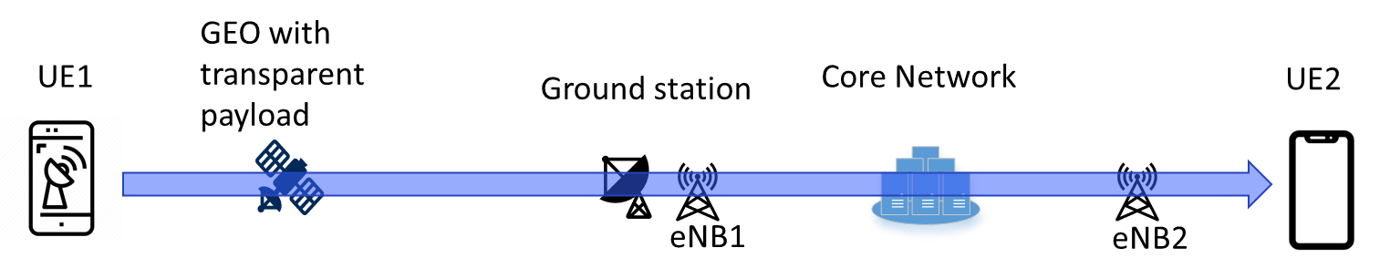
Figure 4.2.2.2-1: Bi-directional voice data flow for main scenario
NOTE: Core network typically stands for 3GPP core network and IMS core network.
In this scenario, UE1 is a phone supporting IMS voice call service over GEO satellite access. One may distinguish two cases depending on UE2:
- UE2 is a "regular" phone supporting IMS voice call service but not supporting ULBC nor GEO satellite access. In this case, UE2 may not be aware that UE1 is using a GEO satellite link during the communication and transcoding is performed in the core network.
- UE2 is an "upgraded" phone supporting IMS voice call service with ULBC, but using another access than satellite access (e.g., LTE, NR or WLAN). In this case UE2 may be able to communicate with UE1 using ULBC in a transcoder-free operation.

4.2.2.3 [Sub-] Scenario: Both UEs connect via GEO-satellite access
In a less common scenario, both parties in the conversation are connected to a GEO satellite as outlined in Figure 4.2.2.3-1 using IMS-based communication services. This scenario may be less frequent than the [main] scenario but become relevant to support multiple contexts including disaster or cyberattack with potentially no terrestrial PLMN available which will be leading to the UEs communicating through NTN.

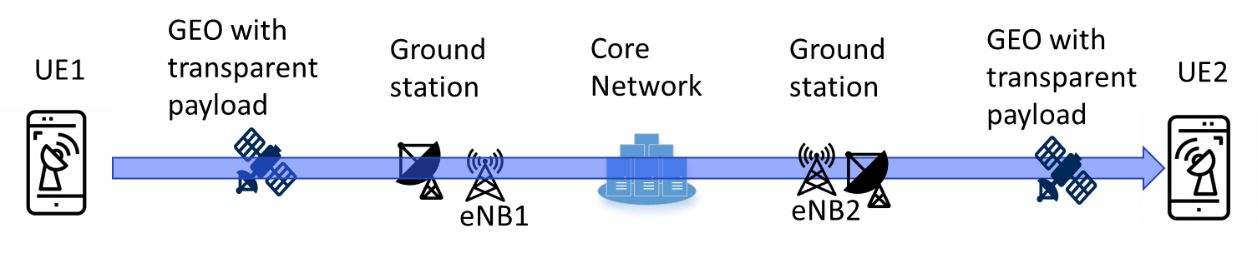
Figure 4.2.2.3-1: Bi-directional voice data flow for sub-scenario
NOTE: Core network typically stands for 3GPP core network and IMS core network.
When the GEO satellite operates in a transparent payload, the voice packets are transmitted to the ground before transmitted to the other UE, even if both UEs are connected to the same GEO satellite. In this case, the communication between UE1 and UE2 may use ULBC in a transcoder-free operation.

4.2.3 Derived high-level prerequisites

4.2.3.1 General
The following general prerequisites for the ULBC apply based on application scenario 1.
Editor’s note: Some high-level prerequisites could be added such as:
"To serve application scenario 1, the ULBC codec is expected to meet the following high-level prerequisites:
- Very low bitrate support
- DTX support [to be confirmed]
- Error concealment
- Implementable in real-time (encoding and decoding) on at least a selective set of smartphones
- Good audio quality to ensure a reasonable QoE (Detailed QoE requirements for such services are for study).
Considerations on whether existing audio quality tests (TS 26.131 and TS 26.132) may be considered."

4.3 Scenario 2: Multi-Party Voice Communication

4.3.0 General
This is an addition application scenario for ULBC to be used in Multi-Party Voice Communication, for instance under poor network conditions in WLAN access.

4.3.1 Background
During Multi-Party voice communication, users may experience poor unstable networks. In some cases, this is due to network infrastructure, for example, in elevators or basements, and remote locations. In other cases, even in regions with robust infrastructure, temporary congestion can occur during peak usage (e.g., large online meetings), which reduces the bandwidth available to each user. One of the effective solutions for optimizing performance in poor network conditions is selecting the right speech and video codecs, which can maintain voice quality under limited-bandwidth constraints [AS-1]. For instance, Zoom-enabled devices and products employ proprietary speech codec that adapt to varying network conditions and CPU usage [AS-2], which has proven effective according to their reports [AS-3].

4.3.2 Scenario Description

4.3.2.1 General
The typical UE in this scenario includes smartphones, tablets, and laptops with integrated microphones and speakers. The service is provided by network operators or OTT service providers.
In a common scenario, one participant (UE1) is on an unstable network and uses an ULBC, while the other participant (UE2) is on a stable network using a conventional codec. In this case, a transcoding in the core network is required to convert the low-bitrate stream from UE1 for UE2.
Another scenario is both participants (UE1 and UE2) are on unstable networks and are simultaneously using the ULBC. This can occur in areas of high network congestion or during large-scale events. Since both UEs can encode and decode the ULBC, the core network can forward the packets without the need for transcoding, reducing latency and core network load.

4.3.3 Derived high-level prerequisites from SA4

4.3.3.1 General
The following general prerequisites for the ULBC apply based on the application scenario described above:
Editor’s Note:
- The codec is capable of operating at ultra-low bitrates..
- The codec is able to run in real-time on a range of consumer devices (e.g., smartphones, laptops).
- The codec should deliver audio quality that matches or exceeds existing voice services.

4.4 Scenario 3: IMS Voice Call with ULBC over other access types than GEO

4.4.0 General
By introducing a new codec (ULBC) for voice communication via Geostationary Earth Orbit (GEO) satellites as discussed in clause 4.2, IMS voice calls over other access may be impacted.

4.4.1 Scenario Description

4.4.1.1 General
This scenario deals with the handling of ULBC codec in an IMS call between two UEs, UE1 and UE2, supporting ULBC but connected with no GEO access. The IMS voice call service is considered here between UEs using an access other than GEO satellite access (e.g., LTE, NR, WLAN).
Motivations for considering ULBC in other access type than GEO include:
- The ULBC codec may support enhanced robustness against poor network conditions compared with existing codecs, due to enhancements for GEO satellite access, and services in other access types than GEO may also benefit from such enhancements.
- The ULBC codec is expected to operate at lower bit rates than existing codecs and this may provide benefits in terms of coverage and/or capacity.
- Supporting ULBC in other access types may reduce the need for transcoding in the network when a call is established between GEO satellite access and other access types.

4.4.1.2 Scenario 3: Both UEs support ULBC and connect via a 3GPP access other than GEO satellite access
Both UEs are on a terrestrial 3GPP mobile network (e.g., LTE, NR, WLAN), as outlined in Figure 4.4.1.2-1, where a sketch of the bi-directional voice data flow for this scenario is depicted for the LTE case.
Figure 4.4.1.2-1: Bi-directional voice data flow for scenario 2 in case other access is LTE

4.4.2 Derived high-level prerequisites

4.4.2.1 General
The following general prerequisites for the ULBC apply based on application scenario 3.
Editor’s notes:
Clarify if there are impacts on ULBC design constraints and performance requirements
Consider whether existing audio quality tests (TS 26.131 and TS 26.132) are impacted
Discuss SDP handling of ULBC codec

4.5 Scenario 4: Vehicle Emergency Call Communication

4.5.0 General
This is an addition application scenario for ULBC to be used in vehicle emergency call.

4.5.1 Background
The vehicle emergency call system is an in-vehicle safety technology that automatically dials emergency numbers (such as 112 in the EU) and simultaneously sends a minimum data set (MSD) including precise GPS location, vehicle identification number (VIN), direction and time of the collision when a vehicle is involved in a severe collision. The system is triggered by built-in sensors and also supports activation via a manual SOS button, ensuring that help can still be requested even if the driver is incapacitated. Leveraging GEO satellite, vehicle emergency call can be functional even when there is no terrestrial network.

4.5.2 Scenario Description

4.5.2.1 General
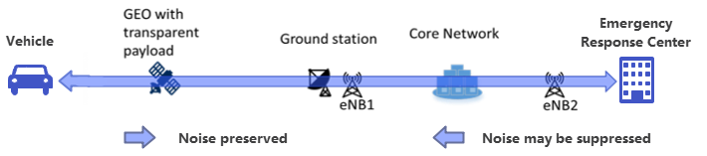
Figure 4.5.2.1-1: Bi-directional voice data flow for vehicle emergency call scenario
In vehicle emergency call scenario, the bi-directional voice data flow is illustrated in figure 4.5.2.1-1. The typical UE in this scenario includes vehicle with integrated microphones and speakers. One party in the conversation is assumed to be using vehicle over a GEO satellite network, while the other like an emergency response center is on a terrestrial mobile network (e.g., VoLTE, VoNR), a fixed-line connection, or another IMS-supported platform. The service is provided by vehicle emergency call service providers and vehicle manufacturers.
In a common scenario, car crash happened and there is no terrestrial network, a call will be initiated automatically from vehicle or manually by users to emergency response center via GEO communication channel. It’s required by vehicle emergency call specification that the noise captured within vehicle should be delivered to emergency response center with fidelity. However, in the opposite direction, noise preservation may not be required.
This link between vehicle and emergency response center is a dedicated system which means that no mobile phone will be involved.
NOTE: Core network typically stands for 3GPP core network and IMS core network.

4.5.3 Derived high-level prerequisites from SA4

4.5.3.1 General
The following general prerequisites for the ULBC apply based on application scenario 4.
Editor’s note: Some high-level prerequisites could be added such as:
"To serve application scenario 4, the ULBC codec is expected to meet the following high-level prerequisites:
- Very low bitrate support
- Background noise preserved and no DTX during the call at least for the direction from vehicle to emergency response center
- Error concealment
- Implementable in real-time (encoding and decoding)
- Good audio quality to ensure a reasonable QoE
- Constraint on hardware can be relaxed comparing to that for mobile phone"

5 Channel characteristics and service-related dependencies
Editor’s Note:
2. Study GEO channel characteristics and derive service-related dependencies, e.g. bitrates, mouth- to-ear delay or loss/delay/jitter profiles.
NOTE: Any impact of ultra-low bitrate voice codec in NB-IoT services is outside of the scope of the study and is expected to be addressed by other working groups.
8. Coordinate work with other 3GPP groups e.g. SA2, RAN, CT1, and others as needed.

5.1 Estimation of mouth to ear delay for GEO scenarios

5.1.1 Overview
This clause estimates the mouth to ear (M2E) delay for IMS voice call over GEO satellites based on the application scenario introduced in clause 4.2. Two sub-scenarios are considered:
- Main Scenario (see clause 4.2.2.2): UE1 is connected via satellite while UE2 is connected via terrestrial network which corresponds to the signal flow UE1 àGEO satellite àGround stationàCore networkà eNodeB àUE2

- Sub-Scenario 1 (see clause 4.2.2.3): Both UEs are connected to a GEO satellite which corresponds to the signal flow UE1 àGEO satellite àGround stationàCore networkàGround stationàGEO satelliteàUE2
This approach aims to estimate the maximum and minimum delay components in the signal flow and finally to estimate a range of the. mouth-to-ear delay accordingly. The estimation assumes jitter free case and no network congestion.
NOTE: In practical deployments, various jitter and network conditions can arise.
Editor’s note: The scenarios and the terminology of this clause needs to be aligned with clause 4.) “Application Scenario” where a detailed description of the call scenarios is expected.

5.1.2 Delay components

5.1.2.1 Overview
In this clause, the individual delay components that contribute to the mouth-to-ear delay are introduced and derived. The derived values are independent of the signal flow direction.

5.1.2.2 UE Delay considering IMS codecs
TS 26.131 [D-1] defines the internal UE delay requirements and objectives depending on the components codec (frame size and algorithmic delay), air interface, jitter buffer depth and vendor specific delay budget. The UE delays in sending (UE1) and receiving directions (UE2) are not separated in TS 26.131, however the sum of the sending and receiving delays can be considered together.
The jitter buffer delay budget contains 40ms if the packet duration is 20ms and it includes the expected jitter profiles for terrestrial network transmission. In case of 40ms packet duration, the budget is doubled to 80ms, which is not further discussed. The value for the air interface in [D.1] just reflects the delay between UE and measurement equipment (2 ms) and needs be replaced by the expected delay for real air interface, i.e. air interface to GEO satellite or terrestrial network.
For MTSI-based speech only services with LTE and NR, the UE delay is outlined in Table 5.1.2-1.
Table 5.1.2-1 UE delay components
 | UE delay in ms (Performance objective)  (Note 2) | UE delay in ms (Maximum requirement)  (Note 2)
Frame size (Note 1) | 20 | 20
alg. Codec Delay (Note 1) | 5 | 12
JBM (jitter free) (Note 3) | 40 | 40
Vendor specific budget (Note 4) | 83 | 123
UE delay Ts+Tr | 148 | 195
Note 1: Values reflect the IMS codecs AMR/AMR-WB/EVS
Note 2: Requirements and Performance Objectives apply to the UE delay only (sum of send (Ts) and receive (Tr) delays) and only for MTSI-based speech-only with LTE, NR or WLAN access in error and jitter free conditions.
Note 3: JBM delay is considered as constant independent of the frame size.
Note 4: Vendor specific budget of TS 26.131 may change for GEO satellite connectivity

Editor’s note: This table assumes LTE/NR air interface and needs to be updated for GEO satellite access air interface.
For ULBC, the air interface delay for GEO depends on the selected voice bundling periods for the ULBC transmission where 80ms, 160ms or 320ms are considered. It is assumed, that the available time budget is entirely used for RUs or repetitions to maximize the spectral efficiency. The delay for the air interface excluding the propagation delay is therefore identical to the voice bundling period.
The frame size of the codec in Table 5.1.2-1 represents the audio capturing delay which is for GEO identical to the voice bundling period.
The codec frame size determines the processing delay of the encoder and decoder. Encoder and decoder processing times are referred to as a vendor specific encoder/decoder processing delay, and the processing times should span between the theoretical extremes from 0 to 100% of the codec frame length.
The vendor specific budget that originally comprises a codec processing delay component of 20 ms is reduced by that amount.
This leads to a UE delay estimation for voice bundling periods of 80, 160 and 320 ms and codec frame sizes of 20, 40, 80, 160 and 320 ms, according to Table 5.1.2-2.
Table 5.1.2-2 UE delay estimation for ULBC
Voice bundling period | Codec frame size | UE delay excluding solution specific delay (Note 1)
Voice bundling period | Codec frame size | lower bound | upper bound
80 | 20 | 268 | 355
80 | 40 | 268 | 395
80 | 80 | 268 | 475
160 | 20 | 428 | 515
160 | 40 | 428 | 555
160 | 80 | 428 | 635
160 | 160 | 428 | 795
320 | 20 | 748 | 835
320 | 40 | 748 | 875
320 | 80 | 748 | 955
320 | 160 | 748 | 1115
320 | 320 | 748 | 1435
Note 1: UE_delay excluding the solution specific delay = 2x voice bundling period + 2x vendor specific encoder/decoder processing delay + vendor delay budget + JBM
Note 2: Solution specific delay X = [TBD ms]
Editor’s note: The above TBD value is characteristic of the solution. It may also depend on the specific operating point. It will be set once the solution is selected. It is for discussion if the JBM contribution to the latency should be covered under solution specific delay X.

5.1.2.3 Core network delay
The delay contribution of the core network consists of the packet transmission delay between two network entities, e.g. ground station to core network or core network to eNodeB. In case of the interop scenario GEO NTN to TN network, an additional delay component for transcoding needs to be considered. Assuming the frame size of both codecs is identical or a multiple of each other, only the algorithmic codec delay contributes to the transcoding delay, i.e. 5ms for AMR/AMR-WB or 12ms for EVS, and an additional delay margin for the processing of the transcoding (2 ms). This means, transcoding with AMR/AMR-WB adds 7ms and with EVS adds 14ms.
Table 5.1.2.3-1 Core network delay components
 | Minimum delay in ms | Maximum delay in ms
Network delay ground station to core network (Delay_GSCN) | [ 5 Note1-1 ,  20 Note1-2] | [200 Note2]
Network delay eNodeB to core network (Delay_eNBCN) | 5 | 20
Transcoding | 7 | 14
[Note1-1: In [D-2] 5 ms network latency is assumed]
[Note1-2: TS 23.501 assumes a static delay value for the CN PDB of 20ms between a UPF and 5G-AN. ]
[Note2: In some NTN deployments, the core network may need to be located far from the ground station due to factors like user distribution, geography, or other practical considerations. As a result, latency can increase, ping statistics between continents, for example, can reach up to 200ms.]

5.1.2.4 Propagation delay UE – GEO - Ground station
Clause 7.4.2 of [D-2] defines the KPI requirement for GEO based satellite access, i.e. 280ms. TR 36.763 clause 7.1.1 describes the max. and min. propagation delay contribution which depends on the location of the UE within the beam. As a result, the round-trip-delay can differ by 64ms which corresponds 32ms for one-way transmission. It is proposed to consider the 280ms as the max. propagation delay and consequently 248ms (280ms – 32ms) as the minimal propagation delay time. This assumes no retransmission over the GEO satellite link.
Table 5.1.2.4-1 Propagation delay GEO satellite
 | Minimum delay in ms | Maximum delay in ms
GEO propagation delay | 248 | 280
Note: Propagation delay ground station to core network counted in Table 5.1.2.3-1.

5.1.2.5 ULBC Delay components
Table 5.1.2-1 lists the algorithmic delay for the IMS codecs AMR and EVS, i.e. in range of 5ms to 12ms. For ULBC, different delay values may result from codec processing delays as well as algorithmic delays. Exact numbers are for further study.

5.1.3 Estimation of Mouth-to-ear delay
Given the values in 5.1.2 the mouth-to-ear delay for scenario can be estimated for the two scenarios outlined in 5.1.1 by summing up the delay components according to the signal flow to derive a lower (minimum values as in Tables 5.1.2.2-1, 5.1.2.3-1, 5.1.2.4-1) and an upper bound (maximum values as in Tables 5.1.2.2-1, 5.1.2.3-1, 5.1.2.4-1).
As the bitrate for GEO satellite link is very restricted, options for minimizing the protocol overhead need to be considered. One option to reduce the protocol overhead are larger frame sizes or a larger voice bundling period or frame aggregation as the protocol stack is transmitted less often. Therefore, Table 5.1.3-1 outlines the delay values for codec frame sizes of 20ms, 40ms, 80ms, 160ms and 320ms and the bundling periods of 80ms, 160ms and 320ms.
Editor’s Note: Current values assume algorithmic delay of AMR and EVS as given in 5.1.2.2-1. ULBC Delay components documented in 5.1.2 still need to be addressed. For the min. Delay_GSCN, 20ms is assumed.
Table 5.1.3-1 Mouth-to-ear delay estimation depending on codec frame size
Voice bundling period | Codec frame size | Mouth to ear delay main scenario in ms  (GEO - TN) (Note 1) |  | Mouth to ear delay sub-scenario in ms  (GEO - GEO) (Note 2)
Voice bundling period | Codec frame size | lower bound | upper bound | lower bound | upper bound
80 | 20 | 548 + X | 872 + X | 804 + X | 1315 + X
80 | 40 | 548 + X | 912 + X | 804 + X | 1355 + X
80 | 80 | 548 + X | 992 + X | 804 + X | 1435 + X
160 | 20 | 708 + X | 1032 + X | 964 + X | 1475 + X
160 | 40 | 708 + X | 1072 + X | 964 + X | 1515 + X
160 | 80 | 708 + X | 1152 + X | 964 + X | 1595 + X
160 | 160 | 708 + X | 1312 + X | 964 + X | 1755 + X
320 | 20 | 1028 + X | 1352 + X | 1284 + X | 1795 + X
320 | 40 | 1028 + X | 1392 + X | 1284 + X | 1835 + X
320 | 80 | 1028 + X | 1472 + X | 1284 + X | 1915 + X
320 | 160 | 1028 + X | 1632 + X | 1284 + X | 2075 + X
320 | 320 | 1028 + X | 1952 + X | 1284 + X | 2395 + X
Note 1: UE delay+GEO transmission+Delay_GSCN+Delay_eNBCN + Solution specific delay X
Note 2: UE delay +2x GEO transmission+2x Delay_GSCN + Solution specific delay X

Editor’s note: The scenarios and the terminology of this clause needs to be aligned with clause 4.) “Application Scenario” where a detailed description of the call scenarios is expected.

5.2 NB-IoT NTN system in 3GPP and design parameters

5.2.1 System architecture
The NB-IoT NTN RAN is shown in Figure 5.2.1-1 [36300]
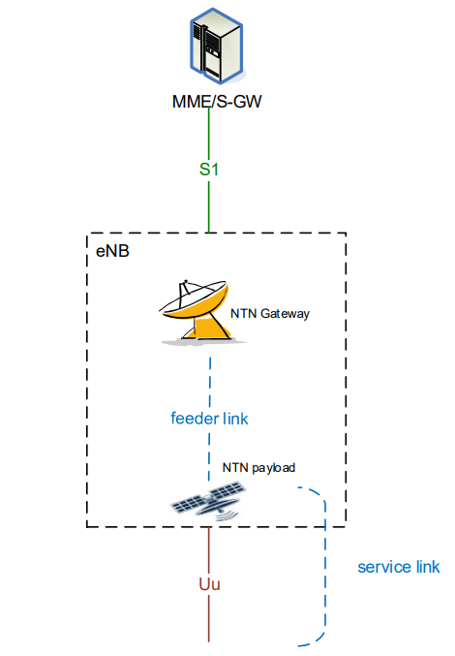
Figure 5.2.1-1 System architecture of an NTN
The service link is between the UE and the NTN payload. The feeder link is between the NTN payload and the NTN Gateway.
NOTE: typically, multiple UEs are scheduled.

5.2.2 RAN parameters
Channel coding
The uplink data channel NPUSCH Format 1 uses Turbo code, and the downlink data channel NPDSCH uses TBCC [36212].
MCS and resource allocation
NB-IoT supports pi/2 BPSK, pi/4 QPSK, QPSK, and 16QAM [36213].
Resource allocation is specified in [36213].
For NPUSCH Format 1, two subcarrier spacings are supported: 3.75kHz and 15kHz. The minimum time-domain resource allocation is the duration of a resource unit (RU). The frequency-domain resource allocation is determined by the number of allocated subcarriers associated with different RU durations, and the RU duration depends on the subcarrier spacing and the number of tones, as shown in Table 5.1.4.2-1 (Table 10.1.2.3-1 of [36211]), where NPUSCH format 1 is relevant to the NB-IoT system with GEO because it is for data while NPUSCH format 2 is for ACK/NACK. For 3.75kHz SCS the a slot is 2ms, and for 15kHz SCS a slot is 0.5ms.
Table 5.2.2-1: Supported combinations of , , and for frame structure type 1.
NPUSCH format
1 | 3.75 kHz | 1 | 16 | 7
1 | 15 kHz | 1 | 16 | 7
1 | 15 kHz | 3 | 8 | 7
1 | 15 kHz | 6 | 4 | 7
1 | 15 kHz | 12 | 2 | 7
2 | 3.75 kHz | 1 | 4 | 7
2 | 15 kHz | 1 | 4 | 7
The number of allowed RUs per repetition is defined in Table 16.5.1.1-2 and the number of allowed repetitions is defined in Table 16.5.1.1-3 of [36213].
For NPDSCH Format 1, there is only one subcarrier spacing supported – 15kHz – and the frequency-domain resource allocation is always 180kHz. The number of allowed subframes per repetition is defined in Table 16.4.1.3-1 and the number of allowed repetitions is defined in Table 16.4.1.3-2 of [36213].
TBS values
[36213] specifies the allowed TBS values.
For NPUSCH, the allowed TBS values depend on the MCS and the number of RUs per repetition and are specified in Table 16.5.1.2-2 of [36213]. For NPUSCH Format 1 single-tone, the allowed TBS values depend on Table 16.5.1.2-1 of [TS 36.213]
For NPDSCH, the allowed TBS values depend on the MCS and the number of NPDSCH subframes per repetition and are specified in Table 16.4.1.5.1-1of [36213].
It is expected that the same TBS value will be used in UL and DL.

5.2.3 QoS characteristics
The QoS is done through QCI [23203]. A QCI is associated with the resource type (GBR or Non-GBR), priority level, packet delay budget (PDB) and packet error loss rate (PELR). See Table 6.1.7-A: Standardized QCI characteristics of [23203] for a list of QCI.
A QCI applies to both UL and DL, and specifically [23203] states “For a certain QCI the value of the PELR is the same in uplink and downlink.” With the background of the half-duplex FDD NB-IoT channel, this suggests that UL and DL time-domain transmission resources need to be balanced to allow for the same PELR on both links.

5.2.4 UE radio capabilities
For NB-IoT NTN operation, UE radio capabilities play a critical role in determining link performance, coverage and system capacity. It is important to consider that NB-IoT devices for ULBC voice service operations may have a large variety of capabilities in terms of radio performance. The following aspects constitute such capability variations:
- Transmit Power Classes:
- From Rel-18 onwards, PC3 (23dBm) is supported for NB-IoT NTN UE on bands 256, 255, 254 and 253, and from Rel-19 onwards on band 252.
- In Rel-19, RAN4 introduced new power classes for NB-IoT NTN UE including PC1 (31dBm) and PC2 (26dBm) for bands 256, and 255. The target device types include both hand-held and non-handheld device types.
- RAN4 also started the work to specify PC 1.5 (29dBm).
- Receive Antennas:
- [For voice, an NB-IoT NTN UE may typically implement two receive antennas.]
- [
Enhanced UE configurations may include more than two receive antennas.]
Editor’s note: The two bullets above require confirmation by RAN1 and RAN4
- Enhanced Capabilities (subject to potential Rel-20 updates to NB-IoT RF requirement and [TS 36.101] and conformance [TS 36.521-1] specifications):
- Future NTN-capable UEs may support advanced features such as:
- UE transmit power higher than PC1 (e.g. up to 37 dBm) for NB-IoT NTN. The feasibility and specific power as well as the designated bands would be under further study (RAN4).
- Improved RF front-end sensitivity to compensate for high path loss and atmospheric attenuation in GEO links.

5.2.5 Multi-user consideration
The selected configurations for UL and DL for a single user result in using only a subset of the total resources. It is expected that scheduling will assign resources to multiple users. Scheduling resources may be done dynamically, or (semi-)statically if SPS is specified for NB-IoT. Any configuration implies using a certain fraction of the total system resources which has implications on the number of supported UEs in the system. Maximizing this number under certain constraints (see below) is an important optimization criterion when identifying suitable configurations.
In practical NB-IoT NTN deployments, multiple UEs share the same carrier resources, making efficient scheduling critical for maximizing system capacity while maintaining acceptable QoS for all users. Rather than assuming a single configuration based on certain assumptions, the system may employ a policy-driven scheduling and load-management approach informed by e.g. capabilities, runtime load conditions, and service-level objectives.
The following principles for multi-user scheduling may be considered, e.g.:
- Capability-Aware Resource Allocation:
UEs with higher transmit power can be scheduled with shorter SPS periods (e.g., 80 ms), reducing latency and improving conversational quality. UEs with limited capabilities may use longer SPS periods (e.g., 160 ms or 320 ms) to maintain link reliability.
- Multi-Tone Transmission for Enhanced UEs:
Higher TX power enables multi-tone NPUSCH transmission, which can increase ULBC bitrate and/or reduce time-domain resource usage. This frees capacity for other users and improves overall system efficiency.
- Dynamic Load Balancing:
Scheduling prioritizes resource allocation based on UE capability to optimize system capacity. Enhanced UEs can achieve higher bitrates or lower latency without negatively impacting capacity, while less capable UEs remain supported with conservative configurations.
- Service Level Differentiation:
The UE and the network may negotiate different service levels, e.g.:
- Baseline Service (a low guaranteed bit rate value (GBR) and low maximum bit rate (MBR)): For least capable UEs and poor channel conditions, using longer SPS periods and single-tone NPUSCH.
- Intermediate Service (a medium GBR and medium MBR): For UEs with moderate enhancements and moderate channel conditions, enabling shorter SPS and possibly multi-tone transmission.
- Enhanced Service (a high GBR and high MBR): For highly capable UEs and good channel conditions, offering higher bitrates and reduced latency through advanced configurations.

Figure 5.2.5-1 illustrates these principles in a simplified example, where the channel conditions for all UEs are assumed to be the same. It shows a scheduler allocating uplink and downlink resources on two 200 kHz NB-IoT carriers to multiple users using 3 different policies, where the policies may be based on any of the principles listed above or further principles. Hereby,
- UEs of users 5-12 are scheduled for example with a 160 ms SPS period, using 128 ms duration single-tone NPUSCH which puts the least TX power requirement on the UE. In the specific case, the voice service may be operated with a net bitrate of about X kbps.
- UEs of users 3 and 4 are scheduled with an 80 ms SPS period, using a reduced-duration (64 ms) NPUSCH whereby higher TX power than for the UEs of users 5-12 is required. Possibly using a multi-tone NPUSCH format. In the specific case, the voice service may also be operated at a net bitrate of about X kbps. As there are 2 transmission instances per 160 ms, the transmission relies on a different, smaller-size TBS suitable to carry the coded speech data. However, higher TX power and multi-tone could also be used to operate with higher UL bitrate.
- UEs of users 1 and 2 are scheduled with an 80 ms SPS period, a reduced-duration (64 ms) NPUSCH and reduced-duration NPDSCH. Reduced-duration NPDSCH may be enabled by higher receiver performance. In the specific case, the voice service may also operated at about X kbps. Like in the previous case, as there are 2 transmission instances per 160 ms, the transmission relies on a different, smaller-size TBS suitable to carry the coded speech data. On UL, a higher bitrate could be used. On DL, the duration of the NPDSCH is reduced by 50% compared to the other UEs.
NOTE: In the above, ‘X’ is a placeholder for a ULBC net bitrate supported by ULBC voice service.
The example illustrates how radio scheduling may lead to reduced latency or higher bitrates for enhanced UEs, while maintaining reliability at lower bitrates for baseline UEs without wasting time-frequency resources.
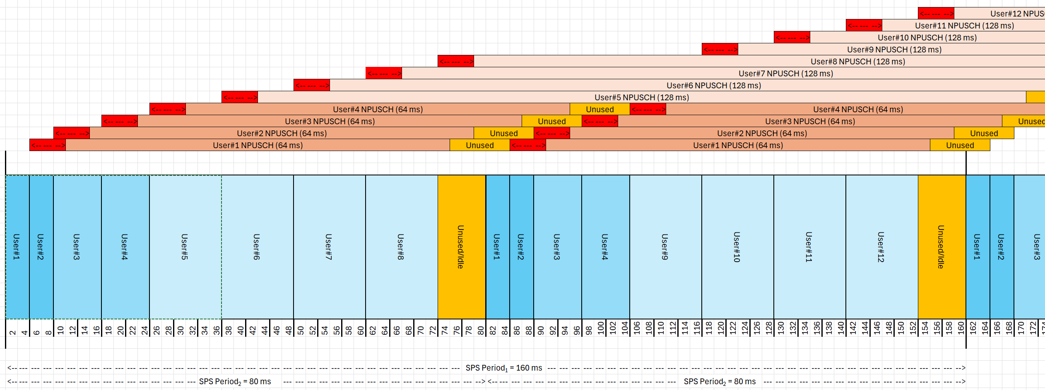
Figure 5.2.5-1 UE capability-aware Multi-user SPS scenario

6 Design constraints
Editor’s Note: Design constraints will be primarily defined for GEO, and we will need to confirm whether the additional application scenarios would be possible with those design constraints, or if adaptations are seemed to be reasonable to also cover additional applications scenarios.
3. Identify the relevant design constraints for such a codec, in coordination with other WGs, including:
- Bit rates
- Sample rate and audio bandwidth
- Frame length
- Complexity and memory demands
- Algorithmic delay
- Packet loss concealment (PLC)
- Potential use of noise suppression as part of the codec
- Discontinuous transmission including voice activity detection and comfort noise
- Speech quality
- Robustness to non-speech input
- Identify or develop objective measures to verify the design constraints as necessary (e.g., to measure complexity and memory demands)
6. Identify or develop objective measures to verify the design constraints as necessary (e.g., to measure complexity and memory demands)
8. Coordinate work with other 3GPP groups e.g. SA2, RAN, CT1, and others as needed.

6.1 General
The following clauses present the design constraints (DC) for an Ultra Low Bitrate Codec for the use in application scenarios as given in clause 4. Clause 6.2 outlines the DC parameter and clause 6.3 outlines objective verification methods of some DC parameter.

6.2 Design Constraint Parameter
Table 6.2-1 List of ULBC design constraint parameter
Parameter | Design Constraint | Note
Bit rates

Sample rate and audio bandwidth

Frame length
Complexity and memory demands
Algorithmic delay |  | The algorithmic delay is defined as the frame size buffering delay plus any other delays inherent in the codec algorithm (e.g., look-ahead, sample-rate conversion, and decoder post-processing)
Packet loss concealment (PLC)
Potential use of noise suppression as part of the codec
Discontinuous transmission including voice activity detection and comfort noise
Robustness to non-speech input |  | Editor’s note: May need to be in performance requirement

Editor’s note: Speech quality to be addressed in the performance requirements.

6.2.1 Considerations on DC: Complexity and Memory
Some guidelines on key factors to consider when developing ULBC codec: The codec must be designed to operate within the compute constraints typical of devices intended for real-time voice communication.

6.2.1.1 Current Evaluation Analysis
The codec must support real-time thread and concurrent processing capabilities, especially when functioning alongside other audio processing units. To better fit the real-time resource constraints of CPUs (and potential accompanying accelerators) and DSPs in a range of devices, codec models with reduced complexity need consideration. For example, ML codecs with parameters in the range of [5-10M] needs consideration to run efficiently within certain latency bounds, suitable for wide range of devices.

6.2.1.2 Memory and Power Considerations
Larger codec models, although potentially more capable, pose significant challenges:
- Memory Access and Usage: Increased memory footprint requires more frequent access to DRAM, which can lead to higher power consumption.
- Power Overhead from DRAM: Not negligible, as larger models may necessitate additional power to maintain data flow between the processor and memory, impacting overall device performance and usability.

6.2.1.3 Codec Deliverables and Performance Metrics
Selecting a suite of performance metrics for complexity/memory evaluation depends on the codec deliverables. Are the codec deliverables simply model weights interfaced within a python-script or is it an integrated implementation?
UE vendors may have custom optimizations to port a typical ML model (e.g., from a PyTorch format) into their internal formats that can be substantially optimized. If the codec deliverables include an integrated implementation, this will limit UE vendors to fully leverage custom architectures and optimizations. In such a case, the complexity evaluations performed on a codec candidate may not reflect consistently across all platform implementations.
A common performance metric that can serve as a reference for both the above codec deliverable options is the “Codec/Model Size”, which directly impacts the memory requirements and power consumption.

6.2.1.4 Complexity metric for AI based codecs
Matrix multiplication and MAC operations are the key elements of AI based solutions. The NPU (Neural Processing Unit) [CM-1] or TPU (Tensor Processor Unit) [CM-2], which are specialized processors to accelerate AI based solutions, generally defines its computational capability in Tera Operations Per Sec (TOPS) [CM-3], [CM-4], [CM-5], [CM-6], wherein TOPS = 2 × MAC unit count × Frequency / 1 trillion. Here, MAC unit count is the theoretical number of MAC operations that can be executed in parallel in one processor cycle (this number has been reported as > 10000 in many of the processors), a factor of 2 is present because each MAC has two operations (Multiply and addition) and Frequency is the processor clock speed. Note that these TOPS values are typically defined with certain precision (for example INT4, INT8, INT16, FP16 or FP32).
When it comes to power efficiency metric, TOPS per Watt (TOPS/W) is a key metric for AI processors that measures how many TOPS a chip can perform for each watt of power consumed, for e.g., the TOPS/W on smartphones with NPU ranges from 2 to 15 TOPS/W. So, the number of MAC operations in an AI based solution may give a theoretical estimate of the power consumption. Another metric that has been used to benchmark computational complexity of AI based solution is real-time factor or RTF, corresponding to the ratio between the frame length of the input audio and the time needed for encoding/decoding. For instance, RTF analysis for some AI based codecs has been done in [7-1]. Existing standard AI codecs like JPEG AI [CM-7] have used both MAC (kMAC per pixel) and real-time factor as metrics for computational complexity assessment. While the real-time factor on various processors/platforms is a very reliable metric for complexity assessment, it may be time and resource consuming to compute that data and comparable numbers require use of same hardware. Therefore, metrics like MACs per second (MACS) or Million MACS may be more practical methods for computational complexity assessment of ULBC. There are existing tools like ptflops [CM-8], torchinfo and fvcore. These tools recognize commonly used layers in an AI based solution and give number of MAC operations and model size for complexity estimation.
It is also worth noting that TOPS figures is a product of highly specialized hardware architectures, including massively parallelized MAC operations and low-precision arithmetic, which are optimized for a specific class of problems. However, the actual performance of an NPU cannot entirely determined by its raw TOPS number alone but should also include among of them a complex interplay of the computational graph structure of the AI model. If a computational graph contains irregular, sequential, or unsupported operations, the NPU's efficiency may be compromised, by e.g. often requiring a performance-degrading "fallback" to the CPU.
Traditionally, 3GPP speech codecs have relied on WMOPS metric [CM-9] to estimate computational complexity. This method assigns weights to various operations (e.g., weight of 1 to arithmetic operations like add(), sub() and L_mac(), weight of 3 to IF conditions and weight of 18-to-16-bit division div_s()). The overall sum of weighted operations can be counted over the frame execution and the worst/average/min statistics can be generated for various functions and for the overall codec. The instrumentation and counting of WMOPS can be automated with floating point code using the WMC tool as mentioned in [CM-9]. For complexity estimate with ULBC C code, WMOPS counting tools may also be modified to give MACS estimate while reporting all other operations (memory load/store, if/else etc) separately. This may be helpful with estimating the part of the code that can be executed with parallel MAC units. Furthermore, it can be beneficial to utilize or derive metrics that allow complexity comparison of existing 3GPP codecs and ULBC, e.g., to determine relative effects of codec use on battery life.

6.2.1.5 Complexity target estimation for AI based codecs
This clause provides information on the target devices and their respective processing capabilities for ULBC. It also introduces complexity estimation metrics and potential complexity limits for AI-based codecs.

6.2.1.5.1 Target devices for ULBC
As mentioned in ULBC SID, “the codec is expected to be deployable on the processing capabilities as can be found in today’s smartphones” and the complexity and memory demands should be studied accordingly. NPUs or Neural engines have become extremely popular in the last decade as they are specifically designed to accelerate artificial intelligence and machine learning workloads and are arguably 5-20x more power efficient than CPUs for AI tasks and hence, they are an important component in modern processors. Almost every smartphone today that is expected to carry out AI tasks has an NPU chip inside it. To give an idea of the presence of NPU in today’s smartphones and smartwatches, [28] provides a list of examples of processors and devices with NPU component.
It should be noted that while ULBC is expected to be deployable on recent smartphones (most of which have NPU components), the codec may still need to run on non-NPU platforms in certain configurations (for e.g., devices which may not have an NPU but have deployed ULBC for NB-NTN or non-NTN use cases). The design objectives for non-NPU accelerated configurations is for further study.
Vendors may choose any form of computing units to implement ULBC fulfilling their business need or product constraints. Considering various advantages of DSP implementation including cheaper in terms of silicon real estate, less power hungry, less heat generation, typically single threaded so that it can operate at very low overhead to guarantee synchronized real time execution and potentially wider range of products support, ULBC should also be deployable on DSP enabled UE devices, e.g. either devices with DSP only or devices with multiple computing units including DSP. Here the DSP means latest available or upcoming generation of audio processing DSPs which may support ML-specific instructions, handle a modern ML-based codec, and are available in mobile phones or other devices for voice communication.

6.2.1.5.2 Computational complexity and power consumption limits for ULBC
The manufacturers of the various processors (as mentioned in [28]) have reported the theoretical max TOPS that can be achieved with the respective NPU, and it ranges from approximately 8 to 59 TOPS [CM-10] [CM-11] at varying numerical precision (typically INT8 precision at higher TOPS and INT16 or FP16 at lower TOPs). Furthermore, TOPS/W (as mentioned in clause 2.1) is a popular metric that has been used to benchmark power efficiency when running AI tasks on these processors and ranges from 2 to 15 TOPS/W [CM-5] [CM-12] [CM-13] (on smartwatches, the TOPS/W ranges from 1 to 3). The source inferenced an existing AI based codec (DAC [CM-14]) with a complexity estimate tool ptflops [CM-8] that estimates number of MAC operations. The average number of MAC operations were estimated to be around 150 Giga MAC per Second (OR around 0.3 TOPS). The actual power consumption estimates when running this on smartphone NPUs is TBD.
It should however be noted that the computational time on the same device may significantly vary depending on the AI algorithm architecture. Higher model size can potentially lead to more DRAM memory operations, depending on the cache utilization, which would impact the actual power efficiency [CM-15] as DRAM operations require significantly higher power compared to the arithmetic operations. The TOPS/W values given for various NPUs may exclude the power consumption of DRAM memory operations. While NPUs can lower the power consumption for the arithmetic operations, the DRAM memory operations can increase overall power consumption significantly.

6.2.1.6 Observations and conclusions
The key observations and conclusions for estimating complexity targets in AI-based codecs:
- ML-based codec that can operate efficiently on CPUs/DSPs requires careful consideration of model size, complexity, and the trade-offs between performance and resource utilization. By focusing on optimizing models to function within certain “Codec/Model Size” constraints, it can create opportunities to deploy the ULBC codec for real-time voice communication across a wide range of devices.
- A large number of commercially available smartphone models have a dedicated chip (NPU or TPU or neural engine) for AI tasks and they are much more power efficient in executing AI tasks as compared to CPUs if certain AI algorithm architecture constrains and weight precisions are met.
- The capability of NPUs or neural engines is often reported in TOPS which are determined based on parallel MAC units and clock frequency. The max TOPS capability on these devices ranges from approximately [8 to 59] TOPS [CM-10] [CM-11].
- The power efficiency performance of NPUs is often reported in TOPS/W and ranges from approximately [2 to 15] TOPS/W [CM-5] [CM-12] [CM-13] which typically include internal memory and arithmetic. However, depending on the model size and architecture, the operations on external memory may dominate the overall power consumption of the system
Editor’s Note: The cited TOPS/W figures are typically benchmarked under full-load conditions, for example when executing large language models or video processing. The power efficiency characteristics for comparatively lighter workloads, such as an audio codec, are not yet well-defined and are for further study. An NPU might incur a significant baseline power overhead for activation, regardless of the task's scale, which could lead to a disproportionately high energy cost and a significantly lower effective TOPS/W in such scenarios. This mechanism requires further investigation.
- Given the advancement in hardware (NPUs as compared to traditional DSPs and CPUs), the ULBC complexity design constraints should not be defined in reference to existing 3GPP speech codecs (for example, complexity target of ULBC should not be defined as X times EVS OPS or Y times AMRWB OPS). Instead, the ULBC complexity design constraints should be defined based on the desired power consumption or computational performance limits for running an AI based solution. A theoretical power consumption estimate may be obtained based on number of MMACS (Million MACS), model size of the codec, precision of parameters and the TOPS/W estimate on relevant devices.
- Number of Million MACS executed in an AI based solution along with model size (number of parameters and precision) may provide a first indication of the overall complexity. This metric has been adopted in existing standards like JPEG AI [CM-7]. As shown in [CM-15], also the AI algorithm architecture has a significant impact on the computation time.
- Real-time factor or RTF, corresponding to the ratio between the frame length of the input audio and the time needed for encoding/decoding, has been used to benchmark computational complexity of AI based solutions [7-1] [CM-7]. Using RTF as a metric to define ULBC design constraints will require identification of accessible test benches/platforms for performing the evaluations which is for further study. Furthermore, it should be ensured that RTF evaluations are done in a way such that they are not biased towards certain platform specific optimizations.
- The conventionally used WMOPS metric may not be directly suitable for computational complexity estimation of an AI-based solution on NPU capable devices. However, it can be beneficial to specify complexity metrics that allow for practical complexity comparison between existing 3GPP speech codecs and ULBC, e.g., based on a mapping between WMOPS and TOPS or RTF based metrics.

6.3 Design Constraint Verification
Editor’s note: Algorithmic delay verification method for AI based codecs required.

6.4 Additional Design Considerations

6.4.1 Codec Parameters and Configuration
Codec parameters, including codec identification, audio bandwidth, bit rate, functionalities such as DTX, are commonly aligned between encoder and decoder configurations. Those can be characterized as static and dynamic parameters. Dynamic parameters may need to be repetitive and are typically include in each packet or frame. Static parameters are typically not or only rarely changed within a session and are commonly exchanged by SDP in IMS or predefined.
Editor’s Note: Common static and dynamic parameters are to be identified, reflecting the necessary parameter set for the envisioned scenarios.

7 Existing technologies and feasibility evidence
Editor’s Note:
- Provide some evidence that the design criteria can be met, for example existing reference codecs.

[7.1 Existing codec technologies for GEO scenarios

7.1.1 Overview
The present clause collects information on existing codec technologies that may be suitable for GEO application scenarios and categorizes those using the following definitions:
- 3GPP IMS codecs: Even though the operating bitrates are out of scope for the envisioned services, these codecs can be considered as reference condition regarding the performance requirements.
- Conventional Ultra Low Bitrate Codecs: These codecs are based on conventional signal and speech processing algorithms (like the 3GPP IMS codecs) and can operate in the envisioned bitrate range.
- AI-based postprocessor: The bitstream or decoder of a conventional ultra-low bitrate codec is decoded and enhanced by a AI based postprocessor
- AI-based encoder and decoder: Encoder and decoder implemented as Deep Neural Network (DNN) and can potentially operate in the envisioned bitrate range. Due to fundamental design differences regarding the algorithmic delay, two more sub-categories are defined:
- Causal systems: Codecs which can operate in real-time applications
- Non-causal systems: Codecs which can only operate in non-real-time applications due to large processing look-ahead or framing
The following codec properties are considered:
- Audio bandwidth: Support of NB, WB, SWB, FB and/or 12 kHz
- Codec delay: any delays inherent in the codec algorithm (e.g., look-ahead, sample-rate conversion, and decoder post-processing), excluding framing
- Frame duration: Block size or framing delay, may be bit rate dependent
- Bitrates: List of supported bitrates lower than [3] kbps or the lowest supported constant bitrate.
Editor’s note: Variable bitrate modes in combination with DTX are for FFS.
- Specification / Access / Software:
- Specification determines the level of development for a complete solution
- A: Fully specified and verified coding algorithm including all relevant system components such as channel resilience capability or discontinuous transmission
- B: Specification of codec algorithm only
- Access determines the availability of a reference implementation:
- A: Repository with open access
- B: No repository with open access known
- Software determines the deployment level of the reference software its level of optimization
- A: Software fully functional and optimized C-code
- B: Software fully functional and reference C-code
- C: Experimental software framework in Python only
- X: Software status unknown
NOTE: In the case of a DNN-based codec, both the implementation of the computational graph (i.e. the layer definitions and their order of execution) and the corresponding pretrained weights are needed for inference. For this reason, consider two sets of weights for the same computational graph as defining two different codecs.
Editor’s note: Documentation regarding complexity aspects (computational complexity, memory, ROM) is envisioned, however it requires a clear definition on the measurement first.
In the following a collection of speech codecs and the related parameter is presented in Table 7.1.1-1.
Table 7.1.1-1 List of existing codec technologies
Codec | Source | Audioband-width | Codec Delay  [ms] | Frame duration  [ms] | Bitrates  [kbps] | Specification / Access / Software
3GPP IMS codecs
AMR | 3GPP TS 26.071 | NB | 5 | 20 | 4.75 | A / A / A
AMR-WB | 3GPP TS 26.171 | WB | 5.9375 | 20 | 6.6 | A / A / A
EVS | 3GPP TS 26.445 | NB | 12 | 20 | 7.2 | A / A / A
EVS | 3GPP TS 26.445 | WB | 12 | 20 | 7.2 | A / A / A
EVS | 3GPP TS 26.445 | SWB | 12 | 20 | 9.6 | A / A / A
Conventional Ultra Low Bitrate Codecs
MELP / MELPe  (Note1) | https://www.compandent.com/about-melpe/ and melp_faq | NB | 36.25 | 90 | 0.6 | A / B / A
MELP / MELPe  (Note1) | https://www.compandent.com/about-melpe/ and melp_faq | NB | 27.25 | 67.5 | 1.2 | A / B / A
MELP / MELPe  (Note1) | https://www.compandent.com/about-melpe/ and melp_faq | NB | 20.125 | 22.5 | 2.4 | A / B / A
AMBE-LR | https://www.dvsinc.com/software/technology.shtml#ambelr | NB |  |  | 1.6 – 1.8 | A / B / A
MPEG--HVXC | https://www.iso.org/obp/ui/en/#iso:std:iso-iec:14496:-3:ed-5:v1:en:sec:1.3 | NB |  |  | 2 – 4 | B / B / B  (Note2)
TWELP MR  (Note 1) | https://dspini.com/vocoders/lowrate/twelp-lowrate/twelp300-3600-mr | NB | 20 | 40 | 3.2 | A / B / A  (Note5)
TWELP MR  (Note 1) |  | NB | 20 | 40 | 2.4 | A / B / A  (Note5)
TWELP MR  (Note 1) |  | NB | 40 | 60 | 1.6 | A / B / A  (Note5)
TWELP MR  (Note 1) |  | NB | 40 | 60 | 1.2 | A / B / A  (Note5)
TWELP MR  (Note 1) |  | NB | 80 | 100 | 0.7 | A / B / A  (Note5)
TWELP MR  (Note 1) |  | NB | 80 | 100 | 0.6 | A / B / A  (Note5)
TWELP MR  (Note 1) |  | NB | 100 | 120 | 0.48 | A / B / A  (Note5)
TWELP MR  (Note 1) |  | NB | 100 | 120 | 0.3 | A / B / A  (Note5)
Codec2 | https://github.com/drowe67/codec2 | NB | 40  (Note 3) | [TBD] | 0.45 | A / A / A
 |  |  |  | 40 | 0.7 | A / A / A
 |  |  |  | 40 | 1.2 | A / A / A
 |  |  |  | 40 | 1.3 | A / A / A
 |  |  |  | 40 | 1.4 | A / A / A
 |  |  |  | 40 | 1.6 | A / A / A
 |  |  |  | 20 | 2.4 | A / A / A
AI based decoders
WaveNet Codec2 | Paper | WB | See Codec2 | 20 | 2.4 | B / B / X
CQNV  Codec2 | Paper | WB | 40 | 40-60 | 1.0  1.1 | B / B / X
AI based encoder and decoder (causal)
LPCnet | Paper, Code, Demo | WB | 25 | 40 | 1.6 | B / A / C
LyraV2 (aka SoundStream)  (Note1) | Blog,  Paper (SoundStream), Code, Demo (SoundStream) | WB | [TBD] | 20 | 3.2, 6, 9.2 | B / A / A
EnCodec | Paper, Code, Demo | 24kHz | 0 | 13.3 | 1.5, 3, … | B / A / C
EnCodec | Paper, Code, Demo | FB | 1000 | 13.3 | 6, 12, 24 | B / A / C
Mimi-Codec | Paper(moshi), Code, Demo (moshi) | 24kHz | 0 | 80 | 0.55, 1.1 | B / A / C
TS3 | Paper, Code, Demo | WB | 0 | 20 | 0.64, 0.8 | B / B / X
TAAE | Paper, Code, Demo | WB | 0 | 20, 40 | 0.4, 0.7 | B / B / X
LMCodec2 | Paper, Code, Demo | [TBD] | [TBD] | [TBD] | [TBD] | [TBD]
AI based encoder and decoder (non-causal)
DAC | Paper, Code, Demo | WB | 244 | 20 | 0.5, 1.0, 1.5, … | B / A / C
DAC | Paper, Code, Demo | 24kHz | 366 | 13.3 | 0.75 1.5, 3, … | B / A / C
DAC-IBM | Paper | 24kHz | 366 | 13.3 | 0.75, 1.5, 3 | B / A / C
SNAC | Paper, Code | 24 kHz | 1000 | 80 | 0.98 | B / A / C
SpeechTokenizer | Paper, Code, Demo | WB | full-signal | 20 | 0.5, 1.0 | B / A / C
SemantiCodec | Paper, Code, Demo | WB | full-signal | 10 | 1.25, …, 1.4 | B / A / C
 |  |  |  | 20 | 0.63, …, 0.70 | B / A / C
 |  |  |  | 40 | 0.31, …, 0.35 | B / A / C
FunCodec  (Note4) | Paper, Code, Demo | WB | [TBD] | 20 | 0.5, 1.0, … | B / A / C
 |  |  |  | 40 | 0.25, 0.5, … | B / A / C
WavTokenizer (Note4) | Paper, Code, Demo | 24kHz | [TBD] | 40 | 0.25, 0.5, … | B / A / C
 |  |  |  | 25 | 0.9 | B / A / C
BigCodec  (Note4) | Paper, Code, Demo | WB | [TBD] | 12.5 | 1.04 | B / A / C
FocalCodec | Paper, Code, Demo | WB | [TBD] | 20 | 0.65 | B / A / C
 |  |  |  | 40 | 0.33 | B / A / C
 |  |  |  | 80 | 0.16 | B / A / C
ALMTokenizer | Paper, Code, Demo | WB | [TBD] | 13.3 | 0.41 | B / A / C
XY-Tokenizer | Paper, Code, Demo | WB | [TBD] | 20 | 1 | B / A / C
LongCat-Audio-Codec | Paper, Code, Demo | WB | [TBD] | 60 | 0.87, 0.65, 0.43 | B / A / C
MuCodec | Paper, Code, Demo | FB | [TBD] | [TBD] | 0.35, 1.35 | B / A / C

Note1: These codecs may include a noise
Note2: Decoder and reference encoder are available in the MPEG reference software and for MPEG members
Note3: Encoder with 20ms overlapping FFT and iFFT at decoder with same overlap-add size
Note4: Only non-causal version publicly available
Note5: Although TWELP does not have an open reference implementation, a complete quality assessment testbench is available at https://dspini.com/files/downloads/speechsamples/C2_vs_TWELP.zip.
Editor’s note: More codecs may be added to the table

7.1.2 Observations regarding codec parameter
The following observations are extracted from the Table 7.1.1-1:
- Audio bandwidth: While conventional ultra-low bitrate codecs operate in the envisioned bitrate range on NB only, modern AI based codecs offer an audio bandwidth of WB or higher
- Algorithmic codec delay: frame size buffering delay plus any other delays inherent in the codec algorithm (e.g., look-ahead, sample-rate conversion, and decoder post-processing),
- IMS codecs operate in range between 25ms (AMR) and 32ms (EVS)
- Conventional audio codecs operate in the delay range of 60ms – 80ms (Codec2) up to 126.25ms (MELPe).
- Causal AI based codecs can operate between 20ms (TS3) and up to 80 ms (Mimi/Fun-Codec)
- Non-Causal AI based codecs require several 100ms (min. 500ms for DAC/DAC-IBM) or the entire input signal
- Frame duration: For conventional ultra-low bitrate codecs, the frame duration is increased compared to the regular 20ms VoIP framing. A similar tendency can be observed for AI based codecs (MimiCodec), even though some designs maintain the frame duration parameter but increase other parameter values such as bitrate (LyraV2).
- Bitrate: All listed codecs (except the IMS codecs and LyraV2) offer at least one bitrate mode lower than 3kbps.

7.1.3 Complexity Considerations
The following observations on complexity considerations are extracted from the Table 7.1.1-1:
- Complexity: Almost all AI based codecs may have higher computational complexity than IMS codecs and conventional ultra-low bitrate codecs. One exception is LyraV2, which only requires 35% of an ARM A53 core according to measurements on RaspberryPi 3+. More real-time factor or RTF (ratio between the frame length of the input audio and the time needed for encoding/decoding) analysis for some AI based codecs has been done in [7-1]. The final method for complexity evaluation is for further study.
- RAM: RAM numbers may highly depend on the implementation esp. for AI based solutions. However, it should be noted that at least some of the AI based codecs in available implementation show a significant higher RAM demand compared to conventional codecs, e.g. LyraV2 show ca. 54 Mbyte while EVS was characterized with 294 kByte.
- ROM It is expected that ROM number for AI based solutions are significantly higher compared to legacy codecs, e.g. EVS was characterized with ca. 2MB while for TAAE 950M parameters are reported. In general, the number of parameters for AI based solution correlates to the ROM demand. Assuming 8bit integer values for the parameters, this corresponds to ca. 900 Mbyte. Other solution like SNAC operate with 19M parameters which correspond to 18 Mbyte. Implementations may also use 32bit floating point parameters which leads to an ROM increase by a factor four.

7.1.4 Performance Evaluation
NOTE: As this is a pre-evaluation, the test methodology gives no precedence for testing methodologies of ULBC candidates.
In order to get a first impression on the performance of the codecs listed in Table 7.1.1-1, an ITU-T P.808 ACR listening test has been conducted in English clean speech (4 talker x 6 samples). The direct signal was 32kHz sampled with SWB, normalized to -26 dBoV, to accommodate the SWB conditions. The following conditions were included:
- Conventional codecs:
- Codec2 at 0.7, 1.2, 2.4 kbps
- AMR at 4.75 kbps
- AMR-WB at 6.65 kbps
- EVS-WB at 7.2 kbps
- EVS-SWB at 9.6 kbps
- AI based codecs:
- LPCNET at 1.6 kbps
- LyraV2 at 3.2 kbps
- Mimi 0.55, 1.1 kbps
- SemantiCodec 0.34, 0.68, 1.35 kbps
- DAC_ibm 1.5 kbps
- SNAC 0.98 kbps
- Excluded codecs
- EnCodec was not considered due the poor P.800 scoring at 1.5 kbps in [7-1]
- DAC was excluded in favour of the better optimized DAC-ibm for this bitrate range
- FunCodec will be added in a potential follow up test.
Figure 7.1.4-1 shows the Mean Opinion Scores and 95% confidence intervals of 24 subjects.
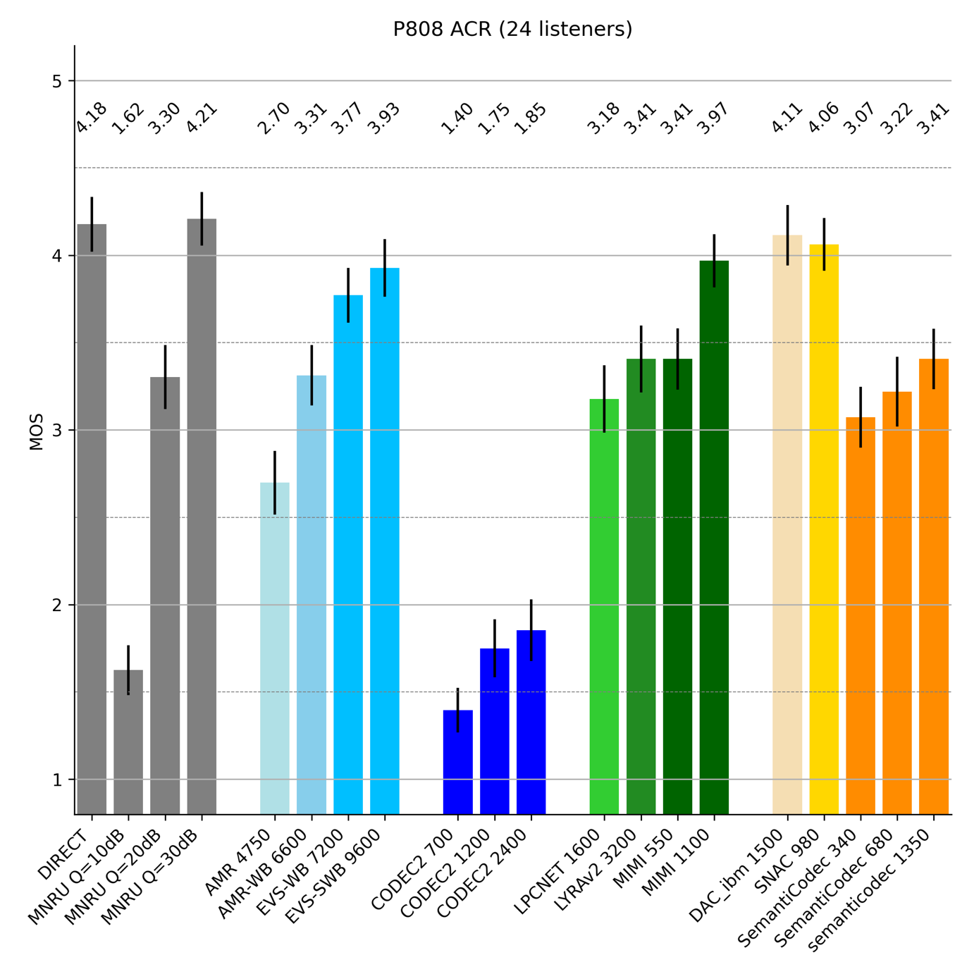
Figure 7.1.4-1 P.808 Mean Opinion Scores and 95% confidence intervals
The following observations can be extracted from the results in Figure 7.1.4-1:
- Codec2 at any rate performs significantly worse than AMR at 4.75 kbps
- SemantiCodec, LyraV2, LPCnet and Mimi-Codec at 0.55 kbps score comparable to AMR-WB at 6.65 kbps
- Three conditions show a promising performance on par or slightly better than EVS at 9.6 kbps and therefore, might reach a level quality considerable for voice services. At least one is considered as causal codec
- Mimi-Codec at 1.1 kbps
and two more as non-causal codecs
- DAC-ibm at 1.5 kbps
- SNAC at 0.98 kbps
- Comparing conventional ultra-low bitrate codecs to AI based solutions, a significant quality gain of 2 MOS or more can be observed

7.1.5 PLC with existing technology

7.1.5.1 PLC experiment with DAC

7.1.5.1.1 Introduction
DAC codec is trained as a scalable codec in terms of bitrate and the models are available for 16 kHz, 24 kHz and 44.1 kHz input sample rates [7-7]. The sources took the default model available at 16 kHz sampling rate and performed an experiment with 4 different bitrates by introducing 4 different loss percentages at the input to decoder. The bitrates and corresponding loss percentages are mentioned in Table 7.1.5.1-1.
Table 7.1.5.1-1 Loss percentages
Bitrate (kbps) | Loss percentage (%) | Frame size considered (ms)
1 | 1 | 80
2.5 | 6 | 80
4.5 | 10 | 80
6 | 20 | 80

The bitrates and loss percentages (upto 4.5 kbps) were chosen based on the data shared in [7-9]. For this experiment, we took an operating point at around 3 dB CNR for SCS=15kHz and 9dB for SCS=3.75 kHz (UE Power = 26 dBm). The selected configuration for TBS=144 is case 3, 4 or 5 in Table 4 of [7-9] which would achieve some BLER of 1% or even less. The selected configuration for TBS=256 is case 11 in Table 6 of [7-9] yielding a BLER of 6%. The selected configuration for TBS=424 is case 45 in Table 10 of [3] with worst case BLER of 10% (With X=0 in (3GPP SET-1 UL SNR) – 10*log10(B/3.75) + (P - 23dBm) + G + [X] dB, the TBS=424 case does not strictly fit into the CNR values and X > 0 is assumed). The values considered here can also be achieved with UL CNR = 5.06 dB (UE Power = 31 dBm) in case 3, case 13/14 and case 45 of [7-9].
Note that the TBS to be transmitted and the achievable data rates will depend on the assumptions made for the link budget analysis and will be impacted e.g. by the scheduling schemes [7-10].
The DAC codec follows an autoencoder architecture wherein the input is down sampled into a latent representation which is then quantized using a residual vector quantizer (RVQ). At 16 kHz sampling rate, with the default configurations of DAC, the input is padded and down sampled by a factor 320 (corresponds to 20ms). So, a padded input of X samples is converted into X/320 blocks of 1024 embeddings. Each block is then quantized using N number of codebooks (wherein each codebook results in 10 bits or 0.5 kbps rate) of the RVQ. The DAC model is trained as a scalable codec in a way that number of codebooks can be changed during inferencing to achieve different bitrates (quantizer dropouts technique during training as used in DAC helps with achieving a scalable solution here).

7.1.5.1.2 Introducing loss in quantized blocks
Packet loss was introduced in two different ways as shown below:

7.1.5.1.3 Consecutive 4 blocks drop and repeat
As mentioned above, each block after the DAC 16 kHz encoder represents 20 ms of data. Assuming a packet size of 80ms, each packet loss would result in a loss of 4 blocks. In this step, 4 consecutive blocks were dropped and replaced by N-1 block. For example, if the input is X samples then that gets converted into X/320 blocks after encoder and to simulate 2 % packet loss, Y = (X*0.02)/320 blocks are dropped by randomly choosing Y/4 indices and dropping 4 consecutive blocks. If index 5 is chosen then blocks 5, 6, 7, 8 are dropped and replaced by block 4.

7.1.5.1.4 Interleaved drop and repeat
With this method, two 80 ms packets were concatenated and each loss is spread over 2 packet frames in an interleaved fashion. As shown below, y is quantized 20 ms block and x is lost block that is replaced by previous y block in order to simulate packet loss.
|y y y y|x x x x|. ------- >. |y x y x|y x y x|
This method avoids consecutive drops and may potentially help improve the performance of the codec. However, it comes at a cost of extra added latency.

7.1.5.1.5 Results
A MUSHRA test was conducted with 8 listeners and 10 conditions described as follows:
- Uncoded reference
- 3.5 kHz low pass filtered anchor
- 1 kbps, 1 % loss as per clause 7.1.5.1.3
- 1 kbps, 1 % loss as per clause 7.1.5.1.4
- 2.5 kbps, 6 % loss as per clause 7.1.5.1.3
- 2.5 kbps, 6 % loss as per clause 7.1.5.1.4
- 4.5 kbps, 10 % loss as per clause 7.1.5.1.3
- 4.5 kbps, 10 % loss as per clause 7.1.5.1.4
- 6 kbps, 20 % loss as per clause 7.1.5.1.3
- 6 kbps, 20 % loss as per clause 7.1.5.1.4
The test items were 80% clean speech items and 20 % noisy speech items

Figure 7.1.5.1.5-1 MUSHRA results for all items

Figure 7.1.5.1.5-2 MUSHRA results (mean result of all items)

7.1.5.1.6 Observations
- Despite of the higher loss percentage, both 4.5 kbps and 6 kbps variants show significant improvement over 1 kbps and 2.5 kbps
- 6 kbps with 20 % error rate was rated very close to 4.5 kbps with 10% error rate.
- As the error rate increases, the benefit with interleaving approach as described in clause 2.2.2 becomes more evident.
- Given that the experiment was done without modifying DAC model, there is a potential to further improve the resiliency of AI based solutions if the model is trained with random loss patterns. Although this needs to be verified.

7.1.5.2 PLC experiment with DAC and DAC-IBM
In order to understand the impact on the training on the performance of a neural codec under error prone conditions, the study done in clause 7.1.5.1 is extended by comparing two models sharing the same architecture and same complexity (in terms of number of parameters) but having different training strategies.
For this purpose, the study considers the default DAC model trained on general audio at 16kHz sampling rate and as a scalable codec in terms of bitrate [6]. This default model was compared to a variant with the same model architecture but trained at 24 kHz and fine-tuned at a fixed bitrate of 1.5 kbps and on speech data [7]. The bitrates, models and corresponding loss percentages considered in this study are listed in Table 7.1.5.2-1.
Table 7.1.5.2-1 Experiment configuration
Bitrate (kbps) | Packet loss percentage (%) | Transmission Packet size considered (ms) | DAC model | Stride | Number of strides/blocks per packet
1.5 | 3 | 80 | DAC IBM @24kHz | 13.33ms (320 samples) | 6
1.5 | 3 | 80 | Default @16kHz | 20ms (320 samples) | 4
4.5 | 10 | 80 | Default @16kHz | 20ms (320 samples) | 4
6 | 20 | 80 | Default @16kHz | 20ms (320 samples) | 4
The experiment configuration is very similar to clause 7.1.5.1, meaning the bitrates and loss percentages (up to 4.5 kbps) were chosen based on the data shared in [3].

7.1.5.2.2 Packet loss simulation
The same simulation as described in clause 7.1.5.1.1 was followed, adapting also for 6 blocks for the DAC model running at 24 kHz. Interleaving was also simulated for extra latency cases.

7.1.5.2.3 Results
A MUSHRA test following a very similar design as in clause 7.1.5.1 was conducted involving 8 listeners. 7 conditions, all sampled or resampled at 16 kHz are under test as described as follows:
- Hidden reference
- 3.5 kHz low pass filtered anchor
- DAC-IBM 1.5 kbps, 3 % loss, non-interleaving PLC
- DAC-16kHz 1.5 kbps, 3 % loss, non-interleaving PLC
- DAC-16kHz 4.5 kbps, 10 % loss, non-interleaving PLC
- DAC-16kHz 6 kbps, 20 % loss, non-interleaving PLC
- DAC-16kHz 6 kbps, 20 % loss, interleaving PLC
10 test items were included in the test, 8 clean speech and 2 noisy speech (20dB SNR). It is worth noting that the potential audio bandwidth advantage of the DAC-IBM processing speech at 24 kHz was eliminated by resampling the decoded speech at 16kHz.
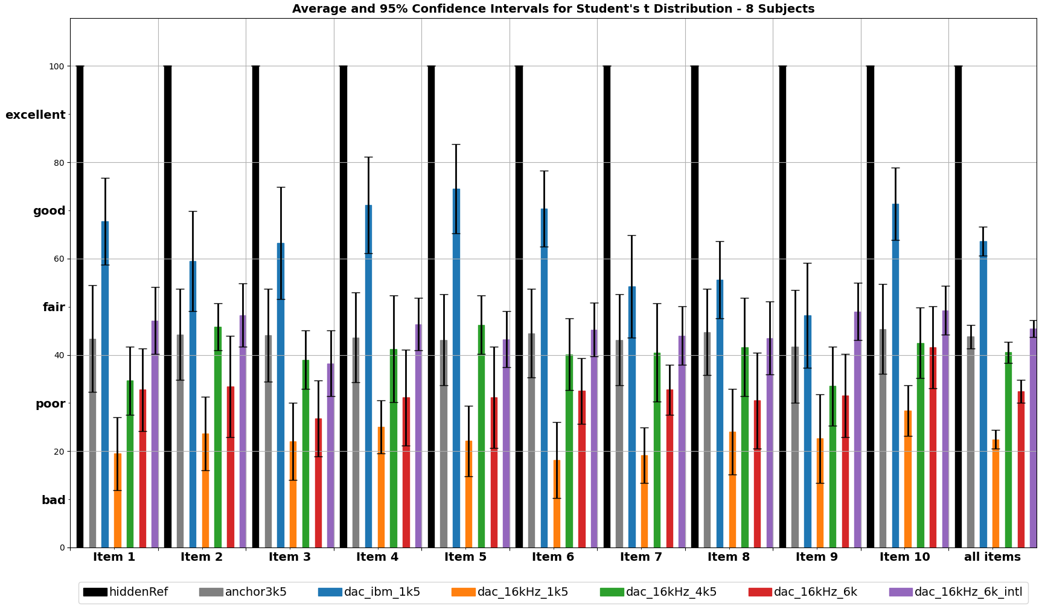
Fig 7.1.5.2-1: MUSHRA results for individual items and average averaged over all items
- As also mentioned in clause 7.1.5.1.3, when only comparing the DAC model at different rates both 4.5 kbps at 10% PLR and 6 kbps at 20% PLR show significant improvement over 1.5 kbps at 3% PLR
- Comparing all DAC conditions to the specifically trained 1.5 kbps DAC-IBM version at 3% PLR, the DAC-IBM version outperforms significantly all other conditions.
- Couple with higher loss percentage, both 4.5 kbps and 6 kbps variants show no significant improvement over 1.5kbps when specifically trained for this bitrate.
- 6 kbps with 20 % error rate was rated very close to 4.5 kbps with 10% error rate only when using interleaving and increasing the latency by an extra 80ms.
- All models under test were designed and trained without considering any packet error losses. Therefore, error resilience can be improved by appropriate training or design choices.

7.1.6 Conclusion on existing technology
The following conclusions on existing technologies can be drawn based on this sub-clause 7.1:
- AI based solution may have the potential to provide substantial better audio quality compared to conventional solutions
- Whether AI based codecs fit into complexity constraints of current chipset is FFS.
Increasing the frame duration to larger blocks than the standard 20 ms VoIP size seems to be beneficial for ultra-low bitrate coding.
- None of the presented solutions can be considered as a complete candidate for ULBC.
- Besides an optimal match on the basic parameters such as frame length or bitrate, the ULBC candidate needs to be implementable on mobile devices. Furthermore, the candidate needs to support required system aspects such as channel resilience capability or discontinuous transmission, which is currently not supported by any AI-based solution.
- The observations made in clause 7.1.5.1.6. suggests that more design freedom should be allowed in terms of bitrate and BLER to achieve best possible quality at a given SNR.
- Observations made in clause 7.1.5.4 suggest that optimal coding performance, even under error-prone conditions, is achieved when an appropriate training strategy is employed, e.g., by targeting a dedicated bit rate, and considering a specific BLER.
- Bitrate scalability, e.g. as used in the existing model DAC, comes with a significant cost in performance, especially for the lower bitrates. While sharing the same architecture, models trained for specific operation modes, e.g. DAC-IBM, are much more efficient.

]

[7.2 Very low bitrate listening test results

7.2.1 Overview
There are several traditional (DSP based) speech codecs available for very low bit operation as described in [7-2]. They are commonly considered as vocoder-style codecs. They provide understandable voice quality with somewhat limited perceptual quality, often sounding a bit “synthetic”. Their bandwidth is usually limited to narrowband (4 kHz).
On the other hand there are several AI/ML based codecs coming from various universities, researchers, and companies working in the ML area. Some of these codecs target very low bitrates, e.g., 0.5 to 1 kbit/s and some aim at a bit higher operation points, e.g., 1-6 kbit/s. Some are optimized for voice, some are even trained only with certain language. Some codecs are optimized for general audio.
Different ML codecs use varying sampling rates and some of those are different to the common 3GPP sampling rates. Thus we included different bandwidth limits to the listening test. Bandwidths included are:
- Narrowband (NB) 4 kHz
- Mediumband (MB) 6 kHz
- Wideband (WB) 8 kHz
- 10 kHz
- Semi-Super Wideband (SSWB) 12 kHz
- Super Wideband (SWB) 16 kHz
- Fullband (FB) 20 kHz
For the listening test three DSP based vocoder style codecs were chosen:
- Codec2 0.7, 1.3, 2.4, and 3.2 kbit/s, tested using ffmpeg [7-3], 7-[4]
- MELP 2.4 kbit/s [7-5]
- MPEG4 HVXC 2.0 and 4.0 kbit/s [7-6]
3GPP solutions at slightly higher bitrates are represented by:
- AMR 4.75 and 7.95 kbit/s
- AMR-WB 6.6, 8.85, and 12.65 kbit/s
- EVS-NB 5.9 and 7.2 kbit/s
- EVS-WB 5.9, 7.2, and 9.6 kbit/s
- EVS-SWB 9.6 and 13.2 kbit/s
Finally tested ML/AI based codecs include:
- DAC (Descript Audio Codec) 44k 0.9, 1.7, 2.6, 3.4, and 6.9 kbit/s [7-7]
- TSAC (Modified version of DAC) 44k 0.6, 1.2, 2.5, 3.2, and 5.9 kbit/s [7-8]
Bolded bitrates and bandwidths were tested in both ACR and DCR listening tests.
The sizes of ML codec models vary wildly. Some of them are reasonably sized (e.g., few tens of megabytes), but sometimes they are several gigabytes in size.
For codecs in current tests:
- Descript-audio-codec uses “weight.pth”-file of size 292MB.
- TSAC codec apparently has for mono operation two files “dac_mono_q8.bin” and “tsac_mono_q8.bin” for a total of 128MB.

7.2.2 Listening test results
Nokia conducted two listening tests using clean speech material. Clean speech consisted of Finnish language sentence pairs spoken by three males and three females, four sample pairs from each. The listening was conducted diotically using Sennheiser HD650 headphones in quiet listening booths. All listeners were experienced listeners, most of them were experts in the field of speech and audio processing. The first listening test used extended ACR5 test methodology, which is straightforward extension of standard P.800 ACR test [7-9]. The voting scale is extended as shown in Table 7.2.2-1 and Figure 7.2.2-1.
Table 7.2.2-1 Extended ACR5 voting scale
Grade | Quality
5.5
5 | Excellent
4.5
4 | Good
3.5
3 | Fair
2.5
2 | Poor
1.5
1 | Bad
0.5

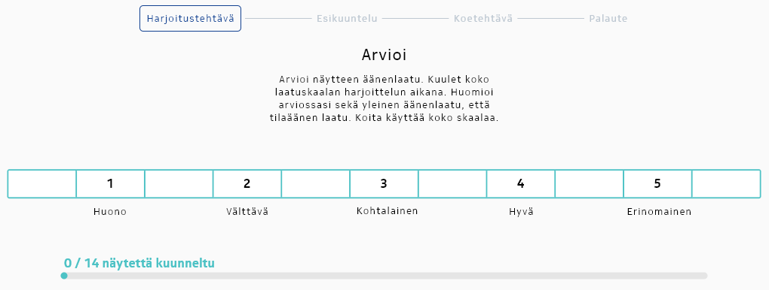
Figure 7.2.2-1 Example of extended ACR 5 voting scale in the listening test software.

7.2.3 Extended ACR5 listening test results
ACR listening results in Figure 7.2.3-1 and Figure 7.2.3-2 show that increased signal bandwidth increases perceptual quality up to a certain point. The high-frequency perception is very personal and also depends on hearing. Overall it seems that 12 kHz signal bandwidth is in the saturation region in this test. On the other hand it can be seen from the bandwidth experiment that 4 kHz signal bandwidth significantly limits the perceived quality of speech.
Regarding DSP based vocoders, MELP 2.4k and MPEG4 HVXC perform better than Codec2. From quality point of view, they could be considered as reasonable references representing DSP based vocoders.
3GPP standard codecs AMR, AMR-WB and EVS at their lowest supported bitrates perform as expected and provide good targets for performance.
Finally ML-based codecs DAC and TSAC have very good performance in clean speech, when considering their low bitrates. TSAC has somewhat better quality than DAC, which is in line with the web-page description, where they state that TSAC is an improved version of DAC. Both tested codecs have poor quality at their lowest tested bitrates below 1 kbit/s. However TSAC starting at 1.2 kbit/s and DAC starting at 1.7 kbit/s could be considered to represent ML-based codec references. Both of them were relatively easy to make run without issues.

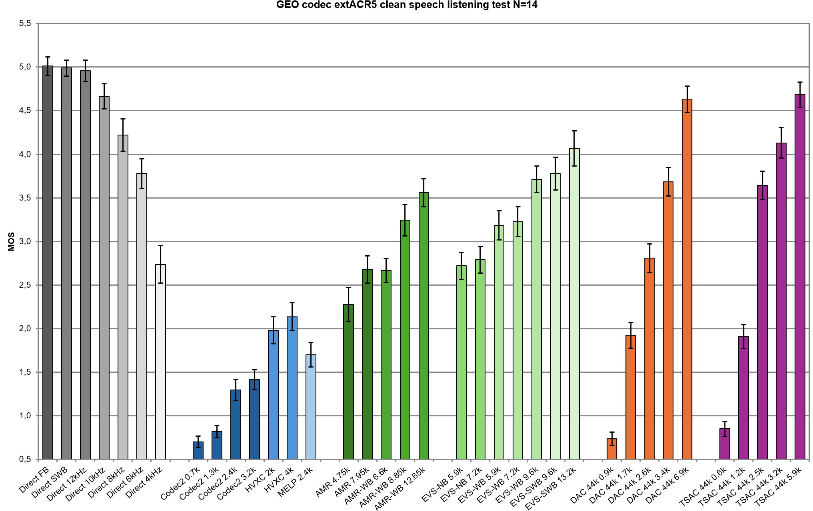
Figure 7.2.3-1 Extended ACR5 listening results of low bit rate voice codecs in clean speech.
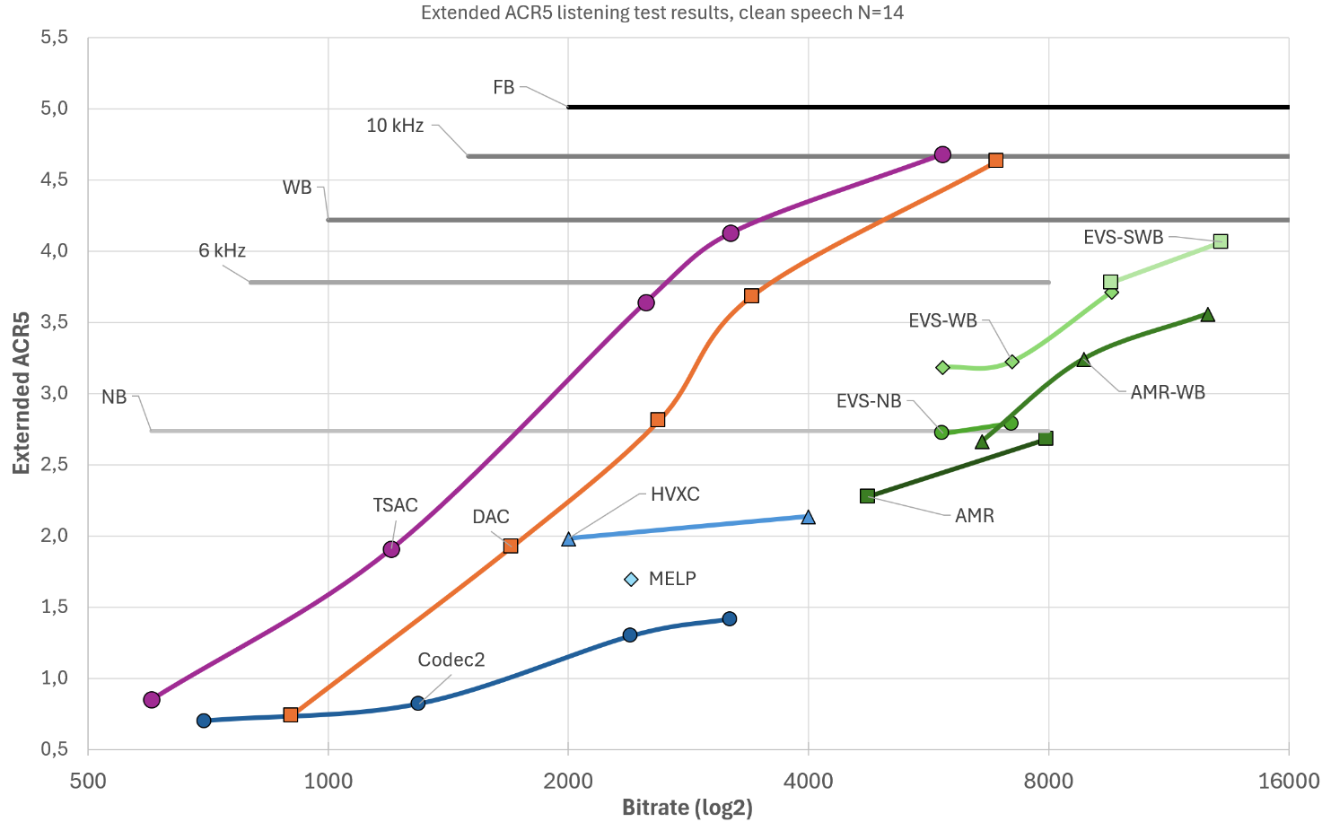
Figure 7.2.3-2 Extended ACR clean speech listening results with 14 listeners in curve format and logarithmic bitrate.

7.2.4 DCR listening test results
DCR listening test was constructed from a subset of conditions of the ACR listening test. The direct reference was the full-band signal. As can be seen listeners are more likely to notice degradations, when there is reference available. Overall the results are in line with the ACR test, with the exception that MELP is preferred over HVXC 2.0 in DCR test, when it is the other way around in the ACR test. The likely reason is that MELP has full 4 kHz bandwidth, but HVXC 2.0 has somewhat limited signal spectrum to approximately 3.7 kHz, and it therefore sounds a bit more muffled.
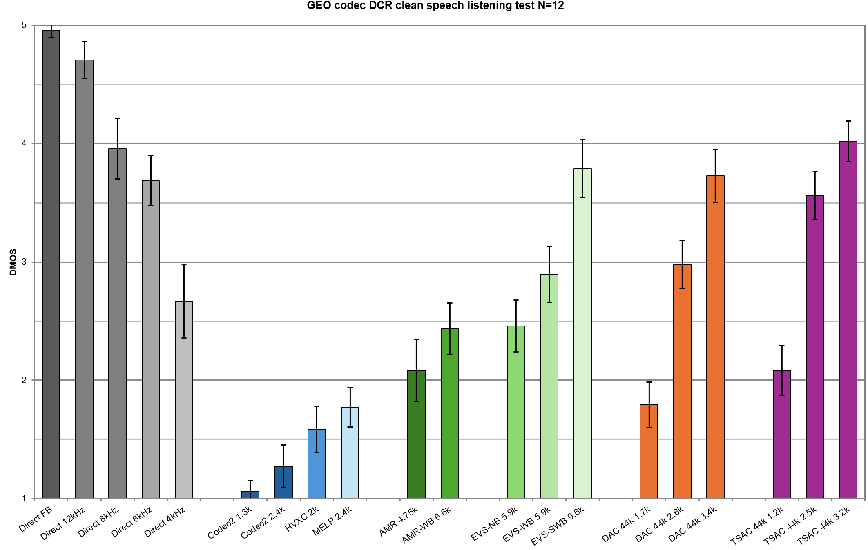
Figure 7.2.4-1 DCR listening test results of low bit rate voice codecs with clean speech

[7.3 Test results on clean speech and music/mixed content

7.3.1 Overview
The present clause collects test results comparing neural audio codecs and traditional codecs, summarizing results documented in [7-1], [7-11], and [7-12].

7.3.2 DCR test results on clean speech
A P.800 DCR experiment on clean speech is documented in [7-1]. The following codecs were included in the test:
- Conventional codecs:
- Opus at 12, 16, 24 kbps
- EVS-WB at 7.2 and 8 kbps
- EVS-SWB at 9.6, 13.2, 24.4 kbps
- AI based codecs:
- LPCNet at1.6 kbps
- Lyra V2 at 3.2, 6, 9.2 kbps
- EnCodec at 1.5, 3, 6, 12, 24 kbps
- AudioCraft at 1.5, 3, 6 kbps
- AudioDec (libritts sym) at 6.4 kbps
- DAC at 1.7, 2.6, 5.2, 7.8 kbps
- AudioDec (vctk sym) at 12.8 kbps
At the time this DCR test was conducted, codecs like Mimi, DAC-ibm were not available

In addition to these codec conditions, the Direct condition was included together with calibration conditions, corresponding to P.50 MNRU with Q = 36, 23, and 10 dB. Resampling was used to match the input sampling frequency of codecs.
For this evaluation, only clean speech was used to compare codecs. The DCR test was conducted in French. A total of 30 listeners were recruited for the subjective test and split in 5 panels of 6 listeners. The audio samples presented during the test consisted of 8sec double sentences from a phonetically balanced dataset, with 3 male and 3 female talkers. The input samples were pre-processed by a 20-20,000 Hz bandpass filter and normalized to -26 dB LKFS.
Figure 7.3.2-1 shows the Degradation Mean Opinion Scores (DMOS) and 95% confidence intervals.

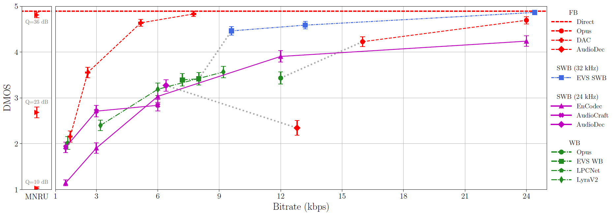
Figure 7.3.2-1 DMOS scores and 95% confidence intervals
The following observations can be extracted from the results in Figure 7.3.2-1.
- DAC has the best DMOS score among the tested codecs operating around 1.5 kbps, and increasing bitrate improves quality to a score close to Direct at less than 8 kbps
- EnCodec does not achieve the quality of ”Direct” even at 24 kbps and is below EVS and Opus at this bitrate.
- Lyra V2 (at 6, 9.2 kbps) is on par with EVS-WB at similar bitrates (at 7.2 and 8 kbps).

7.3.3 ACR test results on clean speech
A P.800 ACR experiment on clean speech is documented in [7-11]. The setup (test conditions, processed material, lab conditions) is the same as in clause 7.3.2, except that the test methodology is P.800 ACR. The motivation to replicate the experiment with an ACR test methodology to enable a more direct comparison with objective metrics predicting MOS scores such as POLQA or PESQ.
Figure 7.3.3-1 shows the Mean Opinion Scores (MOS) and 95% confidence intervals.
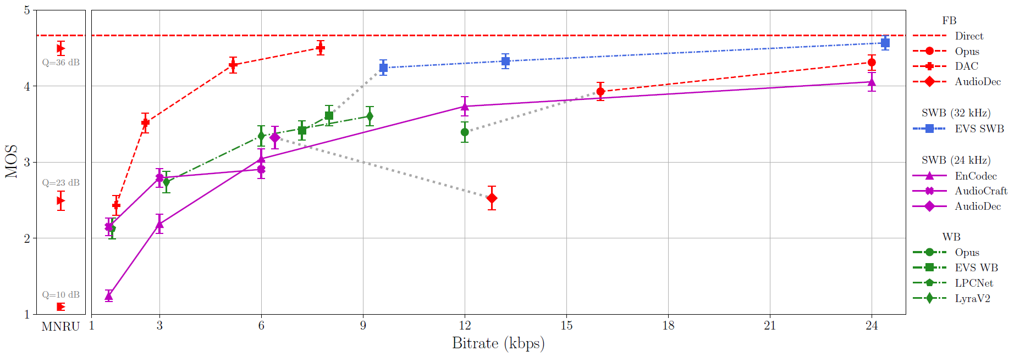
Figure 7.3.3-1 MOS scores and 95% confidence intervals
The same observations as in clause 7.3.2 can be extracted from the results in Figure 7.3.3-1.

7.3.4 DCR test results on music and mixed content
A P.800 DCR experiment on music and mixed content is documented in [7-12]. The following codecs were included in the test:
- Conventional codecs:
- xHE-AAC at 8, 12, 16, 24 kbps
- Opus audio at 16 and 24 kbps
- Opus voip at 12, 16, 24 kbps
- EVS-SWB at 9.6, 13.2, 24.4 kbps
- AI based codecs:
- EnCodec at 12 and 24 kbps
- DAC at 4.3, 6, 7.8 kbps
- HILCodec at 4.5, 6 and 9 kbps
- SNAC at 2.6 kbps
- FlowDec (75m) at 4.5, 6 and 7.5 kbps
A total of 30 listeners were recruited for the subjective test and split in 5 panels of 6 listeners.
Note that the following additional neural codecs were also pretested at all available bit rates, but not included in the test because their level of quality was found to be too low for music and mixed content: LPCNet, Lyra V2, AudioDec, FreqCodec, HifiCodec, Spectral Codecs, Vocos, DisCodec, Mimi and AudioCraft.
Editor’s Note: the table in TR 26.940 listing codecs (incl. aspects such as complexity and causal vs. no causal) should be reviewed and updated to cover codecs that were tested
The test included 30 conditions : the Direct condition, MNRUs and 24 coded conditions. The test database consisted of 6 categories (instrumental and vocal classical music, instrumental and vocal modern music, captured mixed content, artificially generated mixed content in the form of clean speech with music background). The input samples were pre-processed by a 20-20,000 Hz bandpass filter and normalized to -26 dB LKFS. Figure 7.3.4-1 shows the Degradation Mean Opinion Scores (DMOS) and 95% confidence intervals.
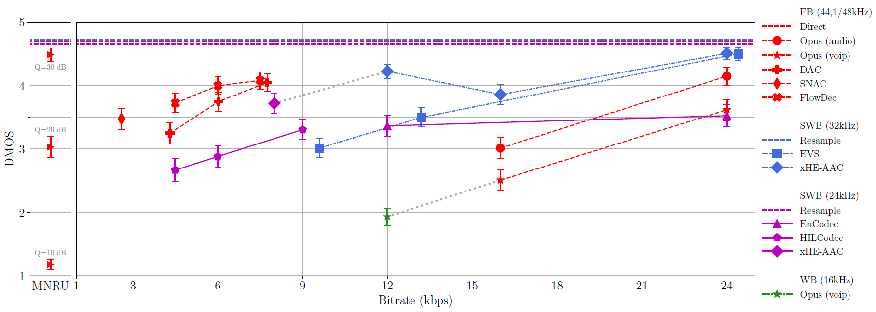Figure 7.3.4-1 DMOS scores and 95% confidence intervals
The following observations can be extracted from the results in Figure 7.3.4-1.
- Tested codecs achieving the best quality are EVS and xHE-AAC at a bitrate around 24 kbps
- The advantage of neural audio codecs is clearly visible at low bit rates. Still, no tested neural codec achieves a quality level close to Direct, and FlowDec at 7.5 kbps achieves a score of 4,08 DMOS.
- According to these results, there was no tested AI codec that could provide reasonable audio quality for music and mixed content below 2.6 kbps.
]

7.4 Impact of noise suppression on AI based codecs

7.4.1 Existing systems using noise suppression

7.4.1.1 General
In the following and in the first part, a brief review of existing coding systems that already integrate a noise reduction or suppression into a classical coding scheme is given. In the second part, some considerations are made about the robustness of neural coding in noisy environments and the merit of noise suppression in this context.

7.4.1.2 Classical speech coding
Several studies have investigated the impact of noise suppression or reduction on low bit rate classical parametric speech coders, such as MELPe [7-13] and AMR[7-14]. It reveals that noise reduction as preprocessing generally improves the quality of the extracted coding parameters and can improve the final decoded speech, especially in noisy conditions and at low SNRs. This preprocessing helps to correct errors in parameter estimation (like fundamental frequency and LPC coefficients) and reduce distortion, leading to higher intelligibility and perceptual quality.
Noise reduction modules were also designed as part of the 3GPP2 standards EVRC [7-15] and VMR-WB [7-16], with the aim of improving performance in noisy environments. In these cases, the speech coder transmits the denoised version of the noisy speech directly.

7.4.1.3 Neural speech coding
Neural speech codecs are known to be sensitive to noisy environments [7-17]. Their robustness can be influenced by factors such as training data diversity, their very low bit rates, their capacity and complexity, and quantization strategies. However, data-driven approaches implicitly make it difficult to anticipate failure modes, especially in unseen acoustic scenarios. Using noise suppression or reduction as a preprocessing step or integrated into the neural speech coder can minimize these potential issues as will be seen in the following. For low bitrates and low complexity, this also allows the neural coder to focus on modeling only the useful signal.

7.4.2 Impact of noise suppression on AI based coded speech

7.4.2.1 General
To determine the value of noise suppression for low-bit-rate speech coding, two listening tests with an absolute opinion scale were conducted in various noisy scenarios. The objective of using an absolute opinion scale is to identify listener preferences and understand how adding or not adding noise suppression to the processing chain affects user experience.
As noisy environments may vary greatly, two different assumptions and associated tests are made:
- In a first test, the assumptions done in 3GPP EVS characterization (S4-141372.zip) are adopted. It uses relatively high mixing ratios targeting SNRs between +15 dB and +20 dB in WB mode. In this first test, the same noisy types as in 3GPP EVS testing are considered, i.e. car, street and office noises.
- In a second test, more adversarial environments are considered, using also more diverse types of background noises. The SNRs have been lowered to between -5 and +15 dB, and background noise has been augmented with construction, transportation, and restaurant noises.

7.4.2.2 Test design and mixing procedure
For avoiding too exhaustive test effort, different noises are tested in the same test. The tests were performed on English speech, following the ITU-T P.808 recommendation [7-18]. The noises were taken from Annex B of the ITUT-P.501 [7-19].
In the first test, car, office and street noises are mixed randomly to 8 pairs of sentences each, at a SNR of 15, 20 and 20dB, respectively. It leads to a total of 24 pairs of sentences.
In the second test, street, construction, metro, car, office and restaurant were mixed to 4 pairs of sentences each at -5, -2.5, 0, 2.5, 10, and 15 dB respectively, leading to a total of 24 pairs of sentences.
The mixing between the noises and the speech item was performed after loudness normalization of the speech and noise signals using the BS1770demo tool from ITU-T STL [7-20]. RMS long-term option was used for the background noise level measurement by disabling the gating.
It should be noted that ACR is not the methodology used in the past in 3GPP to evaluate noise suppression or noisy speech. P.835 is typically used for evaluating systems with noise suppression. As all conditions contain the same noise suppressor, P.835 does not provide any additional information but additional testing overhead. In this experiment, the DCR methodology, which is typically used for noisy speech tests, was not chosen as subjects may consider the noise suppression as degradation when comparing with the uncoded noisy speech as given reference.

7.4.2.3 Conditions under test
Different classical and neural audio coders are under evaluation. They are tested with and without combining them with a noise suppression module used as pre-processor. An advanced and state-of-the-art noise suppression technique known as DeepFilterNet2 was used. It is based on a DNN-based discriminative model and is available as open-source software [7-21]. It has the advantage of operating at 48kHz and can be applied for the different audio bandwidth supported by the codecs under test.
For the classical speech coders, we selected MELPe, AMR, AMR-WB and EVS, covering a large range of bitrates and quality obtainable by legacy systems.
For neural audio codecs, models specifically trained on speech and targeting relatively low bitrates relevant to ULBC activities were favored. Thus, SNAC[7-22], MIMI[7-23], and DAC model with IBM weights (DAC_IBM) [7-24], which all target bitrates below 2 kbps and are trained on relatively clean speech data, are incorporated into the test. In addition, LyraV2 at 3.2 kbps has been added [7-25]. It was most likely trained on a more diverse type of data, including noisy speech, following the training strategy of the original Soundstream model from which it is derived. Furthermore, the performance of a neural codec like LyraV2 can be appreciated at a lower level of complexity in comparison to other neural codecs selected.
In addition, and only for the first test, the original DAC model and weights [7-7] at a sampling rate of 24 kHz are tested at bitrates of 1.5, 3, and 6 kbps. This will allow us to appreciate the influence of the training strategy in relation to DAC IBM.

7.4.2.4 High SNR test results
The results of test 1 and for 20 listeners are shown in Figure 7.4.2.4-1. The suffix of the conditions corresponds to the operated bitrate in bps. The suffix “_nr” in the codec names corresponds to the conditions where the codecs process and code the denoised speech after processing the noisy speech items by the noise suppressor DeepFilterNet2. For better illustration and visualization, the difference between the MOS obtained with noise suppression and without noise suppression for each codec under test is plotted in Figure 7.4.2.4-2.
The main observations are:
- Listeners prefer the uncoded clean and denoised speech over the uncoded noisy version.
- With these high SNRs and using a state-of-the-art noise suppression method, the denoised speech is as good as clean speech. This shows that current noise suppression methods introduce no or very few artifacts under these high SNR conditions.
- Noise suppression as a preprocessor is beneficial for all codecs, except for MELPe in this test, for which, at these high SNRs and global low quality, the advantage of speech enhancement could simply be greatly minimized. It should also be noted that MELPe already features a noise reduction module, which further diminishes the value of a more aggressive noise suppression at least for high SNRs.
- For classical speech codecs, the benefit of noise suppression appears to increase with bit rate or, at least, with the quality of the coded speech. One possible interpretation is that at low quality, limited bandwidth or high quantization noise could mitigate the benefit of the noise suppressor.
- For neural codecs, the benefit of noise suppression is greater, with more than 0.5 MOS point of improvement for different codecs (e.g., SNAC, DAC_ibm, DAC at 3 kbps).
- The comparison between DAC_ibm and DAC shows that the same model (same architecture and same complexity) behaves very differently depending on the training data and the target bitrate(s) during training. It is also shown that the plain DAC with original weights at 24kHz is not competitive at 1.5 kbps and probably below.
- LyraV2 operates with significantly less complexity than other neural codecs (about 70 times less complex). At 3.2 kbps, it performs worse than other neural codecs under test except for DAC at 3kbps, which is on par.
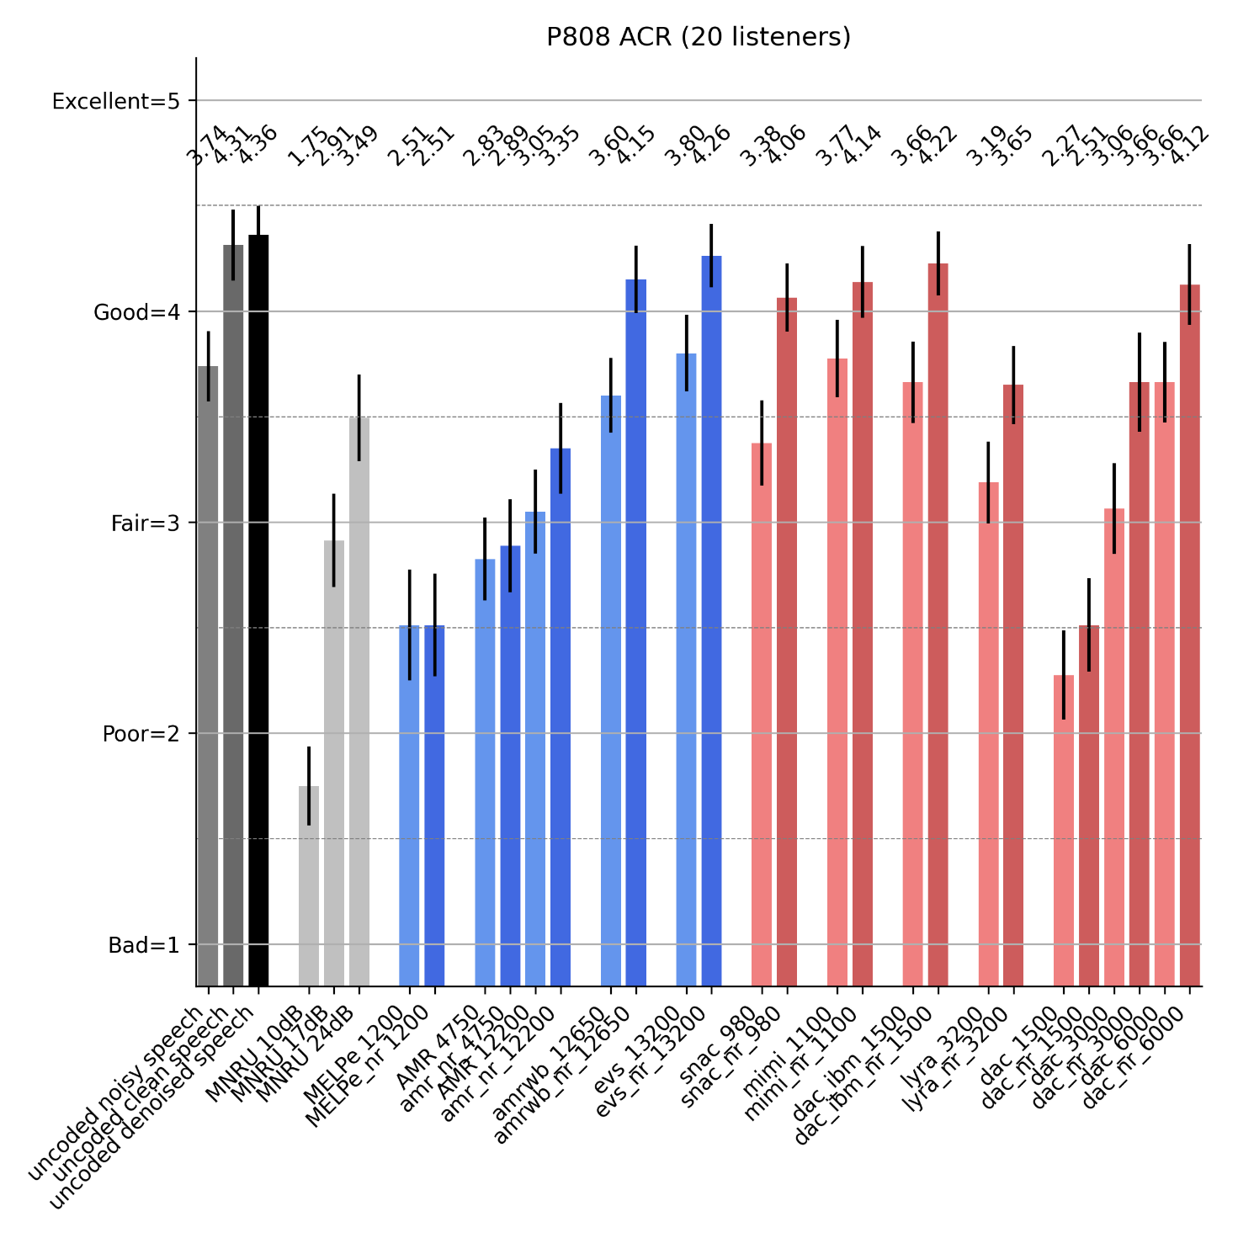
Figure 7.4.2.4-1 – P.808 ACR test results for high SNRs
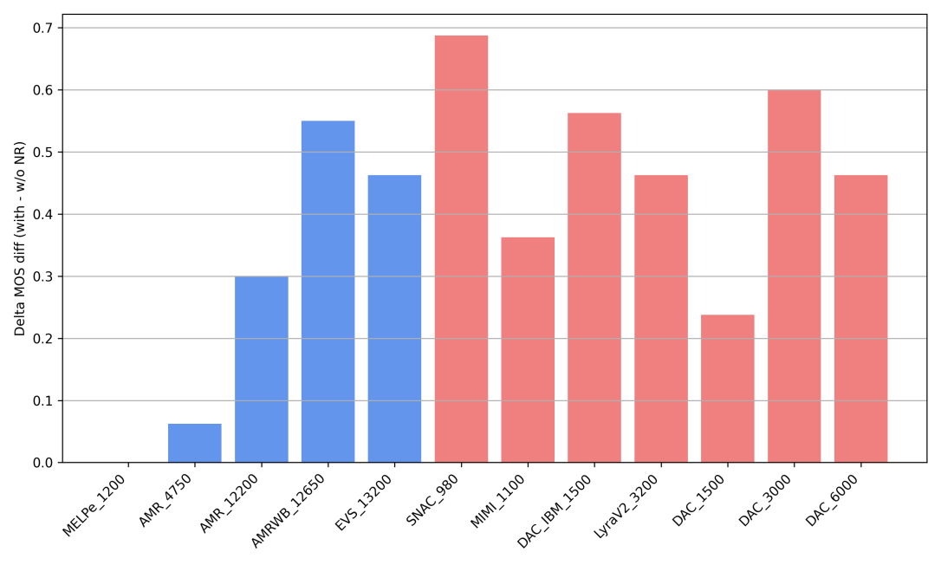
Figure 7.4.2.4-2 – Delta MOS between coded denoised speech and coded noisy speech for high SNRs

7.4.2.5 Low SNR test results
In this test, DAC codec was removed from the conditions under test, since it was already shown at high SNRs to be suboptimal for the applications considered. The results for 21 listeners are shown in Figure 7.4.2.5-1 . The difference between the MOS obtained with noise suppression and without noise suppression for each codec under test is plotted in Figure 7.4.2.5-2.
The main observations are:
- Listeners prefer largely uncoded denoised speech over uncoded noisy speech, and this by about 1 MOS of difference.
- All classical speech coders benefit from coding the denoised speech. Still, the improvement is less than 1 MOS.
- Neural speech coders benefit even more from the noise suppression stage, with an improvement which can be over 1 MOS.
- Neural speech codecs with vastly lower bit rates can compete with conventional codecs, even under adverse conditions, when combining with a state-of-the-art noise suppression method.
- Generative-AI based neural codecs as illustrated by the DAC IBM score in the test on the coding of the denoised speech can even improve the absolute quality of the input signal to code.

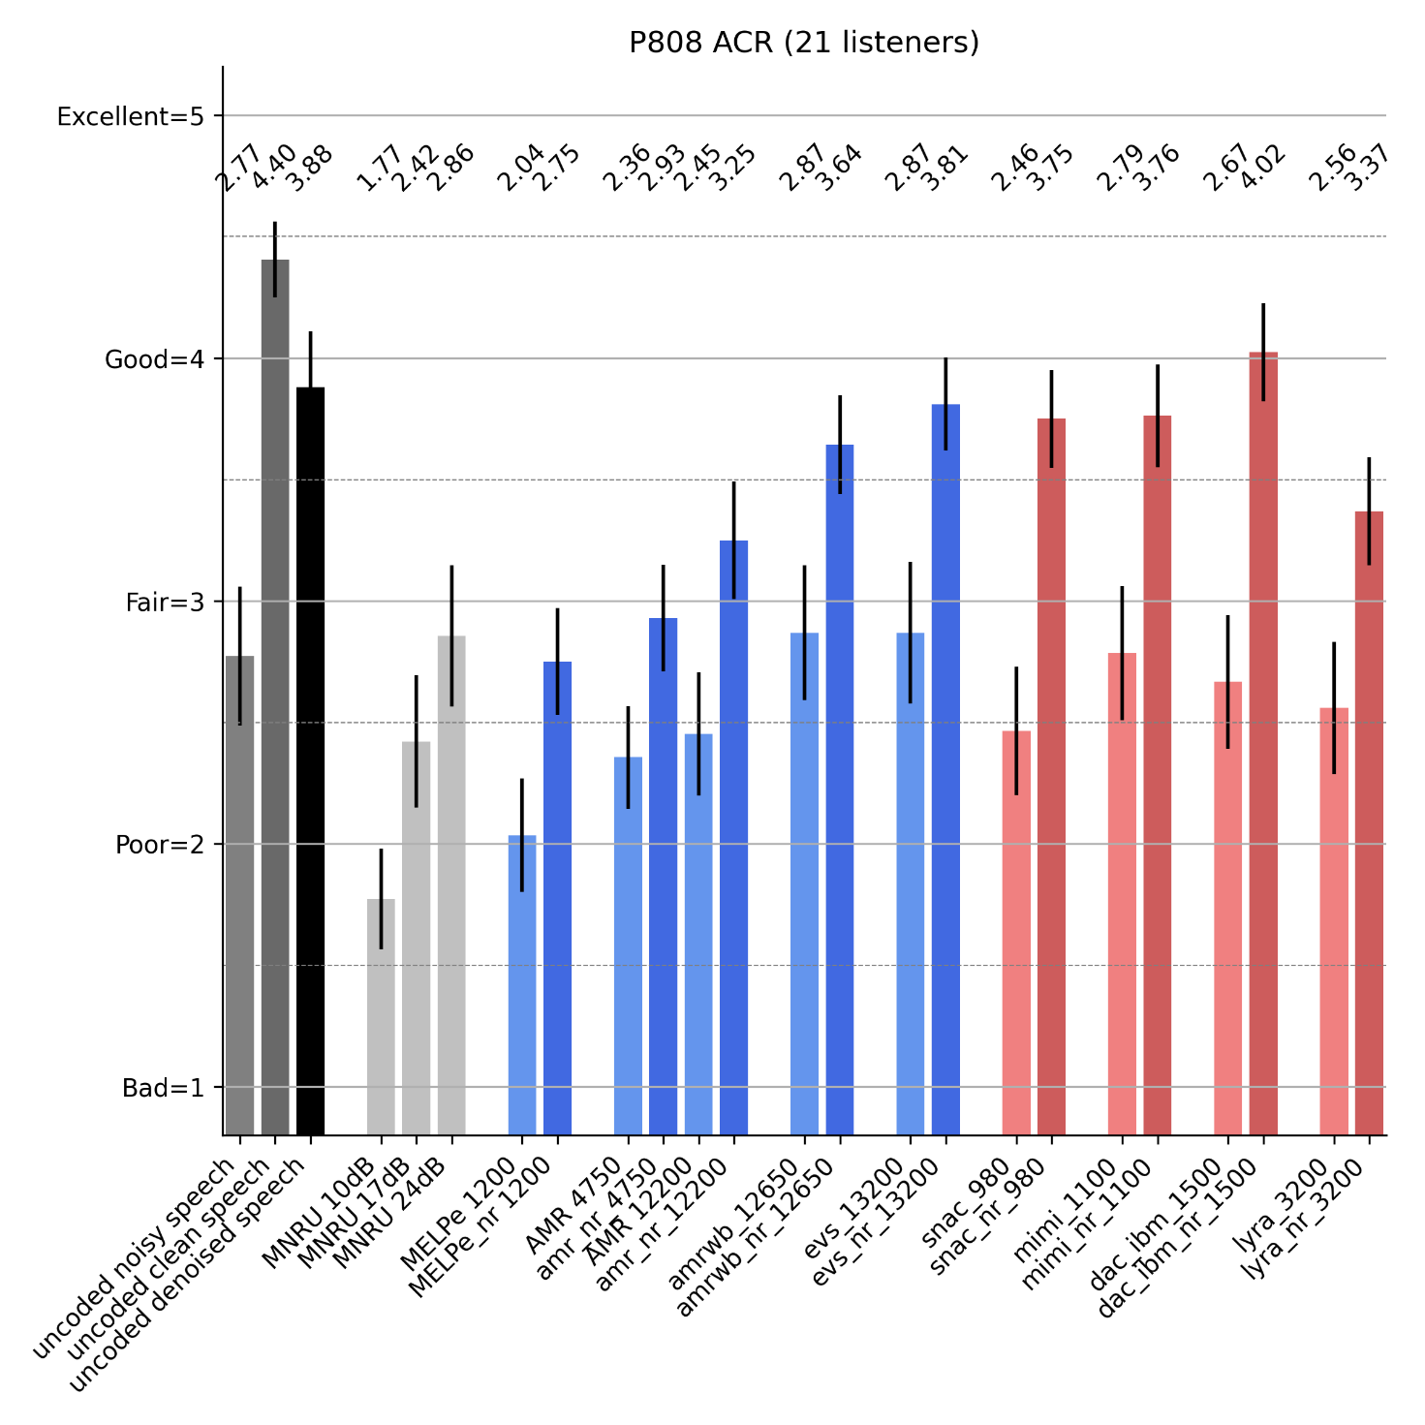
Figure 7.4.2.5-1 – P.808 ACR test results for low SNRs
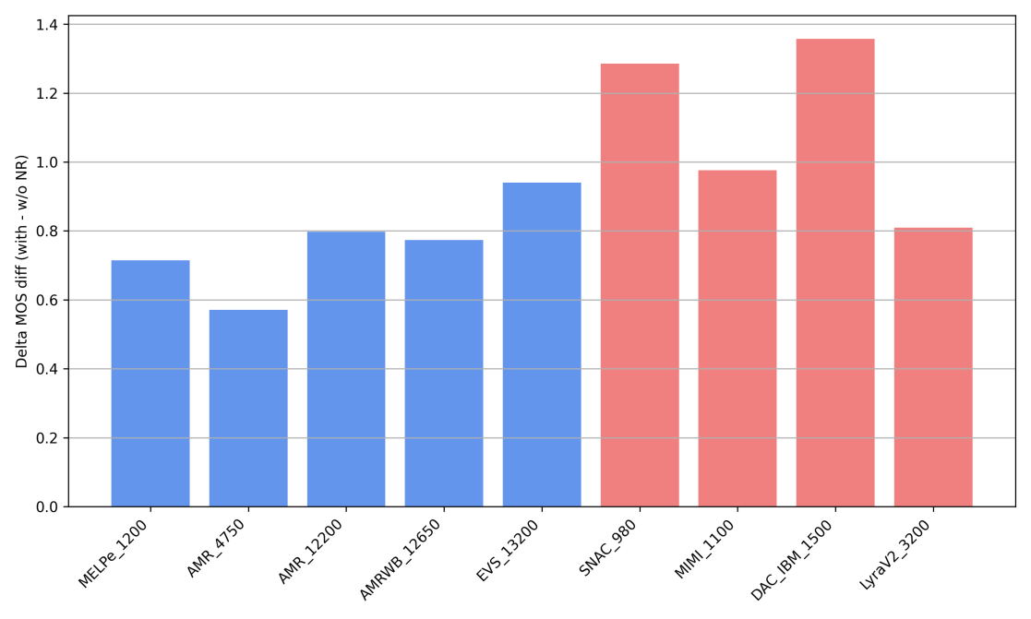
Figure 7.4.2.5-1 – Delta MOS between coded denoised speech and coded noisy speech for low SNRs

7.4.3 Conclusions
This clause presents two different listening tests demonstrating that performance of speech coders in noisy conditions can be significantly enhanced by ensuring a dedicated high SNR, e.g. by combining noise suppression and speech coding. Current neural speech coders seem sensitive to noisy environments and may benefit more from noise suppression than traditional speech coders. Ensuring a dedicated high SNR enables improved performance at very low bitrates under both high and low signal-to-noise ratio (SNR) condition.
Generally, using noise suppression methods might have an impact on overall delay and complexity, which is for further study. However, complexity and delay aspects do not affect the results of the subjective evaluation presented and the observations done thereafter.
NOTE: While speech is considered the primary information, removing all parts of the background audio scene may in some cases not be desirable, e.g. when there is no active speech, as the background may contain relevant information, e.g. in the case of emergency calls.
Editor’s note: I t is TBD whether the design constraints and performance requirements should reflect the note above.

7.5 Analysis of an existing AI codec: Lyra V2
Google Lyra V2 codec serves as a powerful case study. Its publicly reported performance of "38x faster than real-time" on a high-end modern smartphone from 2021 [7-26] is achieved entirely via CPU execution. A direct analysis of the open-source codebase confirms that all performance-critical components are implemented to run directly on the CPU, with a complete absence of NPU/TPU delegate calls. Furthermore, the codec is open-sourced under the Apache 2.0 license [7-27], which is permissive for commercial and standardization purposes, making it an ideal reference for this study.

7.5.1 Code-Level analysis
The Lyra V2 implementation consistently defaults to a CPU-based execution path for neural network inference.
- The core LyraGanModel [7-28] and SoundStreamEncoder [7-29] components explicitly use a flag (use_xnn=true) that directs the TensorFlow Lite [7-30]interpreter to use its CPU backend (XNNPACK backend [7-31]) for execution, rather than offloading to specialized hardware accelerators.
- Location: lyra/lyra_gan_model.cc
- std::unique_ptr<LyraGanModel> LyraGanModel::Create(
- const ghc::filesystem::path& model_path, int num_features) {
- auto model =
- TfLiteModelWrapper::Create(model_path / "lyragan.tflite",
- /*use_xnn=*/true, /*int8_quantized=*/true);
- if (model == nullptr) {
- LOG(ERROR) << "Unable to create LyraGAN TFLite model wrapper.";
- return nullptr;
- }
- Location: lyra/soundstream_encoder.cc
- std::unique_ptr<SoundStreamEncoder> SoundStreamEncoder::Create(
- const ghc::filesystem::path& model_path) {
- auto model = TfLiteModelWrapper::Create(
- model_path / "soundstream_encoder.tflite", /*use_xnn=*/true,
- /*int8_quantized=*/false);
- if (model == nullptr) {
- LOG(ERROR) << "Unable to create SoundStream TFLite model wrapper.";
- return nullptr;
- }

- The TFLite model wrapper implementation is notably devoid of any delegates for hardware acceleration. There are no calls to the NNAPI [7-32] delegate (for Android NPUs), Hexagon delegate [7-33] (for Qualcomm DSPs), CoreML [7-34] delegate (for Apple Neural Engine), or TPU [7-35] delegate. The architecture is fundamentally CPU-centric.
- It should be noted that the number of threads is explicitly set to only 1 in the Lyra code, as can be seen here in lyra/lyra/tflite_model_wrapper.cc Line 68 (https://github.com/google/lyra/blob/main/lyra/tflite_model_wrapper.cc#L68C5-L72C43).
- The benchmark results provided in the codebase comments confirm exceptional performance (38x real-time on a high-end modern smartphone from 2021 [7-26]) achieved through this CPU-only pathway.
Location: Comments showing a high-end modern smartphone CPU from 2021 results
# If you press 'Benchmark', you should see something like the following in logcat
# on a high-end modern smartphone CPU from 2021 when running the benchmark:
lyra_benchmark: feature_extractor: max: 1.836 ms min: 0.132 ms mean: 0.153 ms
lyra_benchmark: quantizer_quantize: max: 1.042 ms min: 0.120 ms mean: 0.130 ms
lyra_benchmark: quantizer_decode: max: 0.103 ms min: 0.026 ms mean: 0.029 ms
lyra_benchmark: model_decode: max: 0.820 ms min: 0.191 ms mean: 0.212 ms
lyra_benchmark: total: max: 2.536 ms min: 0.471 ms mean: 0.525 ms
A mean processing time of 0.525 ms for a 20 ms audio frame corresponds to being ~38 times faster than real-time.

7.5.2 Conclusion
Lyra V2 CPU-only approach provides several insights for the ULBC study and definitively proves that a state-of-the-art, low-bitrate AI speech codec, similar to Lyra v2, can achieve and exceed real-time performance requirements on a high-end modern smartphone CPU from 2021, with a significant margin towards max. RTF.

7.6 Complexity Analysis of an existing AI Codec: DAC
To investigate the relationship between theoretical complexity and practical performance, we conducted a detailed analysis of a publicly available AI codec, DAC (Descriptive Audio Codec) [7-36]. For this analysis, we used the methodology described in Clause 7.3.1 and a pretrained model from [7-37], which has a 44.1 kHz sample rate and an 8-kbps codec bitrate.

7.6.1 Methodology for Complexity Analysis
To provide objective and reproducible data, a standardized benchmarking methodology was employed. The methodology involves using the ONNX Runtime library [7-32] to execute AI models on target hardware. This approach allows for complexity performance measurement across different "execution providers." For this analysis, we used the standard CPU backend and NNAPI (Neural Networks API) [7-33] backend, which is Android's interface for offloading AI workloads to specialized hardware accelerators like NPUs.
For all tests, the original, unmodified pretrained model from reference [7-37] was used. No changes were made to the model architecture or its parameters, and no retraining was performed. The model's fully convolutional architecture allows it to process variable-length inputs; the different frame sizes tested were achieved simply by varying the length of the input audio sample provided to the model. Furthermore, no quantization (e.g., to INT8 or INT16) was applied. The original float model was used for all execution providers, including NNAPI, as quantizing this type of generative audio model can be challenging due to its sensitivity to precision.
The method is designed to measure key complexity indicators by processing audio frames of various durations. For each test configuration, warm-up iterations are performed before collecting detailed statistics over multiple runs. The primary metric gathered is the Real-Time Factor (RTF), calculated for the full end-to-end pipeline as well as for individual components (e.g., encoder and decoder stages). This allows for a comprehensive analysis of both overall complexity performance and potential bottlenecks within the model architecture.

7.6.2 Theoretical Complexity Analysis
The theoretical computational load of the DAC model was analyzed using two established profiling libraries, ptflops (v0.7.5) [7-38] and thop (v2.0.17, via the ultralytics fork) [7-39][7-40], to cross-verify the results. The complexity scales with the audio frame size, increasing from approximately 1.4 GFLOP counts a 20ms frame to 31.6 GFLOP counts for a 320ms frame, as shown in Figure 7.6.2-1.
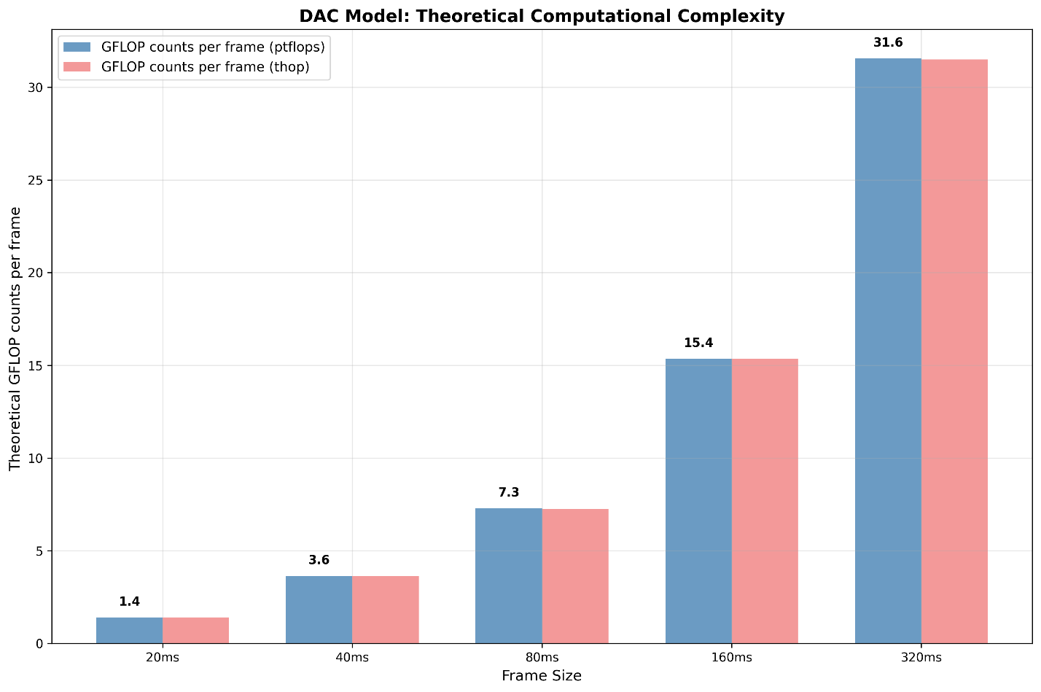
Figure 7.6.2-1 DAC Model Theoretical Complexity Comparison
The model's complexity was profiled both end-to-end and by evaluating its components separately. To simulate real-world usage, the encoder was profiled using dummy input tensors representing raw audio waveforms of shape [1, 1, floor(sample_rate * duration_in_seconds)], with the duration varied to measure complexity scaling. The decoder, which takes the quantized latent representation as input, was profiled using dummy tensors of shape [1, 1024, T], where T (time) was varied using values [1, 3, 6, 13, 27] to correspond to increasing audio durations.
Initial analysis (as documented in S4-251333) was conducted using older library versions (ptflops v0.7.4 and thop v1.1.1), which produced aligned results. However, when re-evaluating with the current, updated library versions cited in this document, a different set of results was obtained. While the newer libraries are also aligned with each other, their figures do not match the previous analysis. The change was traced back to a fundamental shift in the calculation methodology for ConvTranspose1d layers between the older and newer generations of the profiling tools.
The complexity metric we are using here (GFLOP counts per frame) represents the total number of floating-point operations required to process a single input frame of a given length. The results from both tools were highly consistent. The model has 76.9M parameters, resulting in a model size of 293 MB.

7.6.3 Real-World Inference Performance Analysis
To see how the DAC model performs in the real world, we tested it on two very different types of devices. We chose a powerful high-end desktop computer to see how fast it could run in an ideal case. We also tested it on a high-end mobile phone, which is closer to what users will actually have. This helps us understand the performance gap between a best-case scenario and a typical use case.
For our main measurement, we used the Real-Time Factor (RTF). This is an important metric because an RTF lower than 1.0 means the codec can process audio in real-time, like during a phone call. A lower RTF is always better.

7.6.4 Key Findings
Our tests gave us some important insights into how the codec performs in the real world. These findings are shown in the figures 7.6.4-1 and 7.6.4-2.
- On the high-end desktop CPU (frequency fixed to 5.7GHz), the codec is not real-time capable with a single thread (RTF between 1.6 and 1.9). As shown in Figure 7.7.4-1, real-time performance (RTF between 0.67 and 0.86) is only achievable with multi-threaded execution (4 threads). However, it is still very slow for such a high-end desktop CPU.
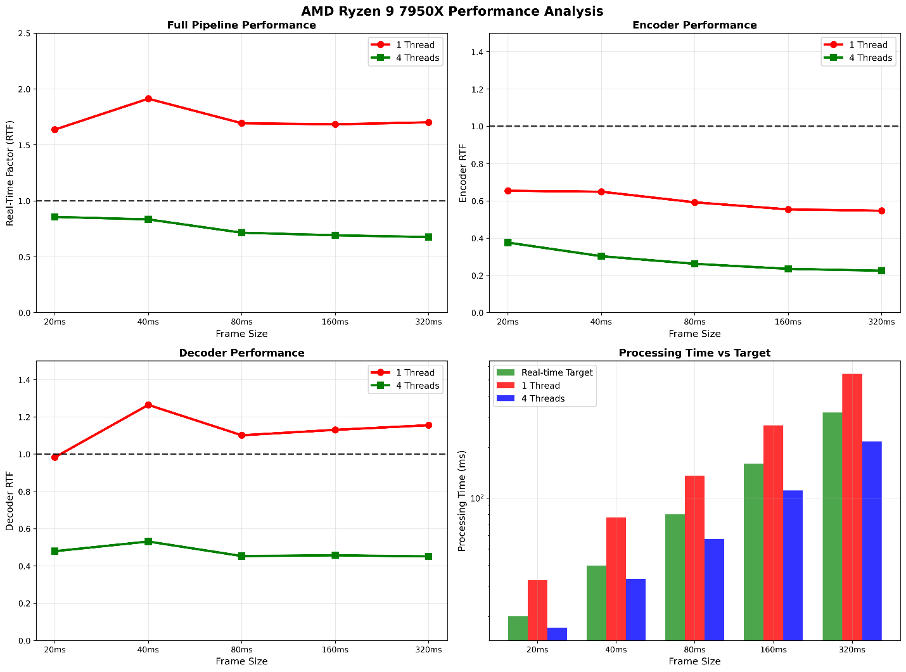
7.6.4-1 DAC Model on AMD Ryzen 9 7950X Inference Performance Analysis
- On the high-end mobile SoC (Qualcomm Snapdragon 8 Gen 2), no tested configuration achieves real-time performance. The best-case mobile RTF was 2.125 (over 2x slower than real-time), with the worst case reaching 5.884 (nearly 6x slower than real-time).
- We had hoped that using the phone's NPU through the NNAPI backend would make the codec faster. However, the results were inconsistent (Figure 7.6.4-2). Sometimes it helped a little, but for one test, it actually made performance much worse than using the CPU. This shows that we cannot simply assume that using an NPU will automatically lead to better performance in all cases and some NPU specific optimizations may be required to achieve better performance.
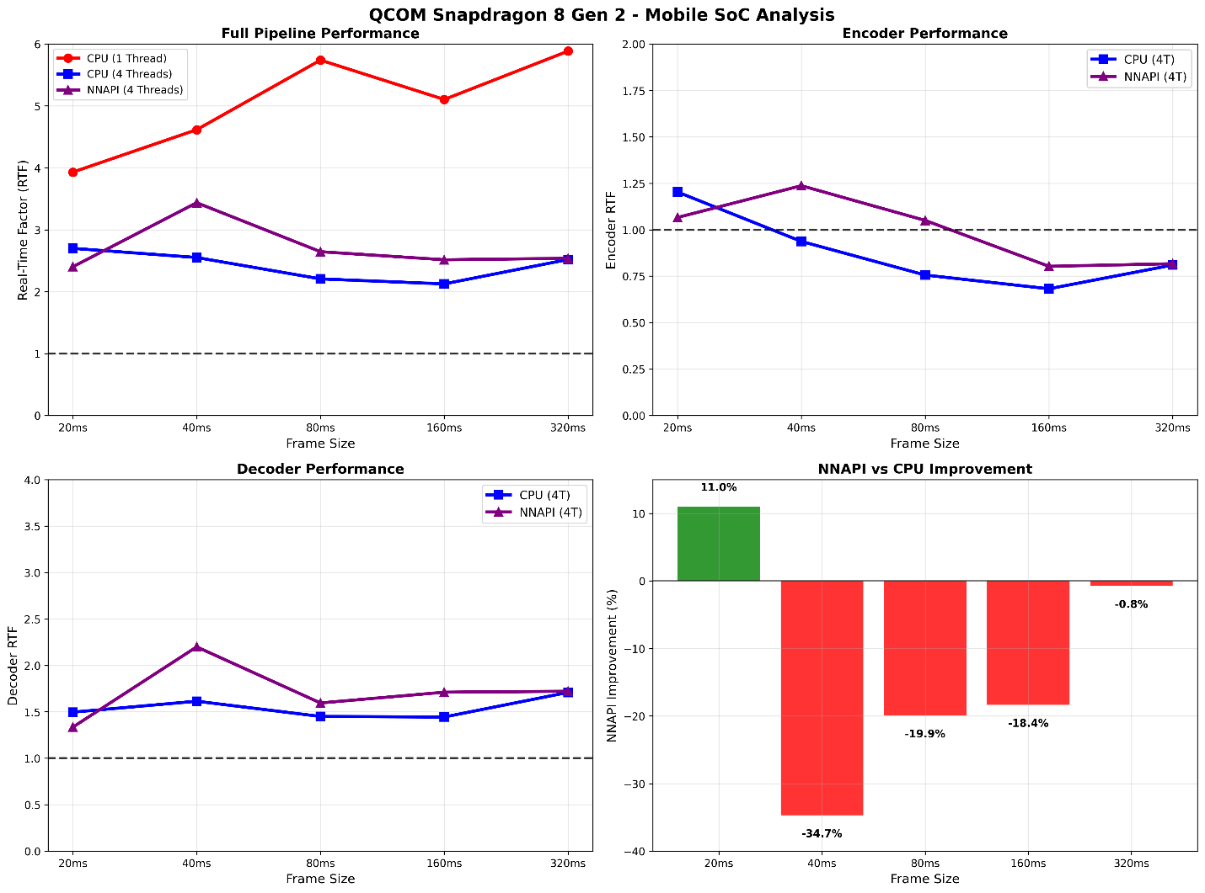
Figure 7.6.4-2 DAC Model on Qualcomm Snapdragon 8 Gen 2 Inference Performance Analysis
- The most important finding is the gap between the maximum theoretical capacity of the NPU and the actual measured performance (RTF), as shown in Figure 7.6.4-3. A model that seems to fit on paper (~2-5 GFLOP counts per frame) was not able to run in real-time on a top-of-the-line mobile phone. This result suggests that real-world testing is useful.
Editor’s note: NNAPI may fallback to CPU usage if float model is used. The impact of this behavior needs to be further verified.

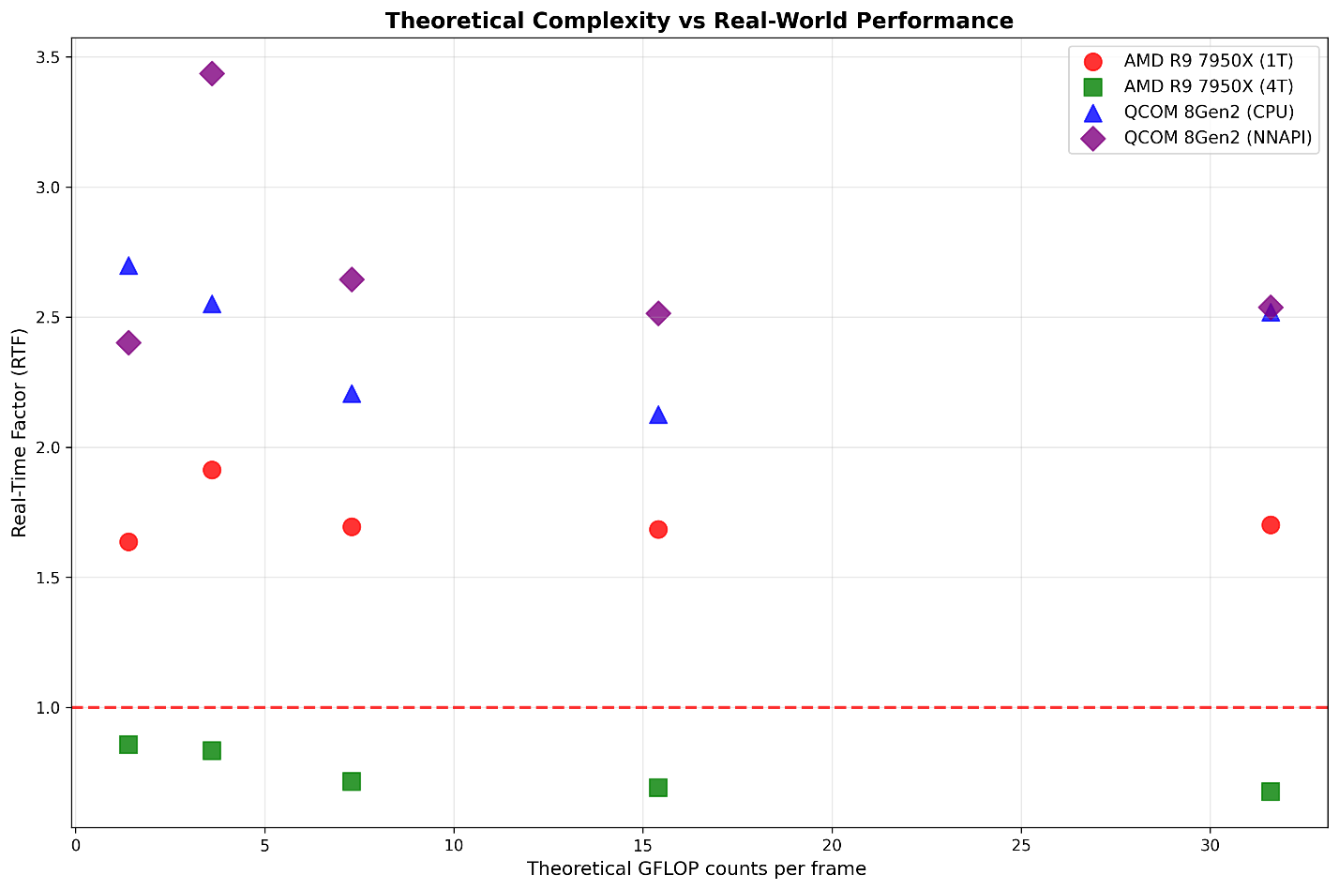
Figure 7.6.4-3 DAC Model Theoretical Complexity vs. Real-World Inference Performance

8 Performance requirements
Editor’s Note:
5a. Define performance requirements regarding speech quality, intelligibility, conversational quality, in particular taking into account:
- Clean speech and noisy speech
- Tandeming with existing IMS voice codecs
- Clean channel and GEO channel conditions
7. Identify relevant reference codecs for comparison and evaluation purposes.
8. Coordinate work with other 3GPP groups e.g. SA2, RAN, CT1, and others as needed.

8.1 General

8.1.1 Introduction
Given the envisioned application scenarios of ULBC codec in Clause 4, TR 26.940 targeting IMS voice service over GEO and NGSO, the codec is expected to deliver a level of quality consistent with what end users have come to expect based on the deployed VoLTE IMS voice services. AMR-WB 12.65kbps and EVS-SWB 13.2kbps are among the commonly deployed VoLTE codec operating points. The ULBC codec is expected to meet the following “minimum” performance requirements:
- at the operating range, e.g., around 1kbps, the ULBC codec provides speech quality that is no worse than (NWT) that of [AMR-WB @12.65kbps] in clean speech, noisy speech, and in packet loss conditions,
- at the operating range, e.g., around 3kbps, the ULBC codec provides speech quality that is no worse (NWT) than that of [EVS-SWB @13.2kbps] in clean speech, noisy speech, and in packet loss conditions
Editor’s Note: the above assumption needs to be backed by the ongoing link-level simulations within SA4. Additional bitrates may be added consequently.
Editor’s Note: ULBC codec performance in Mixed/Music content is FFS.

8.1.2 A List of Reference Codecs and Operating Points
At a minimum, the following deployed VoLTE codecs and potential operating points in the ULBC codec subjective evaluation are expected to be included.
- AMR: 12.2kbps
- AMR-WB: 8.85kbps, 12.65kbps, 23.85kbps
- EVS AMR-WB-IO: 8.85kbps, 12.65 kbps, 23.85kbps
- EVS-WB/SWB: 7.2kbps, 8kbps, 9.6kbps, 13.2kbps, 13.2kbps CA, 24.4kbps

9 Test methodologies
Editor’s Note:
5b. Identify appropriate test methodologies, regarding speech quality, intelligibility, conversational quality, in particular taking into account:
- Clean speech and noisy speech
- Tandeming with existing IMS voice codecs
- Clean channel and GEO channel conditions

9.1 General

9.1.1 Typical quality impairments of ultra-low bit rate speech coding
Speech codecs operating at ultra-low bit rates may impact aspects of speech communication in at least the following categories
- Loss of listening-only audio quality
- Audio bandwidth loss
- Impaired intelligibility
- Impaired speaker identifiability
- Prosodic impairments
- Hallucination, i.e. word and phone confusions
A related quality impairment category is sensitivity to non-speech input. Non-speech input in this context may mean any non-clean speech input such as background noise, music, but also noisy speech, interfering talker speech, reverberant speech.
Additionally, speech codecs operating at ultra-low bit rates may imply speech enhancement algorithms, such as noise suppression, gain normalization etc.
Editor’s note: Investigate impairment relevance in context of use case, e.g. emergency call.

9.1.2 Challenges of quality assessment of ultra-low bit rate speech codecs
Testing of ULBC introduces new challenges in comparison to signal processing-based codecs that may necessitate additional or alternative evaluation methods compared to previous 3GPP SA4 speech coding development activities.
Conversation-opinion tests are intended to reproduce, in a laboratory situation, the actual service conditions experienced by telephone customers. [ITU-T P.800 Section 6]. For practical reasons, and due to the need of strict test control, listening-opinion tests are often employed as an alternative in speech coding development.
According to ITU-T Rec. P.800, the recommended test method for listening-only tests is the "Absolute Category Rating" (ACR) method described in Annex B of ITU-T P.800 (see ITU-T P.800 Clause 6.2). An alternative to the Absolute Category Rating method is the Degradation Category Rating (DCR) method which is described in detail in Annex D of ITU-T P.800. As this is a comparative method it is suitable when the impairment (especially digital impairments) is small.
Based on the principles of ITU-T Rec. P.800, 3GPP established a practice of listening-only evaluations in the context of the standardization of its voice codecs. AMR, AMR-WB and EVS codecs were all evaluated using P.800 ACR and (modified) DCR test methodologies, the latter also applied for tests with larger impairments such as noisy speech over poor channel conditions. ACR was generally used for clean speech tests while P.800 DCR was used for SWB clean speech, mixed-bandwidth, speech + background noise and mixed/music quality evaluations. Other aspects relevant to speech communication, such as impaired intelligibility, impaired speaker identifiability and prosodic impairments were not the focus of testing in AMR, AMR-WB and EVS codec standardization.
For ULBC, these other aspects may need to be addressed more directly, through dedicated tests. Hallucination, for example, is a category that plays only a role in ML-based coding systems but not for signal-processing based codecs, which AMR, AMR-WB and EVS are.
While P.800 recommends ACR as the listening-only test method, it may not be the optimal test to quantify all potential impairments in speech communication such as hallucination, impaired intelligibility and prosodic impairments. These impairments are possible in ML-based coding systems and could be covered by alternative tests such as automatic speech recognition methods, modified rhyme tests and DCR tests (see below).
In contrast, DCR methodology generally focuses on differences to a reference. If such differences are small and pertain to prosodic differences, these may not directly impact the conversational capability of a communication system but can be relevant for other aspects such as identity recognition.
Besides the usage of ACR and DCR, further subjective or objective test methodologies are available that are specifically designed for the evaluation the above-listed impairment categories of ultra-low-rate speech codecs. A non-exhaustive list of such methods is:

- Diagnostic Rhyme Tests (DRT)
- Modified Rhyme Tests (MRT)
- MOS testing for speaker similarity
- Speaker verification/identification tests
- Prosodic naturalness MOS tests
- Intonation recognition tests
- Transcription tests involving testing for word and semantic equivalence
- Phoneme recognition tests
- Automatic speech recognition tests
Speech enhancing tool, which may be part of ultra-low bitrate-codecs, are typically evaluated by multi-dimensional rating scales provided by P.835. Here, the quality of speech and the noise suppression capability are evaluated separately.

9.1.3 Subjective Testing Considerations
In addition to the test methodologies, it is important to focus on test material and criteria.

9.1.3.1 Robustness related to source material
To ensure the general robustness of the ULBC codec, it is critical to conduct evaluations across multiple languages with talkers with diverse intonations as well as non-speech signals. This diversity should encompass a variety of linguistic features and accents to gauge the codec’s effectiveness across diverse phonetic and linguistic environments. Moreover, incorporating a wide range of speakers, with different voice pitches and speaking styles, overlapping talkers will further test the codec’s versatility and its ability to handle natural variations in speech.

9.1.3.2 Simulation of Real-world Acoustic Conditions
The testing environment should mimic real-life scenarios to validate the codec's performance in practical applications. This involves simulating different acoustic conditions such as clean (minimal background noise), noisy environments (traffic, human chatter, vehicle), and spaces with varying levels of reverberation (e.g., various RT60s ranging from 0.3s to 1.0s).

9.1.3.3 Tandeming and Compatibility Testing
An important aspect of codec evaluation (e.g., during candidate Selection) is codec’s performance in tandeming scenarios, where audio data is processed multiple times by different codecs. For ULBC subjective testing, it is vital to test how well the codec performs when handling speech previously encoded by codecs such as ITU-T G.711, AMR, AMR-WB, and EVS. Besides tandeming, the testing should cover various input levels, e.g., -16dBov, -26dBov, and -36dBov.

9.1.3.4 Conclusion
While ITU-T P.800 ACR/DCR can serve as the backbone for most of the subjective testing of ULBC, other methodologies may be considered.
Besides the test methodology, emphasis should be given on selecting and creating a diverse test material and criteria considering: 1) multilingual, multi-speaker testing, 2) real-world acoustic conditions, and tandeming.
Editor’s note: Other options for listening methods are invited for documentation.

9.1.4 Objective Testing Considerations

9.1.4.1 Correlation analysis results
NOTE: The correlation results in the present subclause cannot be used to derive general conclusions on metric performance or identify what could be in general the “best” objective quality metric; these results are based on limited data (one ACR experiment with clean speech, one DCR experiment with music and mixed content) and the number of very low bitrate codecs was limited.
Based on the ACR experiment presented in clause 7.3.3, a correlation analysis was performed to evaluate a selected subset of objective models in [7-11]:
- Speech-oriented metrics: PESQ, POLQA, ViSQOL-S (S for speech), WARP-Q, DNSMOS, NISQA, NORESQA, UTMOS
- Metrics for general audio: PEAQ, ViSQOL-A (A for audio).
In addition, the more recent SCOREQ, NOMAD, SSLMOS metrics have been incorporated in this analysis.
These objective models were compared based on typical evaluation metrics: Pearson correlation coefficient, root
mean squared error (RMSE) and Kendall’s Tau rank correlation coefficient. Details on the evaluation, including the determination of linear and 3rd order polynomial mapping, can be found in [7-11].

Figure 9.1.4.1-1 summarizes results from this correlation analysis on clean speech.
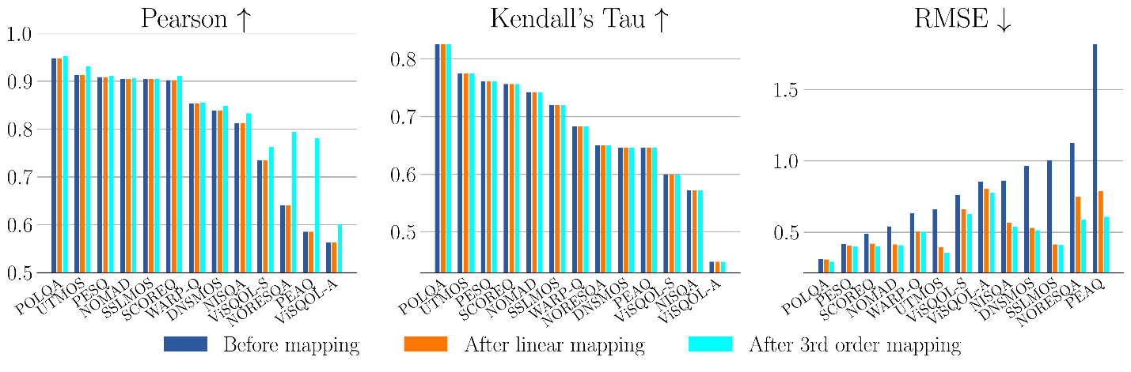
Figure 9.1.4.1-1 Correlation results on clean speech.
The following observations can be extracted from the results in Figure 9.1.4.1-1.
- The models reported as “best performing” in [7-11] (i.e., POLQA, UTMOS, PESQ, WARP-Q), as well as SCOREQ which was not included in [7-11], predicted accurately the monotonic bitrate/quality behavior of tested multirate codecs – which was not always the case for other tested models.
- Models operating at 16 kHz (PESQ without mapping, UTMOS and WARP-Q with mapping) had relatively good performance, even for fullband codecs.
- Except for few models (e.g., PESQ or POLQA), mapping helps improving accuracy (RMSE).

Similarly, based on the DCR experiment on music and mixed content presented in clause 7.3.4, a correlation analysis was performed to evaluate a selected subset of objective models in [7-12]: POLQA, PEMO-Q, ViSQOL-A, POLQA. To get a more complete benchmark, the 2f-model has also been incorporated in this analysis.

Figure 9.1.4.1-2 summarizes results from this correlation analysis on music and mixed content.
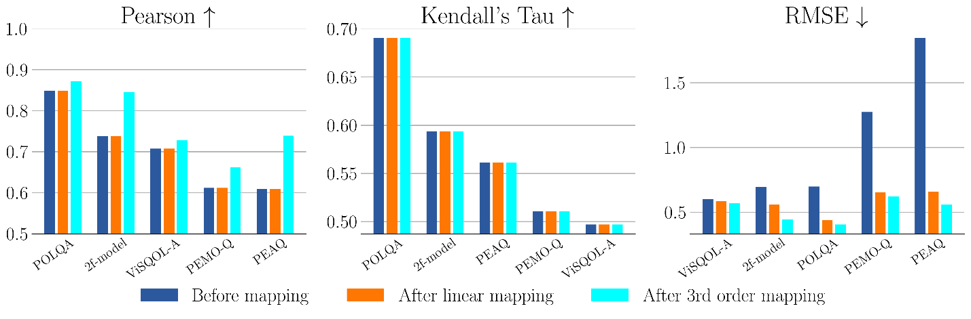
Figure 9.1.4.1-2 Correlation results on music/mixed content.
The following observations can be extracted from the results in Figure 9.1.4.1-2.
- POLQA is not recommended for non-speech signals, still this metric gives the best correlation results (in terms of Pearson, Kendall, and RMSE after 3rd order mapping). The 2f model is the second-best performing model in the tested cases.
- ViSQOL Audio, PEAQ and PEMO-Q have fair performance, although they are adapted to music and mixed content.
- Correlation scores in Figure 9.1.4.1-2 are lower than in Figure 9.1.4.1-1, this may be due to a more difficult task of predicting quality for general audio and a mismatch with test methodology grading (DCR).

9.1.4.2 Discussion
P.862 (PESQ) is officially “withdrawn” by ITU-T. This model cannot be considered as a “valid” standard. P.863 is still the “main” standard in ITU-T, however P.SAMD is emerging as a potential alternative.
Testing and parameter adjustment based on objective tools is typically not recommended. 3GPP TR 26.921 already documented that tuning noise reduction based on PESQ should be avoided.

9.1.4.3 Conclusion
For codec selection subjective testing remains the “golden reference”. Objective metrics are not recommended for codec selection criteria and even codec tuning. However, the correlation of subjective and objective metrics may be considered as part of the characterization of a new codec, and objective metrics have merits in other tasks such as codec conformance testing.

9.1.5 ULBC Codec Testing Considerations in Noise

9.1.5.1 Background
Noise suppression (NS) algorithms are typically tailored for each device, optimized according to the specific placement and design of microphone arrays to maximize sound quality. [Adopting an NS algorithm within a codec can introduce challenges, particularly in terms of front-end processing efficiency.]
- Device-Specific Optimization: The effectiveness of NS algorithms is highly dependent on the physical and acoustic properties of each device. A generic NS algorithm applied uniformly across different device types could result in suboptimal audio performance, particularly in devices with specialized hardware configurations.
- ULBC codec’s robustness in noise: Testing the ULBC codec in clean and noisy conditions following the principles of EVS codec testing (TR 26.952) may provide better understanding of the ULBC candidate’s robustness.
For emergency calls, it may be important not to remove all background noise, as the noise may contain critical information — for example, voices or sounds in the background that help identify the caller’s environment or indicate ongoing danger. In situations such as emergency response or law enforcement communications, some background sounds can provide valuable context and may be preserved. In non-emergency voice calls, noise suppression may be tuned and adaptively configured to remove noise and minimize distractions.
It is essential to allow flexibility in the implementation of the NS algorithms. This will enable manufacturers to develop and integrate NS systems that are fine-tuned to the specific requirements, thereby ensuring optimal performance across all device types and use cases.

9.1.5.2 Recommendations for ULBC Codec Testing
EVS codec testing (TR 26.952) in noise considered car noise, street noise, and office/babble noise at 15 dB, 20 dB, and 20 dB, respectively. The ITU-T P.800 DCR test methodology (e.g.,“Degradation of Speech in Noise” DMOS test) was used for the tests to evaluate the codec’s performance in noisy speech.
Following the principles of established testing framework from EVS, an example proposal is given in Table 9.1.4.1 below where the ULBC codec is tested in the following scenarios:
- Clean speech
- Noisy speech: Stationary noise e.g., at SNR of 15 dB
- Noisy speech: Non-stationary noise e.g., at SNR of 20-25 dB
Editor’s note: It is still TBD how to handle the case of noise suppression effect by the codec.
In accordance with the principles outlined in the “EVS-3 Permanent Document: EVS Performance Requirements,” it is recommended that objective performance methods be used to verify background noise attenuation in ULBC codec noise testing.
Table 9.1.5.2 ULBC testing following the EVS codec testing framework
Source Material | Noise type | SNRs | Subjective test methodology
Clean speech | - | - | ITU-T P.800 DCR, [and/or ACR]
Speech + Noise | Stationary noise (car, etc) | 15 dB | ITU-T P.800 DCR, [and/or ACR]
Speech + Noise | Non-stationary noise (street, babble, etc) | 20-25dB | ITU-T P.800 DCR, [and/or ACR]

10 Considered work plan for potential normative work
Editor’s Note:
9. Define potential normative work item objectives and timeline.

11 Conclusions and recommendations

Annex A (informative):
Change history
Date | Meeting | TDoc | CR | Rev | Cat | Subject/Comment | New version
2025-04 | SA4#131-bis-e | S4-250451 |  |  |  | Initial version submitted for SA4#131-bis-e | 0.0.1
2025-04 | SA4#131-bis-e | S4-250749 |  |  |  | Agreed version in SA4#131-bis-e | 0.1.0
2025-05 | SA4#132 | S4-251152 |  |  |  | Updated with agreed Tdoc: S4-250857,S4-251161, S4-250923, S4-251116, S4-251125, S4-251172 | 0.2.0
2025-08 | SA4#133-e | - |  |  |  | Version withdrawn | 0.3.0
2025-11 | SA4#134 | S4-251810 |  |  |  | Updated with agreed Tdoc: S4aA250256, S4aA250265, S4aA250260, S4aA250276, S4aA250253, S4aA250269, S4aA250275, S4aA250261, S4aA250262, S4aA250263, S4aA250264, S4aA250268, S4aA250252, S4aA250275 | 0.4.0
2025-11 | SA4#134 | S4-252107 |  |  |  | Editorial corrections + Tdoc S4-252129 | 0.5.0
2026-02 | SA4#135 | S4-260144 |  |  |  | Upated with agreed Tdoc: S4aA250136 | 0.5.1
2026-02 | SA4#135 | S4-260424 |  |  |  | Upated with agreed Tdoc: S4-260316, S4-260447, S4-260154,  S4-260354, S4-260364, S4-260417, S4-260419, S4-260420. | 0.6.0

