3GPP TSG-SA WG4 Meeting #135 S4-260282
9-13 February 2026, Goa, India

CR-Form-v12.2
CHANGE REQUEST
 | 26.804 | CR | 0038 | rev | 2 | Current version: | 19.1.0
For HELP on using this form: comprehensive instructions can be found at
http://www.3gpp.org/Change-Requests.

Proposed change affects: | UICC apps |  | ME |  | Radio Access Network |  | Core Network

Title: | [FS_AMD_Ph2] WT#8: Multi-access media delivery – additional requirement
Source to WG: | LG Electronics Inc., Samsung Electronics Co. Ltd.
Source to TSG: | S4
Work item code: | FS_AMD_Ph2 |  |  |  |  |  | Date: |  |  | 2026-02-10
Category: | C |  |  |  |  |  | Release: |  |  | Rel-19
 | Use one of the following categories:  F (correction)  A (mirror corresponding to a change in an earlier release)  B (addition of feature),  C (functional modification of feature)  D (editorial modification)  Detailed explanations of the above categories can  be found in 3GPP TR 21.900. |  |  |  |  |  |  |  | Use one of the following releases:  Rel-8 (Release 8)  Rel-9 (Release 9)  Rel-10 (Release 10)  Rel-11 (Release 11)  …  Rel-16 (Release 16)  Rel-17 (Release 17)  Rel-18 (Release 18)  Rel-19 (Release 19)
Reason for change: |  | For the transport of M4 media flows using GBR QoS flows, the UE application can required to provide a mechanism that performs QoS mapping between non-3GPP access and 3GPP QoS profiles, ensuring consistent QoS treatment across heterogeneous access networks.  - WT#8: Multi-access media delivery phase 2: Clause 5.18.7 of TR 26.804 lists topics for further study on multi-access media delivery, including the impact on splitting M4 media flows when transported as GBR QoS flows; implications of the ATSSS architecture for UE multipath management, dynamic policy, network assistance, and network slicing procedures; and alignment with the study on media delivery from multiple service locations/endpoints. Additionally, based on discussion with 5G-MAG, the impact of multi-access media delivery for uplink streaming is to be studied.
Summary of change: |  | The UE collects QoS information from non-3GPP access and maps it to the relevant 3GPP QoS profiles.
Consequences if not approved: |  | Consistent QoS support for M4 media flows cannot be achieved in multi-access media delivery.
Clauses affected: |  | 5.18.1.5, 5.18.3, 5.18.5.3.1,
 |  | Y | N
Other specs |  |  | X | Other core specifications |  |  |  | TS/TR ... CR ...
affected: |  |  | X | Test specifications |  |  |  | TS/TR ... CR ...
(show related CRs) |  |  | X | O&M Specifications |  |  |  | TS/TR ... CR ...
Other comments:
This CR's revision history:

===== CHANGE#1 =====

5.18.1.5 Key Issue objectives
When the UE and the network agree to use a Multi-Access PDU Session (as described in clause 5.18.1.2.1 of the present document) for a 5G Media Streaming session, it is not clear how the Dynamic Policy feature specified in TS 26.501 [15] and TS 26.510 [108] is activated and implemented for application flows over multiple access networks.
Specifically, the following issues need to be studied:
- If M4 application flows are carried over two access networks, what does "activate dynamic policy with QoS requirements" mean – whether the requested network QoS is applicable to one, or more, or all access paths.
- Is it feasible to request QoS for a subset of access paths over specific access networks?
- Are any enhancements to the ApplicationFlowDescription type described in TS 26510 [108] needed to support identification of M4 application flows over multiple access networks?
NOTE : It needs to be checked when the QoS related information from the 3GPP access nodes and non-3GPP access nodes is sent to the UE if such information is available to the UE, it needs to be studied:
- How Media Client in the UE gets access to this information
- How the Media Client in the UE maps the QoS related information between 3GPP and non-3GPP access networks

===== CHANGE#2 =====

5.18.5 Gap analysis and requirements

5.18.5.3 Gaps in Multi-Access media delivery using without ATSSS

5.18.5.3.1 Gaps in mapping QoS between Non-3GPP and 3GPP
In TS 26.501, the 5G Media Streaming architecture (Figure 4.1.1) does not need a mechanism or reference point to convey QoS related information from non-3GPP accesses to the 5GMS control plane/entities. To enable GBR QoS Flows support in multi-access scenarios, QoS mapping from non-3GPP access to 3GPP-based QoS is required. It should be possible to compare whether the QoS required for media streaming can be supported across 3GPP and non-3GPP accesses, regardless of which access node the UE is connected to. The mapped information can assist multipath steering or switching decision without using ATSSS scenario. In addition, when traffic steering is considered for GBR QoS flows, it is necessary to verify that the required QoS can be supported across all involved access nodes. In the current Release of TS 23.501, non-3GPP access is required to include Additional QoS Information; however, this is outside the scope of ATSSS.
NOTE: The multipath feature can be supported over any type of access network including untrusted and trusted non-3GPP access networks described in clause 4.2.8 and 5.5 of TS 23.501. MA PDU Session can be established over these types of access network.
NOTE: If the QoS of the Non-3GPP access can be mapped to an equivalent QoS value in the 3GPP access, this can facilitate the support of GBR QoS flows.

===== CHANGE#3 =====

5.18.X.X Multi-access switching procedures with Non-3GPP QoS mapping procedure
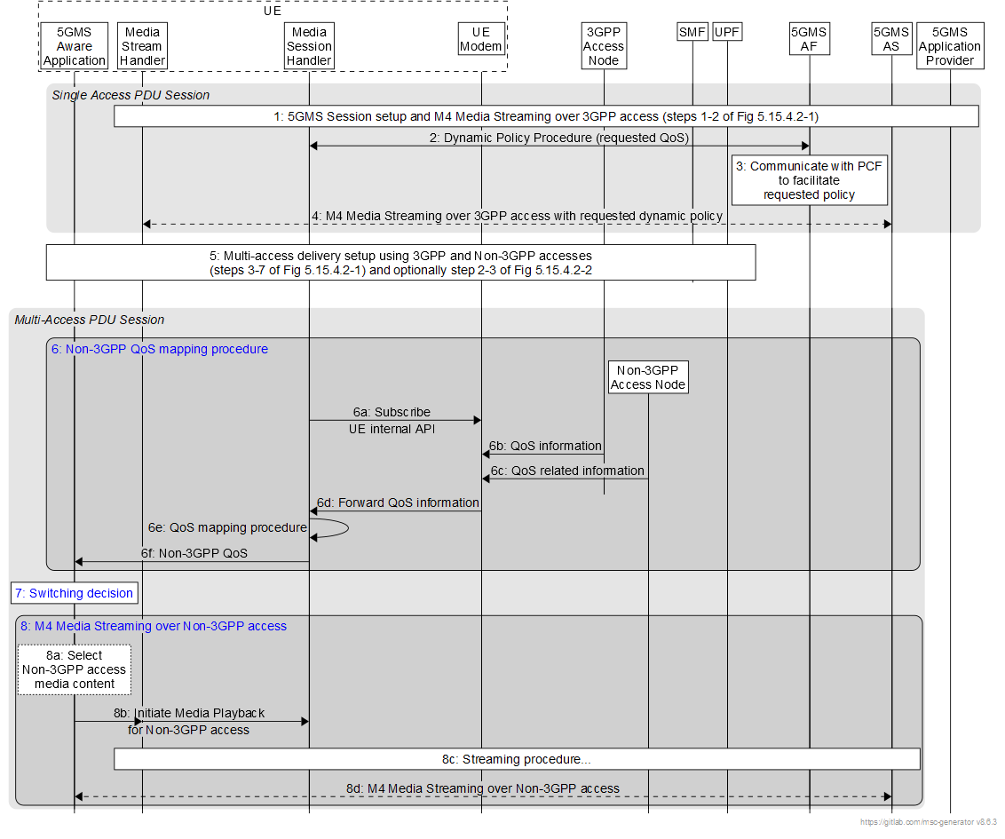
The steps are as follows:
1. A 5G Media Streaming session over a Multi-Access PDU Session is set up, and M4 media flows are exchanged by the Media Stream Handler in the UE and 5GMS AS over an access network (e.g., 3GPP access) as described in steps 1–2 of figure 5.18.4.2-1 of the present document.
2. The Media Session Handler in the UE 5GMS Client instantiates a Dynamic Policy in the 5GMS AF to be applied to 5G Media Streaming session as described in clause 5.7.4 of TS 26.501 [15]. In some cases, a QoS specification may be provided which contains the desired QoS information.
3. The 5GMS AF interacts with the PCF on behalf of the 5GMS Client (directly if the 5GMS AF is deployed in the Trusted DN, or via the NEF if 5GMS AF is in the external Data Network) to facilitate the application of the requested Dynamic Policy.
4. The M4 media flows are transferred between the Media Stream Handler and 5GMS AS over 3GPP access with the requested dynamic policy.
5. A multi-access media delivery session is set up using 3GPP access and non-3GPP access networks as described in steps 3–7 of figure 5.18.4.2-1 and steps 2–3 of figure 5.18.4.2-2 of the present document. The 5GMS-Aware Application may or may not be aware of multi-access media delivery.
6. Non-3GPP QoS mapping procedure :
6a. The UE Media Session Handler subscribes to receive QoS related information from the UE Modem about 3GPP and Non-3GPP access networks using an UE internal API.
6b. The UE Modem collects QoS information from the 3GPP access (e.g. QoS profile, GBR capability) as described in clause 4.12a.5 of TS 23.502 [23502].

6c. The UE Modem collects QoS related information from the non-3GPP access node associated with the non-3GPP access. (e.g. DSCP) as described in clause 4.12a.5 of TS 23.502 [23502].

6d. UE Modem notifies the UE Media Session Handler about the QoS related information received from the 3GPP and Non-3GPP access nodes received in above steps
6e. The Media Session Handler performs a QoS mapping procedure based on the association between non-3GPP access QoS characteristics and 3GPP QoS profiles. (e.g. DSCP-QCI, DSCP-5QI) as described in clause 4.12a.2 of TS 23.502[23502]
NOTE: The mapping of a DSCP value to a QoS level of the non-3GPP Access Network is outside the scope of 3GPP and is left to implementation. An example mapping is described in an informative annex in clause C.3 of TS 29.513 [29513].
6d. The Media Session Handler updates the mapped non-3GPP QoS parameters to the 5GMS-Aware Application.
7. Based on the QoS mapped information, the UE Media Session Handler decides to switch the media delivery path and selects Non-3GPP access for subsequent media content delivery.
8. Media delivery over non-3GPP access :
8a. The 5GMS-Aware Application determines the media content to be delivered over the non-3GPP access.
8b. Media playback over the non-3GPP access is initiated. Subsequently, the M4 media flows are transported over the non-3GPP access with the requested QoS applied.
8c. The M4 media flows are delivered to the UE Media Stream Handler over the non-3GPP accesses.
8d. Based on the requested Dynamic Policy and the mapped non-3GPP acess parameters, the M4 media flows are delivered over the non-3GPP access.

===== End of Changes =====

