3GPP TSG-SA WG4 Meeting #135 S4-260282
9-13 February 2026, Goa, India

CR-Form-v12.2
CHANGE REQUEST
 | 26.804 | CR | 0038 | rev | 0 | Current version: | 19.1.0
For HELP on using this form: comprehensive instructions can be found at
http://www.3gpp.org/Change-Requests.

Proposed change affects: | UICC apps |  | ME |  | Radio Access Network |  | Core Network

Title: | [FS_AMD_Ph2] WT#8: Multi-access media delivery – additional requirement
Source to WG: | LG Electronics Inc.
Source to TSG: | S4
Work item code: | FS_AMD_Ph2 |  |  |  |  |  | Date: |  |  | 2026-02-10
Category: | C |  |  |  |  |  | Release: |  |  | Rel-19
 | Use one of the following categories:  F (correction)  A (mirror corresponding to a change in an earlier release)  B (addition of feature),  C (functional modification of feature)  D (editorial modification)  Detailed explanations of the above categories can  be found in 3GPP TR 21.900. |  |  |  |  |  |  |  | Use one of the following releases:  Rel-8 (Release 8)  Rel-9 (Release 9)  Rel-10 (Release 10)  Rel-11 (Release 11)  …  Rel-16 (Release 16)  Rel-17 (Release 17)  Rel-18 (Release 18)  Rel-19 (Release 19)
Reason for change: |  | For the transport of M4 media flows using GBR QoS flows, the UE application can required to provide a mechanism that performs QoS mapping between non-3GPP access and 3GPP QoS profiles, ensuring consistent QoS treatment across heterogeneous access networks.  - WT#8: Multi-access media delivery phase 2: Clause 5.18.7 of TR 26.804 lists topics for further study on multi-access media delivery, including the impact on splitting M4 media flows when transported as GBR QoS flows; implications of the ATSSS architecture for UE multipath management, dynamic policy, network assistance, and network slicing procedures; and alignment with the study on media delivery from multiple service locations/endpoints. Additionally, based on discussion with 5G-MAG, the impact of multi-access media delivery for uplink streaming is to be studied.
Summary of change: |  | The UE collects QoS information from non-3GPP access and maps it to the relevant 3GPP QoS profiles.
Consequences if not approved: |  | Consistent QoS support for M4 media flows cannot be achieved in multi-access media delivery.
Clauses affected: |  | 5.18.5 Gap analysis of Multi-access dynamic policy procedures
 |  | Y | N
Other specs |  |  | X | Other core specifications |  |  |  | TS/TR ... CR ...
affected: |  |  | X | Test specifications |  |  |  | TS/TR ... CR ...
(show related CRs) |  |  | X | O&M Specifications |  |  |  | TS/TR ... CR ...
Other comments: |  | 5.18.4.2 or 5.18.X.X, 5.18.5.2.2
This CR's revision history:

===== CHANGE =====

5.18.1.5 Key Issue objectives
When the UE and the network agree to use a Multi-Access PDU Session (as described in clause 5.18.1.2.1 of the present document) for a 5G Media Streaming session, it is not clear how the Dynamic Policy feature specified in TS 26.501 [15] and TS 26.510 [108] is activated and implemented for application flows over multiple access networks.
Specifically, the following issues need to be studied:
- If M4 application flows are carried over two access networks, what does "activate dynamic policy with QoS requirements" mean – whether the requested network QoS is applicable to one, or more, or all access paths.
- Is it feasible to request QoS for a subset of access paths over specific access networks?
- Are any enhancements to the ApplicationFlowDescription type described in TS 26510 [108] needed to support identification of M4 application flows over multiple access networks?
- In order to fully support the steering, switching, and splitting functionalities defined in the ATSSS framework, information on QoS characteristics of non-3GPP accesses is necessary.

5.18.5 Gap analysis and requirements

===== CHANGE =====

5.18.5.2.2 Gaps in Dynamic Policy procedures
Existing procedures for Dynamic Policies do not allow the 5GMS Client to request policy treatment over a specifc access network if the M4 flows are exchanged using multiple access networks. This is due to the fact that the currently specified data model parameters for dynamic policy procedures (as described in clause 5.18.1.4 of the present document) do not allow for identification of specific paths if multiple paths are possible between the UE and the 5GMS AS. Specifically, the sourceAddress and destinationAddress parameters of IPPacketFilterSet used in the Application‌Flow‌Description type (as described in clause 5.18.1.4 of this present document) both use the IP addresses of the Multi-Access PDU Session (as described in clause 5.18.1.3.1 of present document) assigned to the UE and UPF Steering Functionalities.
For identification of specific path, it is required that either the MPTCP link-specific multipath addresses or the MPQUIC link-specific multipath addresses be used, but these addresses are not routable via N6 (see clause 5.18.1.3.1 of present document), so these IP addresses are not candidates for use during the Dynamic Policy instantiation request that is to be sent to the 5GMS AF over N6.
This is an issue if one of the paths is a problematic path in a multipath environment as described in clause 5.18.1.3.2 of the present document. However, according to clause 5.32.4 of TS 23.501 [23], traffic splitting for GBR QoS Flows is not supported. So, if M4 media flows are transported as GBR QoS Flows, then traffic splitting of M4 media flows using ATSSS is not supported in this release, and the study needs to be revisited in a future release.
NOTE: The Rel-18 ATSSS specification does not support traffic splitting for GBR QoS Flows between 3GPP and Non-3GPP accesses. The ATSSS specification work in future releases is to be monitored, and referenced here when there is an update.
In TS 26.501, the 5G Media Streaming architecture (Figure 4.1.1) does not provide a mechanism or reference point to convey QoS related information from non-3GPP accesses to the 5GMS control plane/entities. To enable GBR QoS Flows support in multi-access scenarios, QoS mapping from non-3GPP access to 3GPP-based QoS is required. It should be possible to compare whether the QoS required for media streaming can be supported across 3GPP and non-3GPP accesses, regardless of which access node the UE is connected to. The mapped information can assist ATSSS functionality, in particular for steering or switching decisions. In addition, when traffic steering is considered for GBR QoS flows, it is necessary to verify that the required QoS can be supported across all involved access nodes. In the current Release of TS 23.501, non-3GPP access is required to include Additional QoS Information; however, this is outside the scope of ATSSS.
NOTE: If the QoS of the Non-3GPP access can be mapped to an equivalent QoS value in the 3GPP access, this can facilitate the support of GBR QoS flows.

===== CHANGE =====

5.18.X.X. Multi-access dynamic policy procedures with Non-3GPP mapping procedure
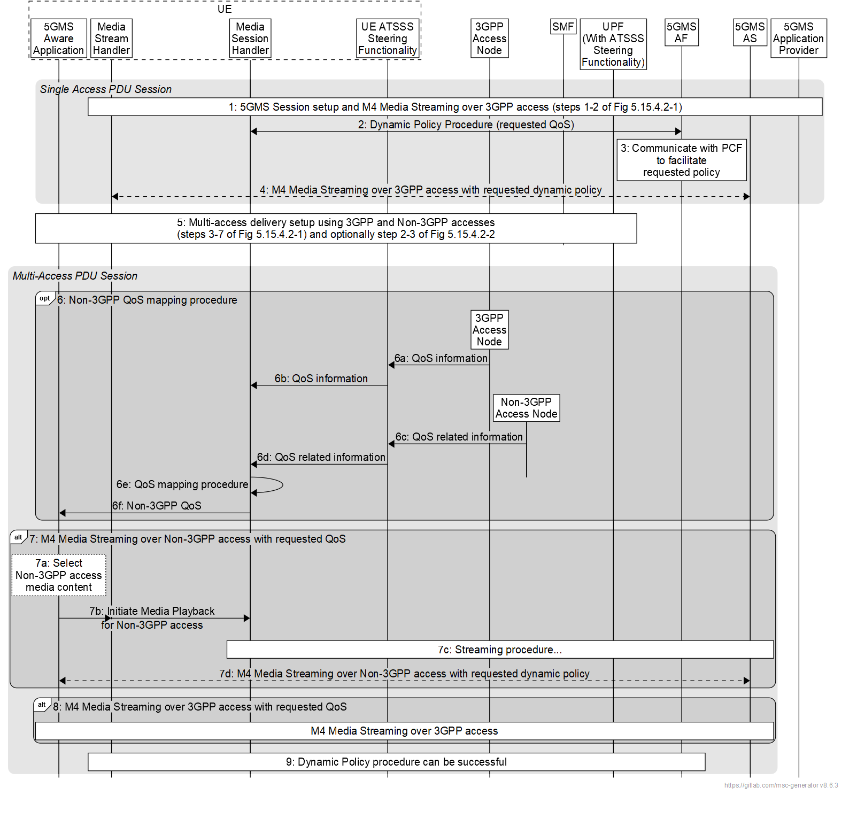
The steps are as follows:
1. A 5G Media Streaming session over a Multi-Access PDU Session is set up, and M4 media flows are exchanged by the Media Stream Handler in the UE and 5GMS AS over an access network (e.g., 3GPP access) as described in steps 1–2 of figure 5.18.4.2-1 of the present document.
2. The Media Session Handler in the UE 5GMS Client instantiates a Dynamic Policy in the 5GMS AF to be applied to 5G Media Streaming session as described in clause 5.7.4 of TS 26.501 [15]. In some cases, a QoS specification may be provided which contains the desired QoS information.
3. The 5GMS AF interacts with the PCF on behalf of the 5GMS Client (directly if the 5GMS AF is deployed in the Trusted DN, or via the NEF if 5GMS AF is in the external Data Network) to facilitate the application of the requested Dynamic Policy.
4. The M4 media flows are transferred between the Media Stream Handler and 5GMS AS over 3GPP access with the requested dynamic policy.
5. A multi-access media delivery session is set up using 3GPP access and non-3GPP access networks as described in steps 3–7 of figure 5.18.4.2-1 and steps 2–3 of figure 5.18.4.2-2 of the present document. The 5GMS-Aware Application may or may not be aware of multi-access media delivery.
6. Non-3GPP QoS mapping procedure :
6a. The UE collects QoS information from the 3GPP access (e.g. QoS profile, GBR capability)
6b. The UE ATSSS steering functionality forards the received 3GPP QoS information to the Meida Session Handler in the UE.
6c. The non-3GPP access node provides QoS-related information associated with the non-3GPP access. (e.g. DSCP)
6d. The UE ATSSS steering functionality forwards the received non-3GPP QoS-related information to the Media Session Handler in the UE.
6e. The Media Session Handler performs a QoS mapping procedure based on the association between non-3GPP access QoS characteristics and 3GPP QoS profiles. (e.g. DSCP-QCI, DSCP-5QI)
6f. The Media Session Handler updates the mapped non-3GPP QoS parameters to the 5GMS-Aware Application.
7. Media delivery over non-3GPP access :
7a. The 5GMS-Aware Application determines the media content to be delivered over the non-3GPP access.
7b. Media playback over the non-3GPP access is initiated. Subsequently, the M4 media flows are transported over the non-3GPP access with the requested QoS applied.
7c. The streaming procedure for M4 media delivery is performed over the non-3GPP accesses.
7d. Based on the requested Dynamic Policy and the mapped non-3GPP acess parameters, the M4 media flows are delivered over the non-3GPP access.
8. M4 media flows are transferred over the 3GPP accesss.
9. The Media Session Handler interacts with the 5GMS AF to modify the Dynamic Policy as described in clause 5.7.4 of TS 26.501 [15] so that it applies to the multi-access 5G Media Streaming session.

===== End of Changes =====

