3GPP TSG-S4 Meeting #135 S4-260240

Goa, India, 9th February – 13th February 2026 Revision of S4-252076
CR-Form-v12.0
CHANGE REQUEST
 | 26.941 | CR | 0003 | rev | 2 | Current version: | 19.0.1
For HELP on using this form: comprehensive instructions can be found at
http://www.3gpp.org/Change-Requests.

Proposed change affects: | UICC apps |  | ME | X | Radio Access Network |  | Core Network | X

Title: | [FS_AMD_Ph2] AF requested modification of set of Network Slice(s) for a UE
Source to WG: | Samsung Electronics Co. Ltd.,
Source to TSG: | S4
Work item code: | FS_AMD_Ph2 |  |  |  |  |  | Date: |  |  | 2026-01-25
Category: | B |  |  |  |  |  | Release: |  |  | Rel-20
 | Use one of the following categories:  F (correction)  A (mirror corresponding to a change in an earlier release)  B (addition of feature),  C (functional modification of feature)  D (editorial modification)  Detailed explanations of the above categories can  be found in 3GPP TR 21.900. |  |  |  |  |  |  |  | Use one of the following releases:  Rel-8 (Release 8)  Rel-9 (Release 9)  Rel-10 (Release 10)  Rel-11 (Release 11)  …  Rel-15 (Release 15)  Rel-16 (Release 16)  Rel-17 (Release 17)  Rel-18 (Release 18)
Reason for change: |  | TS 23.501 (Rel-19) describes a new procedure on AF influenced slice change for a UE. A document S4aI250082 was looked at on this topic in Rel-19. SA4 MBS group decided to pursue this study topic in Rel-20.
Summary of change: |  | Proposes a brief description of the new procedure on AF request modification of set of Network Slice(s) for a UE specified in TS 23.501. Proposes a key issue description related to media delivery on this topic for study in Rel-20.
Consequences if not approved: |  | Network slicing features for 5G Media Streaming will be incomplete
Q
Clauses affected: |  | 4.2.2, 6.x(new)
 |  | Y | N
Other specs |  |  | X | Other core specifications
affected: |  |  | X | Test specifications
(show related CRs) |  |  | X | O&M Specifications
Other comments:
This CR's revision history: |  | S4-251922: Initial contribution on AF requested modification of network slices for a UE based on SA2 procedures  S4-252076: Updates to previous version with comments during SA4#134  S4-260240: Addition of candidate solution, conclusions and recommendations from the previous version
CHANGE-1

4.2.2 Network slicing for specific applications

4.2.2.1 Introduction
Before application services are allowed to access specific network slices, a third-party Application Service Provider can negotiate with the MNO and the MNO may create or allocate the network slices based on the service requirements as specified in TS 28.531 [4]. For example, a cloud gaming service provider may interact with the MNO to reserve specific network slices supporting low latency, and high computing resources.
Afterwards, the Application Function, on behalf of the Application Service Provider, informs the 5GC that the target application service can use the specific network slices, i.e., by providing application guidance for UE Route Selection Policy (URSP) determination as defined in clause 4.15.6.10 of TS 23.502 [15]. Depending on the nature of the application guidance, the operator may update the Network Slice Selection policies in the URSP accordingly. As a consequence, the application service may be migrated to the new network slice/DNN duple based on the updated URSP rule.
The URSP rules in the UE, which are used to associate applications with usage of particular network slices, may be pre-configured or provided by the PCF as defined in clause 6.6.2.2 of TS 23.503 [16]. Each URSP rule is expressed as a traffic descriptor for application detection of packets sent by the UE on the uplink, e.g. IP descriptors, application descriptors, domain descriptors.
NOTE: There is no restriction on which part of UE should (re-)evaluate the URSP rules. This may be done by either the Operating System or the modem layer.
Once an application is started or detected on the UE, the following procedure is followed:
1. The UE evaluates its URSP rules in the order of Rule Precedence and determines whether the uplink application traffic matches the traffic descriptor of any URSP rule.
a. When a URSP rule is determined to be applicable for a given application, the UE derives the suitable network slice(s) based on the applicable URSP rule.
b. If the UE determines that there is more than one existing PDU Session which matches a given URSP rule, it is up to UE implementation (Operating System or modem layer) to select one of them to use. Otherwise, the UE tries to establish a new PDU Session using the derived network slices.
2. If there is no matching URSP rule (except the “match all” rule), the UE uses its own local configuration (if any) to determine which PDU Session to use.
NOTE: The UE local configuration in this context is information about the associated application, such as application-specific parameters to set up a PDU Session or end user configuration for specific applications. This can be provisioned in the UE via the application layer, e.g. following interaction between the Edge Enabler Client (EEC) and the Edge Configuration Server (ECS), as defined in TS 23.558 [24].
3. When URSP rules are updated, or when a particular URSP rule’s validity changes, the association of existing applications to PDU Sessions may need to be re-evaluated.
4. Depending on UE implementation, the associations between applications and PDU Sessions may also be re-evaluated periodically, independent of any changes to URSP rules.

4.2.2.2 Network slice replacement without application influence
When a network slice becomes unavailable (e.g. due to overload), the AMF is triggered, either by local configuration (e.g. trigger from OAM) or by a notification from the Access and Mobility Management PCF (AM PCF) or by the NSSF [26], to replace the current S-NSSAI with a previously chosen Alternative S-NSSAI. Using a suitable NAS procedure (e.g. UE Configuration Update) the AMF informs the UE about the Alternative S-NSSAI as well as providing the mapping between S-NSSAI(s) and Alternative S-NSSAI(s) in the Allowed NSSAI and/or in the Configured NSSAI.
1. In the case where there is no existing PDU Session in the unavailable slice and the UE is trying to establish a new one to support a 5G Media Streaming session, the UE may provide both the Alternative S-NSSAI and the current S-NSSAI in the PDU Session Establishment message, in which case the AMF provides both S-NSSAI values to the SMF for the PDU Session establishment. The SMF proceeds with the PDU Session Establishment using the Alternative S-NSSAI. As a result, the new PDU Session is established over the Alternative S-NSSAI with a new IP address.
2. In the case where an ongoing 5G Media Streaming session is already being carried over the PDU Session associated with the unavailable slice, the AMF informs the SMF responsible for the PDU Session that it is to be transferred to the Alternative S-NSSAI. Then, depending on the Session and Service Continuity (SSC) mode of the existing PDU Session, either:
- SSC mode 1: The SMF further updates the network slices in the UE/RAN/UPF via the PDU Session Modification procedure. In this case, the IP address of the PDU Session remains the same.
- SSC mode 2 or 3: The SMF triggers the modification/release of the PDU Session and re-establishment of the PDU Session in the Alternative S-NSSAI. In this case, a new IP address is allocated during the PDU Session re-establishment procedure and the ongoing 5G Media Streaming session at reference point M4 and M5 needs to be migrated to the new PDU Session.
When the AMF is notified that the replaced network slice has become available again (e.g., congestion has been mitigated), the AMF reconfigures the UE (e.g., by using the UE Configuration Update procedure or else as a matter of course when the UE next registers with the network) to use the replaced S-NSSAI if it has already configured the UE to use the Alternative S-NSSAI when the S-NSSAI became unavailable. Furthermore, if a PDU Session was established in the Alternative S-NSSAI when the replaced S-NSSAI became unavailable, the AMF triggers transfer of that PDU Session to the replaced S-NSSAI when the S-NSSAI becomes available again by updating the SMF(s) of the PDU Session using the Nsmf_PDUSession_UpdateSMContext service operation described in clause 5.2.8.2.6 of TS 26.502 [15].

4.2.2.3 AF-requested modification of set of Network Slice(s) for a UE
Clause 5.15.5.2.2A of TS 23.501 [7] specifies the procedure for AF-requested modification of the set of Network Slice(s) for a UE. This procedure specifies:
- An authorized AF, or an AF subject to authorization via the NEF, may request the PCF for the UE to replace a certain S-NSSAI (Replaced S-NSSAI) with another S-NSSAI (Alternative S-NSSAI) which is part of the UE subscription.
- The AF subscribes to notification from the PCF about the outcome of AF-requested network slice replacements.
- The PCF sends slice replacement management information to the AMF in the access and mobility management policies implicitly per subscription, as defined in clauses 6.1.2.1 and 6.1.2.6 of TS 23.503 [16]. The slice replacement management policy includes the Replaced S-NSSAI and the corresponding Alternative S-NSSAI as provided in the AF request, and a Network Slice Replacement Type. The Network Slice Replacement Type indicates that the network slice replacement is requested by an AF.
- The AMF, upon receiving the above slice replacement management policy, performs the necessary slice management operations (e.g., remove Replaced S-NSSAI from Allowed S-NSSAI, and add the Replaced S-NSSAI into the Rejected S-NSSAI by UE Configuration Update procedure). The UE and AMF release PDU sessions that were using the Replaced S-NSSAI. After updating necessary UE context information locally, the AMF reports to the PCF the outcome of network slice replacement as specified in clause 6.1.2.5 of TS 23.503 [16]. The PCF further notifies the AF of this outcome.
- Operator policies in the PCF ensure that UE is configured with a URSP rule that contains the Alternative S-NSSAI to establish a new PDU Session.
The AF (or NEF) may then later on request the PCF for the UE to terminate the slice replacement and switch back to the original network slice. The PCF for the UE sends updated access and mobility management policies to the AMF as described in clause 6.1.2.6 of TS 23.503 [16] to indicate that the original network slice is available again. The AMF updates the Allowed NSSAI accordingly and removes Replaced S-NSSAI from Rejected S-NSSAI by a UE configuration update procedure.
In both the cases, when switching from the original network slice to an alternate network slice, or vice versa, any PDU Sessions carrying application traffic are transferred as described in clause 4.2.2.1 of the present document.
change-2 (ALL-NEW TEXT)

6.X Key Issue #X: AF-requested slice change for a UE

6.X.1 Description

6.X.1.1 Identification and usage of Alternate S-NSSAI during AF-requested modification of Network Slice(s) for a UE procedure
Clause 4.2.2.3 describes the procedure for AF-requested modification of the set of Network Slice(s) available for use by a UE. As part of this procedure, the AF interacts with the PCF to modify a current network slice (Replaced S-NSSAI) of a UE with a network slice associated with the Alternate S-NSSAI. When the PCF for the UE receives a request for modification of the network slice for a UE, it interacts with the AMF to facilitate such modification of the network slice, and migration of any PDU sessions carrying M4 application flows to the Alternate S-NSSAI.
The procedure for AF-requested modification of the set of Network Slice(s) described in clause 4.2.2.3 of the present document provides a method for dynamic update of network slice that is used by a UE. This procedure for slice replacement may be preferable to a slice replacement procedure facilitated by the 5G Core network (i.e., the procedure described in clause 4.2.2.2 of present document) for use cases that require dynamic modification of application QoS treatment by means of network slice selection. This could be used to satisfy the use case described in clause 5.3.2 of the present document wherein application traffic is migrated to an appropriate network slice under the direction of the Media AF to realise premium gaming QoS treatment for a desired duration.
In current versions of TS 26.501 [26501] and TS 26.510 [26510], the 5GMS Application Provider uses the Provisioning API to configure the network slice information at the 5GMS AF via reference point M1. Clause 5.15.5.2.2A of TS 23.501 [23501] specifies that how the AF obtains information about the Alternate S-NSSAI is out of its scope.
Open issues:
- When and how is a decision is made by the 5GMS AF to trigger the procedure for AF-requested modification of the set of Network Slice(s) for a UE?
- How does the 5GMS AF obtain information about the S-NSSAI to be replaced, and the Alternate S-NSSAI?

6.X.2 Candidate solutions
This Candidate Solution describes a procedure for temporary upsell treatment of M4 application flows of a Media Delivery session so they are carried over a premium network slice at reference point M4. This Candidate Solution addresses the two open issues described in clause 6.X.1.1 as below:
- A UE application makes a request for upsell treatment and a network API request for upsell treatment at reference point M5 is sent to the network (as described in clause 5.3.2 of the present document - a user purchases the gaming slice treatment for a desired duration, and network API request is accessed to enable the user to access the gaming slice)
- The Media AF obtains the information about Alternate S-NSSAI from the Media Application Service Provider
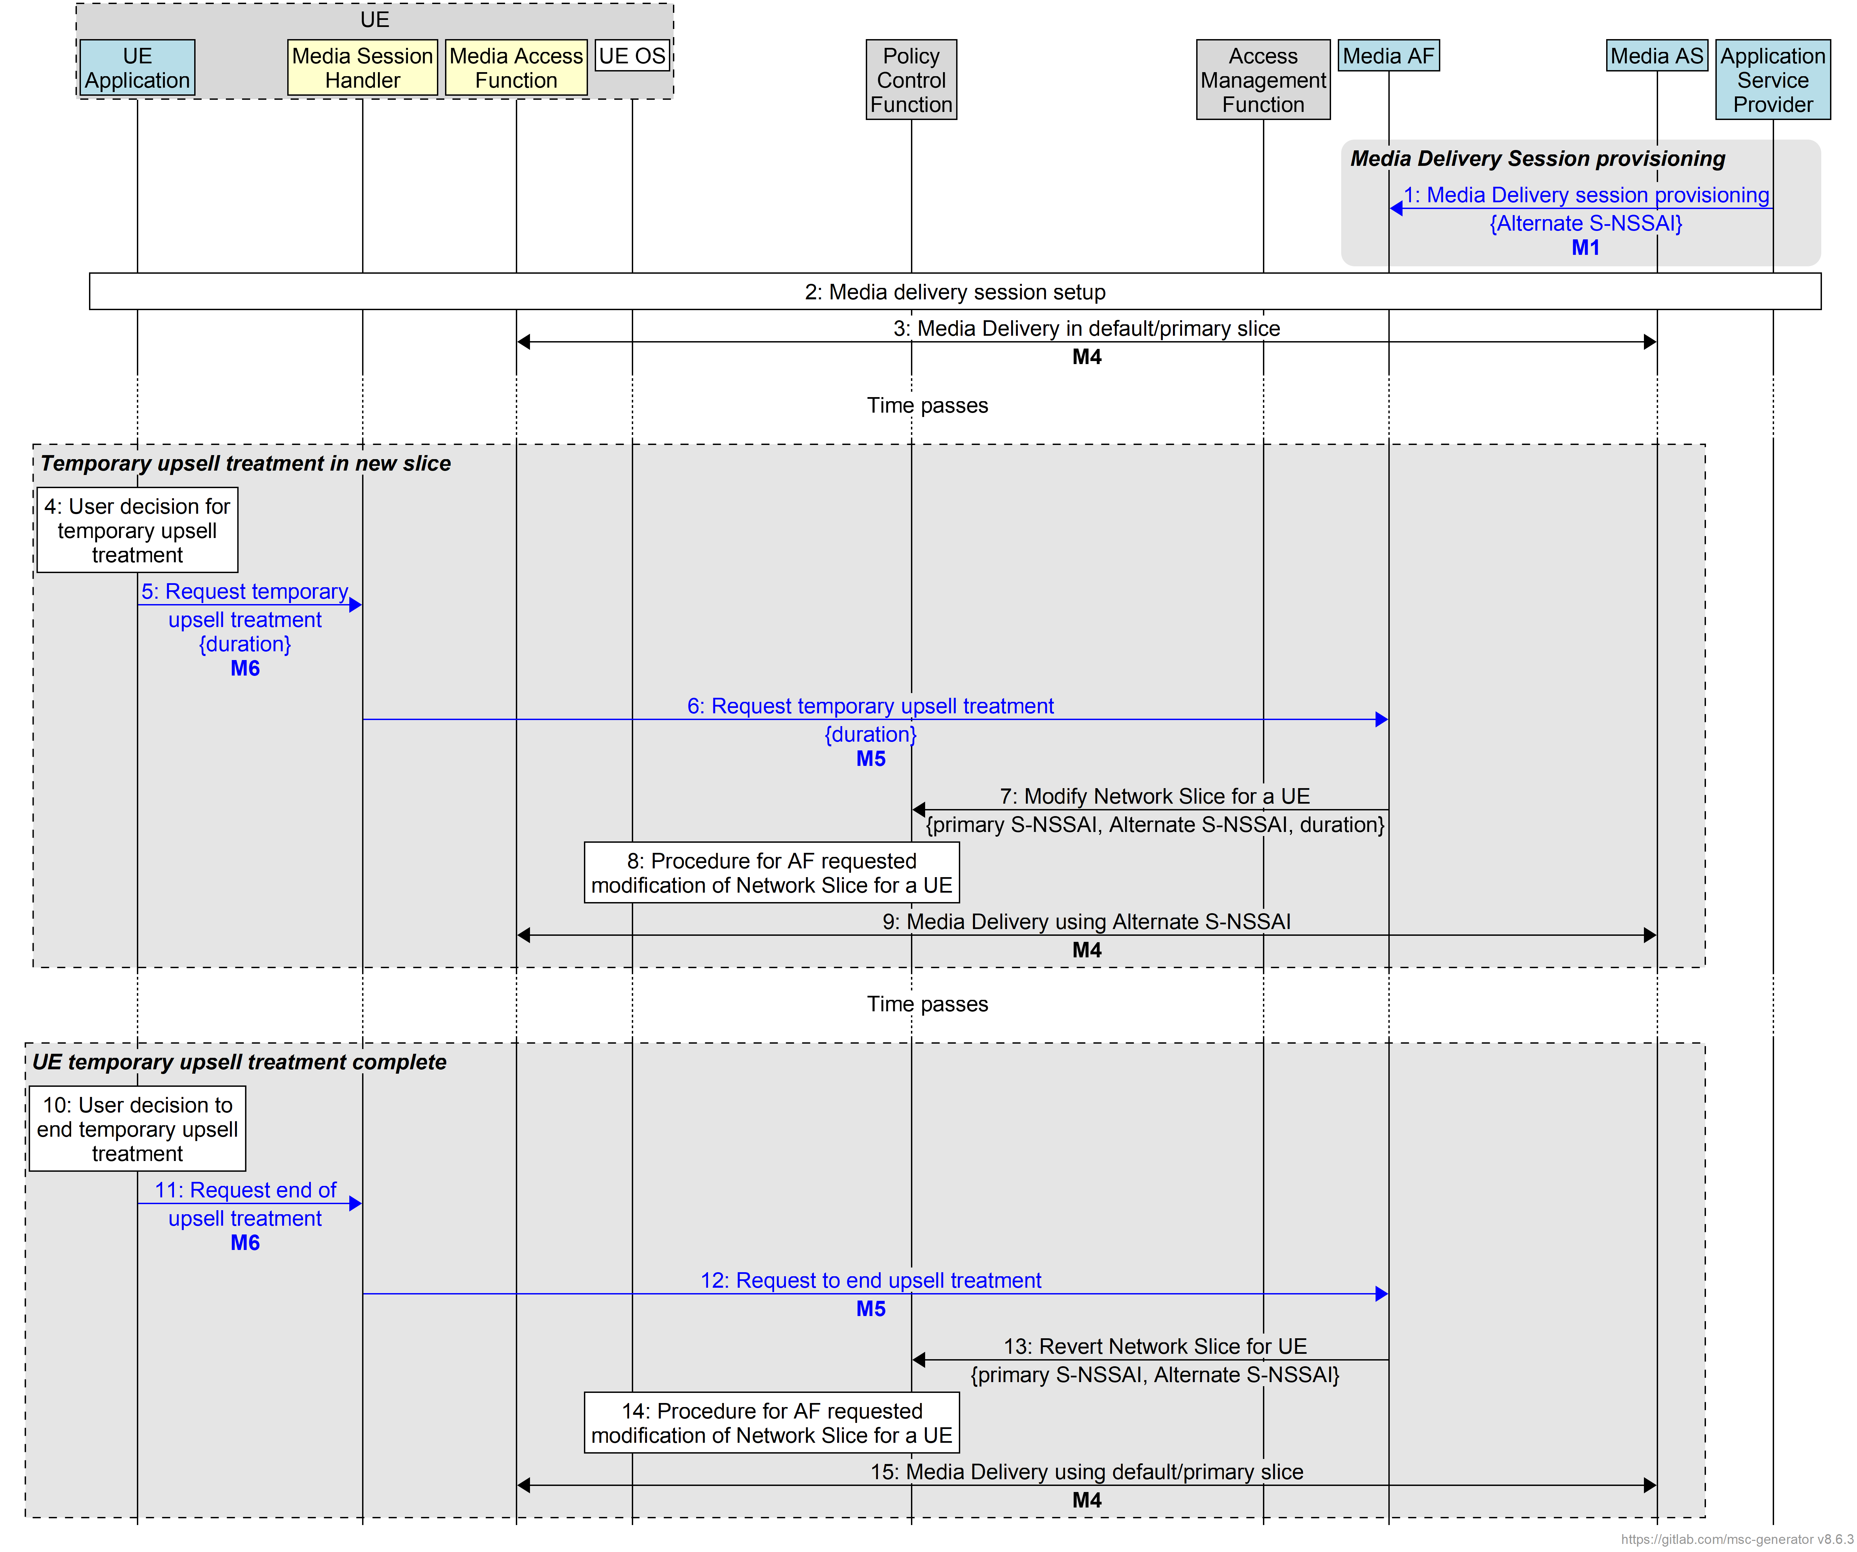
Figure 6.X.2-1: Procedure for AF requested slice change for a UE
Assumptions:
- The Media Application Service Provider negotiates with the MNO for the both the default/primary network slice and the Alternate network slice (Alternate S-NSSAI) as described in clause 4.2.2 of the present document
Below are the steps:
- The Media Application Provider provisions a Media Delivery session at the Media AF via reference point M1 using the baseline procedure for downlink media delivery described in clause 5.1 of TS 26.501 [20]. The Media Application Provider includes the Alternate S-NSSAI information with the provisioning information.
- A Media Delivery session is established as described in clause 5.1 of TS 26.501 [20].
- The Media Access Function and the Media AS perform media delivery at reference point M4 using the default/primary network slice.
At some later point, the user decides to access premium service for temporary duration (for example, the user purchases gaming slice treatment for a temporary duration as described in clause 5.3.2 of the present document):
- The user decides for temporary upsell treatment as described above. This requires dynamic modification of application QoS treatment of M4 application flows for a certain duration.
- The UE Application requests the Media Session Handler for temporary upsell treatment for the M4 application flows at reference point M6. The UE Application includes the duration for the upsell treatment.
- The Media Session Handler forwards the temporary upsell treatment request from the UE Application to the Media AF at reference point M5. The Media Session Handler includes the duration for which the upsell treatment is requested for.
- The Media AF requests the PCF (directly if it is a trusted AF, or via the NEF if it is an untrusted AF) for modification of Network Slice for the UE by requesting to replace the primary S-NSSAI for the UE with an Alternate S-NSSAI as described in clause 5.15.5.2.2a of TS 23.501 [7]. Based on the information provisioned in step 1, the Media AF is aware of the primary S-NSSAI that the UE is currently using, and the Alternate S-NSSAI. The Media AF includes the duration for which the network slice replacement is sought.
- Based on the information received from the Media AF, the PCF interacts with the AMF to facilitate modification of Network Slice of the UE as described in clauses 5.15.5.2.2a of TS 23.501 [7] and clauses 6.1.2.1 and 6.1.2.6 of TS 23.503 [16]. As described in clause 5.15.5.2.2a of TS 23.501 [7], PCF ensures that the UE is configured with a URSP rule that contains the Alternate S-NSSAI to establish a new PDU Session if required. As a result of this procedure, the UE OS ensures the use of the alternate network slice for further communication with the Media AS.
- The Media Access Function and the Media AS perform media delivery at reference point M4 using the Alternate S-NSSAI.
At some later point, the user decides to stop using the premium service:
- The user decides to end the upsell treatment of M4 application flows.
- The UE Application requests the Media Session Handler for ending the upsell treatment for the M4 application flows at reference point M6.
- The Media Session Handler forwards the request to end upsell treatment to the Media AF at reference point M5.
- The Media AF requests the PCF (directly if it is a trusted AF, or via the NEF if it is an untrusted AF) for modification of Network Slice for the UE by requesting to replace the Alternate S-NSSAI with the original primary S-NSSAI for the UE as described in clause 5.15.5.2.2a of TS 23.501 [7].
- Based on the information received from the Media AF, the PCF interacts with the AMF to facilitate reverting back to the original Network Slice as described in clauses 5.15.5.2.2a of TS 23.501 [7] and clauses 6.1.2.1 and 6.1.2.6 of TS 23.503 [16]. As described in clause 5.15.5.2.2a of TS 23.501 [7], the PCF ensures that the UE is configured with a URSP rule that contains the primary S-NSSAI to establish a new PDU Session if required. As a result of this procedure, the UE OS ensures the use of primary S-NSSAI for further communication with the Media AS.
- The Media Access Function and the Media AS perform media delivery at reference point M4 using the primary S-NSSAI.

6.X.3 Conclusions
This Candidate Solution describes how Alternate S-NSSAI information from the Media Application Service Provider allows the 5G System components to modify the Network Slice(s) of a UE using the AF-requested modification of Network Slice(s) of a UE procedure described in clause 5.15.5.2.2a of TS 23.501 [7]. Following are the gaps in the current specifications to realize the proposed Candidate Solution:
- The Media Application Service Provider provisions the Alternate S-NSSAI information required by the 5G System Components for performing the AF-requested modification of Network Slice(s) of a UE procedure.
- The Media Aware Application requests the Media Session Handler over reference point M6 for initiating or terminating temporary upsell treatment for M4-application flows. The Media Session Handler sends a request to the Media AF over reference point M5 for initiating or terminating upsell treatment to M4-application-flows
The following normative changes are proposed to implement the Candidate Solution presented in the present document:
1. Modify/add the following in the stage-2 specification TS 26.501 [20]:
a. Modify the domain model for dynamic policies (figure 4.0.6-2) to additionally illustrate the property of Alternate S-NSSAI identifier in the Policy Template entity.
b. In the procedure for Dynamic Policy based on Network Slicing for downlink media streaming (clause 5.8.1), update the call flow in figure 5.8.1-1 to describe the messaging between the Media-aware Application, Media Session Handler, Media AF, and the 5G System components as described in the procedure proposed in clause 6.X.2 of the present document to illustrate the procedure for AF-requested Network Slice replacement. Add text in this clause to describe the design principles and the procedure for moving UE M4 application flows in and out of an Alternate Network Slice as described in the procedure proposed in clause 6.X.2 of the present document.
c. In the procedure for Dynamic Policy based on Network Slicing for uplink media streaming (clause 6.9.6), update the call flow in figure 6.9.6-1 to describe the messaging between the Media Aware Application, Media Session Handler, Media AF, and the 5G System components as described in the procedure proposed in clause 6.X.2 of the present document to illustrate the procedure for AF-requested Network Slice replacement. Add text in this clause to describe the design principles and the procedure for moving UE M4 application flows in and out of an Alternate Network Slice as described in the procedure proposed in clause 6.X.2 of the present document.
2. Modify the following in the stage-3 specification TS 26.512 [21]:
a. In the Procedures of the M6d (UE Media Session Handling) interface (clause 4.8), add a brief procedure description for the 5GMSd-Aware Application requesting the Media Session Handler for a change in traffic treatment, as described in the procedure proposed in clause 6.X.2 of the present document.
b. In the Procedures of the M6u (UE Media Session Handling) interface (clause 5.8), add a brief procedure description for the 5GMSu-Aware Application requesting the Media Session Handler for a change in traffic treatment as described in the procedure proposed in clause 6.X.2 of the present document.
3. Modify/add the following in stage-3 specification TS 26.510 [42]:
a. Update the Dynamic Policy provisioning and invocation interactions in clauses 5.2.7 and 5.3.3 to describe the interaction between the Media Application Provider and the Media AF, and the Media Session Handler and Media AF as described in the procedure proposed in clause 6.X.2 of the present document
a. Update the PolicyTemplate resource data model in clause 8.7.3 to include the property of Alternate S-NSSAI.
d. Update the DynamicPolicy resource data model in clause 9.3.3 to add a property, that if present, represents the request (in step 6 and step 12 of the procedure proposed in clause 6.X.2 of the present document) from the Media Session Handler to the Media AF for different traffic treatment by means of AF-requested Network Slice modification as described in clause 6.X.2 of the present document.
end of CHANGEs

8 Conclusions and recommendations
Network slicing is one of the key features of 5G which allows Mobile Network Operators to provision logical networks to serve a specific service or service category, or to serve customers with specific service requirements. Network slicing standardization has progressed in various different 3GPP Working Groups. Specification related to this feature includes architecture, orchestration and management, network resource models, capability management and exposure. The Key Issues studied in the present document point to a need to extend the 5GMS architecture in order to take advantage of network slicing when delivering 5G Media Streaming services.
The present document provides an overview of network slicing architecture and aspects related to slice orchestration and management as well as network slice capability exposure. It briefly describes different network slice management options such as operator-managed network slicing and third-party-managed network slicing. The present document also collects a set of use cases for running 5G Media Streaming services in one or more network slices, and describes a number of collaboration scenarios for exploiting network slicing capabilities within the 5GMS architecture. It also documents key issues and candidate solutions related to service provisioning, moving media flows to other network slices, and bootstrapping application invocation on a network slice.
It is recommended that:
1. The use cases and collaboration scenarios for network slicing documented in clauses 5.3 and 5.4 respectively be included in an informative annex to TS 26.501 [20].
2. The changes to the PolicyTemplate resource data model definition described in clause 6.1.2.1 be implemented in TS 26.510 [42] to support Policy Template provisioning for a plurality of Network Slices and/or Data Networks, and the corresponding alignment changes described in clause 6.1.3 be implemented in TS 26.501 [20].
3. The Key Issue description and corresponding candidate solution on bootstrapping application invocation on a Network Slice documented in clause 6.7 of the present document be included as an informative clause or annex to TS 26.501 [20] as guidance for implementations.
4. To support the procedure for AF-requested modification of Network Slice(s) for a UE, the following are adopted into media delivery specifications as described in clause 6.X.3 of the present document:
a. In stage-2 specification TS 26.501 [20], update of domain model for dynamic policies to illustrate provisioning of Alternate S-NSSAI, and the procedures for Dynamic Policy based on Network Slicing, for both downlink and uplink streaming
b. In state-3 specification TS 26.512 [21], add procedure descriptions for M6d and M6u for the 5GMSd/5GMSu Aware Application requesting the Media Session Handler for change of traffic treatment
c. In stage-3 specification TS 26.510 [42], update the PolicyTemplate and DynamicPolicy resource data models, and the Dynamic Policy provisioning and invocation interactions to enable AF-requested modification of Network Slice(s) of a UE

end of CHANGEs

