3GPP TSG-SA4 Meeting #135 S4-260255r04

India, India, 9th Feb 2026 - 13th Feb 2026

Source: SA4

Title: [FS_AMD_Ph2] WT#8: pCR for application-layer approaches to enable multi-access media delivery

Document for: Approval
Agenda Item: 8.6

1 Decision/action requested
Approval to merge the changes proposed within the present document into 3GPP TR 26.804, CR 0036 [2].

2 References
[1] 3GPP TR 26.804: "Study on 5G media streaming extensions".
[2] S4-252099, 3GPP TR 26.804, CR 0036: "[FS_AMD_Ph2] Network Assistance for multi-access media delivery".

3 Rationale
- Reason for change: Document the use of application-layer multi-access downlink media delivery approaches in cases where lower-layer multi-access support is unavailable or insufficient as part of the FS_AMD_Ph2 feasibility study (approved in S4-251576).
- Summary of change: Updates to introduce and describe how CMMF may be used to enable multi-access media delivery (clause 5.18.1.2 of TR 26.804 [1]), a mapping of application-layer multi-access approaches onto the 5GMS architecture (clause 5.18.3.2 of TR 26.804 [1]), a high-level call flow showing the application-layer multi-access media delivery procedure (clause 5.18.4.1 of TR 26.804 [1]), additions to the gap analysis (clause 5.18.5.1 of TR 26.804 [1]), updates to the CMMF candidate solution (clause 5.18.6.1 of TR 26.804 [1]), updates to the key issue’s summary and conclusions (clause 5.18.7 of TR 26.804 [1]), and updates to the multi-access media streaming conclusions (clause 6.18 of TR 26.804 [1]).
- Consequences if not approved: Multi-access media delivery feature is incomplete.

4 Detailed proposal

===== CHANGE =====
…
MTSI Multimedia Telephony Service for IMS
N3IWF Non-3GPP InterWorking Function
NAT Network Address Translation
…
TMGI Temporary Mobile Group Identity
TNGF Trusted Non-3GPP Gateway Function
TOI Transmission Object Identifier
…

===== CHANGE =====

5.18.1.2 Multi-access using upper layer approaches under application control

5.18.1.2.1 Introduction
UEs connected to multiple access networks (whether they be a 3GPP access network, a non-3GPP access network, multiple disjoint 3GPP access networks, etc.) inherently have the capability to deploy and utilise multi-access techniques without lower-layer support such as ATSSS. Upper layer approaches not dependent on lower layer multi-access implementations may be preferred in cases where lower layer protocols are not supported at both endpoints, the Media Application Provider wants to influence how connections over multiple access networks are used, media is streamed from multiple service locations that are possibly tied to one access network or another, etc.
Within the 5G System (5GS) architecture:
- A UE may be registered and served over both a 3GPP access and a non-3GPP access either consecutively or simultaneously as specified in clause 5.3.2.4 of TS 23.501 [23].
- A single-access PDU Session as defined in clause 5.6.1 of TS 23.501 [23] may be setup where a PDU Session is associated with a single access (i.e., either 3GPP access or non-3GPP access) type at given time.
NOTE 1: Clause 5.6.1 of TS 23.501 [23] specifies that a PDU Session may support a single-access PDU Connectivity Service or a multi-access PDU Connectivity Service (i.e., the PDU Session is simultaneously associated with both 3GPP access and non-3GPP access). A PDU Session supporting a single-access PDU Connectivity Service is referred to as single-access PDU Session, while a PDU Session supporting multi-access PDU Connectivity Service is referred to as a Multi-Access PDU Session (MA PDU). A MA PDU Session is used to support the ATSSS feature as specified in clause 5.32 of TS 23.501 [23].
NOTE 2: As of Release 20 of TS 23.501 [23], at any given time, a single-access PDU Session is routed over only a single access network.
- A UE registered over multiple accesses may choose over which access to establish a single-access PDU Session as specified in clause 5.6.1 of TS 23.501 [23],
- A UE may establish multiple single-access PDU Sessions, to the same data network or to different data networks, via 3GPP and via non-3GPP access networks at the same time as specified in clause 5.6.1 of TS 23.501 [23].
In cases where the UE exposes the capabilities to associate a PDU Session with a particular access network and select which PDU Session to use at any given time, an application may use one of the approaches listed below to enable multi-access media delivery.

Examples of non-ATSSS multi-access network approaches include:
- Use of a multipath transport protocol such as MPTCP [134] or MPQUIC [136]. This approach requires implementation of the protocol(s) on both the UE and Application Server.

- Use of an application layer approach similar to those described in clause 5.19.1. For example, an application may switch between access networks or employ CMMF [126] to enable efficient simultaneous use of the available access networks. The benefits of these approaches are the transport-layer, network-layer, and Application Server can remain largely agnostic of the UEs’ use of multiple access networks.
In either case, traffic steering and routing across the appropriate network is performed using functionality in both the UE and network. Multiple TCP and/or QUIC connections are set up where each is bound to a different single-access PDU Session or UE network interface (each with an assigned IP address appropriate to its interface’s network). An Application Server may transmit media over one access network or another via the appropriate TCP and/or QUIC connection.

5.18.1.2.2 Multi-access downlink media streaming using CMMF
Given the capabilities described above, enabling multi-access downlink media streaming using CMMF is similar to the multiple service location use case described in clause 5.19. Media is encoded within CMMF bitstreams or transport objects and made available at one or more service locations. Media clients request and download these CMMF bitstreams/transport objects, decode them, and render the desired media. No changes to how the CMMF bitstream/transport objects are created nor how the network is provisioned are necessary. Furthermore, network and transport layer support (e.g., availability of multipath transport protocols, ATSSS support, etc.) are not required to enable multi-access media delivery when using CMMF. Clients using CMMF to enable multiple access delivery only require the capabilities to communicate over multiple access networks and to steer network traffic (e.g., HTTP requests/responses) over the access network of their choice. Finally, the use of CMMF enables the operation over one access network to be largely independent of the others. Whichever CMMF information (i.e., from one or more CMMF bitstreams/transport objects) is obtained, regardless of the access network it was obtained from, is used to recover media resources.
Two HTTP-based deployment examples are provided in figures 5.18.1.2.2-1 and 5.18.2.2-2. The first figure illustrates a deployment scenario where CMMF-encoded media is made available to media clients from multiple service locations and each of these service locations is used to serve requests obtained over a specific access network. This deployment scenario is almost identical to the one described in clause 5.19. The second figure illustrates a deployment scenario where a single service location is used to deliver CMMF-encoded media across both access networks. In both scenarios, the CMMF Access Client requests and downloads a different CMMF-encoded representation (e.g., CMMF-A and CMMF-B) over each of the different access networks.

Figure 5.18.1.2.2-1: Example multi-access and multi-service location network deployment scenario enabled by CMMF

Figure 5.18.1.2.2-2: Example multi-access network deployment scenario enabled by CMMF
For HTTP-based delivery, steering network traffic over one access network versus the other can be accomplished, for example, by using multiple HTTP connections in parallel (one for each access network) and binding the underlying transport session for each of these HTTP connections to a different access network interface. The capability to bind an HTTP connection to a specific network interface is commonly supported on existing mobile devices; once bound, HTTP messages sent over the HTTP connection, as well as subsequent responses, results in the HTTP traffic being transmitted/received over the bound interface/access network.
An example download process is shown in figure 5.18.1.2.2-3 assuming the deployment example shown in figure 5.18.1.2.2-1. In this example, a Media Player requires seg_1.mp4 to be downloaded. The Media Player first requests that the segment is retrieved by the CMMF Access Client. The CMMF Access Client then generates two HTTP requests in parallel, one for a different CMMF-encoded representation of the segment, where each HTTP request is transmitted over a different HTTP connection using a transport session bound to a different access network interface. Upon retrieval of enough information from both downloaded CMMF-encoded representations of the segment, the CMMF Access Client decodes the segment and delivers it to the Media Player.
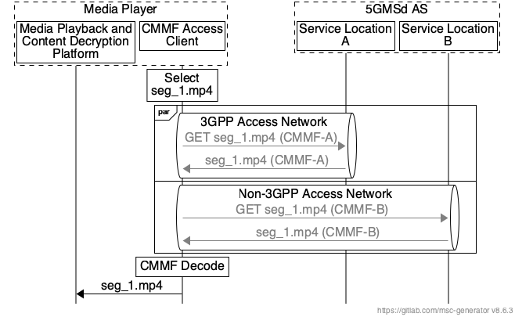
Figure 5.18.1.2.2-3: Example multi-access network deployment scenario enabled by CMMF
The results of an example media session are provided in figures 5.18.1.2.2-4 through 5.18.1.2.2-6. This media session was captured using a web-based media player streaming an HLS media asset through a local CMMF-enabled proxy that implemented the necessary functionality to download and recover media resources using CMMF. The client, executing both the media player and proxy, was connected to both a local WLAN network and a 5G cellular network. Every media resource was encoded into two different CMMF representations/variants, and each CMMF representation was cached at a different service location (in this case, service locations were different CDNs). Throughout the media session, the client maintained a stable connection with a 5G cellular network. However, its connection with the local WLAN network was gradually degraded until it became unusable.
Figure 5.18.2.2-4 shows the playback bit rate of the media streamed during the media session along with the signal-to-noise ratio (SNR) measured by the client’s WLAN radio (labelled as "WiFi SNR" within the figure). During the media session, the media player was able to establish and maintain the maximum playback bit rate regardless of the quality of its connection with the WLAN access network.
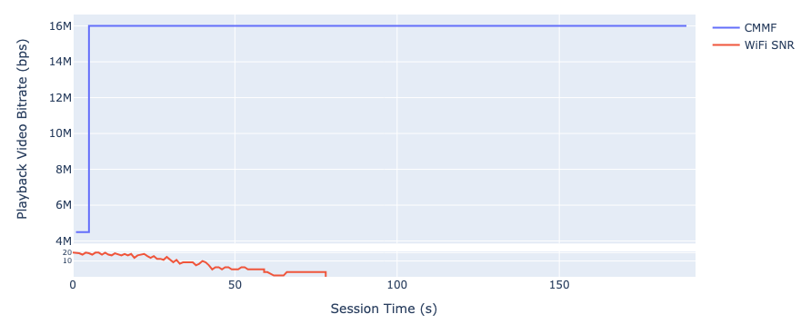
Figure 5.18.1.2.2-4: Playback bit rate during the example CMMF media session
Figure 5.18.1.2.2-5 shows the media player’s playback buffer, along with the SNR measured by the client’s WLAN radio, during the media session. Like the playback bit rate, the media player was able to establish and maintain a healthy playback buffer, resulting in minimizing the probability of a rebuffering event, throughout the media session regardless of the quality of its connection with the WLAN access network.
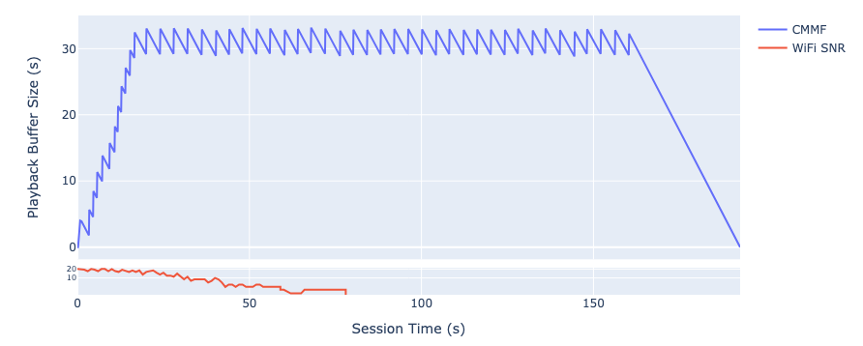
Figure 5.18.1.2.2-5: Playback buffer size during the example CMMF media session
Finally, figure 5.18.1.2.2-6 shows the percent of each video segment downloaded over each access network, along with the SNR measured by the client’s WLAN radio (labelled as "Mean WiFi SNR" within the figure), during the media session. When the client had a stable connection with the WLAN access network, most of the information necessary to recover each segment was obtained from the CMMF bitstream/transport object sent over the WLAN access network. As the WLAN access network connection degraded, the use of CMMF allowed for a seamless transition to the 5G cellular access network where most or all of the information needed to recover each segment was obtained from the CMMF bitstream/transport object sent over the 5G cellular access network.
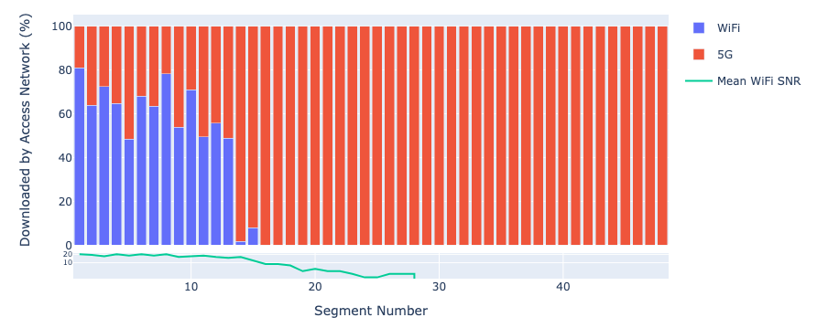
Figure 5.18.1.2.2-6: Percent of each video segment downloaded over each access network
during the example CMMF media session

===== CHANGE =====

5.18.3 Architecture mapping

5.18.3.1 Multi-access downlink media streaming using application layer approaches
Figure 5.18.3.1-1 shows the mapping onto the 5GMS architecture of multi-access downlink media streaming using application-layer approaches assuming the collaboration scenario illustrated in figure 5.18.2.1-1.
Figure 5.18.3.1-1: Multi-access media delivery architecture using application-layer approaches
Within figure 5.18.3.1-1, it is assumed that the UE exposes the capability for a Media Access Client to steer network traffic to one UE network interface/access network or another (e.g., by initializing multiple HTTP connections where each uses a different transport session bound to a different single-access PDU Session or network interface). As specified in clause 4.2.8.1 of TS 23.501 [23], downlink media traffic associated with a single-access PDU Session over:
- 3GPP access network is routed between the Media Access Client and 5GMSd AS via the UPF.
- A Trusted Non-3GPP access network is routed between the Media Access Client and 5GMSd AS via the TNGF and UPF.
- An Untrusted Non-3GPP access network is routed between the Media Access Client and 5GMSd AS via the N3IWF and UPF.
A Media Access Client may switch between access networks or use both simultaneously. In the latter case where CMMF is used, the 5GMSd AS is provisioned to host and possibly prepare CMMF-encoded media. A Media Access Client retrieves a different CMMF representation or variation of a media resource over each access network. Retrieved CMMF bitstreams/transport objects (either in full or partially) are provided to a CMMF decoder (a sub-component of the Media Access Client) where the requested media resource is recovered.
Since reference point M4d is defined over both 3GPP and non-3GPP access networks and the architecture of the Media Access Client is not normatively specified within the 5GMS System, no changes to the 5GMS architecture are anticipated.
NOTE: A Media Access Client may download content over either a 3GPP or non-3GPP access network from one or more service locations at reference point M4d or reference point M13d. The latter is not shown since it is outside the scope of the 5GMS System.

===== CHANGE =====

5.18.4 High-level call flow

5.18.4.1 Multi-access downlink media streaming using application layer approaches
Figure 5.18.4.1-1 illustrates a variant of the high-level procedure for DASH streaming defined in clause 5.2.3 of TS 26.501 [23] and it is similar to the procedure for downlink streaming from multiple service locations defined in clause 5.2.6 of TS 26.501 [23]. Differences from the baseline procedure in clause 5.2.6 of TS 26.501 [23] are highlighted in boldface.
The procedure makes the following assumptions:
- The Media Player has the necessary functionality to stream media content from multiple service locations and/or across multiple access networks. This may include the functionality needed to:
- Switch between service locations, for example by client decision, or based on steering information from the network,
- Use multiple service locations concurrently,
- Steer network traffic to one UE network interface or another,
- Use connections to multiple access networks concurrently,
- etc.
- Multiple service location and/or multiple access network configuration information required to access content across multiple service locations and/or access networks respectively is available in one of the following ways:
- Embedded in a Media Player Entry document (e.g., MPD),
- Provided alongside the Media Player Entry document, such as in a separate document referenced by a Media Player Entry document (e.g., MPD), or
- Provided as the Media Player Entry document with a reference to a document containing the media streaming presentation information (e.g., MPD).
- For media delivery from multiple service locations, content is hosted at two or more service locations. These service locations may be located inside the 5GMS System (i.e., hosted by the 5GMSd AS) or outside (i.e., hosted by the 5GMSd Application Provider).
- For media delivery over multiple access networks, content may be streamed over two or more access networks.
NOTE 1: It is the responsibility of the 5GMSd Application Provider to configure and provision service locations hosted outside of the 5GMS System. In such cases, the 5GMSd Application Provider is also responsible for updating the Media Player Entry to include the necessary multiple service location configuration information to access content from these service locations. Furthermore, management and use of non-3GPP access networks by the client (e.g., WLAN access networks) are outside the scope of the 5GMS System.
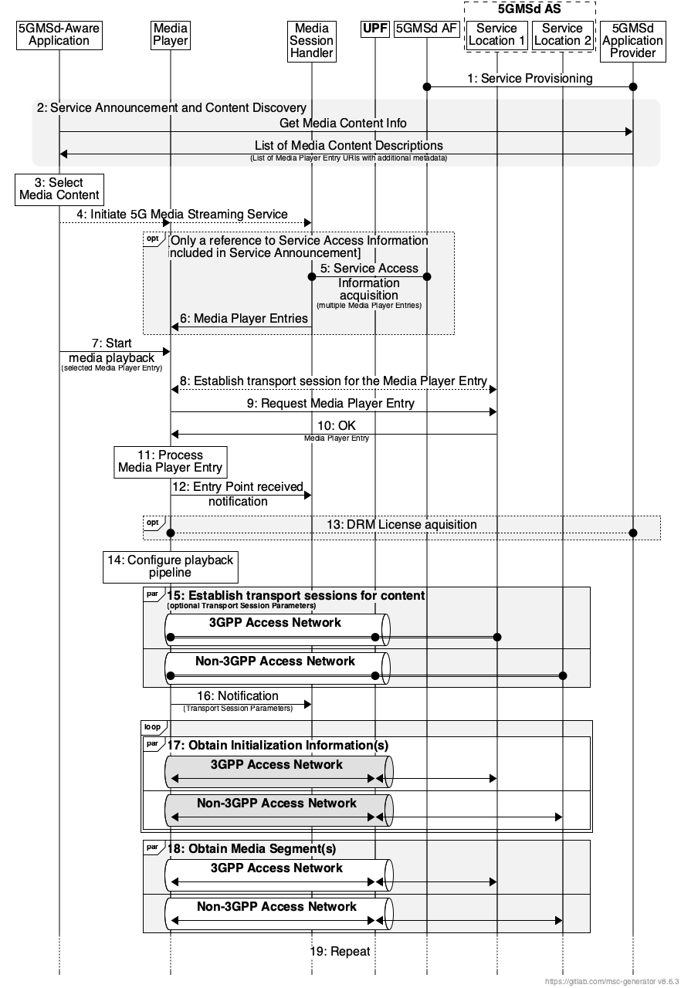
Figure 5.18.4.1-1: High-level procedure for downlink streaming from multiple service locations and/or over multiple access networks within the 5GMS System
NOTE 2: While the procedure shows the 5GMSd AS has two service locations where each supports content delivery at reference point M4d over different access networks, a single 5GMSd AS service location may support content delivery at reference point M4d over both 3GPP and non-3GPP access networks. Furthermore, content may be delivered at reference point M13d from the 5GMSd Application Provider over either access network (i.e., 3GPP access or non-3GPP access).
Steps:
1. The 5GMSd Application Provider provisions the 5G Media Streaming System, including content hosting and ingest, such that content is available from two or more service locations (labelled Service Location 1 and Service Location 2). Upon successful provisioning and content ingest (see clause 5.4.4), either the 5GMSd Application Provider or the 5GMSd AS may create or update Media Player Entry documents (or documents pointed to by each Media Player Entry document) to include any necessary multiple service location configuration information required by the 5GMSd Client to access media content from multiple service locations.
2. The 5GMSd-Aware Application triggers the Service Announcement and Service and Content Discovery procedure. The Service and Content Discovery procedure only involves the 5GMSd-Aware Application and the 5GMSd Application Provider. The Service Announcement includes either the Service Access Information (i.e. details for Media Session Handling at reference point M5d and for Media Streaming access at reference point M4d) or a reference to the Service Access Information.
3. A media content item is selected.
4. The 5GMSd-Aware Application triggers the 5GMSd Client to initiate the 5G Media Streaming Service.
When the 5GMSd-Aware Application has received only a reference to the Service Access Information (see step 1):
5. The Media Session Handler interacts with the 5GMSd AF to acquire the whole Service Access Information. The Service Access Information may include Media Player Entry URLs.
6. The Media Session Handler provides the Media Player Entries to the 5GMSd-Aware Application. The information may indicate a precedence order for these Media Player Entries.
Then:
7. The Media Player is invoked with the selected Media Player Entry to start media access and playback.
8. The Media Player establishes the transport session for acquiring the Media Player Entry.
9. The Media Player requests the Media Player Entry.
10. The Media Player receives the Media Player Entry.
11. The Media Player processes the Media Player Entry. From the Media Player Entry, the Media Player determines the multiple service location configuration, including the locations of the available service locations where content can be accessed and the method in which it should access this content (e.g., switch between service locations, use of a content steering to guide access to service locations, simultaneous use of service locations, etc.). It further determines, for example, the number of needed transport sessions for media acquisition to each service location. The Media Player should be able to use the Media Player Entry information to initialize the media pipelines for each media stream. The Media Player Entry should also contain information to initialize the DRM client, when DRM is used.
12. The Media Player notifies the Media Session Handler about the Media Player Entry.
13. Optional: the Media Player acquires the necessary DRM information, for example a DRM License.
14. The Media Player configures the media playback pipeline.
15. The Media Player establishes the necessary transport sessions for the content according to the multiple service location strategy, multiple access network strategy, and configuration information indicated by the Media Player Entry. These transport sessions may be established between the Media Player and any one or more of the available service locations. For example, the Media Player may establish one transport session for each media component (audio, video, etc) and possibly additional transport sessions for other media representations to each service location. Furthermore, these transport sessions may be established between the Media Player and the 5GMSd AS via the UPF over different access networks (e.g., 3GPP access and non-3GPP access) dependent on the UE’s connection to more than one access network and the Media Player’s capabilities to steer network traffic to one access network or another.
16. The Media Player notifies the Media Session Handler that it is ready to commence playback and optionally provides transport session parameters for those transport sessions terminating at the 5GMSd AS.
17. The Media Player requests and obtains the initialization information according to the multiple service location strategy and/or multiple access network strategy in use. This initialization information may be obtained from any one service location or a combination of service locations. In the case where multiple transport sessions have been established over different access networks, the Media Player may request and obtain the initialization information from the 5GMSd AS at reference point M4d over one or more of these access networks. The Media Player repeats this step for each required initialization segment.
18. The Media Player requests and obtains the media segments according to the multiple service location strategy and/or multiple access network strategy in use. These media segments may be obtained from any one service location or a combination of service locations. In the case where multiple transport sessions have been established over different access networks, the Media Player may request and obtain the media segments from the 5GMSd AS at reference point M4d over one or more of these access networks. The received information is put into the appropriate media rendering pipeline.
19. Previous steps are repeated according to the Media Player Entry information.

===== CHANGE =====

5.18.5 Gap analysis and requirements

5.18.5.1 Multi-access downlink media streaming using application layer approaches
Existing methods in the 5GMS System allow a 5GMSd Application Provider and/or 5GMSd-Aware Application to configure multi-access downlink media streaming. Clause 12.4 of TS 26.512 [16] enables a 5GMSd Application Provider to communicate a preference to use multipath media delivery using the 3GPP Service URL, and clause 13.2.4 of TS 26.512 [16] provides an API for the 5GMSd-Aware Application or Media Session Handler to configure multipath operation within the Media Player. However, there may be situations where a preference to use multiple access networks cannot be acted upon by the Media Player. Examples include:
- The Media Player cannot stream media over multiple access networks given a lack of multipath support (e.g., either the UE or the 5GMSd AS service location does not support lower-layer multi-access or multipath transport protocols).
- The 5GMSd Application Provider may want control over how those access networks are used than a multipath transport protocol can offer (e.g., the use of one access network for communications with one 5GMSd AS service location versus the use of another access network for communications with a different 5GMSd AS service location).
The following potential open issues are identified in the specific case where multi-access downlink media streaming is performed using application layer approaches only:
1. Existing procedures for downlink media streaming specified in clause 5 of TS 26.501 [23] do not address multi-access downlink media streaming using application layer approaches.
2. The Media Access Client may have the capability to use multiple access networks without requiring multipath support (e.g., MPTCP, MPQUIC, ATSSS, etc.). This capability is not addressed in TS 26.512 [16].
3. CMMF procedures, protocols, and formats specified in annex H of TS 26.512 [16] are only defined for downlink media streaming from multiple service locations. Procedures, protocols, and formats are not defined in the case where CMMF is used to enable application layer multi-access downlink media streaming.

===== CHANGE =====

5.18.6 Candidate solutions

5.18.6.1 Multi-access downlink media streaming using application layer approaches

5.18.6.1.1 Overview
The candidate solutions in the following clauses are considered to enable multi-access downlink media streaming using application layer approaches. Situations where these application layer approaches may be used, for example, include:
- The 5GMSd Application Provider wants to influence how connections to multiple access networks are used.
- Use of multiple access networks to access media hosted at different service locations.
- Network layer multi-access (e.g. ATSSS) and/or multipath transport protocols (e.g., MPTCP, etc.) are not supported by one or both of the 5GMSd Client and the 5GMSd AS.

5.18.6.1.2 Multi-access downlink media streaming using CMMF
This candidate solution includes approaches where a 5GMSd Client accesses and downloads, via reference point M4d, CMMF-encoded media objects [126], and possibly original source media (e.g., MPEG-DASH or HLS media segments), over multiple access networks simultaneously from one or more 5GMSd AS service locations. CMMF (discussed in detail within clause 5.19.6.3) enables multi-access capabilities through application-layer implementations of the 5GMSd Client without requiring lower-layer (e.g., network, transport, etc.) multi-access integrations.
In this solution, multiple different CMMF-encoded bitstreams/objects (or representations) of the source media are stored/cached within a single logical 5GMSd AS. A CMMF-enabled 5GMSd Client requests and downloads a different CMMF-encoded representation (stripe) of the required original source media over each of the access networks available to it. These (potentially partially) received CMMF bitstreams/objects are decoded by a CMMF decoder in the 5GMSd Client yielding the required original source content once enough information has been received over all of the available access networks.
Unlike other multi-access technologies such as MPTCP, MPQUIC, ATSSS, etc., the responsibility to set up, request, and steer the delivery of content across each available access network rests with the application layer (e.g., Media Player) in this solution. For example, a Media Player sets up multiple HTTP connections in parallel, each one bound to a different network interface (each assigned with an IP address appropriate to that network). Requests to a single 5GMSd AS for different CMMF-encoded representations (stripes) of the original source media are sent from each of the HTTP connections over the different access networks. The HTTP response from the 5GMSd AS to each of these requests is routed appropriately over the appropriate access network, following standard network-layer/IP routing rules and procedures.
As mentioned above, traffic steering over each access network may be performed by the application layer (e.g., Media Player); and multiple policies can be defined/implemented based on the desired outcome. For example, a best-effort policy may involve downloading as much CMMF-encoded content from each available access network until the CMMF decoder can successfully decode the required media. Networks that have lower latency, higher bandwidth, etc. will naturally contribute more to the download than those with higher latency, lower bandwidth, etc. Another policy may preference delivery of content from one access network over another. In this case, a schedular may be implemented so that requests of CMMF-encoded content made to the Application Server can be throttled over one access network so that the majority of the download is completed on the other(s).
Integration of CMMF within the 5GMS System for the purposes of downlink media delivery from multiple service locations is discussed in detail within clause 5.19.6.3 and annex H of TS 26.512 [16]. For the purposes of using CMMF to enable multi-access downlink media delivery within the 5GMS System, the following changes are proposed:
1. Define a procedure within either clause 5.2 or annex H of TS 26.501 [23] for application layer multi-access downlink media delivery as described in clause 5.18.4.1 of the present document.
2. Define procedures, protocols, and formats within annex H of TS 26.512 [16] necessary to enable application-layer multi-access media delivery using CMMF. These updates include:
- Specify Media Player requirements and recommendations necessary to enable multi-access downlink media delivery using CMMF. In addition to the requirements and recommendations listed in clause H.2.2.5 of TS 26.512 [16], this clause also needs to specify that a CMMF Media Access Client should also support the capability to select and steer network traffic over the access network(s) of its choice.
- Specify the use of the CMMF delivery conformance profile specified in clause H.2.3.1 of TS 26.512 [16] for use during multi-access downlink media streaming.
- Provide recommendations and/or examples for constructing CMMF Media Player Entries for the purposes of using multiple access networks.

===== CHANGE =====

5.18.7 Summary and conclusions
Multi-access media delivery enables media streaming applications to efficiently access content over multiple access networks. This Key Issue has examined the use of application layer multi-access approaches and existing specifications relating to the ATSSS (Access Traffic Steering Switching and Splitting) architecture in TS 23.501 [23] and TS 23.502 [24] to identify its impact on 5GMS. Topics relating to application awareness and influence on multi-access delivery, potential enhancements to dynamic policy feature of 5GMS to support multiple access paths, and network assistance with multi-access delivery have been studied. The Key Issue has documented collaboration scenarios, application layer approaches, and the mapping of the ATSSS architecture into the 5GMS architecture.
The MPTCP and MPQUIC link-specific multipath IP addresses are not routable via N6 as of current release, and therefore identification of specific paths for any 5G Media Streaming procedures is not supported. Further, traffic splitting for GBR QoS Flows is not supported. If M4 media flows are transported as GBR QoS Flows, then traffic splitting of M4 media flows using ATSSS is not supported in this release, and the study is to be revisited in a future release.
It is recommended that:
1. An informative annex is added to TS 26.501 [23] documenting:
a. A brief description of multi-access media delivery, based on clause 5.18.1 of the present document.
b. The mapping of the ATSSS architecture into the 5GMS architecture, as described in clause 5.18.3.2 of the present document.
c. The mapping of application layer approaches into the 5GMS procedures to enable multi-access network delivery, as described in clause 5.18.4.1 of the present document.
2. Changes to the Configuration Settings API and to the Dynamic Status Information API as described in clause 5.18.6.2 of the present document are implemented in TS 26.510 [108] to allow for application configuration and status information exchange for multi-access media delivery.
3. A future study on the topic of multi-access media delivery looks into the following aspects:
a. Whether future specification work on ATSSS supports traffic splitting for GBR QoS Flows between 3GPP and non-3GPP accesses. If it is supported, study the impact on splitting M4 media flows if they are transported as GBR QoS Flows as described in clause 5.18.5.2.2 of the present document.
b. Impact of multi-access media delivery using ATSSS architecture on UE multi-path management, Dynamic Policy, Network Assistance, and network slicing procedures, as described in clause 5.18.5.2 of the present document.
c. Whether and how a closer alignment with the study on media delivery from multiple service endpoints/locations in clause 5.19 of the present document is required.
4. Updates to the procedures, protocols, and formats specified in annex H of TS 26.512 [16] to enable application layer multi-access media delivery using CMMF as described in clause 5.18.6.1.2 of the present document.

===== CHANGE =====

6.18 Multi-access media delivery
Multi-access media delivery enables media streaming applications to efficiently access content over multiple access networks. This Key Issue has examined existing the use of application layer multi-access approaches and specifications relating to the ATSSS (Access Traffic Steering, Switching and Splitting) architecture in TS 23.501 [23] and TS 23.502 [24] to identify its impact on 5GMS. Topics relating to application awareness and influence on multi-access delivery, potential enhancements to dynamic policy feature of 5GMS to support multiple access paths, and network assistance with multi-access delivery have been studied. The Key Issue has documented collaboration scenarios, application layer approaches, and the mapping of the ATSSS architecture into the 5GMS architecture.
Based on the conclusions, the following normative changes are recommended for stage-2:
- An informative annex is added to TS 26.501 [15] documenting:
a. A brief description of multi-access media delivery, based on clause 5.18.1 of the present document.
b. The mapping of the ATSSS architecture into the 5GMS architecture, as described in clause 5.18.3.2 of the present document.
c. The mapping of application layer approaches into the 5GMS procedures to enable multi-access network delivery, as described in clause 5.18.4.1 of the present document.
Based on the conclusions, the following normative changes are recommended for stage-3:
- Changes to the Configuration Settings API and to the Dynamic Status Information API as described in clause 5.18.6.2 of the present document are implemented in TS 26.510 [108] to allow for application configuration and status information exchange for multi-access media delivery.
- Updates to the procedures, protocols, and formats specified in annex H of TS 26.512 [16] to enable application layer multi-access media delivery using CMMF as described in clause 5.18.6.1.2.
It is recommended that future specification work on ATSSS in TS 23.501 [23] and TS 23.502 [24] is to be monitored to further study traffic splitting of M4 flows across multiple access networks.
It is recommended that future study on this topic looks into the impact of media delivery using ATSSS architecture on UE multi-access path management, Dynamic Policies, Network Assistance, and network slicing procedures as described in clause 5.18.7 of the present document.

