3GPP TSG-SA4 Meeting #135 S4-260047

India, India, 9th Feb 2026 - 13th Feb 2026 revision of S4-252044
CR-Form-v12.5
CHANGE REQUEST
 | 26.804 | CR | 0029 | rev | 4 | Current version: | 19.1.0
For HELP on using this form: comprehensive instructions can be found at
https://www.3gpp.org/Change-Requests.

Proposed change affects: | UICC apps |  | ME | X | Radio Access Network |  | Core Network | X

Title: | [FS_AMD_Ph2] WT#6: Latency Measurement and control
Source to WG: | Qualcomm Germany
Source to TSG: | S4
Work item code: | FS_AMD_Ph2 |  |  |  |  |  | Date: |  |  | 2026-01-30
Category: | B |  |  |  |  |  | Release: |  |  | Rel-20
 | Use one of the following categories:  F (correction)  A (mirror corresponding to a change in an earlier release)  B (addition of feature),  C (functional modification of feature)  D (editorial modification)  Detailed explanations of the above categories can  be found in 3GPP TR 21.900. |  |  |  |  |  |  |  | Use one of the following releases:  Rel-8 (Release 8)  Rel-9 (Release 9)  Rel-10 (Release 10)  Rel-11 (Release 11)  …  Rel-18 (Release 18)  Rel-19 (Release 19)  Rel-20 (Release 20)  Rel-21 (Release 21)
Reason for change: |  | The study item identifies the following work topic  - WT#6: Latency Measurement and control: Media Service quality is often determined by network latency, and controlling latency is an important topic. The support of latency measurements in 5G Media streaming provides opportunities for service and network providers to judge the quality of the service.  The study item identifies the following objectives  1. Document the following additional Key Issues in more detail, in particular how they relate to the 3GPP Media Delivery architecture and/or the MBS User Service architecture:  2. Study collaboration scenarios between the Application Service Provider and the 5G System and for each of the key topics.  3. Based on existing architectures, develop one or more deployment architectures that address the key topics and the collaboration models.  4. Map the key topics to basic functions and develop high-level call flows.  5. Identify the issues that need to be resolved.  6. Provide candidate solutions including call flows, protocols and APIs for each of the identified issues.  7. Coordinate work with other 3GPP groups e.g. SA2, SA3, SA5, SA6 and others as needed.  8. Coordinate work with external organizations such as SVTA, CTA WAVE, ISO/IEC JTC29 WG3 (MPEG Systems), 5G-MAG, DVB or IETF, as needed.  9. Identify gaps and recommend potential normative work for stage-2 and stage-3, including which existing specifications would be impacted and/or if any new specifications would preferably be developed.
Summary of change: |  | The issues are addressed
Consequences if not approved: |  | Feature not supported
Clauses affected:
 |  | Y | N
Other specs |  |  |  | Other core specifications |  |  |  | TS/TR ... CR ...
affected: |  |  |  | Test specifications |  |  |  | TS/TR ... CR ...
(show related CRs) |  |  |  | O&M Specifications |  |  |  | TS/TR ... CR ...
Other comments:
This CR's revision history:
  TDoc | S4-251709
  Title | [FS_AMD_Ph2] WT#6: Latency Measurement and control
  Source | Qualcomm Germany
  Contact | Thomas Stockhammer
  Agenda Item | 8.7
  E-mail Discussion | Richard Bradbury on Mon, 17 Nov 2025 12:45:39 +0000
  Revisions | S4-251709_BBC.docx
  Minutes | - Thorsten: wouldn’t it be also interesting to measure from the edge cache as well? Time sync is always a bit tricky. Is there anything what could be measured, when time sync is not available?  - Thomas: time sync is well established today. So, its not built for accurate measurement.  - Thorsten: how normal is it in a real deployment to do such a scenario?  - Thomas: We should look into such details.  - Richard: in general, time sync is a good thing, but here it could make things worse. In case if there are several clients synced to a media server, each one under different network conditions, with lots of buffer, wouldn’t that make the situation complicated?  - Thomas: I don’t believe so. We need separate the clients.
  Disposition | Revised to xxxx and endorsed
  Status | revised to S4-252044
  TDoc | S4-252044
  Title | [FS_AMD_Ph2] WT#6: Latency Measurement and control
  Source | Qualcomm Germany
  Contact | Thomas Stockhammer
  Agenda Item | 8.7
  E-mail Discussion
  Revisions | No revisions available.
  Minutes
  Disposition
  Status | endorsed

===== CHANGE =====

2 References
The following documents contain provisions which, through reference in this text, constitute provisions of the present document.
- References are either specific (identified by date of publication, edition number, version number, etc.) or non-specific.
- For a specific reference, subsequent revisions do not apply.
- For a non-specific reference, the latest version applies. In the case of a reference to a 3GPP document (including a GSM document), a non-specific reference implicitly refers to the latest version of that document in the same Release as the present document.
[9] DASH-IF/DVB: "Report on Low-Latency Live Service with DASH", July 2017, available here: https://dash-industry-forum.github.io/docs/Report%20on%20Low%20Latency%20DASH.pdf
[10] DASH-IF: "IOP Guidelines v5, Low-latency Modes for DASH", available here: https://dash-industry-forum.github.io/docs/CR-Low-Latency-Live-r8.pdf
[90] "DASH-IF WebRTC-based Streaming", https://dashif.org/news/webrtc/
[105] Consumer Technology Association Specification CTA-5004-A: "Web Application Video Ecosystem – Common Media Client Data", December 2025.
[DIF-WEBRTC] DASH-IF Report: DASH and WebRTC-Based Streaming, https://dashif.org/webRTC/report.html, March 2022.
[TIMBRE] A. Murphy, "BBC Project Timbre: Investigating mobile coverage for live radio streaming on BBC Sounds", March 2024, https://www.bbc.co.uk/rd/blog/2024-03-project-timbre-investigating-mobile-coverage-for-live-radio-streaming-on-bbc-sounds.
[14496-12] ISO/IEC 14496-12: "Information technology — Coding of audio-visual objects; Part 12: ISO base media file format".

===== CHANGE (new clause) =====

5.X Latency measurement and control

5.X.1 Description
Service Latency is known to be an important measure for the quality of experience associated with a service. Several data points on this matter have been collected by DVB and DASH-IF [9], [10], [90], and [DIF-WEBRTC]. Also, in Project Timbre [TIMBRE] the BBC identified latency as an important measure, in particular the delivery latency of each audio segment was identified as a key indicator of Quality of Experience for the listener. However, while it is possible to measure the segment delivery latency in a client application , as was done in Project Timbre, it would also be helpful to be able to measure latency, of one kind or another, from the network side. This information may then be exposed as an API in the network.
More particular, in segmented media streaming as for example assumed in 5G Media Streaming, (typically CMAF objects described by a presentation manifest such as a DASH MPD or HLS playlist), the service provider wants to control the end-to-end latency, possibly also for synchronized playback across clients, but also wants to measure the latency and report this information back to the network or service provider.
Latency is typically measured from glass to glass (i.e., from the camera to the screen) or measured from the encoder to the screen – for details refer to [9] and [DIF-WEBRTC]. Information on the latency may include:
- what the actual latency is
- if a desired target latency is met
- the deviation from the target latency
- The reason for the target latency: late arrival, network issues, user controlled, etc.
The network and/or service provider may use this information to:
- Measure QoE based on the latency for each client
- Do some network improvements if the latency is not met, e.g. Content Steering, QoS, etc.
- Aggregate the information across multiple/all users

5.X.2 Problem statement and collaboration scenarios
Figure 5.X.2-1 provides a basic architecture for latency measurement in a live service aligned with DASH-IF [10].
1. The content capture device (e.g., production camera) and/or the Encoder embed timing information in the media that relates to when the content was produced and/or encoded, respectively, using a Time Synchronisation server to provide a common time reference.
2. After encoding, the content is packaged, a manifest is generated, and it is distributed via a CDN.
3. The Media Client consumes the media, measures the latency it observed by also syncing to the Time Synchronisation Server and provides the latency information to a Reporting Server.
4. The Reporting Server exposes information that can be used in operations or for QoE measurements.
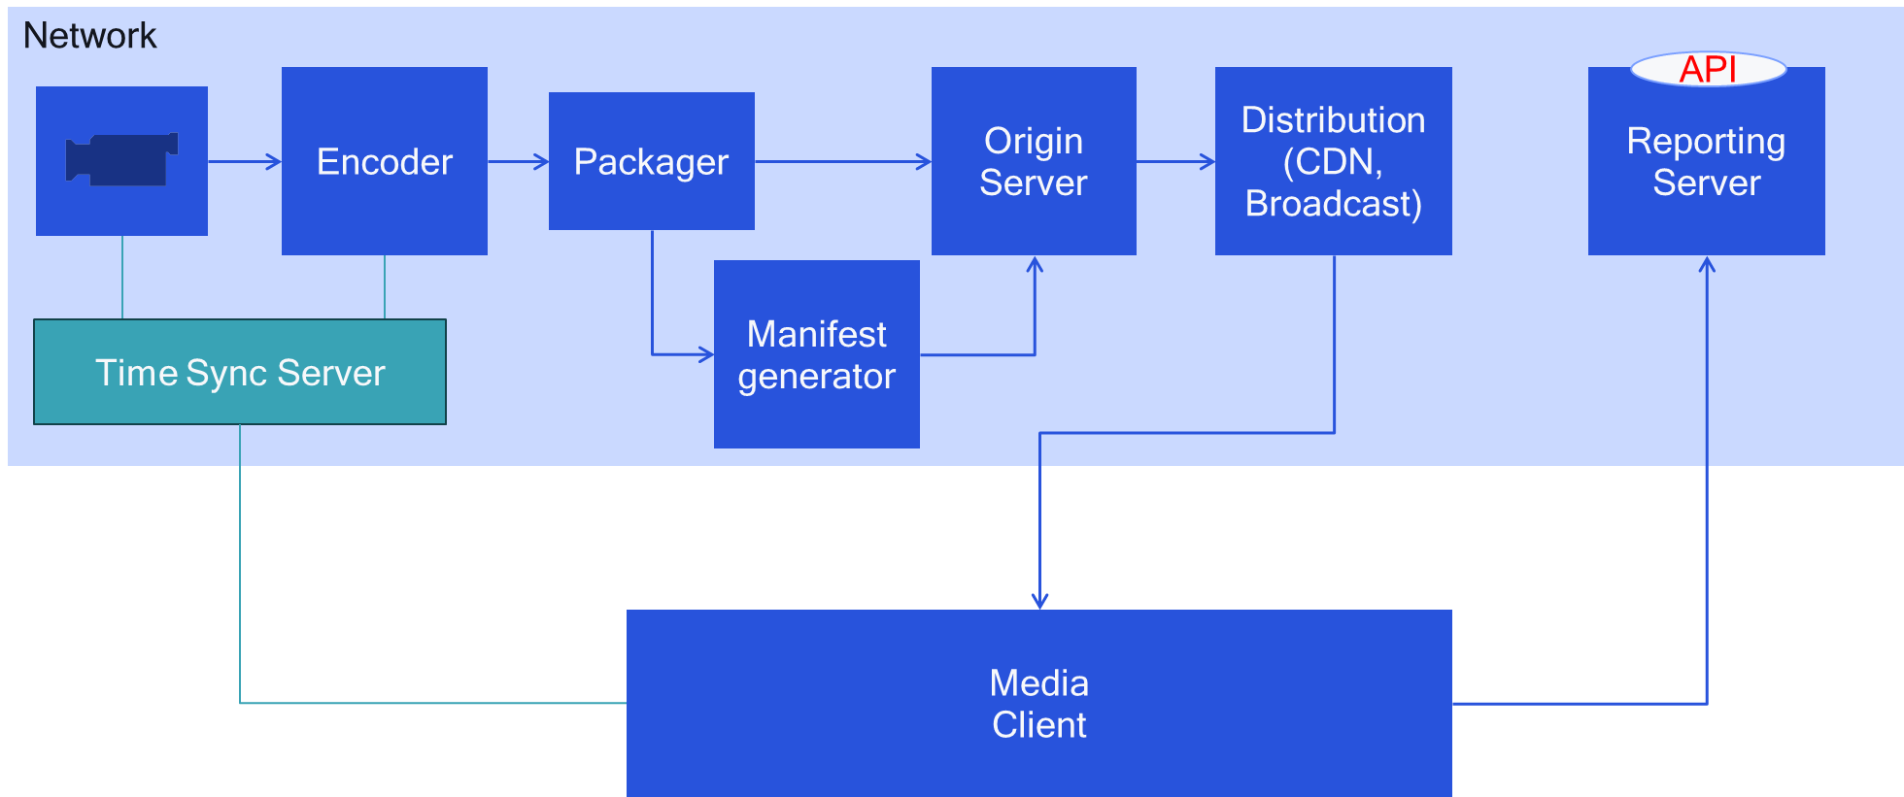
Figure 5.X.2-1 Basic Architecture for latency measurement in a live service aligned with DASH-IF [10]
Latency in a streaming service can be measured for example based on the description in the DASH-IF Low-Latency modes in clause 9.X.6.2.3 of [10]. A summary is provided in the following:
- The Producer Reference Time supplies timestamps corresponding to the production or encoding time of the associated media. This information permits among others to (i) provide media clients with information to enable consumption and production to proceed at equivalent rates, thus avoiding possible buffer overflow or underflow, and (ii) enable measurement of and potentially control over the latency between the production of the media and its presentation.
- The Producer Reference Time as defined in ISO/IEC 14496-12 [14496-12] may be provided in band as part of the Segments (in the prft box), in the DASH MPD or both. In the context of low-latency DASH service offerings, providing information in the MPD is strongly recommended, whereas providing information in band is left to the deployment. The packager can extract the information from CMAF segments and place it into the corresponding presentation manifest.
- The producer reference time permits the DASH client to measure and control the End-to-End Latency (EEL) or the Encoding+Distribution Latency (EDL), and permits the service provider to provide information to the client to control this value.
- Either or both values (capture time and encoding time), can be expressed in the manifest and/or in the segments. It is also possible to create an application-specific anchor for the times embedded in the media.
- Clients synchronized to the same time synchronisation server can now use the information in the media as well as the presentation time to determine the presentation latency. For details, see clause 9.X.5 of [10].
Different collaboration scenarios may be considered, depending on the placement of different functions shown in figure 5.X.2.1-1. The following different deployment options are discussed:
Option 1: The 5GMSd Application Provider runs all encoding and packaging related functions, and the 5GMSd AS only provides content hosting for the DASH Presentation as a CDN. Also, the reporting server is in the 5GMSd Application Provider domain.
Option 2: The 5GMSd System runs a time synchronisation server that is trusted and can be accessed by the 5GMSd Application Provider as well as by the Media Player. The time synchronisation server may be deployed in either the 5GMSd AF or 5GMSd AS.
Option 3: The 5GMSd AS additionally performs manifest generation, requiring functionality to convert in-band timing information to manifest timing information. The time synchronisation server may be internal or external: three sub-options are considered.
Option 4: The 5GMSd System encodes and packages the media and provides a latency from ingest (distribution encoding) to the client. In this case the 5GMSd system controls the latency and does potential operational improvements in encoding, packaging and so on. Reporting may be done between Media Player and the 5GMSd AS, or between the Media Session Handler and the 5GMSd AF.
Option 5: The 5GMSd System is responsible only for reporting. This may be done between the Media Player and 5GMSd AS, or between the Media Session Handler and the 5GMSd AF.
Table 5.X.2-1 summarizes the different deployment options on how the latency measurement functions are mapped to the downlink media streaming functions.
Table 5.X.2-1 Possible deployment options to map latency measurement functions
to downlink media streaming functions
Latency measurement function | 5GMSd Application Provider | 5GMSd AS | 5GMSd AF | Media Player | Media Session Handler
Content Generation | 1,2,3,4,5
Time Sync Server | 1,3a,5 | 2a, 3b, 4a | 2b, 3c, 4b
Encoder | 1,2,3,5 | 4
Packager | 1,2,3,5 | 4
Manifest Creator | 1,2,5 | 3,4
Content Hosting |  | 1,2,3,4,5
Media Client Playback |  |  |  | 1,2,3,4a,5a | 4b
Media Client Reporting |  |  |  | 1,2,3,4 | 5b
Reporting Server | 1,2,3 | 4a,5a | 4b,5b

Based on the discussions,
- Option 1 is out of scope of 5G Media Streaming.
- Option 3 may be considered a subset of Option 4 and hence is not explicitly discussed further, although the suboptions for the time synchronisation server remain relevant.
- Option 5 may be considered a subset of Option 4 and hence is not explicitly discussed further.
For the remaining options 2 and 4, it is worthwhile to consider more detailed architecture mappings and call flows.

5.X.3 Architecture mappings

In figure 5.X.3-1, corresponding to Option 2, a time synchronisation server is operated by the 5GMS System, either in the 5GMsd AF or in the 5GMSd AS. Both the 5GMSd Application Service provider as well as the 5GMSd Client have access to this information. In this case, reporting to the 5GMSd Application Service Provivder by the Media Player is done via reference point M13d.
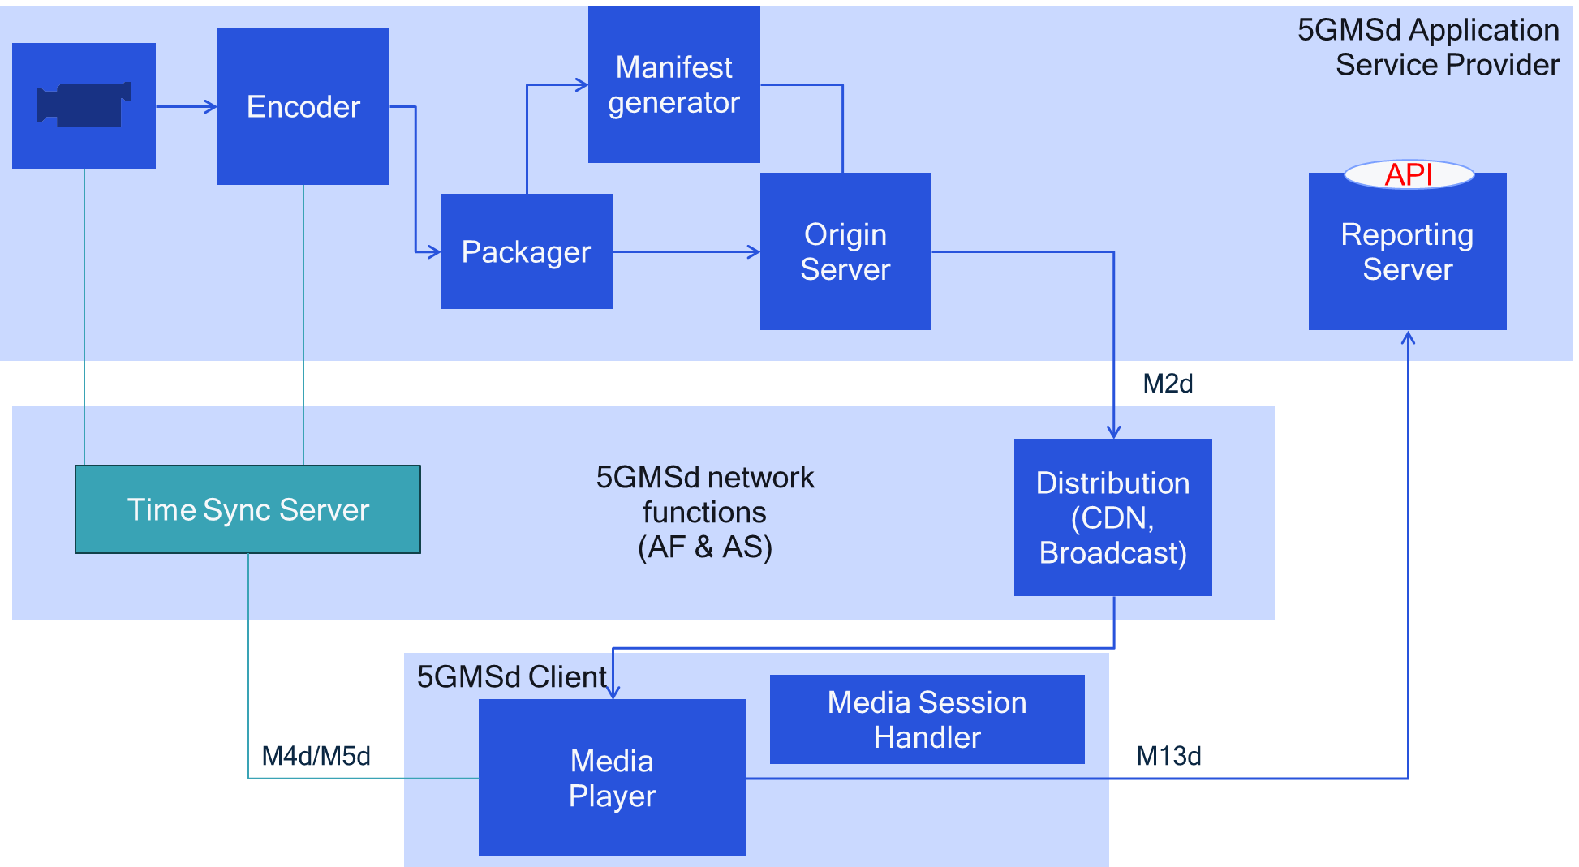

Figure 5.X.3-1: External time synchronisation server and reporting server (Option 2)
In figure 5.X.3-2, corresponding to Option 4, the media encoder and packager are operated in the 5GMSd AS. In this case, reporting is done to the 5GMSd AS via reference point M4d. Note that even that the encoder is in the packager co-located with the Time Sync Server, it may be to identify camera to glass latency, the contribution link may want to have access to timing information as well.
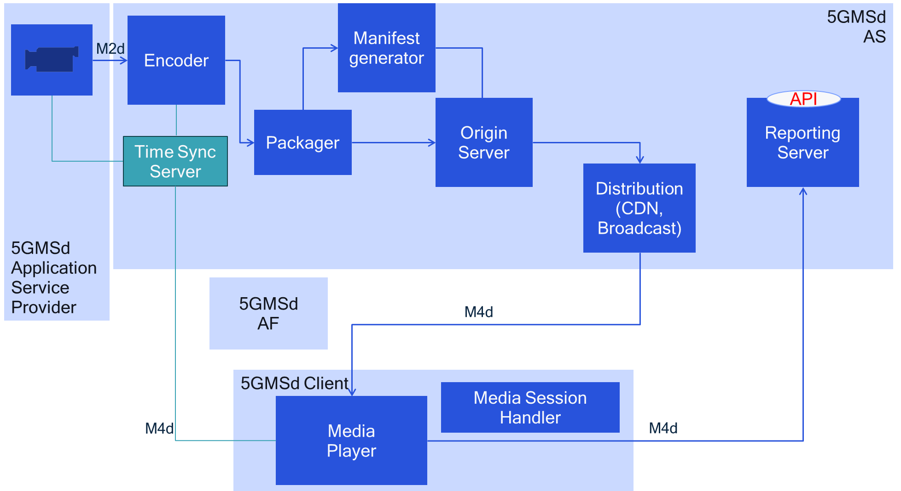
Figure 5.X.3-2: 5GMSd AS hosts time synchronisation server and reporting server (Option 4)

5.X.4 High-level call flows

Based on the problem statement and the architectures in clause 5.X.2 and 5.X.3, respectively, a high-level call flow is provided in figure 5.X.4. A "camera" is added to describe the ability to provide glass-to-glass latency measurement. A time synchronisation server is provided by the 5GMSd System, deployed either in the 5GMSd AF or in the 5GMSd AS. A reporting server is also provided by the 5GMSd System, deployed either in the 5GMSd AF or in the 5GMSd AS
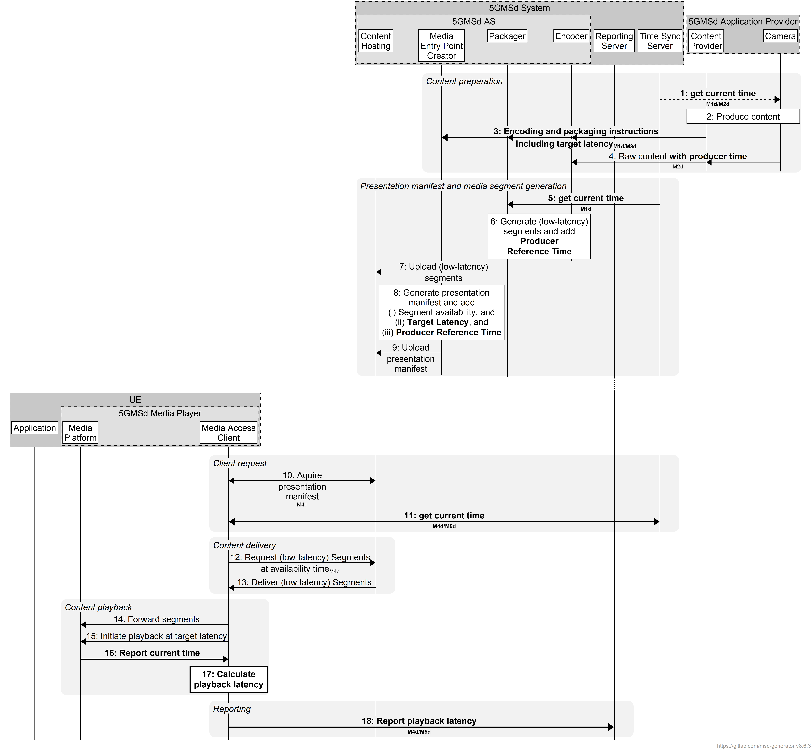
Figure 5.X.4-1 Generalized call flow for latency measurement in 5G Media Streaming
The steps are as follows, highlighting in bold relevant information exchanged via 5GMSd reference points:
Content preparation phase
1. The content source requests the current wall-clock time from the Time Sync Server via M1d or M2d, allowing the content producer to align content creation with a global reference time.
2. The Camera captures live media and sends the raw content, annotated with Producer Time, to the Content Provider.
3. The Content Provider provides the raw content to the Encoder via reference point M2d with Producer Reference Time, ensuring that downstream components can embed producer time metadata consistently.
4. The Content Provider sends encoding and packaging instructions, including the target live latency, to the Encoder, Packager, and Manifest Creator in the 5GMSd AS via reference point M1d followed by M3d, typically using a Content Preparation Template.
Presentation manifest and media segment generation phase
5. The Packager retrieves the current wall-clock time from the Time Sync Server, allowing it to align segment timing with the producer’s clock.
6. The Encoder and Packager generate media segments, potentially using a low-latency mode. During this process, the Packager embeds one or multiple Producer Reference Time into the segment metadata.
7. The generated low-latency segments are uploaded to the Content Hosting function.
8. The Manifest Creator generates the presentation manifest (e.g., DASH MPD) and enriches it with:
- Segment availability times,
- Target Latency,
- Producer Reference Time (with a reference to the Time Sync Server).
9. The Manifest Creator uploads the presentation manifest to the Content Hosting subfunction of the 5GMSd AS.
Client request phase
10. The Media Access Client (on the UE) acquires the presentation manifest from the Content Hosting subfunction of the 5GMSd AS via reference point M4d, learning both the target latency and the publisher’s time references.
11. The Media Access Client obtains the current time from the Time Sync Server via either reference point M4d or M5d, enabling calculation of end-to-end latency later.
Content delivery phase
12. The Media Access Client requests low‑latency segments from Content Hosting via M4d, timed according to the availability information contained in the manifest.
13. Content Hosting delivers the requested segments (possibly using a low-latency mode) to the Media Access Client.
Content playback phase
14. The Media Access Client forwards the received segments to the Media Platform for decoding and playback.
15. The Media Access Client instructs the Media Platform to initiate playback according to the target latency signaled in the manifest.
16. The Media Platform reports its current local playback time to the Media Access Client.
17. The Media Access Client calculates the end‑to‑end playback latency, using the Producer Reference Time (from segments and manifest), synchronized current time (from the time synchronisation server), and the player's current rendering time.
Reporting phase
18. The Media Access Client reports the measured playback latency to the Reporting Server via M4d or M5d using an existing reporting mechanism (e.g. in-band CMCD, DASH metrics). This enables network operators or application providers to monitor delivery performance and adjust latency targets if needed.

5.X.5 Gap analysis and requirements
The following gaps are identified:
- Provisioning of a Time Synchronisation Service via M4d to the Media Player as well as via an exposure function to the 5GMSd Application Provider via M3d and M1d.
- Addition to producer reference times to media segments and manifests and time synchronization between 5GMSd Client and adder of reference times.
- Implementation of latency measurement in 5GMSd Client.
- Reporting of latency information via M4d and M13d, and possibly M5d.
- Controlling the presentation latency for a client.
- Exposing the latency measurement.

5.X.6 Candidate solutions
Editor’s Note
- The producer reference time may be
  - the capture time of the media sample
  - the encoding time of the media sample
  - Any other relevant time relevant for the network provider
- The Time Synchronization is accomplished by UTC Time Sync in DASH
- Producer reference time can be carried in Segments, Manifest or is implicit (see DASH-IF)
- Reporting of latency may be done in DASH metrics or CMCD
- Latency metric may be measured, but also other information such as latency deviation from target latency, reasons for latency and so on
- API for exposure may use NWDAF or any other defined API

5.X.7 Summary and conclusions
To be completed
==============End of change==============

