3GPP TSG-SA4 Meeting #135 S4-260043

India, India, 9th Feb 2026 - 13th Feb 2026 revision of S4-252095
CR-Form-v12.5
CHANGE REQUEST
 | 26.942 | CR | 0010 | rev | 2 | Current version: | 19.0.0
For HELP on using this form: comprehensive instructions can be found at
https://www.3gpp.org/Change-Requests.

Proposed change affects: | UICC apps |  | ME | X | Radio Access Network |  | Core Network | X

Title: | [FS_Energy_Ph2_MED] Energy-aware Streaming
Source to WG: | Qualcomm Germany
Source to TSG: | S4
Work item code: | FS_Energy_Ph2_MED |  |  |  |  |  | Date: |  |  | 2026-01-30
Category: | B |  |  |  |  |  | Release: |  |  | Rel-20
 | Use one of the following categories:  F (correction)  A (mirror corresponding to a change in an earlier release)  B (addition of feature),  C (functional modification of feature)  D (editorial modification)  Detailed explanations of the above categories can  be found in 3GPP TR 21.900. |  |  |  |  |  |  |  | Use one of the following releases:  Rel-8 (Release 8)  Rel-9 (Release 9)  Rel-10 (Release 10)  Rel-11 (Release 11)  …  Rel-18 (Release 18)  Rel-19 (Release 19)  Rel-20 (Release 20)  Rel-21 (Release 21)
Reason for change: |  | Energy-aware streaming is tied to 3GPP architecture which is overall limiting
Summary of change: |  | Add access-independent energy-aware streaming and combine with 3GPP.
Consequences if not approved:
Clauses affected: |  | 6.X (new), 7.X (new)
 |  | Y | N
Other specs |  | X |  | Other core specifications |  |  |  | TR 26.952 CR 0003  TR 26.952 CR 0004  TR 26.952 CR 0005
affected: |  |  | X | Test specifications |  |  |  | TS/TR ... CR ...
(show related CRs) |  |  | X | O&M Specifications |  |  |  | TS/TR ... CR ...
Other comments:
This CR's revision history:
  TDoc | S4-251712
  Title | [FS_Energy_Ph2_MED] Energy-aware Streaming
  Source | Qualcomm Germany
  Contact | Thomas Stockhammer
  Agenda Item | 8.6
  E-mail Discussion | Richard Bradbury on Mon, 17 Nov 2025 11:41:31 +0000Richard Bradbury on Wed, 19 Nov 2025 10:47:02 +0000  Richard Bradbury on Wed, 19 Nov 2025 10:53:05 +0000  Thomas Stockhammer on Thu, 20 Nov 2025 13:02:10 +0000  Richard Bradbury on Thu, 20 Nov 2025 16:22:08 +0000
  Revisions | S4-251712_BBC.docx  S4-251712r01.docx
  Minutes | - Richard: We need to understand what aggregation really means  - Thomas: I thought about aggregation. It is not SA4 job, somebody needs to define metrics  Wash-up.  Thomas presents R02.  New key issue stated.  Examples added to address Richard’s comments.  Richard is happy with this.  Julien - need to understand how the 5G system uses this solution.  Thomas - agreed, this is FFS. Many aspects still have this problem, needs further work.  Julien agrees to endorse this.
  Disposition | Revised and endorsed.
  Status | revised to S4-252095
  TDoc | S4-252095
  Title | [FS_Energy_Ph2_MED] Energy-aware Streaming
  Source | Qualcomm Germany
  Contact | Thomas Stockhammer
  Agenda Item | 8.6
  E-mail Discussion | No e-mail discussion.
  Revisions | No revisions available.
  Minutes
  Disposition
  Status | endorsed

===== CHANGE =====

2 References
…
[23009-1] ISO/IEC 23009-1: "".
[23009-5] ISO/IEC 23009-5: "".
[CMCD]
[CMSD]

===== CHANGE (new – changemark compared to 2095) =====

6.X Key Issue #7: In-band signalling of energy consumed in the upstream preparation of content and its distribution

6.X.1 Description
This Key Issue may be limited in scope to downlink 5G Media Streaming only.
Acknowledging that distribution of media over the 5G System comprises only a portion of the total energy required to operate the media service, the issue addresses the ability to include information from the end-to-end media service and individual functional components into the consideration of media streaming..
Two aspects are relevant for energy accounting: scope and attribution.

Scope is the most important thing to nail down, but attribution is the most challenging to address.
On scope, it is a question of how far back in the chain one may go, and how far forwards. This is primarily a question about what dynamic behaviour one would attempt to change with what energy-related information. For example, the selection of components of a media service based on energy metrics requires that any differentiating factors through the chain are in scope.
As an example, the energy used in content production and post-production is already accounted for (the BBC created the Albert certification scheme and this is now widely used in the UK television and film production industry to do carbon accounting for productions).
But these upstream production considerations are likely to apply more to the content selection process by an end user rather than driving downstream technical choices once the content has been selected.
It is therefore sensible to limit the scope of this Key Issue to the content distribution aspects.
This starts with content encoding, then content packaging, then origin hosting.
- Different codecs and encoder implementations have different energy costs associated with them.
- Different packaging technologies and their implementations have different energy costs associated with them.
- Different origin hosting technologies and their implementations have different energy costs associated with them. For example,
there is an energy cost to keeping a media segment warm on an origin server, and of serving it.
The question of attribution is more difficult to answer. Some considerations:
1. For every fan-out (e.g. in a multi-tier CDN), the responsibility for the energy cost is divided among the next tier of destinations.
2. The number of destinations is a moving target.
3. An approach to maintain a rolling average based on destinations so far may be an interesting aspect.
- The "cost" of delivering a media segment to a CDN node from the parent tier is fixed for each cache miss.
- The "cost" of keeping the media segment in cache is a time-dependent factor.
This is a kind of "opportunity cost" for having the media segment readily available for fast response.

- The "cost" to provide the media segment to the next tier down is the divisor for the above carbon "costs". Part of this is the "cost" of the CPU cycles in servicing the request.
- This attribution divisor increments monotonically for each downstream request, hence the "cost" per requester decreases until the cache entry expires and is ejected, resulting in a cache miss.
4. The consequence of the above model is that the first requester bears the full cost of acquiring the content at a given CDN node, but a negligible share of the time-dependent caching factor. Subsequent requesters share the acquisition cost fairly, and one may argue whether
this is a fair attribution model.
The "cost"of distribution by a 5GMSd AS in scope would have to be included in the 5GMSd-based distribution, since this is how a CDN is modelled inside the 5G System.
5. This goes right to the edge cache.
which is probably the last point in the distribution chain at which energy costs can be inserted in band.
6. However, accounting for the "cost" of using the 5G RAN to distribute the packets comprising the media segment, and some fraction of the cost of running the 5G Core Network Functions that support the RAN may be needed, but probably this turns out to be
too complex to embed any information in band at this point in the chain.
However, this is where the energy-related information provided by SA2's Energy Information Function of the 5G Core is useful because it provides a view on the RAN and Core "costs".
- The Energy Information AF proposed in Solution #5 (see clause 7.6) may be able to marry up the two sets of information: the (generic) information about the energy consumed in distributing the content to the 5G System and the (system-specific) information about the energy consumed in delivering the content over the 5G System. This combined "cost" can then be shared back to the Application Provider, either via reference point M8 or via R6. This is the "value" that this function can add.

6.X.2 Potential requirements
No requirements have been identified yet. This is for further study.

===== CHANGE (new) =====

7.X Solution #X: Energy-aware streaming

7.X.1 Key Issue mapping
This Candidate Solution pre-dominantly addresses the following Key Issues:
- Key Issue #2: Energy-related monitoring and measurement, as introduced in clause 6.2.
- Key Issue #4: Energy-related configuration by the Application Service Provider for media delivery services in clause 6.4.
- Key Issue #5: Media Application Server Energy management in clause 6.5.
- Key Issue #6: Client-driven management of media delivery service energy optimisation in clause 6.6.
- Key Issue #7: In-band signalling of energy consumed in the upstream preparation of content and its distribution
The solution primarily addresses streaming services, for example in the context of 5G Media Streaming, and in particular the following aspects:
- The Key Issues introduced above rely to some extent on information that is provided in the user plane, i.e. withn the streaming service itself. No specific solution is presented to address these issues.
- There is a general hesitation to introduce and in particular mandate the collection and reporting to the network of energy-related information in a UE.
- At this stage, there is no means for a streaming media client, also referred to as Media Access Function (client) to obtain energy-related metrics related to the media resources it has selected, streamed and consumed. Generally, a streaming media client could benefit from knowledge of the energy attributed to the service – and, even better, to the individual service components – it is consuming.
- Metrics assigned to energy consumption need to be well defined. At this stage there is no single well-defined metric, for energy consumption of streaming services. These metrics are still under development and require testing and feasibility in practice.
- Energy consumption may need to address regulatory constraints, see for example Key Issue #1. Providing specific signalling and handling of such information may be required, for example comparable to accessibility information. At this stage there is no specific exposure of energy-related information in the streaming services themselves, for example in well-defined manifest descriptors, or other well-defined metadata schemes.
- Generally, media streaming services lack a framework to support reporting of energy-related information. A framework may beneficially be defined, and be used in 3GPP with appropriate integration into the 5G System.
Based on this discussion, this proposal provides the following high-level aspects:
- Integrate energy-related information into general media streaming services.
- Create an extensible framework that can be used by different environments.
- Combine the general framework with 3GPP services.
In particular, for the first two aspects, collaboration with other organisations may be considered useful.

7.X.2 Functional description

7.x.2.1 Overview
Figure 7.X.2.1-1 provides an overview of a generic streaming workflow. The workflow may be considered as simple, and can obviously be extended for redundant operations, adding DRM, inserting advertisements, and so on. However, for the purpose of the discussion, this is not relevant.
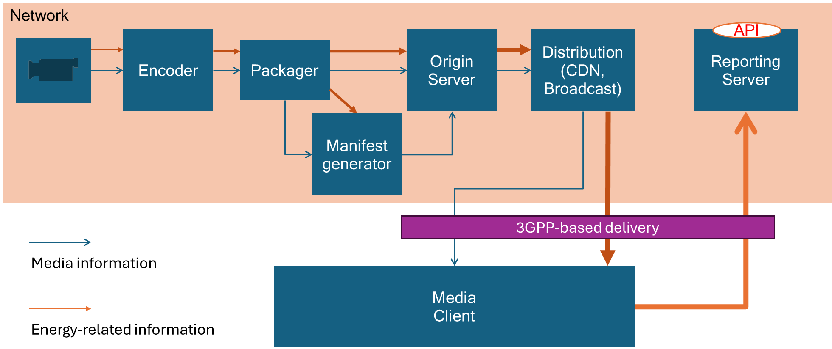
Figure 7.X.2.1-1: Streaming architecture with energy related information workflows
The workflow is as follows:
1. Produced content is provided to a distribution encoder, possibly in multiple variants (for example different resolutions, an SDR and an HDR version, and so on). The captured content may have associated static and/or dynamic information related to the energy needed to produce the content.
2- The encoder encodes the content and aggregates the energy information provided upstream, and the energy/power that it required to encode, possibly also for different variants, for example the encoding technology, the bit rate and so on.
3. The aggregated energy information may then be propagated through the distribution chain, by aggregating and accumulating the energy usage at each stage of the distribution.
A core concept is that the aggregated energy information is included as metadata in the media streaming data, and different options are possible. The media may be delivered via a 3GPP delivery network and reach a media client, but it may also be delivered via other means that are not 3GPP-based. The media client is typically not 3GPP-specific and hence information is expected to be agnostic of the media delivery system and access network(s) used to deliver it. The media client or any node in the network may use information provided in the metadata to optimize the delivery based on energy-related metrics.
In summary, the following functional aspects are considered:
- Propagate energy-related information downstream within the media streaming workflow.
- Make the energy-related information accessible at the level of individual media streams, such that nodes in the delivery chain can access the information.
- Allow the energy-related information to be aggregated and/or accumulated at specific nodes in the media delivery path.
- Collect energy-related information at appropriate nodes in the media delivery path and use the provided information for operational decision-making.
- Allow the aggregated and accumulated energy-related information to be reported to reporting servers:
- Excluding the measured energy consumption at the client.
- Including the measured energy consumption at the client.
- Allow the client to select content based on energy-related metrics.
In order to provide meaningful and trustworthy energy reporting, the nodes in the media delivery chain adding energy-related metrics are preferably trusted energy consumption reporters.
In the following, some specific aspects related to this Candidate Solution are discussed.

7.x.2.2 Assignment and aggregation of energy usage

Media resources available on a specific storage or distribution node may include a record of the energy that has been consumed up to the current point in the media delivery chain, for example including production, encoding, distribution and so on. The information may be scaled to the number of users assigned to this resource. Such a scaling is obviously difficult to estimate, but for example, it may be predicted how many users will request a Segment based on how many requested the previous Segment in the same Representation, and hence such information can be extrapolated to estimate future behaviour. Aggregation may be done by summing the energy information or by other means of aggregation, depending on the assigned metrics.
The energy metric may be assigned to the entire media asset, or to a subset of the media asset, for example to a specific variant, to a specific segment or to a time range.

7.x.2.3 Common repository of energy-related metrics
Metrics assigned to energy consumption are currently not well defined, but may improve over time. A framework is expected to be applicable with an evolution of energy metrics. For this purpose it is proposed to create a registry/repository/catalogue for energy-related metrics, similar to MP4RA’s registry of four-character codes (4CC) for MP4 box types (https://mp4ra.org/‌registered-types/‌boxes) or DASH-IF identifiers (https://dashif.org/‌identifiers/‌introduction/). To each metric a unique key may be assigned, for example using a 4CC code or a URN. In addition, the metric identified by the key is well-defined, typically by reference to a specification and/or implementation. This allows different metrics to be used, and also avoids the need for frameworks to redundantly define the metrics they use. As hypothetical examples:
- Greening of Streaming defines a URN urn:org:gos:energyindex:2025 and/or a 4CC 'eeix' with a well-defined value assigned to it and the energy index expressing the average aggregated consumed energy per second for the media assigned to it.
- French regulator AFNOR defines urn:org:afnor:carbonindex:2025 and/or a 4CC 'eecx' with a well-defined value being assigned to it and the carbon index expresses the average aggregated consumed carbon per second for the media assigned to it.
Such a repository may be hosted by a registration authority, or for example by an organization such as Greening of Streaming.

7.x.2.4 In-band carriage of energy-related metrics
Once the metrics are well defined, for example following what is presented in clause 7.x.2.3, the information may be carried by different means within the media delivery chain. Examples include, but are not limited to:
- Metadata tracks: If the information is dynamic, a metadata track may be used to carry one or different energy-related metrics. Metrics may also be delivered, for example, as part of Addressable Resource Index (ARI) tracks as defined in ISO/IEC 23009-1 [23009-1].
- Common Media Client Data (CMCD) metrics: In the reporting mechanism associated with media delivery, custom energy metric keys may be defined, for example using the definitions in clause 7.x.2.3, and providing the energy related to the consumed assets.
- Common Media Server Data (CMSD) information: In the streaming of media assets, information may be assigned to each resource using data for each segment. This may again use custom energy metric keys.
- SAND information: CMCD- and CMSD-equivalent information may also be provided as part of SAND messages as defined in ISO/IEC 23009-5 [23009-5], for example using custom keys.
- DASH metrics: Equivalently to CMCD, DASH metrics as defined in ISO/IEC 23009-? [23009-?] may be used to report energy-related information.
- Events and Event Streams: Event Streams as defined in ISO/IEC 23009-? [23009-?] may carry energy-related information, similarly to CMSD.
- Information in streaming presentation manifest: A DASH MPD may carry information about energy metrics, for more details refer to clause 7.x.2.5. Equivalently to the information in a DASH MPD, energy metrics may be carried in other streaming manifest formats such as HLS playlists.
- Service Information and API calls as defined in MPEG DASH allow operational information to be carried that defines the API to the client from the application and may provide energy-related information.
The information may be assigned to the entire media delivery chain or parts of the chain.

7.x.2.5 Carriage of energy-related information in streaming presentation manifest
A streaming presentation manifest may carry energy-related information. In the following, examples for a DASH MPD are provided.
- Energy information may be assigned to each resource in the MPD, including all information relevant for the service provider.
- Energy information may be assigned to individual components of the presentation:
- Content – providing information on aggregate energy consumption
- An Adaptation Set
- A Representation
- A Segment
- Service Locations – providing information on the energy required to distribute content from this service location, possibly normalized to the bit rate.
- Adding labels to reference energy-related information. Labels are, for example, available in DASH MPDs to expose information to the user for user-based selection of resources.
- In order to address regulatory requirements, a dedicated Energy descriptor Energy is added to the DASH manifest that allows carriage and exposure of energy-related information, similar to Accessibility information.
- If information is available on different levels, it may be combined (summed, for example, or combined after scaling appropriately). As an example, in a presentation manifest, energy-related information is associated with a base URL or a service location (describing the CDN energy efficiency scaled with bit rate) and is also associated with a Representation (describing the energy consumed in the encoding of the resources). In this case, the consumption of this resource is a combination of using this resource and this CDN and the client may combine this to report overall energy.

7.x.2.6 Usage of energy information in media client or other functions
The information in the presentation manifest, as documented in clause 7.x.2.5 may be used in the media client for different means:
- Exposing energy-related information to the user.
- Exposing energy-related information to the application.
- Based on the above, the user and/or application can use the energy-related information provided to select content based on energy. Obviously, such operational changes may change the actual information, and other users may be informed of this, for example using CMSD headers.
- Selecting content and/or service locations based on energy-related information.
- Reporting the aggregated metric to a reporting server, for example using DASH Metrics or CMCD.
- Possibly adding client energy consumption to the aggregated metrics.
Other functions in the media delivery chain may use the in-band information for operational and reporting purposes as well.

7.x.2.7 Integration into 5G System
Generic energy-aware media delivery may be integrated into the 5G System. Examples include:
- The CDN may be a 5GMSd AS.
- The CDN may expose different service locations. Delivery from multiple service locations may be used to optimize energy usage. For example, the client may select statically and/or dynamically between service locations with different assigned energy metrics. Content Steering may be used to steer clients towards more energy-efficient delivery.
- Reporting from the client may include client UE consumption or may just report what was provided from the network, by aggregating the selection.
- The 5GMSd AS may collect information from the 5GMSd AF and/or EIF to insert energy-related metrics into the streaming metadata, for example in the presentation manifest or in HTTP response headers encoded as CMCD data according to [CMCD/CMSD].

7.X.3 Collaboration scenarios
Editor’s Note: TODO

7.x.4 Architecture mapping
Figure 7.x.4-1 depicts a reference architecture that realises this Candidate Solution in the 5GMSd architecture defined in TS 26.501 [23]. It is based on the solution for collecting and exposing energy-related characteristics instantiated in the 5G Media Streaming System (Solution #5) outlined in clause 7.6.3.2 of the present document.
Figure 7.x.4-1: Reference architecture for exposing energy information in media streaming

7.X.5 Energy-related information
Editor’s Note: TODO

7.X.6 Procedures

7.x.6.1 General procedures
Figure 7.X.6.1-1 provides a general high-level call flow for enery-aware streaming.
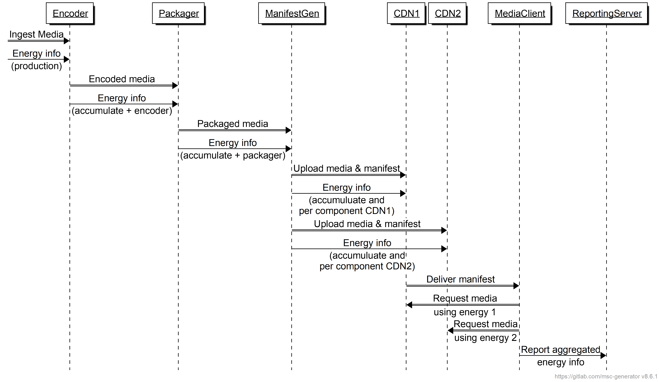
Figure 7.X.6.1-1 General call flow for enery-aware streaming
Here is the description of the call flow:
1. Encoder
a) Processes ingested media.
b) Processes energy information (production).
c) Sends encoded media to Packager.
d) Shares accumulated energy info with Packager.
2. Packager
a) Receives encoded media.
b) Packages media.
c) Sends packaged media to Manifest Generator.
d) Shares accumulated energy info with Manifest Generator.
3. Manifest Generator
a) Receives packaged media.
b) Uploads media and manifest to CDN1 and CDN2.
c) Adds energy info for each media component (Adaptation Set, Representation, etc.).
d) Adds energy information for each service location/CDN.
4. Delivery
a) Delivers manifest to Media Client.
b) Media Client request media based on energy information from CDN1 and/or CDN2.
5. Reporting
- Media client reports aggregated energy information to Reporting Server.

7.x.6.2 5GMSd procedures
The procedure is based on the steps outlined in Solution #5 in clause 7.6, except for those involving the Energy Information Collector, which is not used in the context of this solution. The Media Stream Handler, in the UE, is the decision-making function. But it receives energy-related information directly from the 5GMSd AS conveyed over reference point M4d using in-band information in the presentation manifest and/or encoded in HTTP response headers according to CMSD [CMSD].
NOTE 1: CMSD is just one way to send information in band.
NOTE 2: The presentation manifest may differentiate energy related information not only on service location, but based on other data as well.
Figure 7.x3.2-2: Procedure for service location selection based on in-band energy-related metadata
The steps that are different from the baseline call flow are:
Editor’s Note: To be completed

7.X.7 Gap analysis
Editor’s Note: TODO

7.X.8 Proposed normative changes
Editor’s Note: TODO

7.X.9 Summary

Editor’s Note: TODO
Adaptive Streaming formats such as DASH or HLS permit different ways to provide metadata to a client, including information assigned to components of a media presentation, such that the client can use the information, expose it to applications, or make decisions based on it. At the time of writing, no client is known to implement any energy-related metrics processing or operation.
However, what is relevant is that appropriate energy-related metrics are defined and are in due course added to the User Plane procedures. A simple means is the addition of energy-related information to the presentation manifest, assigned to different components.
More complex dynamic mechanisms to report energy-related information in band reporting, such as CMSD or metadata tracks, are for further study and need work by relevant domain experts.
Based on the discussion it is proposed to progress the efforts as follows:
- In the short-term
- Support the addition of energy-related information in the presentation manifest as static information assigned to components or resources of the Media Presentation, and define how the information is to be aggregated in the client.
- Support the ability that the information extracted from the manifest is reported through 5GMS reporting mechanisms such as DASH metrics or in-band client reporting.
- Engage with relevant stakeholders to define proper metrics and to extend standards (MPEG-DASH, SVTA, CTA WAVE) and reference implementations such as dash.js to support this.
- In the mid-term
- Study how more dynamic energy-related information can be distributed in media streaming, both in downlink (for example using in-band data or metadata tracks), as well as in the uplink.
- Continue to engage with relevant stakeholders to define proper metrics and extend standards (MPEG-DASH, SVTA, CTA WAVE) and reference implementations such as dash.js to support this more dynamic collection of information.
==============End of change==============

