3GPP TSG-WG SA4 Meeting #135 S4-260097
Goa, IN, 9th Feb – 13th Feb, 2026

Source: Huawei, HiSilicon
Title: Embodied AI use case and related requirements.
Document for: Discussion and Agreement
Agenda Item: 11.1
Work Item / Release: FS_6G_MED / Rel-20
Abstract: details on embodied AI use case from SA1 are presented and target requirements for SA4 are derived

1. Introduction
At the last SA4 meeting #134 in Dallas the use case on embodied AI in the context of SA4 was discussed in S4-251826.
Based on this paper it was commonly understood and agreed that this use case is important for study in the FS_6G_MED.
The basic use case is already captured in TR 22.870 clause 6.28 and S4-251826.
In the use case of embodied AI, the sensors are mobile and upstream cloud or servers are used for AI processing.
The upstream data may include video streams, point clouds and other modalities e.g. pose, feature maps.
The tasks performed may leverage advanced processing capabilities in the AI cloud.
In this paper we provide further details based on the conclusions in S4-251826:
- Specific example tasks illustrating the use cases for embodied AI based on current state of the art.
- Example formats used in a specific scenario and corresponding network requirements cross-checking the SA1 study on this topic.
- Elaborate on the transmission formats and optimization solutions based on the current state of the art.
- Potential 5G-A/6G support and related requirements for features in the network.
- Suggested text for TR on FS_ 6G_MED

2. Embodied AI summary based on S4-251826 and TR 22.870
S4-251826 and the ITU-T workshop held last October 2025 observes the shift in using in the production of media in the wild from static observation sensors to sensors actively interacting with the world:
The Old Paradigm (Static & Constrained): Relies on fixed cameras and sensors with limited fields of view, struggling to achieve comprehensive and flexible coverage of complex environments.
The New Paradigm (Mobile & Embodied): Robots, UAVs, and other mobile devices are becoming our "mobile eyes and limbs." They can actively enter, explore, and interact deeply with the physical world
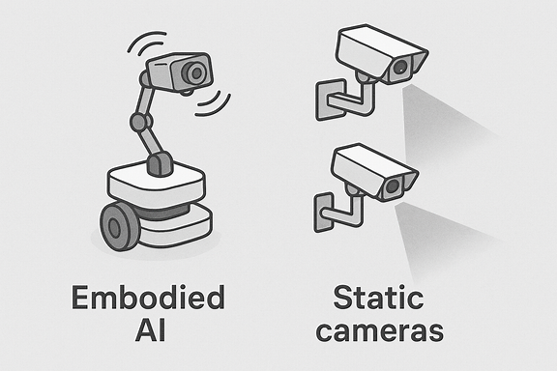
Figure 1 New paradigm with moving cameras versus the old paradigm of static cameras
The example devices that can benefit from embodied AI include Robots, UAV that also use the “observations” for making real time autonomous decision making.
Some recent developments in this area include the humanoid robot project from Nvidia Isaac GR00T - Generalist Robot 00 Technology | NVIDIA Developer [x21] and the workshop held by the ITU-T SG21 [x22] on this topic: https://www.itu.int/en/ITU-T/Workshops-and-Seminars/2025/1010/Pages/default.aspx
The typical use case as outlined in S4-251826;
“Devices such as robots and UAVs equipped with multiple cameras are required to capture and upload multi-modal concurrent data streams (e.g., video, point clouds) for network-based AI inference. These streams are transmitted via a unified bearer network to a network-based platform or third party platforms for distributed AI inference tasks, including multi-modal perception, 3D digital twin modelling, trajectory planning, and task orchestration. This supports various embodied tasks in educational, home, industrial, and special environments, such as automatic inspection and troubleshooting, human-computer interaction and remote operation”
In this paper we provide some more examples based on state of the art solutions and research.
It shows that advanced AI capabilities (beyond reconstruction) are typically performed at the cloud/server.
In S4251826 the following important aspects were identified:
- Compression and transmission of concurrent, heterogeneous data streams (2D video, beyond 2D media, etc.)
- AI tasks such as perception, 3D construction, and planning, understanding, interpretation are completed on the network or third party platforms.
- The demand for the network: e.g. data rate, and latency, error-resillience of the uplink (and in some cases downlink).
- Support for specific diverse scenarios (Educational, Home, Industrial, Dangerous environments）
In this paper we provide additional information and examples.

3. Embodied AI example use cases/tasks (B) in different scenarios (D)

3.1 general
The recent advances in AI, in particular, re-enforcement learning, large language models, and multi-modal large language models are enabling more use cases for embodied AI agents that can independently explore and navigate physical environments. In this clause we detail some example tasks that embodied AI can do using re-enforcement learning and large language models based on research work. In addition we detail some of the evaluation approaches for the different scenarios.

3.2 Task example 1: explore and explain
Task example 1: Explore and Explain [x3]: an independent AI agent (robot) explores a previously unknown environment while recounting what it sees on during the exploration path at important moments. The agent (robot) navigates and explores the physical environment and at the right moment it explains in natural language what it observes. This case is an example of joint captioning and exploration. The agent explores the environment based on an exploratory goal. One way to address this challenge is using a curiosity (new information) based exploration that can be used to learn a policy that can be generalized to also be used in unseen environments. Curiosity based exploration was introduced in Atari and other exploration games [x1, x7, x11] and was extended in [x3] for usage in photo realistic environments for exploring and explaining previously unseen environments.
In [x3] the raw RGB-D data obtained by robot sensors is encoded using a neural network obtaining embedded representation and both forward and inverse dynamics model are defined based on neural network parameters. The forward dynamic model can be used to predict the next embedding (i.e. transformed visual observation). The final neural network parameters for this model are trained by minimizing an expected loss function which is defined as square l2 norm of the difference between observed and predicted embeddings. The reward function in this case was based on the square l2 norm of the difference between embedding predicted by the model and the actual embeddings observed (defined as surprisal [x23] value corresponding to the curiosity based approach). Besides the exploration and the captioning, the agent also needs to identify the moments when it is necessary or useful to do the explanation. To address this, a speaker policy i.e. when to caption was developed. Different policies were developed including a depth driven policy that is triggered when the mean depth is above a certain threshold, and a curiosity threshold. This implies that the surprisal value (based on square of l2 norm between predicted and actual embedding using forward dynamic model) is above a certain threshold. The captioning model itself was developed based on transformer model using self-attention on sets of image features [x16].
In [x3] the evaluation of the exploration mode was done using average surprisal value/score, while the captioning was evaluated versus labels in ground truth data using a coverage measure that is computed as the ratio of the intersection score and the number of ground-truth, semantic classes. The score is computed using two factors, 1) how well the predicted caption covers all the ground-truth objects, and 2) a diversity score that measures the diversity in terms of described objects of two consecutively generated captions. The computation then, given a predicted caption, extract all nouns n from the sentence and computes the optimal assignment between them and the set of ground-truth categories, using distances between word vectors and using the Hungarian algorithm[x17].
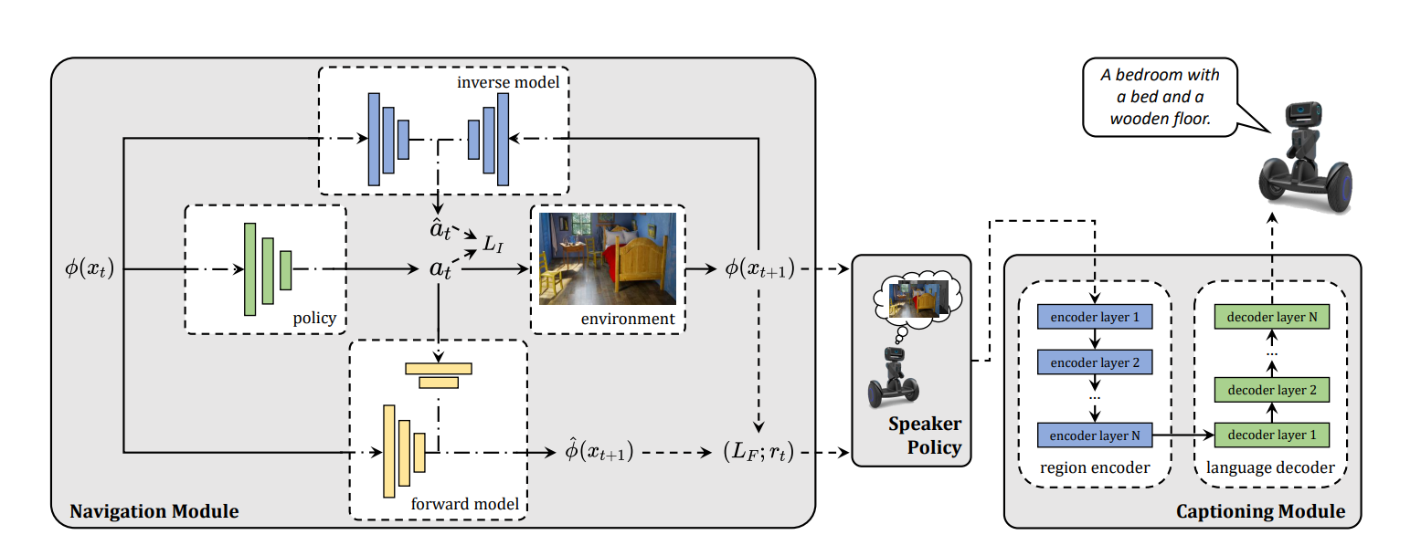
Figure 3.2-1 The 3 modules in [x3] for navigation (using surprisal and forward/inverse model), speaker policy and captioning.
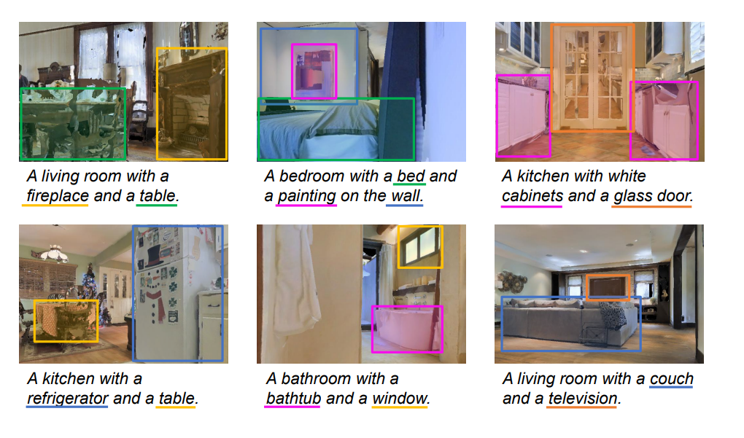
Figure 3.2-2 Sentence generated in different navigation trajectories, the relevant terms are presented in the sentences/captions and eventually evaluated against a baseline courtesy of [x3]

3.3 Task example 2 spot the difference
Task example 2: Spot the difference [x20]: in this example embodied AI task, the robot/agent already has a global understanding of the scene, i.e. it has already explored the scene or has retrieved information about the global scene that was applicable at an earlier instant. In this task, the embedded agent/robot may be asked to spot or observe certain differences in the scene that may have taken place or the agent/robot is given a specific task related to the environment (e.g. can you check if my coffee cup is still on the table). Simply said, in this task the goal is to spot the difference i.e. the agent/robot must identify the differences between an outdated map and the environment in the current state. This task combines exploration and embodied navigation with spatial reasoning. To succeed in the task, the agent needs to develop efficient exploration policies to focus on likely changed areas. One of the key factors is the map representation that contains the knowledge of the environment. Still, the case of the environment changing over time remains challenging and many solutions do not really fully address it. Also many of the 3D datasets used to train embodied AI agents, lack some flexibility to change some of these aspects easily making it hard to train agents for such tasks. In this task the agent/robot has a fully pre-built map representing its spatial knowledge of the environment. In a spot the difference task T time steps might be given as a budget to find differences. Different semantic object maps may exist. In [x20] techniques inspired from neural SLAM [x19]. In [x20] the evaluation of this use case considered three main classes of metrics. First, the percentage of navigable area in the environment seen by the agent during the episode (Seen[%]). Second, the percentage of elements that have been correctly detected as changed in the occupancy map (Acc. [%]) and the pixel-wise Intersection over Union for the changed occupancy map elements (IoU). Besides, the evaluation considered the task of the two-class problem of detecting added/removed objects computes the IoU score for objects that were added in place of free space (IoU+) and for objects that were deleted during the map creation (IoU−). To evaluate the performance of this detection independently from the exploration capability, the metrics are only on the portion of space that the agent actually visited (mAcc. and mIoU).
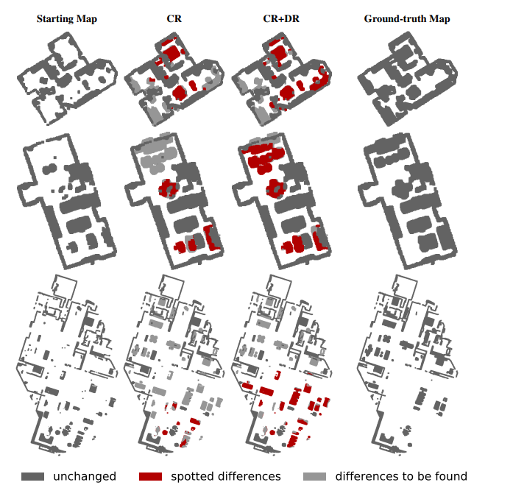
Figure 3.3-1 Evaluation of spot the difference task, with the unchanged map, the spotted differences and differences to be found with CR and CR + DR agents [x20]

3.4 Task example 3 indoor exploration
Task example 3: Indoor Exploration [x9]: this is one quite fundamental task in embodied AI to acquire spatial information (for example represented as map information) to support other important tasks such as planning and goal driven navigation. Popular approaches also use deep re-enforcement learning as it is more flexible and robust than geometric methods traditionally used in such applications [x10, x15]. Examples of recently proposed intrinsic rewards for robot exploration are based on curiosity [x18], novelty [x15], and coverage [x19]. The lack of a ground truth in exploration task makes reinforcement learning once again an attractive approach. The development of photo-realistic environment simulators has triggered research on self-supervised approaches for exploration using re-enforcement learning. Following the current state-of-the-art architectures for navigation for embodied agents [x19, x14], an example solution for an agent doing this task developed in [x9] comprises three main components: a CNN-based mapper, a pose estimator, and a hierarchical navigation policy. The mapper generates a map of the free and occupied regions of the environment discovered during the exploration. The pose estimator in [x9] is used to predict the displacement of the agent in consequence of an action. The navigation policy/navigator in [x9] is in charge of deriving the actions for the agent to undertake at each step, to reach certain local or global exploration goals. To evaluate the indoor exploration, in [x9], the following metrics were considered: The IoU between the reconstructed map and the ground-truth map of the environment: this metric considered two different classes for every pixel in the map (free or occupied). Similarly, the map accuracy (Acc, expressed in m²) is the portion of the map that has been correctly mapped by the agent. The area seen (AS, in m²) is the total area of the environment observed by the agent. For both the IoU and the area seen, the results relative to the two different classes can be reported: free space and occupied space respectively (FIoU, OIoU, FAS, OAS). Last, the mean positioning error achieved by the agent at the end is reported.

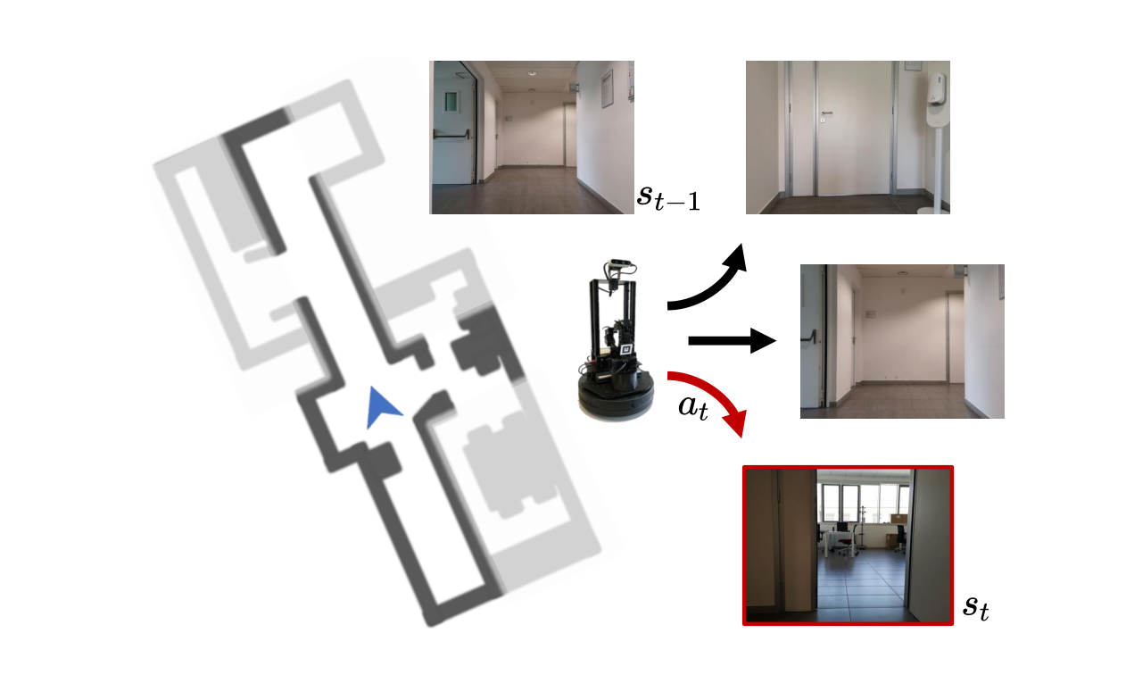
Figure 3.4-1 Robot explores the environment by choosing next step that maximizes the suprisal to explore the indoor environment

3.5 Task example 4 Vision and Language Navigation
Task example 4: Vision and Language Navigation[x2]: In Vision-and-Language Navigation (VLN), an embodied agent needs to reach a target destination with the only guidance of a natural language instruction. To explore the environment and progress towards the target location, the agent must perform a series of low-level actions, such as rotate, before stepping ahead. A challenging task that demands an embodied agent to reach a target location by navigating unseen. For example, walking past the piano requires to find and focus on the piano, rather than considering other objects in the scene. Finally, the agent needs to understand when the navigation has been completed and send a stop signal to indicate this state. In low-level VLN, the agent takes moves in the environment by using actions such as rotate, tilt up, and step ahead. Work in [x5] builds on a traditional sequence-to-sequence architecture, while [x13] employ a mixture of model-free and model-based reinforcement learning. In these works the agent perceives only the first person view of the surrounding environment. In [x2] an approach was developed that encodes the visual input of high quality 360 panorama in a 12x3 grid and computes 2048 dimensional feature maps also adding coordinates of the position, the language input is tokenized per word per word, i.e. one word is a token. Attention mechanism was used to identify the most relevant parts of the navigation instruction, as the instructions are complex as they include an order and time based interpretation besides an interpretation of the instruction. In [x2] was trained on a public (room2room) data set [x24] and the simulator also provides a ground truth to train the model. For evaluation of this use case in [x2] the following metrics were considered: navigation error (NE), oracle success rate (OSR), success rate (SR), and success rate weighted by path length (SPL). NE is the mean distance in meters between the final position and the goal of the navigation. SR is fraction of episodes terminated within no more than 3 meters from the goal position. OSR is the success rate that the agent would have achieved if it received an oracle stop signal in the closest point to the goal along its navigation. SPL is the success rate weighted by normalized inverse path length and penalizes overlong navigations.
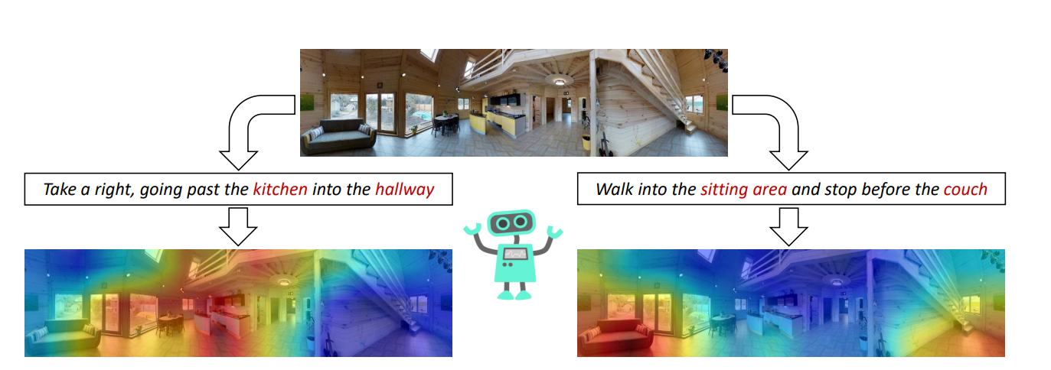
Figure 3.5-1 language based navigation

3.6 Conclusion
These are some example embodied AI tasks and corresponding related quality evaluation metrics and methodologies.
Example embodied AI tasks include but are not limited to:
Explore and explain
Spot the difference
Indoor exploration
Vision and language navigation
It is by no means an exhaustive list.
Based on recent advances, we can learn from them to get an understanding of aspects relevant to 3GPP.
With regard to deployment in different scenarios of embodied AI, in hazardous scenarios it may be prefere-able to keep the robot/agent simple and offload tasks to the cloud upstream server that is in a safe non-hazardous environment. Similarly in educational settings it may be prefer-able to have a centralised AI processing/model (AI processing models can become large) and many students or learners may make use of servers. In general, current AI models often use cloud based processing. However, for offloading to the cloud network it may be a requirement to provide low latency connectivity suitable for this type of service. Similar arguments may apply in an industrial setting where many robots are executing embodied AI, it may be more efficient to centralise the cloud based processing.
Observation 1: There may be scenarios where AI processing for embodied AI is happening at a cloud or server, in such case, the client could either send raw unprocessed visual data (with standard compression) or pre-processed visual data e.g. embeddings derived from the observations made.
Observation 2: when the tasks are implemented in a cloud server, given that scenario of real time navigation and interaction with the environment, low latency connectivity and error resilience can become a critical factor.
Observation 3: For embodied AI tasks, the evaluation method is highly task dependent and different metrics are applied for different tasks.

4. Transmission of streams for Embodied AI (A) and Related Network Requirements
As stated in TR 22.870, the embodied AI can use AI inferencing in a mobile device, however for more advanced tasks it may benefit from offloading AI processing tasks to the network. Also in different setting there may be benefits to offloading the tasks.
- Hazardous environment: it may be preferable to keep the robots simple/light as they may be vulnerable to environmental hazards.
- In industrial environments with many robots/agents it may be preferable to centralise the AI processing as robots may make use of similar embodied AI processing
- In home settings different coupled home devices make use of similar AI processing that could be centralised either at cloud or local home gateway.
To support such offloading, TR 22.870 already made an investigation of the possible requirements on the device and the network.
In a simple case, current widely deployed 3GPP codecs are used to distribute content between the clients and the server such as HEVC video coding. Table 6.28.1-1 in TR 22.870 provides some corresponding network requirements for embodied AI using 6 and 8 cameras. Resulting peak data rates could be in the range of 20-100 Mbit.
Observation 4: Offloaded embodied AI may be demanding in bit-rates on the uplink of 20-100 Mbit
Alternative options may be as shown earlier to use alternative codecs or transmission techniques, either proprietary or based on standardized technologies are shown in Table 1. For audio some similar trade-offs exist.
Table 1 transmission requirement multi-modal AI formats for offloading embodied AI and corresponding network requirements
Transmission Format | UE requirements | Network requirements
3GPP codec e.g. HEVC | Support HEVC encoding and transmission | ~20-100 Mbit peak (TR 22.870), bursty, uplink peak, ultra-low latency
Standardized Feature map/codec | MPEG VCM/FCM, JPEG AI (only decoding), | Unknown peak bit-rate, bursty, ultra-low latency up-link
Proprietary or open source based e.g. specific embedding [x3] | Able to compute this representation in software and transmit it to the cloud | Unknown, bursty, ultra-low latency up link

Observation 5: To support this use cases more investigation of proprietary and standardized feature map codecs may be needed.

6. Proposal
1) Take the requirements for embodied AI into account in FS_6G_MED, in particular the real-time AI inference requirement and related real-time AI data communication.
2) Document the simplified embodied AI use case and related requirements based on this paper (based on clause 8)

7. References/Bibliography
[x1] Pulkit Agrawal, Ashvin V Nair, Pieter Abbeel, Jitendra Malik, and Sergey Levine. Learning to poke by poking: Experiential learning of intuitive physics. In Advances in Neural Information Processing Systems, 2016. 26, 28
[x2] Federico Landi, Lorenzo Baraldi, Massimiliano Corsini, and Rita Cucchiara. Embodied Vision-and-Language Navigation with Dynamic Convolutional Filters. In Proceedings of the British Machine Vision Conference, 2019
[x3] Roberto Bigazzi, Federico Landi, Marcella Cornia, Silvia Cascianelli, Lorenzo Baraldi, and Rita Cucchiara. Explore and Explain: Self-supervised Navigation and Recounting. In Proceedings o
[x4] Roberto Bigazzi, Federico Landi, Marcella Cornia, Silvia Cascianelli, Lorenzo Baraldi, and Rita Cucchiara. Out of the Box: Embodied Navigation in the Real World. In International Conference on Computer Analysis of Images and Patterns, 2021.the International Conference on Pattern Recognition, 2020.
[x5] Peter Anderson, Qi Wu, Damien Teney, Jake Bruce, Mark Johnson, Niko Sunderhauf, Ian Reid, Stephen Gould, and Anton van den Hengel. Vision- and-language navigation: Interpreting visually-grounded navigation instructions in real environments. In Proceedings of the IEEE/CVF Conference on Computer Vision and Patttern Recognition 2018
[x6] Federico Landi, Lorenzo Baraldi, Marcella Cornia, and Rita Cucchiara. Working Memory Connections for LSTM. Neural Networks, 144:334–341, 2021.
[x7] Sule Anjomshoae, Amro Najjar, Davide Calvaresi, and Kary Framling. ¨Explainable agents and robots: Results from a systematic literature review. In AAMAS, 2019
[x9] Roberto Bigazzi, Federico Landi, Silvia Cascianelli, Lorenzo Baraldi, Marcella Cornia, and Rita Cucchiara. Focus on Impact: Indoor Exploration with Intrinsic Motivation. IEEE Robotics and Automation Letters, 2022.
[x10] Farzad Niroui, Kaicheng Zhang, Zendai Kashino, and Goldie Nejat. De Reinforcement Learning Robot for Search and Rescue Applications: Exploration in Unknown Cluttered Environments. IEEE Robotics and Automation Letters,
[x11] Deepak Pathak, Pulkit Agrawal, Alexei A Efros, and Trevor Darrell.
Curiosity-driven exploration by self-supervised prediction. In Proceedings of the IEEE Conference on Computer Vision and Pattern Recognition Workshops, 2017.
[x12] Shaoqing Ren, Kaiming He, Ross Girshick, and Jian Sun. Faster R-CNN: towards real-time object detection with region proposal networks. IEEE Transactions on Pattern Analysis and Machine Intelligence, 39(6):1137– 1149, 2017. 33, 37
[x13] Xin Wang, Wenhan Xiong, Hongmin Wang, and William Yang Wang. Look before you leap: Bridging model-free and model-based reinforcement learning for planned-ahead vision-and-language navigation. In Proceedings of the European Conference on Computer Vision, 2018. 80, 89, 107, 108
[x14] Santhosh K Ramakrishnan, Ziad Al-Halah, and Kristen Grauman. Occuppancy Anticipation for Efficient Exploration and Navigation. In Proceedings of the European Conference on Computer Vision, 2020.
[x15] Santhosh K Ramakrishnan, Dinesh Jayaraman, and Kristen Grauman. An Exploration of Embodied Visual Exploration. International Journal of Computer Vision, 129(5):1616–1649, 2021
[x16] Shaoqing Ren, Kaiming He, Ross Girshick, and Jian Sun. Faster R-CNN: towards real-time object detection with region proposal networks. IEEE Transactions on Pattern Analysis and Machine Intelligence
[x17] Harold W Kuhn. The Hungarian method for the assignment problem. Naval Research Logistics Quarterly, 2(1-2):83–97,
[x18] Roberto Bigazzi, Federico Landi, Marcella Cornia, Silvia Cascianelli, Lorenzo Baraldi, and Rita Cucchiara. Explore and Explain: Self-supervised Navigation and Recounting. In ICPR, 2020. 60, 116
[x19] Devendra Singh Chaplot, Dhiraj Gandhi, Saurabh Gupta, Abhinav Gupta, and Ruslan Salakhutdinov. Learning To Explore Using Active Neural SLAM. In Proceedings of the International Conference on Learning Representations, 2019
[x20] F. Landi, R. Bigazzi, M. Cornia, S. Cascianelli, L. Baraldi and R. Cucchiara, "Spot the Difference: A Novel Task for Embodied Agents in Changing Environments," 2022 26th International Conference on Pattern Recognition (ICPR), Montreal, QC, Canada, 2022
[x21] Nvidia gr00t project: available online https://developer.nvidia.com/isaac/gr00t
[x22] Embodied AI and Multimedia Technology Standards, ITU-T workshop held on10th of October 2025 https://www.itu.int/en/ITU-T/Workshops-and-Seminars/2025/1010/Pages/default.aspx
[x23] Joshua Achiam and Shankar Sastry. Surprise-based intrinsic motivation for deep reinforcement learning. In Advances in Neural Information Processing Systems Workshops, 2017. 32
[x24] Chih-Yao Ma, Jiasen Lu, Zuxuan Wu, Ghassan AlRegib, Zsolt Kira, Richard Socher, Caiming Xiong (2024). Dataset: Room-to-Room (R2R) dataset. https://doi.org/10.57702/e4wqnskj

8. Suggested changes

CHANGE 1

4.2.2.X Requirements for embodied AI
These are some example embodied AI tasks and corresponding related quality evaluation metrics and methodologies.
Example embodied AI tasks include but are not limited to:
Explore and explain
Spot the difference
Indoor exploration
Vision and language navigation
It is by no means an exhaustive list.
Based on recent advances, we can learn from them to get an understanding of aspects relevant to 3GPP.
With regard to deployment in different scenarios of embodied AI, in hazardous scenarios it may be prefere-able to keep the robot/agent simple and offload tasks to the cloud upstream server that is in a safe non-hazardous environment. Similarly in educational settings it may be prefer-able to have a centralised AI processing/model (AI processing models can become large) and many students or learners may make use of servers. In general, current AI models often use cloud based processing. However, for offloading to the cloud network it may be a requirement to provide low latency connectivity suitable for this type of service. Similar arguments may apply in an industrial setting where many robots are executing embodied AI, it may be more efficient to centralise the cloud based processing.
Observation 1: There may be scenarios where AI processing for embodied AI is happening at a cloud or server, in such case, the client could either send raw unprocessed visual data (with standard compression) or pre-processed visual data e.g. embeddings derived from the observations made.
Observation 2: when the tasks are implemented in a cloud server, given that scenario of real time navigation and interaction with the environment, low latency connectivity and error resilience can become a critical factor.
Observation 3: For embodied AI tasks, the evaluation method is highly task dependent and different metrics are applied for different tasks.

As stated in TR 22.870, the embodied AI can use AI inferencing in a mobile device, however for more advanced tasks it may benefit from offloading AI processing tasks to the network. Also in different setting there may be benefits to offloading the tasks.
- Hazardous environment: it may be preferable to keep the robots simple/light as they may be vulnerable to environmental hazards.
- In industrial environments with many robots/agents it may be preferable to centralise the AI processing as robots may make use of similar embodied AI processing
- In home settings different coupled home devices make use of similar AI processing that could be centralised either at cloud or local home gateway.
To support such offloading, TR 22.870 already made an investigation of the possible requirements on the device and the network.
In a simple case, current widely deployed 3GPP codecs are used to distribute content between the clients and the server such as HEVC video coding. Table 6.28.1-1 in TR 22.870 provides some corresponding network requirements for embodied AI using 6 and 8 cameras. Resulting peak data rates could be in the range of 20-100 Mbit.
Observation 4: Offloaded embodied AI may be demanding in bit-rates on the uplink of 20-100 Mbit
Alternative options may be as shown earlier to use alternative codecs or transmission techniques, either proprietary or based on standardized technologies are shown in Table 1. For audio some similar trade-offs exist.
Table 4.2.2.X transmission requirement multi-modal AI formats for offloading embodied AI and corresponding network requirements
Transmission Format | UE requirements | Network requirements
3GPP codec e.g. HEVC | Support HEVC encoding and transmission | ~20-100 Mbit peak (TR 22.870), bursty, uplink peak, ultra-low latency
Standardized Feature map/codec | Support standard based feature/image codec | Unknown peak bit-rate, bursty, ultra-low latency up-link
Proprietary or open source based e.g. specific embedding or tokenizers | Able to compute this representation in software and transmit it to the cloud, this is for example based on implementation by the neural network itself | Unknown, bursty, ultra-low latency up link. Enable efficient transmission of related formats and resulting traffic characteristics.

Observation 5: To support this use cases more investigation of proprietary and standardized feature map codecs is needed to support this use case.
For embodied AI the following requirements are recommended:
a) Real-time communication of native AI data/AI codec data (e.g. embeddings, tokens)
b) Multi modal transmission and MLM integration and server based processing
NOTE: additional requirements related to embodied AI are FFS

