3GPP TSG-WG SA4 Meeting #135 S4-260095
Goa, IN, 9th Feb – 13th Feb, 2026

Source: Huawei, HiSilicon
Title: Neural Network Based Video Codec Architecture and Support for Error Resilience
Document for: Discussion and agreement
Agenda Item: 11.1
Work Item / Release: FS_6G_MED / Rel-20
Abstract: Some of our considerations for the SA4 terms or reference are given

Introduction
We describe advances in the neural network based AI codec architectures with some recent results that include error resilient codec extensions.
We recommend to take these developments into account, as 6G is targeting deployment in 2030 such type of codecs may get more adoption (seeing for example the recent success of Deep Render acquired by Interdigital available in VLC and FFMPEG).
AI codecs can also serve a different range of AI related applications (see our overview of AI native formats).

2. DVC Codec and Neural network based video codec
[Guo Lu et al. 2019] proposed a neural network based video codec DVC. In this new architecture some of the key components in video coding architecture are replaced by neural networks based components but the base architecture is still kept in-tact (traditional components and NNC based components have similar functionalities).
Neural Network based coders can achieve good image coding quality, but in some cases the common NNC approach is not fully up to the task, for example motion vector based on optical flow may not be best. In this paper it was shown that a joint RDO of the different neural network based components to overcome some optimization challenges:
- motion estimation
- motion compensation
- residual compression
- quantization and bit-rate estimation
Are jointly trained/optimized.
Figure 2-1 shows both the components based on the original architecture and the NNC based architecture from DVC. Blue blocks indicate encoder only blocks. In this example, a CNN model used to estimate optical flow is used for motion estimation and compression. A motion compensation network is designed to obtain the predicted frames. The detailed results and technical details are available in [Guo Lu et al. 2019] which show that results competitive to H.264 and H.265 are achieved and also the impact of each separate module is detailed.
Both the paper [Guo Lu et al. 2019] and the source code are available publicly.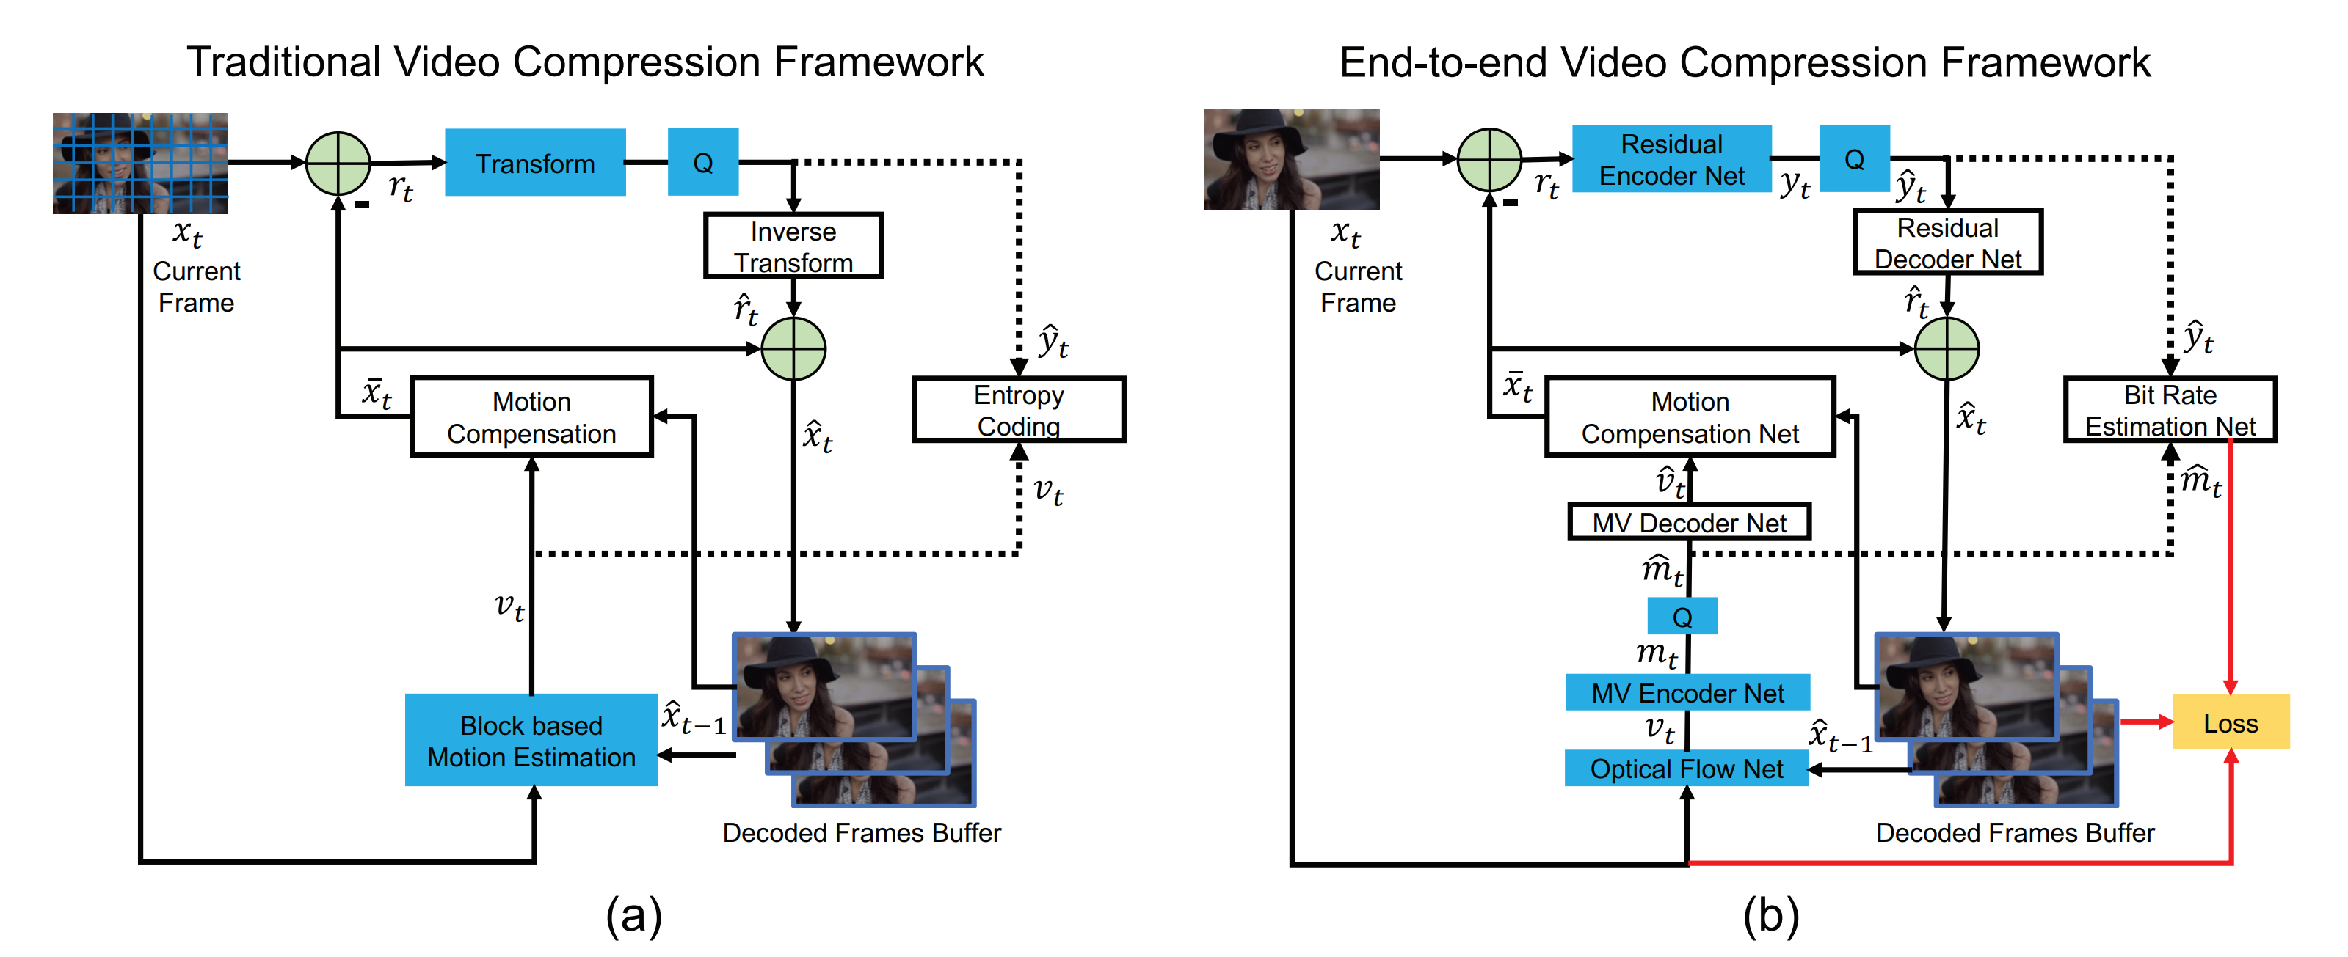
Figure 2-1 traditional video coding and neural network based video coding predictive architecture from [Guo Lu et al. 2019]

3. Grace Codec and Extensions for Error Resilience
[Yihua Cheng et al. 2025] extended the neural network codec architecture by adding a joint training of neural encoder and decoder under a spectrum of simulated packet losses. This enables the codec (encoder and decoder) to become aware of certain loss patterns, and be more resilient to such cases. Grace codec was validated in a user study with 240 crowdsourced participants comparing with state of art H.264/H.265 and error correction (AL-FEC) and receiver side error concealment (concealment at the receiver side, possibly using AI).
MOS scores in the study up to 38 percent better scores were achieved. To summarize, grace extends the DVC framework with adding the loss condition in the training of encoder/decoder enabling the development of channel aware source coding designs. Grace codes each frame in a tensor that is split in independently decodable sub tensors and used arithmetic coding and mapped to packets. In Grace a wide range of loss rates are tested. Additional lighter profiles of Grace that can run on less expensive hardware such as mobile devices was developed (original Grace tested on NVIDIA A40 GPU was used to achieve 31.2 to 51.2 fps).

The testing used realistic condition, using for example Google GCC to emulate google congestion control as used in WebRTC and 61 videos were tested with 240 crowdsourced users. The channel test conditions include several LTE and broadband traces in 0.2-8 Mbps range and 100 ms end-end delay. Rate control was implemented in the encoder using different neural network implementations. A lighter profile of Grace that can run in real time on current mobile devices was also developed referred as Grace-lite.

Grace scored exceptionally well on reducing tail latency (which we see an issue in real-time video delivery in mobile networks), on reducing non-rendered frames and on reducing stalls per second. Based on this Grace also resulted in better video smoothness. These comparisons were done compared to HEVC/AVC baselines with error concealment and/or AL-FEC.

A drawback of NNC is that it may be content specific as the results are based on training data.

Another drawback is reconstruction may fail in some cases. This is due to that some of the arithmetic operations in GPU frameworks are not bit-exact such as floating point arithmetic and some convolution operations. This is a topic FFS and is currently also under discussion in media related standards organization SC29 and might be a key enabler for NNC codecs in the future.

5. Proposal
1. Document the features of neural network codecs and their application to error resilient AI traffic in 6G MED TR under 6G Media based on the text in clause 2 and 3.
2. Take the use case of NNC with channel aware source coding training into account for AI traffic characteristics.

6. References
[x1, Guo Lu et al. 2019] DVC: An End-to-end Deep Video Compression Framework IEEE Conference on Computer Vision and Pattern Recognition (CVPR) 2019
[x2, Yihua Cheng et al. 2025] GRACE: Loss-resilient Real-Time Video through Neural Codes

CHANGE 1

2. References
…..
[x1, Guo Lu et al. 2019] DVC: An End-to-end Deep Video Compression Framework IEEE Conference on Computer Vision and Pattern Recognition (CVPR) 2019
[X2, Yihua Cheng et al. 2025] GRACE: Loss-resilient Real-Time Video through Neural Codes
[X3-MPEG-reproducibility] ISO/IEC/JTC1/SC29/WG2 N00498: “Draft report on reproducibility and NN model handling for AI-based media compression”

CHANGE 2 (all new text)

6.2.4 Work topic #2d: AI Traffic Characteristics

6.2.4.X Work topic #2d: learned-based Codec
6.2.4.X.1 DVC
[x1, Guo Lu et al. 2019] proposed a neural network based video codec DVC. In this new architecture some of the key components in video coding architecture are replaced by neural networks based components but the codec architecture is still kept intact (traditional components and learned-based components have similar functionalities).
It is asserted by the author that DVC can achieve good image coding quality in average.I In some cases the learned-based approach is not fully up to the task, for example motion vector based on optical flow underperforms. In this paper it was shown that a joint RDO of the different neural network based components overcomes some optimization challenges:
- motion estimation
- motion compensation
- residual compression
- quantization and bit-rate estimation
Are jointly trained/optimized.
Figure 2-1 shows both a traditional video codec architecture and the DVC learned-based architecture. Blue blocks indicate encoder only blocks. In this example, a CNN model used to estimate optical flow is used motion estimation and compression. A motion compensation network is designed to obtain the predicted frames. The detailed results and technical details are available in [Guo Lu et al. 2019] reporting results competitive to H.264 and H.265 under the selected test conditions. The impact of each separate module is detailed.
Both the paper [x1, Guo Lu et al. 2019] and the source code are available publicly.
Figure 6.2.4.X-1 traditional video coding and neural network based video coding predictive architecture from [Guo Lu et al. 2019]

6.2.4.X.2 Grace

[x2, Yihua Cheng et al. 2025] extended the neural network codec architecture of DVC by adding a joint training of neural encoder and decoder under a spectrum of simulated packet losses. This enables the DVC codec (encoder and decoder) to become aware of certain loss patterns, and be more resilient to such cases. Grace codec was validated in a user study with 240 crowdsourced participants comparing with state of art H.264/H.265 and error correction (AL-FEC) and receiver side error concealment (concealment at the receiver side, possibly using AI).
MOS scores in the study up to 38 percent better scores were achieved.
To summarize, grace extends the DVC framework with adding the loss condition in the training of encoder/decoder enabling the development of channel aware source coding designs. Grace codes each frame in a tensor that is split in independently decodable sub tensors, and maps the arithmetically coded residuals to packets. In Grace a wide range of loss rates are tested. Grace defines profiles that can run on less expensive hardware such as mobile devices was developed. Grace main profile was tested on NVIDIA A40 GPU and achieved 31.2 to 51.2 fps.

The testing used realistic condition, for example Google GCC to emulate google congestion control as used in WebRTC and 61 videos were tested with 240 crowdsourced users. The channel test conditions include several LTE and broadband traces in 0.2-8 Mbps range and 100 ms end-end delay. Rate control was implemented in the encoder using different neural network implementations. A lighter profile of Grace that can run in real time on current mobile devices was also developed referred as Grace-lite.

It is reported that Grace main profile scored exceptionally well on reducing tail latency, on reducing non-rendered frames and on reducing stalls per second, resulting in in better video smoothness. Comparisons were done against HEVC/AVC baselines with error concealment and/or AL-FEC.

6.2.4.X.Y Complexity of learned-based compression.

Content specific: Some-Learned-based codec (such as DVC) performances may vary for different content types as the compression schemes depend on training data. As with legacy codecs, it is expected that a learned based codec may use a core model and some more specialized models to address a broad range of content types. Codec Architecture based on Implicit Neural Representation (INR) approach do not rely on a training dataset and would be generic by design as the frame to encode is the training dataset itself.

Reproducibility: Reconstruction after learned-based decoding may fail. Hardware implementations of AI processes are currently not deterministic. If floating points are used, or out-of-order operations freedom is allowed (e.g. multi-cores, SIMD, etc.), or undefined behavior operations occurred (e.g. overflow, non-standard operations), then deterministic computation is usually hard to enforce at hardware level. This issue may be critical in some applications such as 2D video coding while being tolerable in others. A learned-based codec design may include mitigation technics. This is a topic currently under investigation in media related standards organization SC29 [X3-MPEG-reproducibility] . Solving the reproducibility issue will be a key enabling factor for the deployment and interoperability of Learned-based codecs on various architecture and implementations (NGPU, GPU).

