Source: Orange, Dolby Laboratories Inc.
Title: On the use of objective metrics in ULBC standardization

Document for: Agreement

Agenda Item: 7.8

- Introduction
The “Study on Ultra Low Bitrate Speech Codec” (FS_ULBC) has been approved at SA#107 [1], and the WID has been further revised in [2]. The latest TR 26.940 (v0.5.1)
In the present Tdoc we address the following study objective from the WID description [2]
5. Define performance requirements and identify appropriate test methodologies, regarding speech quality, intelligibility, conversational quality, in particular taking into account
a) Clean speech and noisy speech
b) Tandeming with existing IMS voice codecs
c) Clean channel and GEO channel conditions

- Proposal
Objective quality models have already been discussed in the scope of ULBC, e.g., in [4]. We revisit this topic by providing correlation analysis results of objective models that were also considered in [5, 6]. This extra information comes as a complement to subjective test results on clean speech and music/mixed content that have been included in TR 26.940 [3].
Proposed revisions to TR 26.940 are detailed in the present Annex based on [3].

References
- 3GPP SP-250378, SID on Ultra Low Bitrate Speech Codec, Source: China Mobile Com. Corporation, vivo, Fraunhofer IIS, Qualcomm Incorporated, Spreadtrum, Dolby Laboratories Inc., Xiaomi, Huawei
- 3GPP SP-250635, Revised Study on Ultra Low Bitrate Speech Codec, Source : SA4
- 3GPP S4-260144, [FS_ULBC]TR 26.940 V 0.5.1, Source: China Mobile Com. Corporation
- 3GPP S4-251814, “[FS_ULBC] Discussion of FS_ULBC Objective Speech Quality Assessment Method,” Source: China Mobile Com. Corporation
- T. Muller et al., “Evaluation of Objective Quality Models on Neural Audio Codecs,” Proc. IWAENC, 2024
- T. Muller et al., “Comparative Quality Study of Neural Audio Codecs - focus on music and mixed content,” Proc. GRETSI, 2025 (in French)

Annex: pCR to TR 26.940

9 Test methodologies
Editor’s Note:
5b. Identify appropriate test methodologies, regarding speech quality, intelligibility, conversational quality, in particular taking into account:
- Clean speech and noisy speech
- Tandeming with existing IMS voice codecs
- Clean channel and GEO channel conditions

9.1 General

9.1.1 Typical quality impairments of ultra-low bit rate speech coding
Speech codecs operating at ultra-low bit rates may impact aspects of speech communication in at least the following categories
- Loss of listening-only audio quality
- Audio bandwidth loss
- Impaired intelligibility
- Impaired speaker identifiability
- Prosodic impairments
- Hallucination, i.e. word and phone confusions
A related quality impairment category is sensitivity to non-speech input. Non-speech input in this context may mean any non-clean speech input such as background noise, music, but also noisy speech, interfering talker speech, reverberant speech.
Additionally, speech codecs operating at ultra-low bit rates may imply speech enhancement algorithms, such as noise suppression, gain normalization etc.
Editor’s note: Investigate impairment relevance in context of use case, e.g. emergency call.

9.1.2 Challenges of quality assessment of ultra-low bit rate speech codecs
Testing of ULBC introduces new challenges in comparison to signal processing-based codecs that may necessitate additional or alternative evaluation methods compared to previous 3GPP SA4 speech coding development activities.
Conversation-opinion tests are intended to reproduce, in a laboratory situation, the actual service conditions experienced by telephone customers. [ITU-T P.800 Section 6]. For practical reasons, and due to the need of strict test control, listening-opinion tests are often employed as an alternative in speech coding development.
According to ITU-T Rec. P.800, the recommended test method for listening-only tests is the "Absolute Category Rating" (ACR) method described in Annex B of ITU-T P.800 (see ITU-T P.800 Clause 6.2). An alternative to the Absolute Category Rating method is the Degradation Category Rating (DCR) method which is described in detail in Annex D of ITU-T P.800. As this is a comparative method it is suitable when the impairment (especially digital impairments) is small.
Based on the principles of ITU-T Rec. P.800, 3GPP established a practice of listening-only evaluations in the context of the standardization of its voice codecs. AMR, AMR-WB and EVS codecs were all evaluated using P.800 ACR and (modified) DCR test methodologies, the latter also applied for tests with larger impairments such as noisy speech over poor channel conditions. ACR was generally used for clean speech tests while P.800 DCR was used for SWB clean speech, mixed-bandwidth, speech + background noise and mixed/music quality evaluations. Other aspects relevant to speech communication, such as impaired intelligibility, impaired speaker identifiability and prosodic impairments were not the focus of testing in AMR, AMR-WB and EVS codec standardization.
For ULBC, these other aspects may need to be addressed more directly, through dedicated tests. Hallucination, for example, is a category that plays only a role in ML-based coding systems but not for signal-processing based codecs, which AMR, AMR-WB and EVS are.
While P.800 recommends ACR as the listening-only test method, it may not be the optimal test to quantify all potential impairments in speech communication such as hallucination, impaired intelligibility and prosodic impairments. These impairments are possible in ML-based coding systems and could be covered by alternative tests such as automatic speech recognition methods, modified rhyme tests and DCR tests (see below).
In contrast, DCR methodology generally focuses on differences to a reference. If such differences are small and pertain to prosodic differences, these may not directly impact the conversational capability of a communication system but can be relevant for other aspects such as identity recognition.
Besides the usage of ACR and DCR, further subjective or objective test methodologies are available that are specifically designed for the evaluation the above-listed impairment categories of ultra-low-rate speech codecs. A non-exhaustive list of such methods is:

- Diagnostic Rhyme Tests (DRT)
- Modified Rhyme Tests (MRT)
- MOS testing for speaker similarity
- Speaker verification/identification tests
- Prosodic naturalness MOS tests
- Intonation recognition tests
- Transcription tests involving testing for word and semantic equivalence
- Phoneme recognition tests
- Automatic speech recognition tests
Speech enhancing tool, which may be part of ultra-low bitrate-codecs, are typically evaluated by multi-dimensional rating scales provided by P.835. Here, the quality of speech and the noise suppression capability are evaluated separately.

9.1.3 Subjective Testing Considerations
In addition to the test methodologies, it is important to focus on test material and criteria.

9.1.3.1 Robustness related to source material
To ensure the general robustness of the ULBC codec, it is critical to conduct evaluations across multiple languages with talkers with diverse intonations as well as non-speech signals. This diversity should encompass a variety of linguistic features and accents to gauge the codec’s effectiveness across diverse phonetic and linguistic environments. Moreover, incorporating a wide range of speakers, with different voice pitches and speaking styles, overlapping talkers will further test the codec’s versatility and its ability to handle natural variations in speech.

9.1.3.2 Simulation of Real-world Acoustic Conditions
The testing environment should mimic real-life scenarios to validate the codec's performance in practical applications. This involves simulating different acoustic conditions such as clean (minimal background noise), noisy environments (traffic, human chatter, vehicle), and spaces with varying levels of reverberation (e.g., various RT60s ranging from 0.3s to 1.0s).

9.1.3.3 Tandeming and Compatibility Testing
An important aspect of codec evaluation (e.g., during candidate Selection) is codec’s performance in tandeming scenarios, where audio data is processed multiple times by different codecs. For ULBC subjective testing, it is vital to test how well the codec performs when handling speech previously encoded by codecs such as ITU-T G.711, AMR, AMR-WB, and EVS. Besides tandeming, the testing should cover various input levels, e.g., -16dBov, -26dBov, and -36dBov.

9.1.3.4 Conclusion
While ITU-T P.800 ACR/DCR can serve as the backbone for most of the subjective testing of ULBC, other methodologies may be considered.
Besides the test methodology, emphasis should be given on selecting and creating a diverse test material and criteria considering: 1) multilingual, multi-speaker testing, 2) real-world acoustic conditions, and tandeming.
Editor’s note: Other options for listening methods are invited for documentation.

9.1.4 Objective Testing Considerations

9.1.4.1 Correlation analysis results
NOTE: The correlation results in the present subclause cannot be used to derive general conclusions on metric performance or identify what could be in general the “best” objective quality metric; these results are based on limited data (one ACR experiment with clean speech, one DCR experiment with music and mixed content) and the number of very low bitrate codecs was limited.

Based on the ACR experiment presented in clause 7.3.3, a correlation analysis was performed to evaluate a selected subset of objective models in [7-11]:
- Speech-oriented metrics: PESQ, POLQA, ViSQOL-S (S for speech), WARP-Q, DNSMOS, NISQA, NORESQA, UTMOS
- Metrics for general audio: PEAQ, ViSQOL-A (A for audio).
In addition, the more recent SCOREQ, NOMAD, SSLMOS metrics have been incorporated in this analysis.
These objective models were compared based on typical evaluation metrics: Pearson correlation coefficient, root
mean squared error (RMSE) and Kendall’s Tau rank correlation coefficient. Details on the evaluation, including the determination of linear and 3rd order polynomial mapping, can be found in [7-11].

Figure 9.1.4.1-1 summarizes results from this correlation analysis on clean speech.
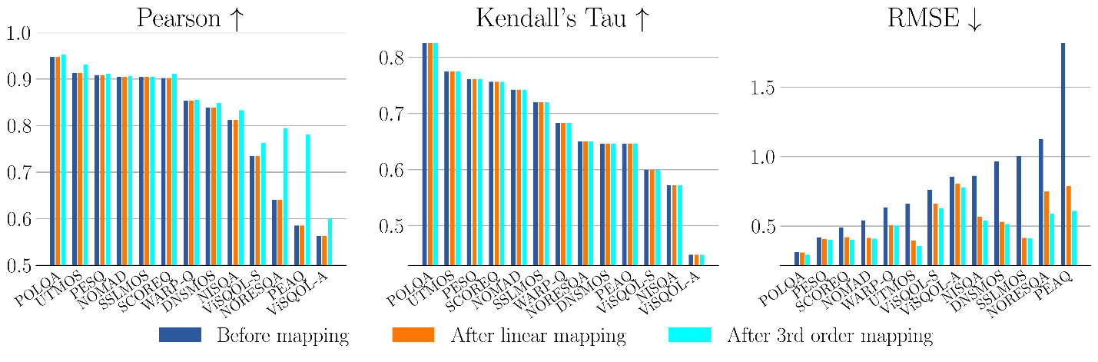
Figure 9.1.4.1-1 Correlation results on clean speech.
The following observations can be extracted from the results in Figure 9.1.4.1-1.
- The models reported as “best performing” in [7-11] (i.e., POLQA, UTMOS, PESQ, WARP-Q), as well as SCOREQ which was not included in [7-11], predicted accurately the monotonic bitrate/quality behavior of tested multirate codecs – which was not always the case for other tested models.
- Models operating at 16 kHz (PESQ without mapping, UTMOS and WARP-Q with mapping) had relatively good performance, even for fullband codecs.
- Except for few models (e.g., PESQ or POLQA), mapping helps improving accuracy (RMSE).

Similarly, based on the DCR experiment on music and mixed content presented in clause 7.3.4, a correlation analysis was performed to evaluate a selected subset of objective models in [7-12]: POLQA, PEMO-Q, ViSQOL-A, POLQA. To get a more complete benchmark, the 2f-model has also been incorporated in this analysis.

Figure 9.1.4.1-2 summarizes results from this correlation analysis on music and mixed content.
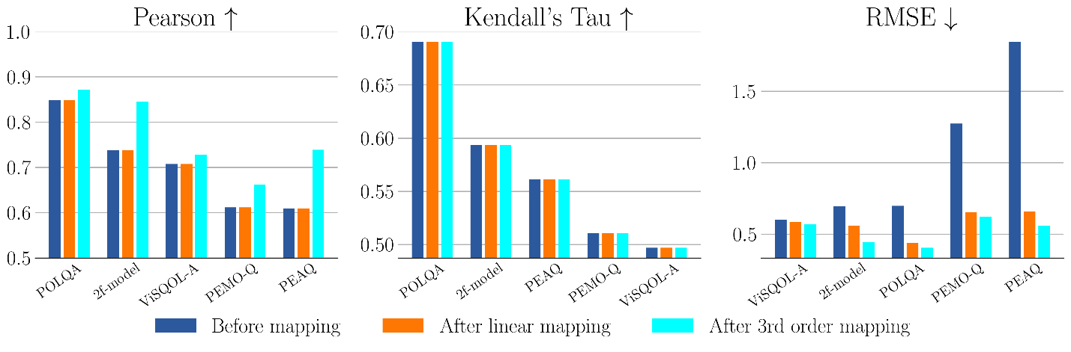
Figure 9.1.4.1-2 Correlation results on music/mixed content.
The following observations can be extracted from the results in Figure 9.1.4.1-2.
- POLQA is not recommended for non-speech signals, still this metric gives the best correlation results (in terms of Pearson, Kendall, and RMSE after 3rd order mapping). The 2f model is the second-best performing model in the tested cases.
- ViSQOL Audio, PEAQ and PEMO-Q have fair performance, although they are adapted to music and mixed content.
- Correlation scores in Figure 9.1.4.1-2 are lower than in Figure 9.1.4.1-1, this may be due to a more difficult task of predicting quality for general audio and a mismatch with test methodology grading (DCR).

9.1.4.2 Discussion
P.862 (PESQ) is officially “withdrawn” by ITU-T. This model cannot be considered as a “valid” standard. P.863 is still the “main” standard in ITU-T, however P.SAMD is emerging as a potential alternative.
Testing and parameter adjustment based on objective tools is typically not recommended. 3GPP TR 26.921 already documented that tuning noise reduction based on PESQ should be avoided.

9.1.4.3 Conclusion
For codec selection subjective testing remains the “golden reference”. Objective metrics are not recommended for codec selection criteria and even codec tuning. However, the correlation of subjective and objective metrics may be considered as part of the characterization of a new codec, and objective metrics have merits in other tasks such as codec conformance testing.

