Source: Bytedance
Title: [FS_ULBC] Analysis on complexity evaluation of ULBC with WMOPS
Agenda item: 7.8
Document for: Discussion & Agreement

1. Introduction
During the discussion of defining complexity metric for ULBC, it is observed that WMOPS [1] has been included as one of the possible metrics [2,3]. In [4], WMOPS data of existing codecs are reported. As the traditional way of evaluating 3GPP speech codecs complexity, WMOPS is automatedly counted with floating point C code using the WMS tool [5].
In this proposal, the source provides observations using this WMS tool for WMOPS calculation.

2. WMOPS with the WMC tool
In clause 18.12.7 (page 293) of [1], examples of WMOPS calculation with floating point code are listed. We write some sample script with simple operators and use the WMC tool to exam the WMOPS as follow:
2.1 Operator ‘Move’
Relate example in Table 18.4 of [1]:
Operation | Counter used | Explanation
b = a / L | MULT(1); | When L is constant; (1/L) is a constant too, so b = a*(1/L)

Test Code:
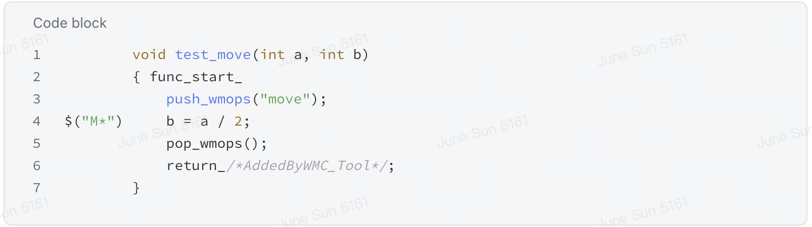
Output of WMC tool:
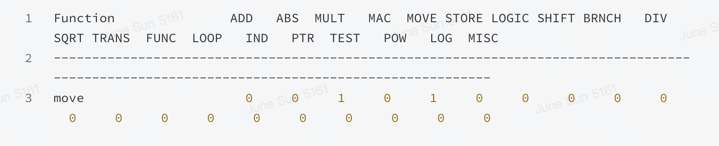
Output in theory | Output of WMC | Difference
1 MULT | 1 MULT + 1 MOVE | 1 MOVE

2.2 Operator ‘++’:
Relate example in Table 18.4 of [1]:
Operation | Counter used | Explanation
(*rnd_T0)++ | ADD(1); STORE(1); | It can be replaced by *rnd_T0 = *rnd_T0 +1;
Test Code:
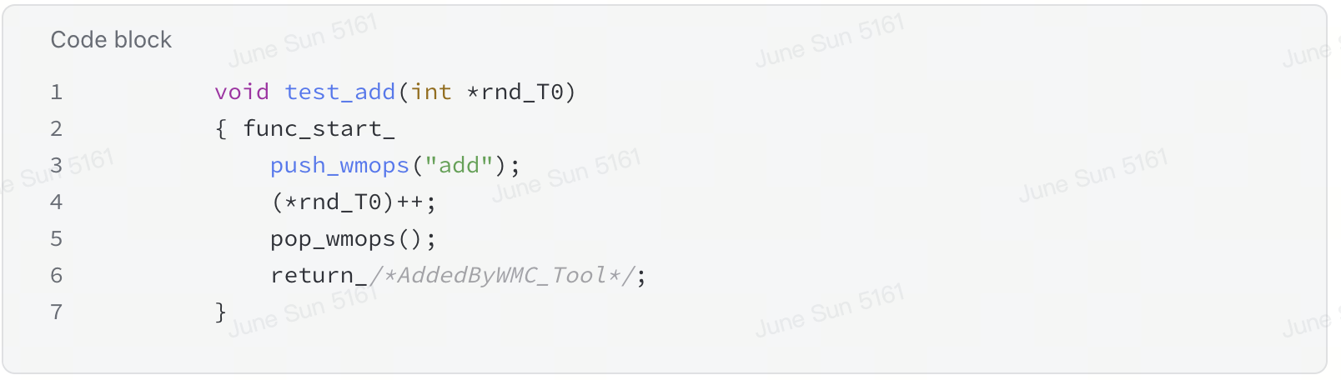
Output of WMC tool:
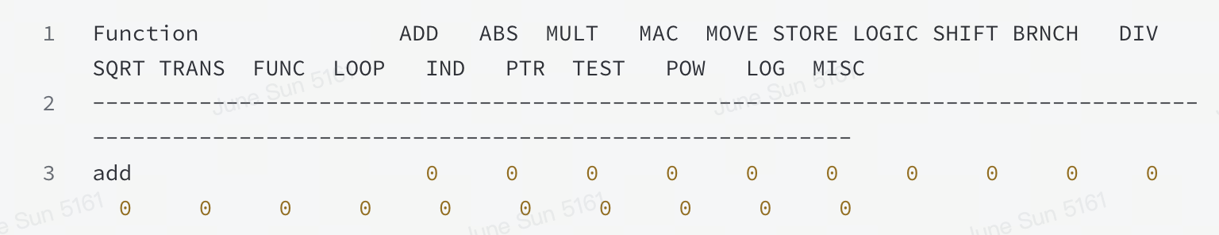
Output in theory | Output of WMC | Difference*
1 ADD + 1 STORE | 0 | 1 ADD + 1 STORE
* This difference may not influence the actual complexity as pointer increment can be done in combination with other operations with a DSP with no extra cost.

2.3 Operator ‘AND/OR’:
Relate example in Table 18.4 of [1]:
Operation | Counter used | Explanation
If (a!=b || c==d){…} | ADD(2); BRANCH(1); TEST(1); | BRANCH for if, TEST for additional condition, ADD for two tests against non-zero value
Test code:
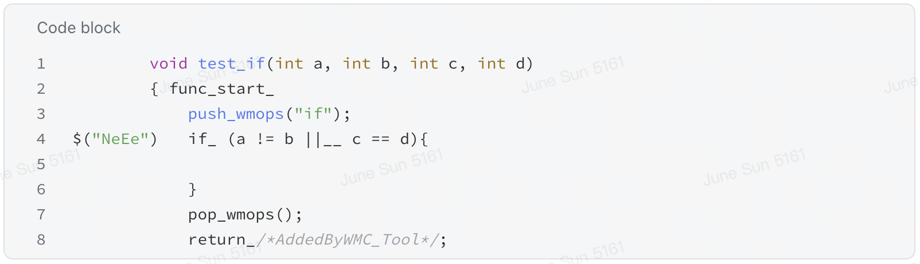
Output of WMC tool:
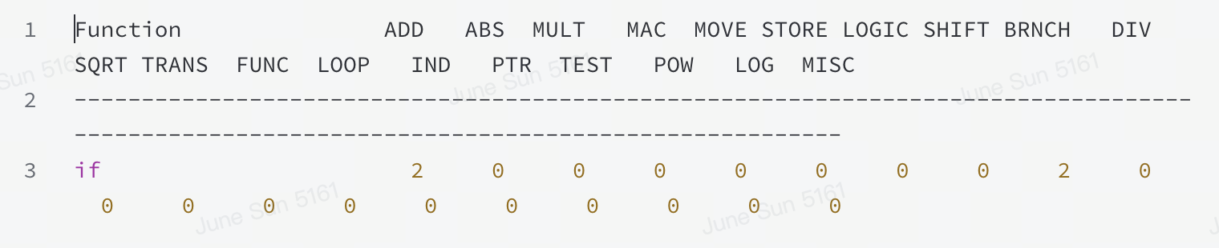
Output in theory | Output of WMC | Difference
2 ADD + 1 BRANCH+1TEST | 2 ADD + 1 BRANCH | 1 TEST

2.4 Operator ‘Indirect addressing’:
Relate example in Table 18.4 of [1]:
Operation | Counter used | Explanation
Indice[0] = indirect_dico1[indice[0]] | INDIRECT(2) | Double indirection
Test code:
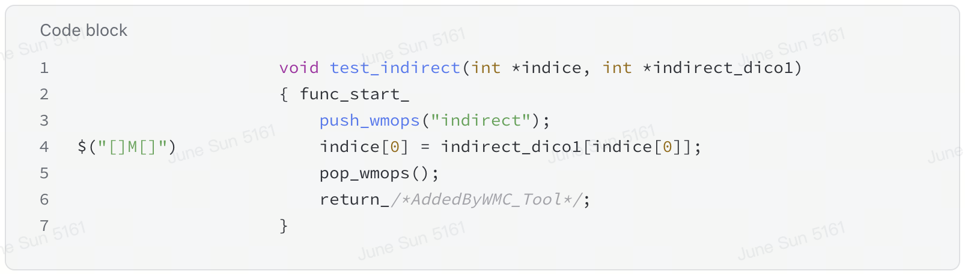
Output of WMC tool:
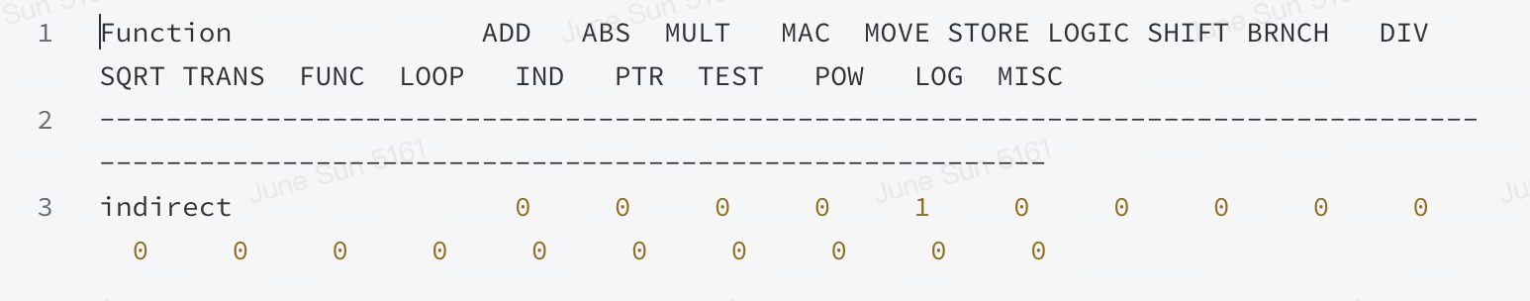
Output in theory | Output of WMC | Difference
2 IND | 1 MOVE | 2 IND; 1 MOVE

2.5 Instrumentation with ‘move’:

By design, the instrumentation tool is not counting arithmetic operations inside the array subscript.
Relate example in Table 18.3 of [1]:
Operation | Counter | Example | Complexity weights
Indirect addressing | INDIRECT() | a=b.c,a=b[c],a=b[c][d],a=*b,a=*(b+c)22,  st−>array  st−>value | 2

Test code:
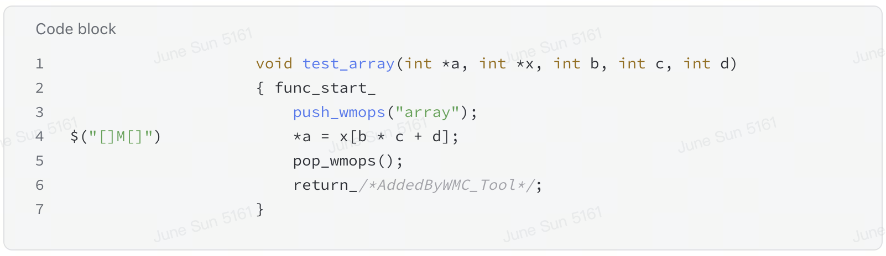
Output of WMC tool:
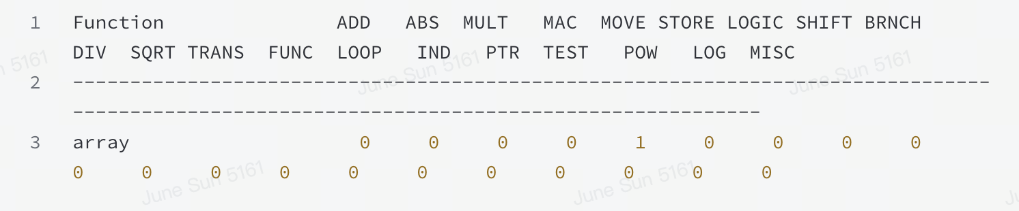
Output in theory | Output of WMC | Difference
1 MOVE | 1 MOVE

3. Observations
1. Difference has been observed between the description in ITU-T standards documentation and WMC tool implementation on WMOPS. There are cases where WMC tools counted both more operators and less operators. Some of these difference may influence the WMOPS data of an codec significantly, such as the counting of operator ‘MOVE’ and the instrumentation inside arrays.
2. The influence of these observed WMOPS calculation differences in Clause 2 on an AI codec are to be further investigated.
3. These differences need to be carefully handled and the way of calculating the WMOPS need to be clearly defined if WMOPS is included as one of the metrics for ULBC complexity.

4. Proposal
The source would like to propose to document clause 2 and clause 3 in clause 6.2 of the pdoc.

References
[1] ITU-T Software Tool Library 2024 User’s Manual
[2] S4aA250269, “[FS_ULBC] On ULBC complexity design constraints”
[3] S4aA250267, “[FS_ULBC] On complexity constraints for ULBC”
[4] S4-251793, “[FS_ULBC] Analysis of AI Codec Complexity Scaling”
[5] WMC Tool · Wiki · IVAS Codec Public Collaboration / IVAS Codec · GitLab. (2023, February 24). GitLab. https://forge.3gpp.org/rep/ivas-codec-pc/ivas-codec/-/wikis/Contributions/WMC-Tool

