3GPP TSG-SA SA4#131 S4-250142

Geneva (CH), 17 – 21 February 2025
CR-Form-v12.2
CHANGE REQUEST
 | 26.956 | CR |  | rev |  | Current version: | 0.2.1
For HELP on using this form: comprehensive instructions can be found at
http://www.3gpp.org/Change-Requests.

Proposed change affects: | UICC apps |  | ME |  | Radio Access Network |  | Core Network

Title: | pCR on Scenario 2 updates for objective and subjective tests
Source to WG: | Nokia, Philips, Interdigital, Deutsche Telekom, Fraunhofer HHI, KDDI, Samsung, Sony Group Corporation, Huawei
Source to TSG:
Work item code: | FS_Beyond2D |  |  |  | Date: |  |  | 2025-02-11
Category: | B |  |  |  | Release: |  |  | Rel-19
 | Use one of the following categories:  F (correction)  A (mirror corresponding to a change in an earlier release)  B (addition of feature),  C (functional modification of feature)  D (editorial modification)  Detailed explanations of the above categories can  be found in 3GPP TR 21.900. |  |  |  |  |  | Use one of the following releases:  Rel-8 (Release 8)  Rel-9 (Release 9)  Rel-10 (Release 10)  Rel-11 (Release 11)  …  Rel-16 (Release 16)  Rel-17 (Release 17)  Rel-18 (Release 18)  Rel-19 (Release 19)
Reason for change: |  | At MPEG#149 MPEG agreed resolutions to make the metric tools and renderer public that has been used for the development of V-PCC. In addition a new V-PCC test model TMC2 R25.0 has been delivered. The updates in this pCR makes the text compatible with these new deliverables.
Summary of change: |  | Updates related metric and renderer tools and test model for V-PCC evaluation
Consequences if not approved: |  | 3GPP could not use the MPEG metric and renderer tools and the updated V-PCC test model for V-PCC evaluation
Clauses affected:
 |  | Y | N
Other specs |  |  |  | Other core specifications |  | TS/TR ... CR ...
affected: |  |  |  | Test specifications |  | TS/TR ... CR ...
(show related CRs) |  |  |  | O&M Specifications |  | TS/TR ... CR ...
Other comments: |  | Changes are tracked starting from TR V0.2.1
This CR's revision history: |  | R1 adds version numbers to the references of mmetric, renderer and tmc2

== CHANGE 1 (all new) ===

7.3.6 Performance Metrics and Requirements

7.3.6.1 Anchors
There is no specification in 3GPP that references a volumetric video anchor codec suitable for the streaming single asset scenario. MPEG V-PCC [Vol-11] is the first codec supporting the dense dynamic point cloud representation format with inter coding and therefore no anchor codec can be selected.

7.3.6.2 Objective tests
Objective tests for dense dynamic point cloud codecs follow the principles as defined in TR 26.955, besides that there is no anchor:
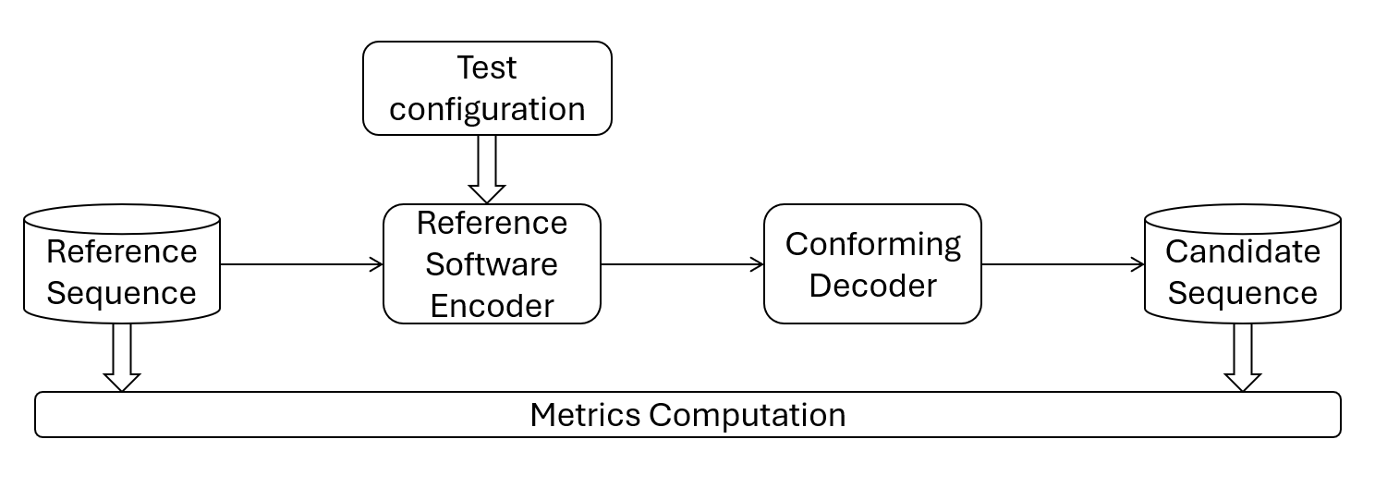
Figure 7.3.6.2-1 Test architecture for objective test
MPEG WG7 specified an objective metric that allows to characterize point cloud codecs. This objective metric is described in in annex B of the Call for Proposals for Point Cloud Compression [Vol-16]. MPEG WG7 used this “point-based” metric to develop codecs for point cloud compression. The “point-based” metric operates in 3D space and provides information on geometry and color distortion.
From 2D video objective testing it is known that a single objective metric is limiting, therefore “PCQM” [Vol-17] is added as a second objective metric in addition to the “point-based” metric.
Both objective metrics, the “point-based” metric and PCQM will be reported for all rate points and for all reference test sequences.
To compute metrics, MPEG provides a public version of mpeg-pcc-mmetric [Vol-18]. The metric software implements the “point-based” metric and the PCQM metric as described in section 7 of this scenario.
Five rate points that cover a range from low quality to high quality for codecs to be characterized will be selected.
A spreadsheet will be provided to 3GPP SA4 that can be used to visualize the objective results.
Note that objective results obtained with the selected metrics can only be used for comparison with other point cloud codecs. There is no known objective metric that allows to compare different volumetric video codecs (e.g. dense point cloud against mesh) in a fair manner.

7.3.6.3 Subjective tests
Persons or objects in the “Streaming of professionally produced Volumetric Video with single asset containing people” scenario can be viewed from any angle and distances. To cope with this free viewpoint, MPEG WG7 developed a special procedure how to subjectively evaluate such volumetric sequences: The selected reference sequences are rendered with a point cloud renderer by following a pre-defined camera path into a 2D video. The procedure is done with the source reference sequence and with the codec/decoded reference sequence. Both 2D videos can then be evaluated with well-known 2D video evaluation methods.
The software tool that implements rendering of 2D videos from dense dynamic point clouds by following a camera path is provided by MPEG [Vol-19] and is named in the following representative renderer.

This representative renderer supports two methods how to render voxels, one method is like cubes of a fixed size, the second method is splat blend. The latter draws a camera facing semitransparent splat of radius PointSize centered on the point position. The transparency (or alpha) varies with the distance from the center from fully opaque at the center to nearly transparent at the edge, to provide blending between points and reduce aliasing. In order to correctly use alpha blending, the points are sorted relative to the camera plane. Two blending modes are available, gaussian and linear, and the alpha falloff speed is customizable using the "pointFocus" setting.
For objective compression performance tests against the source reference, the cube method is recommended. For tests of the dense dynamic point cloud format against other volumetric representation formats such as mesh, the splat blend rendering is recommended as it fills holes between voxels. The representative renderer allows to activate a 3D background model or a neutral background. It also allows to activate a floor so that the test sequences look grounded.
A characteristic camera path for each volumetric test sequence will be pre-defined to get a length of the output video as close as possible to 10s. A camera path that includes a full person view and a closer view at typical distance to the face is a good example.
The representative renderer produces uncompressed RGB 2D videos that can then be compressed with high bitrate HEVC. Resolution of the videos is 1080p, the frame rate and color space is aligned with the input point cloud.
The produced compressed 2D videos will be made available to SA4 members so that they can judge the quality and make up their mind on a codec to be characterized.
Videos rendered with splat blending can be used to compare sequences dense dynamic point format sequences with sequences in other volumetric video formats such as dynamic mesh.
There is no plan to engage an independent subjective test lab.

== CHANGE 2 ===

7.3.9 Detailed test conditions

7.3.9.1 V-PCC test model and configuration files
The public version of the MPEG V-PCC test model named tmc2 in master branch is used to encode and decode dense dynamic point clouds [Vol-26].
Editor’s note: Configuration files to be validated
For using tmc2 in Random Access (RA) mode, MPEG provides a configuration file [Vol-27].
For each selected test sequence, a configuration file containing information needed for tmc2 configuration will be provided.

== CHANGE 3 ===

7.3.9.4 Bitstream Generation, output
The MPEG V-PCC test model is used to encode and decode test sequences as described previously [Vol-26].
To compute metrics, the tool mpeg-pcc-mmetric [Vol-18] is used.
Editor: Remainder of 7.3.9.4 is unchanged

== CHANGE 4 ===

7.3.9.5 Videos Generation for subjective tests
The representative renderer [Vol-19] is used to generate the videos for the subjective test.
To avoid interference between the background and the test material, a neutral background with a color will be selected. A floor makes the rendered scene more realistic by preventing interference with the test material.
A script will be provided to generate videos with chosen camera path.

Editor: Remainder of 7.3.9.5 is unchanged

== CHANGE 5 ===

2 References
The following documents contain provisions which, through reference in this text, constitute provisions of the present document.
- References are either specific (identified by date of publication, edition number, version number, etc.) or non-specific.
- For a specific reference, subsequent revisions do not apply.
- For a non-specific reference, the latest version applies. In the case of a reference to a 3GPP document (including a GSM document), a non-specific reference implicitly refers to the latest version of that document in the same Release as the present document.
…
[Vol-18] MPEG, mpeg-pcc-mmetric V1_1_7, https://github.com/MPEGGroup/mpeg-pcc-mmetric
[Vol-19] MPEG, Representative Renderer release 8.0, https://github.com/MPEGGroup/mpeg-3dg-renderer
[Vol-26] MPEG, V-PCC test model tmc2 release R25.0, https://github.com/MPEGGroup/mpeg-pcc-tmc2

