**3GPP TSG-SA WG4 Meeting** **#131 *S4-250099r01***

**Geneva, Switzerland, 17th – 21th Feb, 2025**

**Source: Huawei, Nokia, Samsung Electronics Co., Ltd, Tencent, Qualcomm**

**Title: [FS_AVATAR] pCR on IMS architecture mapping**

**Spec: 3GPP TR 26.813 v1.0.0**

**Agenda item: 9.7**

**Document for: Discussion and agreement**

**1. Introduction**

During the previous 130 meeting discussion, S4-242208 which updates the IMS architecture mapping for avatar communication was agreed to PD instead of TR. It was asked to suspend the study of IMS mapping for avatar communication until the conclusion from SA2 is available. Since the conclusion of the architecture from SA2 NG_RTC_Ph2 has been reached in clause AC.11 of TS 23.228 v19.1.0 agreed in last SA2#166 meeting, this contribution proposes to update IMS architecture mapping for avatar communication.

**2. Reason for Change**

Update IMS architecture mapping for avatar communication to align with the SA2 conclusion.

**3. Proposal**

It is proposed to agree the following changes in PD and move it to TR 26.813 v1.0.0.

* * * 1st Change * * * *

# 2 References

The following documents contain provisions which, through reference in this text, constitute provisions of the present document.

- References are either specific (identified by date of publication, edition number, version number, etc.) or non‑specific.

- For a specific reference, subsequent revisions do not apply.

- For a non-specific reference, the latest version applies. In the case of a reference to a 3GPP document (including a GSM document), a non-specific reference implicitly refers to the latest version of that document *in the same Release as the present document*.

[1] 3GPP TR 21.905: "Vocabulary for 3GPP Specifications".

[2] 3GPP TR 22.856: “Feasibility Study on Localized Mobile Metaverse Services”

[3] ISO/IEC 23090-14:2023, Information Technology – Coded Representation of Immersive Media – Part 14: MPEG Scene Description.

[4] AFLW (Annotated Facial Landmarks in the Wild), accessible here: <https://paperswithcode.com/dataset/aflw>, January 2024.

[5] The LFPW (Labeled Face Parts in the Wild)，accessible here: <https://paperswithcode.com/dataset/lfpw>, July 2023

[6] WFLW (Wider Facial Landmark in the Wild), accessible here: <https://paperswithcode.com/dataset/wflw>， November 2023

[7] WG03N1316, “Procedures and Test Formats for Avatar Representation Formats as part of MPEG-I”, MPEG#147, Sapporo, Japan, July 2024.

[8] Wang, Feng, Hang Zhou, Han Fang, Xiaojuan Dong, Weiming Zhang, Xi Yang and Nenghai Yu. “Deep 3D mesh watermarking with self-adaptive robustness.” Cybersecurity 5 (2021): n. pag.

[9] Zhu, Xingyu, et al. "Rethinking Mesh Watermark: Towards Highly Robust and Adaptable Deep 3D Mesh Watermarking." Proceedings of the AAAI Conference on Artificial Intelligence. Vol. 38. No. 7. 2024.

[10] Narendra, Modigari, et al. "Levenberg–Marquardt deep neural watermarking for 3D mesh using nearest centroid salient point learning." Scientific Reports 14.1 (2024): 6942.

[11] 3GPP TS 23.228: "IP Multimedia Subsystem (IMS); Stage 2".

* * * 2nd Change * * * *

(ALL TEXT IS NEW to TR, the revision marks are based on the latest PD)

### 8.6.1 Architecture Mapping

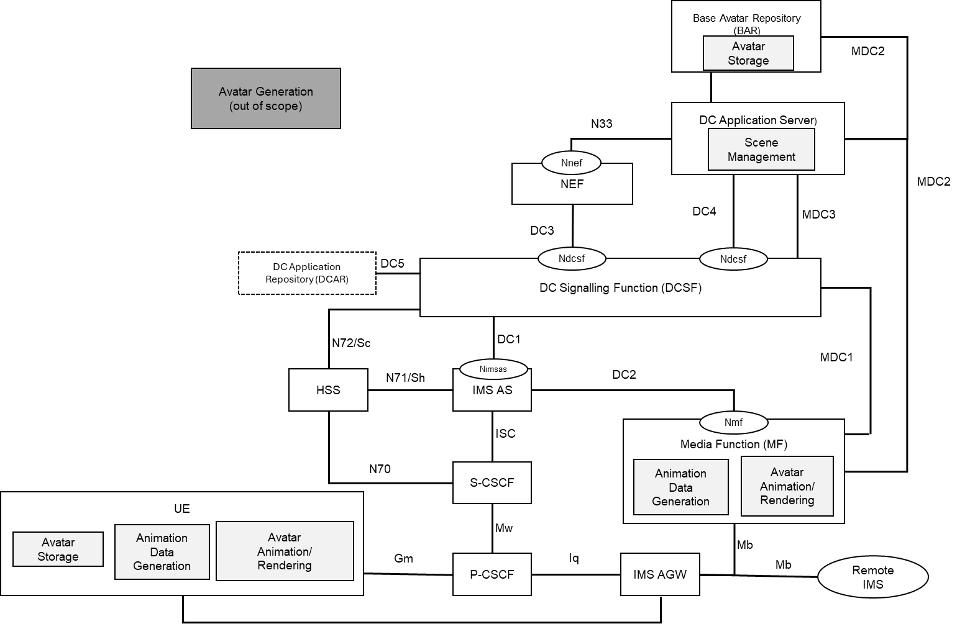

**Figure 13-1: Mapping Avatar Functions to IMS DC Architecture**

Annex AC.11 of TS 23.228 [11] describes the IMS DC architecture for avatar communication. As a supplement to it, figure 13-1 shows the mapping of avatar functions which are defined in Figure 11 of clause 7 to the IMS DC architecture, specifically the possible avatar functions which may be supported by the MF.

The generation of a Base Avatar by the Base Avatar Generation function is not addressed in this report but may happen at the UE, MF, or in the Cloud. It is a pre-requisite that the Base Avatar is already available in the Avatar Storage function either in the UE or the Base Avatar Repository (BAR) prior to starting an Avatar communication session. Base Avatars generated by the UE or the MF or elsewhere are to be stored into the UE or the BAR.

Depending on the possible configurations, as shown in Figure 12 in clause 7, a specific avatar workflow is decided through the negotiation between the UE and the network, ultimately deciding on the need for certain avatar functions in each entity.

The following descriptions are the supplements and refinements based on Annex AC.11 of TS 23.228[11]:

**BAR (Base Avatar Repository):**

- Avatar Storage: Stores the Base Avatar Representations and their associated Avatar IDs.

NOTE1: One or more Base Avatars may be stored for a user, and each Base Avatar is identified with an Avatar ID.

**MF:**

-

- Animation Data Generation: the MF generates animation data using conventional or AI/ML technologies based on the media received from the user. The animation data generation may be a transcoding process between two animation formats associated to avatar representation formats.

- Avatar Animation: the MF generates or downloads the base avatar, and animates the base avatar using the received animation data.

NOTE2: During an IMS based avatar communication, the MF may temporarily store relevant Base Avatars in a cache for provision to participating UEs.

**DC AS:**

- Scene Management: supports the scene description document management. For 2D avatar, the scene description is not needed.

UE oris available in an avatar representation format such as the ones described in clause 6may be as described in clause 6.5consist of

Through such functions, the network may assist the UE with media processing related to the creation of avatar and animation data, as well as the consumption of avatar data, in particular scene management/composition and rendering.

For the support of avatar services based on the IMS DC architecture, media negotiation between the UE and the network should include aspects related to:

* UE capability
* Network capability

The following media interface are used for the IMS-based avatar communication services.

- MDC2: Reference point of Avatar representation downloading between MF and BAR.

* * * End of Changes * * * *