**3GPP TSG-SA WG4 Meeting #131 S4-250069**

**Geneva, CH, 17 – 21 February 2025**

|  |  |  |  |  |  |  |  |  |
| --- | --- | --- | --- | --- | --- | --- | --- | --- |
| *CR-Form-v12.2* | | | | | | | | |
| **PSEUDO CHANGE REQUEST** | | | | | | | | |
|  | | | | | | | | |
|  | **26.956** | **CR** | **pseudo** | **rev** | **-** | **Current version:** | **0.2.1** |  |
|  | | | | | | | | |
| *For* [***HE******LP***](http://www.3gpp.org/3G_Specs/CRs.htm#_blank)*on using this form: comprehensive instructions can be found at* [*http://www.3gpp.org/Change-Requests*](http://www.3gpp.org/Change-Requests)*.* | | | | | | | | |
|  | | | | | | | | |

|  |  |  |  |  |  |  |  |  |
| --- | --- | --- | --- | --- | --- | --- | --- | --- |
| ***Proposed change affects:*** | UICC apps |  | ME | **X** | Radio Access Network |  | Core Network | **X** |

|  |  |  |  |  |  |  |  |  |  |  |
| --- | --- | --- | --- | --- | --- | --- | --- | --- | --- | --- |
|  | | | | | | | | | | |
| ***Title:*** | [FS_Beyond2D] Representation Formats - Dynamic Mesh - Quality Criteria | | | | | | | | | |
|  |  | | | | | | | | | |
| ***Source to WG:*** | China Mobile Com. Corporation | | | | | | | | | |
| ***Source to TSG:*** | SA4 | | | | | | | | | |
|  |  | | | | | | | | | |
| ***Work item code:*** | FS_Beyond2D | | | | |  | ***Date:*** | | | 2025-02-07 |
|  |  | | | |  | |  | | |  |
| ***Category:*** | **B** |  | | | | | ***Release:*** | | | Rel-19 |
|  | *Use one of the following categories:* ***F*** *(correction)* ***A*** *(mirror corresponding to a change in an earlier release)* ***B*** *(addition of feature),* ***C*** *(functional modification of feature)* ***D*** *(editorial modification)*  Detailed explanations of the above categories can be found in 3GPP [TR 21.900](http://www.3gpp.org/ftp/Specs/html-info/21900.htm). | | | | | | | | *Use one of the following releases: Rel-8 (Release 8) Rel-9 (Release 9) Rel-10 (Release 10) Rel-11 (Release 11) … Rel-16 (Release 16) Rel-17 (Release 17) Rel-18 (Release 18) Rel-19 (Release 19)* | |
|  |  | | | | | | | | | |
| ***Reason for change:*** | | The study item description in SP-240479 addresses the following objectives   1. Identify and document beyond 2D formats, that are market-relevant within the next years, generated from established and emerging capturing systems (including cameras for spatial video capturing), contribution, and usable on display technologies (smartphones, VR HMDs, AR glasses, autostereoscopic and multiscopic displays).   Dynamic meshes are are one of the most important and widely used beyond 2D representations of 3D assets. | | | | | | | | |
|  | |  | | | | | | | | |
| ***Summary of change:*** | | This document provides typical quality criteria for dynamic mesh format. | | | | | | | | |
|  | |  | | | | | | | | |
| ***Consequences if not approved:*** | | Incomplete 4.3.5.4.5 | | | | | | | | |
|  | |  | | | | | | | | |
| ***Clauses affected:*** | | 2, 4.3.5.4.5 | | | | | | | | |
|  | |  | | | | | | | | |
|  | | **Y** | **N** |  | | | |  | | |
| ***Other specs*** | |  | **X** | Other core specifications | | | | TS/TR ... CR ... | | |
| ***affected:*** | |  | **X** | Test specifications | | | | TS/TR ... CR ... | | |
| ***(show related CRs)*** | |  | **X** | O&M Specifications | | | | TS/TR ... CR ... | | |
|  | |  | | | | | | | | |
| ***Other comments:*** | | This CR is not yet completed, but will be extended with the detailed definition. It is also expected that test material will be provided for the operation points. | | | | | | | | |
|  | |  | | | | | | | | |
| ***This CR's revision history:*** | |  | | | | | | | | |

# ===== CHANGE =====

# 2 References

The following documents contain provisions which, through reference in this text, constitute provisions of the present document.

- References are either specific (identified by date of publication, edition number, version number, etc.) or non‑specific.

- For a specific reference, subsequent revisions do not apply.

- For a non-specific reference, the latest version applies. In the case of a reference to a 3GPP document (including a GSM document), a non-specific reference implicitly refers to the latest version of that document *in the same Release as the present document*.

[DM-1] MPEG 136, CfP for Dynamic Mesh Coding, <https://www.mpeg.org/wp-content/uploads/mpeg_meetings/136_OnLine/w20972.zip>

[DM-2] MPEG 134, Use cases for Mesh Coding, <https://www.mpeg.org/wp-content/uploads/mpeg_meetings/134_OnLine/w20364.zip>

[DM-3] Y. Choi, J. -B. Jeong, S. Lee and E. -S. Ryu, "Overview of the Video-based Dynamic Mesh Coding (V-DMC) Standard Work," 2022 13th International Conference on Information and Communication Technology Convergence (ICTC), Jeju Island, Korea, Republic of, 2022, pp. 578-581, doi: 10.1109/ICTC55196.2022.9952734.

[DM-10] Owlii Dynamic human mesh sequence dataset” ISO/IEC JTC1/SC29/WG11 m41658, 120th MPEG Meeting, Macau, October 2017.

[DM-11] Pagés, Rafael & Amplianitis, Konstantinos & Ondrej, Jan & Zerman, Emin & Smolic, Aljosa. (2022). Volograms & V-SENSE Volumetric Video Dataset. 10.13140/RG.2.2.24235.31529/1.

[DM-12] M. Corsini, E. D. Gelasca, T. Ebrahimi, and M. Barni, “Water marked 3-d mesh quality assessment,” IEEE Trans. Multimedia, vol. 9, no. 2, pp. 247–256, 2007.

[DM-13] FTorkhani, K. Wang, and J.-M. Chassery, “Perceptual quality as sessment of 3d dynamic meshes: Subjective and objective studies,” Signal Processing: Image Communication, vol. 31, pp. 185–204, 2015.

[DM-14] B. ITU-R RECOMMENDATION, “Methodology for the subjective assessment of the quality of television pictures,” International Telecommunication Union, 2002.

[DM-15] P. ITU-T RECOMMENDATION, “Subjective video quality assess ment methods for multimedia applications,” International Telecom munication Union, 1999.

[DM-16] Y. Nehm´ e, F. Dupont, J.-P. Farrugia, P. Le Callet, and G. Lavou´ e, “Visual quality of 3d meshes with diffuse colors in virtual reality: Subjective and objective evaluation,” IEEE Trans. Visualization and Computer Graphics, vol. 27, no. 3, pp. 2202–2219, 2020.

[DM-17] ITU-T, “Subjective test method for interactive virtual reality applications,” https://www.itu.int/ITU-T/workprog/wp item.aspx?isn= 17817.

[DM-18] MPEG, mpeg-pcc-mmetric, <https://github.com/MPEGGroup/mpeg-pcc-mmetric>

[DM-19] MPEG, Representative Renderer, https://github.com/MPEGGroup/mpeg-3dg-renderer

# ===== CHANGE =====

#### 4.3.5.4 Supporting Information

##### 4.3.5.4.5 Typical Quality Criteria

###### 4.3.5.4.5.1 Objective Metrics

MPEG WG7 proposes two methods for dynamic mesh evaluation: one based on the well-known D1/D2 metric used in point cloud compression (**point-based metric**), and another one based on evaluation of projected images (**image-based metric**) Annex B [DM-1]. Both methods are implemented in the mpeg_pcc_mmetric software which is available on the MPEG GIT [DM-18].

For **point-based metric**, it directly uses the raw data from the reference and distorted meshes to extract features and predict quality. It includes two steps, as shown in Figure 4.3.5.4.5.1-1. First, the input meshes are sampled to be converted into their respective point cloud representations. Second, with the sampled surface point clouds, point cloud objective metrics D1/D2, Y-PSNR, and PCQM are calculated to assess quality. According to experimental results [DM-11], the point-based metrics (particularly PCQMP) show high performance in dynamic mesh quality assessment and do not need rendering. However, these metrics heavily rely on mesh sampling step, which requires dense sampling to achieve accurate results. This can be computationally intensive and significantly increase processing time.

**Figure 4.3.5.4.5.1-1: Point-based method for mesh evaluation**

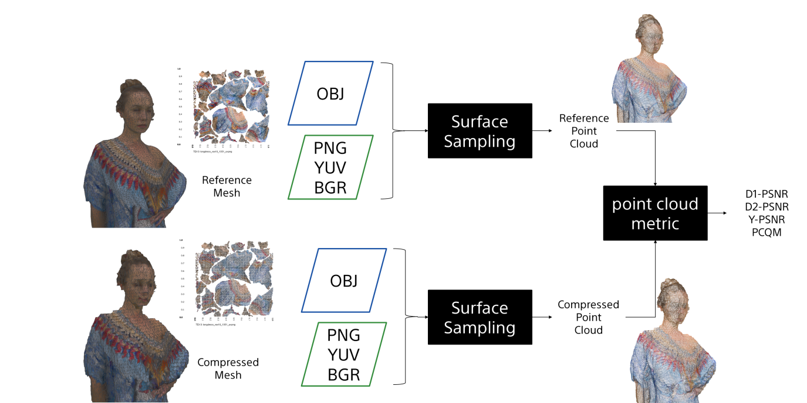

For **image-based metric** as shown in Figure 4.3.5.4.5.1-2, the reference and the distorted meshes are rendered for multiple view directions , using an orthographic projection. The images obtained from the rendering of reference and distorted models are then compared using some adapted image MSE/PSNR metrics The results are averaged over a set of view directions for the frame and over the frames of the sequence. According to experimental results [DM-11], projecting dynamic mesh into colored image and then applying metrics like rgbpsnr and yuvpsnr is more effective than only capturing depth information to use geopsnr. In addition, increasing the number of projected images improves the stability of image-based metrics but also leads to a higher calculation complexity.

**Figure 4.3.5.4.5.1-2: Image-based method for mesh evaluation**

Editor’s Note: Other objective metrics for dynamic mesh evaluation may be added.

###### 4.3.5.4.5.2 Subjective Evalution

There are two prevalent methods to rendering dynamic mesh samples for subjective evaluation: **2D video-based** and **VR-based methods**.

For **video-based subjective evaluation** [DM-12] [DM-13], it uses a 2D monitor to display dynamic meshes with compression and surface noise distortions, and refer to ITU-R BT.500 [DM-14] and ITU-T P.910 Recommendations [DM-15] to conduct the subjective experiment. MPEG describes a video-based subjective evaluation in Annex D of [DM-1. The associated renderer is available on the MPEG Git [DM-19].

For **VR-based subjective evalution**, although there is a lot of academic research to explore the principles of the subjective experiment in a VR environment [DM-16], a standardized protocol has yet to be established. This remains an ongoing effort within ITU-T SG12/Q7 P.IntVR [DM-17].

Editor’s Note: Other subjective methods for dynamic mesh evaluation may be added.