7.6 Solution #5: Energy related information from the network and other Service Provider entities provided to a UE application and Application Service Provider

7.6.1 Key Issue mapping
This Candidate Solution addresses Key Issue #1 (Energy-related Information exposure) described in clause 6.1.

7.6.2 Functional description

7.6.2.1 Introduction
This Candidate Solution addresses how energy-related information from the device, the network and other components of the content delivery system can be provided to a UE application during media consumption for exposure to the user.

7.6.2.2 Generic reference architecture for collection and exposure of Energy Information
Figure 7.6.2.2-1 depicts a reference architecture that realises this candidate solution in the general (i.e., non-media-specific) case.
Figure 7.6.2.2-1: Generic reference architecture for collection and exposure of Energy Information
The following functions are defined in this generic reference architecture:
- The Energy Information AF is an Application Function in the Data Network with some or all of the following responsibilities, depending on its current provisioning state:
- Subscribes to and consumes NF Energy Information from the Energy Information Function as defined in TS 23.501 [72]).
Editor’s Note: Definition of the Energy Information Function in TS 23.501 [72] is a work in progress at the time of writing.
- Subscribes to and consumes AS Energy Information from the Application Server.
- Collates and exposes the above Energy Information to the Energy Information Collector in the UE via the data plane.
- The Energy Information Collector is a UE function with some or all of the following responsibilities, depending on its current configuration:
- Acquires an Energy Information collection configuration from the Energy Information AF. The Energy Information collection configuration may include configuration directing it to collect energy consumption information from the UE at different granularities, e.g. UE, PDU Session and/or QoS flow, as described in clause 5.51.2.3 of TS 23.501 [72] and/or for individual applications.
- Subscribes to and consumes Network Energy Information from the Energy Information AF according to the Energy Information collection configuration.
- Collects UE Energy Information from other UE functions and about itself according to the Energy Information collection configuration.
- Collates and exposes collected Energy Information to the UE Application via a client API.
The following reference points are defined in this generic reference architecture:
E1 Network API used by the Application Service Provider to provision the Energy Information AF. This determines whether and which NF Energy Information and/or AS Energy Information is collected by the Energy Information AF, and which UEs are entitled to consume it.
E12 NF Energy Information exposed by the Energy Information Function (as defined in TS 23.501 [72]) is consumed by the Energy Information AF using a Network API according to the latter’s provisioning state.
Editor’s Note: Definition of the Energy Information Function in TS 23.501 [72] is a work in progress at the time of writing.
E3 AS Energy Information exposed by the Application Server is consumed by the Energy Information AF using a Network API according to the latter’s provisioning state.
Editor’s Note: Subject to the final design of the Energy Information Function in TS 23.501 [72], reference point E3 is not required if AS Energy Information falls within the scope of reference point E12.
E5 Network API used by the Energy Information Collector in the UE to subscribe to and receive Network Energy Information from the Energy Information AF.
E6 Client API used by the UE Application to subscribe to Energy Information notifications from the Energy Information Collector.
E8 Network API used by the Application Service Provider to receive Energy Information from the UE Application. This reference point is beyond the scope of 3GPP standardisation.

7.6.2.3 Instantiation in 5G Media Streaming architecture
Figure 7.6.2.3-1 illustrates how the generic reference architecture for collecting and exposing Energy Information could be instantiated in the 5G Media Streaming architecture defined in TS 26.501 [23].
Figure 7.6.2.3-1: Instantiation of generic reference architecture for collection and exposure of Energy Information in the 5GMS System
The following functions are defined in this instantiation of the generic reference architecture:
- The Energy Information AF is instantiated in the 5GMS AF and has some or all of the following responsibilities, depending on its current provisioning state obtained from the 5GMS AF:
- Subscribes to and consumes NF Energy Information from the Energy Information Function (as defined in TS 23.501 [72]).
- Subscribes to and consumes AS Energy Information from the Application Server.
- Collates and exposes the above Energy Information to the Energy Information Collector in the UE via the data plane.
- The Energy Information Collector is instantiated in the Media Session Handler of the 5GMS Client and has some or all of the following responsibilities, depending on its current configuration:
- Acquires an Energy Information collection configuration from the Energy Information AF embedded in Service Access Information obtained from the 5GMS AF by the Media Session Handler. The Energy Information collection configuration may include configuration directing the Energy Information Collector to collect energy consumption information from the UE at different granularities, e.g. UE, PDU Session and/or QoS flow, as described in clause 5.51.2.3 of TS 23.501 [72] and/or for individual applications.
- Subscribes to and consumes Network Energy Information from the Energy Information AF according to the Energy Information collection configuration.
- Collects UE Energy Information from the Media Stream Handler and from the Media Session Handler according to the Energy Information collection configuration.
- Collates and exposes collected Energy Information to the 5GMS-Aware Application via a client API.
The following reference points are defined in this instantiation of the generic reference architecture:
E1 This reference point is not instantiated: the Energy Information AF is instead provisioned via reference point M1.
M1 Network API used by the Media Application Provider to provision the Energy Information AF via the 5GMS AF. This determines whether and which NF Energy Information and/or AS Energy Information pertaining to the 5GMS AS is collected by the Energy Information AF, and which UEs are entitled to consume it.
NOTE 1: The service API at reference point M1 may be similar to that at reference point E1 in the generic reference architecture described in clause 7.6.2.2.
E12 This reference point is used per clause 7.6.2.2 of the present document.
M3 After configuration of the Content Hosting and/or Content Publishing and/or Content Preparation, features by the 5GMS AF, the 5GMS AS obtains a media-specific Energy Information collection configuration from the Energy Information AF instantiated in the 5GMS AF. The configuration information is embedded in Service Access Information.
E3 This reference point is used per clause 7.6.2.2 of the present document. In this instantiation, the entity exposing AS Energy Information to the Energy Information AF is the Media AS and the AS Energy Information may include the media delivery session identifier.
Editor’s Note: Subject to the final design of the Energy Information Function in TS 23.501 [72], reference point E3 is not required if AS Energy Information falls within the scope of reference point E12.
M5 Network API used by the Media Session Handler to obtain a media-specific Energy Information collection configuration from the Energy Information AF instantiated in the 5GMS AF. The configuration information is embedded in Service Access Information.
NOTE 2: The Energy Information collection configuration may be similar to that exposed at reference point E5 in the generic reference architecture described in clause 7.6.2.2.
E5 This reference point is used per clause 7.6.2.2 of the present document. The Energy Information Collector is instantiated in the Media Session Handler and the media-specific Energy Information collection configuration is instead acquired in Service Access Information via reference point M5 (see above). Media-specific Energy Information exposed to the Media Session Handler relates to a specific media delivery session.
M11 Client API used by the Energy Information Collector to collect UE Energy Information from the Media Access Client.
E6 This reference point is not instantiated: the Energy Information is instead exposed to applications via reference point M6.
M6 Client API used by the Media-aware Application to subscribe to Energy Information notifications from the Energy Information Collector. Notifications correlate UE Energy Information collected from the Media Access Client, AS Energy Information collected from the Media AS and NF Energy Information collected from relevant 5G Core Network Functions with individual media delivery sessions.
NOTE 3: The client API at reference point M6 may be similar to that at reference point E6 in the generic reference architecture described in clause 7.6.2.2.
E8 This reference point is not instantiated: the Energy Information is instead exposed via reference point M8.
M8 Network API used by the Media Application Provider to receive Energy Information from the Media-aware Application. This reference point is beyond the scope of 3GPP standardisation.

7.6.2.4 Instantiation in generalised Media Delivery architecture
Figure 7.6.2.4-1 illustrates how the generic reference architecture for collecting and exposing Energy Information could be instantiated in the generalised Media Delivery architecture defined in TS 26.501 [23] and TS 26.506 [59].
Figure 7.6.2.4-1: Instantiation of generic reference architecture for collection and exposure of Energy Information in the generalised Media Delivery System
Details of the functions and reference points are similar to those described in clause 7.6.2.3.

7.6.3 Procedures

7.6.3.1 Generic high-level procedures for collection and exposure of Energy Information
Figure 7.6.3.1-1 below details the different steps for Energy Information collection and reporting.
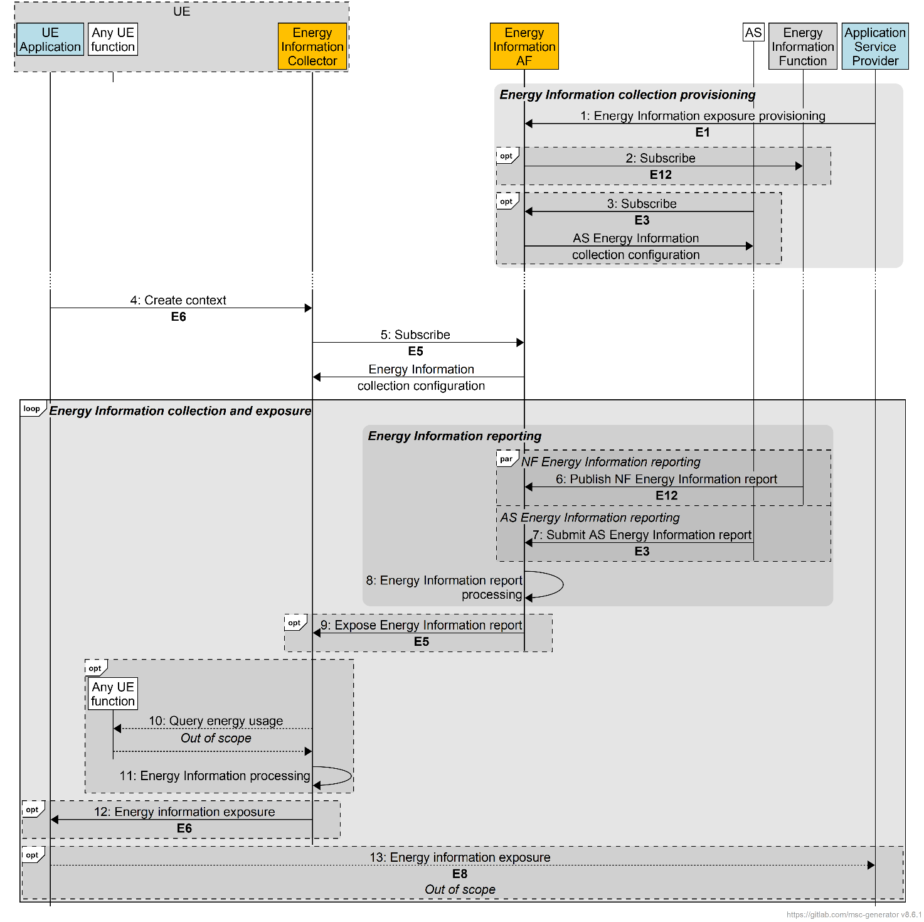
Figure 7.6.3.1-1: Procedures for Energy Information collection and reporting
A first step is required to provision Energy Information Collection:
1. The Application Service Provider provisions the Energy Information AF with the Energy Information exposure configuration via reference point E1.
2. The Energy Information AF subscribes to receive Energy Information reporting from the Energy Information Function via reference point E12, if relevant.
3. The AS obtains an AS Energy Information collection configuration from the Energy Information AF via reference point E3, if relevant. This includes a callback endpoint on the Energy Information AF for submitting AS Energy Information reports.
Editor’s Note: This step requires further discussion. What stimulates the subscription, c.f. step 5 below.
At some later point:
4. The UE Application creates an Energy Information collection and reporting context with the Energy Information Collector via reference point E6.
5. The Energy Information Collector subscribes to Energy Information reporting from Energy Information AF via reference point E5, if relevant, and receives in response a UE Energy Information collection configuration.
After this initialisation phase, reporting can be done:
6. The Energy Information function may submit an Energy Information report to the Energy Information AF via reference point E12.
7. The AS may submit an Energy Information report to the Energy Information AF via reference point E3 using the callback endpoint supplied in step 3.
8. The Energy Information AF processes the energy information report(s) it has received.
9. The Energy Information AF exposes a processed Energy Information report to the Energy Information Collector subscriber via reference point E5. The Energy Information report may include energy consumption information of different granularities, e.g. UE, PDU Session and/or QoS flow, as described in clause 5.51.2.3 of TS 23.501 [72].
10. The Energy Information Collector may collect additional UE-related Energy Information from any UE function using methods beyond the scope of 3GPP standardisation.
11. The Energy Information Collector processes the UE-related Energy Information it has obtained in the previous step.
12. The Energy Information Collector exposes an Energy Information report to the subscribed UE Application via reference point E6. Based on the UE Energy Information collection configuration obtained in step 5, the Energy Information report may include energy consumption information of different granularities, e.g. UE, PDU Session and/or QoS flow, as described in clause 5.51.2.3 of TS 23.501 [72] and/or for individual applications.
13. The UE Application may expose the received Energy Information to the Application Service Provider via reference point E8 using methods beyond the scope of 3GPP standardisation.

7.6.3.2 5GMS high-level procedures for collection and exposure of Energy Information
Editor’s Note: TODO.
N. The Energy Information AF exposes a processed Energy Information report to the Energy Information Collector subscriber via reference point E5. The Energy Information report may include energy consumption information of different granularities, e.g. UE, PDU Session and/or QoS flow, as described in clause 5.51.2.3 of TS 23.501 [72]. The Energy Information received is available to the Media Session Handler enclosing the Energy Information Collector. Based on this, the Media Session Handler may instantiate a Dynamic Policy with a different energy usage profile and/or instruct the Media Stream Handler to change its behaviour (e.g. change its streaming bit rate).
NOTE: Based on the received Energy Information report, the Media Session Handler may perform selection of appropriate Background Data Transfer Policy during the Downlink Background Data Transfer using dynamic policy invocation procedure described in clause 5.7.8 of TS 26.501 [23] and Uplink Background Data Transfer using dynamic policy invocation procedure described in clause 6.9.7 of TS 26.501 [23].

