**3GPP TSG-SA WG4 meeting #131 S4-250189**

**Geneva, 5**

|  |  |  |  |  |  |  |  |  |
| --- | --- | --- | --- | --- | --- | --- | --- | --- |
| *CR-Form-v12.2* | | | | | | | | |
| **CHANGE REQUEST** | | | | | | | | |
|  | | | | | | | | |
|  | **26.942** | **pCR** |  | **rev** |  | **Current version:** | **1.0.1** |  |
|  | | | | | | | | |
| *For* [***HE******LP***](http://www.3gpp.org/3G_Specs/CRs.htm#_blank)*on using this form: comprehensive instructions can be found at* [*http://www.3gpp.org/Change-Requests*](http://www.3gpp.org/Change-Requests)*.* | | | | | | | | |
|  | | | | | | | | |

|  |  |  |  |  |  |  |  |  |
| --- | --- | --- | --- | --- | --- | --- | --- | --- |
| ***Proposed change affects:*** | UICC apps |  | ME | **x** | Radio Access Network |  | Core Network | **x** |

|  |  |  |  |  |  |  |  |  |  |  |
| --- | --- | --- | --- | --- | --- | --- | --- | --- | --- | --- |
|  | | | | | | | | | | |
| ***Title:*** | Solution #8: Potential solution to Key Issue #2: UE application energy consumption measurement | | | | | | | | | |
|  |  | | | | | | | | | |
| ***Source to WG:*** | Nokia | | | | | | | | | |
| ***Source to TSG:*** | S4 | | | | | | | | | |
|  |  | | | | | | | | | |
| ***Work item code:*** | FS_MediaEnergyGREEN | | | | |  | ***Date:*** | | | 2025-02-11 |
|  |  | | | |  | |  | | |  |
| ***Category:*** | B |  | | | | | ***Release:*** | | | Rel-19 |
|  | *Use one of the following categories:* ***F*** *(correction)* ***A*** *(mirror corresponding to a change in an earlier release)* ***B*** *(addition of feature),* ***C*** *(functional modification of feature)* ***D*** *(editorial modification)*  Detailed explanations of the above categories can be found in 3GPP [TR 21.900](http://www.3gpp.org/ftp/Specs/html-info/21900.htm). | | | | | | | | *Use one of the following releases: Rel-8 (Release 8) Rel-9 (Release 9) Rel-10 (Release 10) Rel-11 (Release 11) … Rel-16 (Release 16) Rel-17 (Release 17) Rel-18 (Release 18) Rel-19 (Release 19)* | |
|  |  | | | | | | | | | |
| ***Reason for change:*** | | The latest draft of 3GPP TR 26.942 contains clause 6.2 Key Issue #2: Energy-related monitoring and measurement. In this context, under KI #2; the following questions were defined:  In this context, the subsequent analysis by this Key Issue will consider the following questions:   1. Which UE energy-related information will be collected to measure, correlate, and optimize energy usage across the entire streaming distribution chain? 2. Can existing methods be leveraged to measure/monitor the identified UE energy-related information? 3. Which UE entity is appropriate to measure this UE energy-related information?   It is proposed to add the proposed content to the latest draft of TR 26.942 as one of the potential solutions to KI #2 so that it is not left incomplete. | | | | | | | | |
|  | |  | | | | | | | | |
| ***Summary of change:*** | | This CR proposes new text to be added in TR 26.942 on “Clause 7 Potential Solutions”. | | | | | | | | |
|  | |  | | | | | | | | |
| ***Consequences if not approved:*** | | Proposed objectives will not be met. | | | | | | | | |
|  | |  | | | | | | | | |
| ***Clauses affected:*** | | 2, 7.x (new) | | | | | | | | |
|  | |  | | | | | | | | |
|  | | **Y** | **N** |  | | | |  | | |
| ***Other specs*** | |  | **x** | Other core specifications | | | | TS/TR ... CR ... | | |
| ***affected:*** | |  | **x** | Test specifications | | | | TS/TR ... CR ... | | |
| ***(show related CRs)*** | |  | **x** | O&M Specifications | | | | TS/TR ... CR ... | | |
|  | |  | | | | | | | | |
| ***Other comments:*** | |  | | | | | | | | |
|  | |  | | | | | | | | |
| ***This CR's revision history:*** | |  | | | | | | | | |

|  |
| --- |
| 1st Change |

# 2 References

[x] Ben-Gan, Itzik. "Datetime calculations, Part 4: calculate first/last occurrences of a weekday in a month." *SQL Server Magazine* 9.5 (2007): 19-22.

|  |
| --- |
| 2nd Change |

## 7 Potential solutions

## 7.1 Mapping of solutions to Key Issues

Table 7.1-1: Mapping of solutions to Key Issues

|  |  |  |  |
| --- | --- | --- | --- |
| Solutions |  |  |  |
|  | KI#1 | KI#2 | KI#3 |
| #1 |  |  |  |
| #2 |  |  |  |
| #3 |  |  |  |
| #4 |  |  |  |
| #5 |  |  |  |
| #6 |  |  |  |
| #7 |  |  |  |
| #8 |  | X |  |
| #9 |  |  |  |

|  |
| --- |
| 3rd Change **(all new text)** |

## 7.x Solution #8: UE application energy consumption measurement based on MTD technique

### 7.x.1 Key Issue mapping

This Candiate Solution addresses Key Issue #2.

### 7.x.2 Functional description

#### 7.x.2.1 Introduction

Month-till-Date or Month-to-Date (MTD) is a practical and popular method for performance tracking and analysis since it can be applied to a wide range of metrics and performance indicators. It gives information about how a particular statistic has fared this month in comparison to past months or predetermined goals. It is a widely used concept across different domains for tracking, reporting, and evaluating various metrics and performance indicators within the current month up to the present date [x].

With MTD, a metric's performance is evaluated from the beginning of the current month to the present, taking into account key performance indicators (KPIs). It is usually computed daily and gives an instantaneous picture of performance for the entire month so far.

The monthly total MTD is determined by adding the metrics' values from the first of the month to the present. For instance, adding up the daily battery consumption for a particular application from the first of the month to the current date would yield the total MTD energy consumption of the application.

#### 7.x.2.2 Calculation of MTD

##### 7.x.2.2.1 High-level description

At a very high level, calculating an MTD metric involves determining the period from the beginning of the current month up to the present date. It is calculated as follows:

1. *Identify the current date:* Determine today's date, the end point of the MTD calculation.

2. *Identify the start of the month:* Find the first day of the current month. For example, if today is July 15th, the start of the month would be July 1st.

3. *Count the number of days:* Calculate the number of days from the start of the month up to the current date, including today.

To accurately measure the average battery consumption of MTD on UE devices, battery tests should be conducted over a 24-hour period. This ensures the readings account for typical device usage and provide reliable results.

##### 7.x.2.2.2 UE battery consumption calculation

The energy consumed by a UE application can be expressed as an MTD metric. The percentage of total battery consumed by the application in a particular session is calculated using the following formula:

$$\% {MTD}_{app1, UE}=\frac{Total battery consumed by the app in a session * 100}{\sum_{i=power state}{Total battery capacity of the device (i)}}$$

In the example depicted graphically in figure 7.x.2.2.2‑1 below, the total battery consumed is 0.051% of the total battery capacity of a Google Pixel 6 Pro smartphone with total battery capacity of 5003 mAh. The points on the graph show the cumulative battery consumption by the app till a particular time since the start of the session. In this example, the application has consumed a total of 1.03 mAh battery during the first 34.49 seconds of the session. The axes represent the following:

* X-axis: Depicts the time (in seconds) elapsed since the start of the session. 0 on the X-axis represents the start of the energy profiling session.
* Y-axis: Depicts the cumulative battery energy consumed by the application (in mAh) up to a particular point in time since the start of the energy profiling session. The Y-axis starts with 0 mAh.

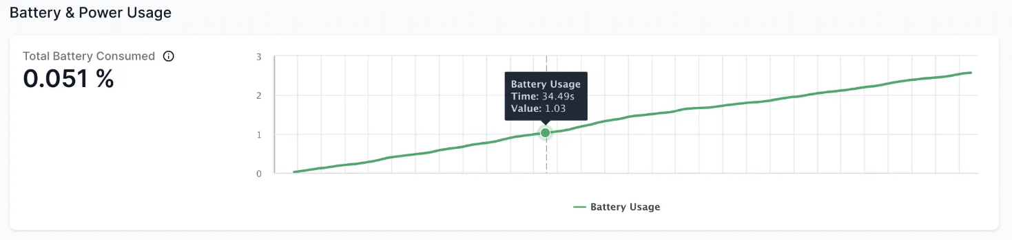

Figure 7.x.2.2.2‑1: Example of energy consumed by an application running on a smartphone

The actual MTD battery consumption is determined by subtracting the battery end percentage from the battery start percentage, and multiplying it by the percentage of consumption of the application (expressed as a decimal). From this, the mean average percentage consumed per hour can then be derived by dividing the actual consumption by 24.

To determine actual MTD battery consumption, the following formula can be used:

*True Consumption (of app 1)* = (*Battery Start %* − *Battery End %*) × (*MTD Consumption %* / 10)

To calculate the percentage of battery used per hour:

*Battery Usage Per Hour (of app 1)* = *True Consumption* / 24

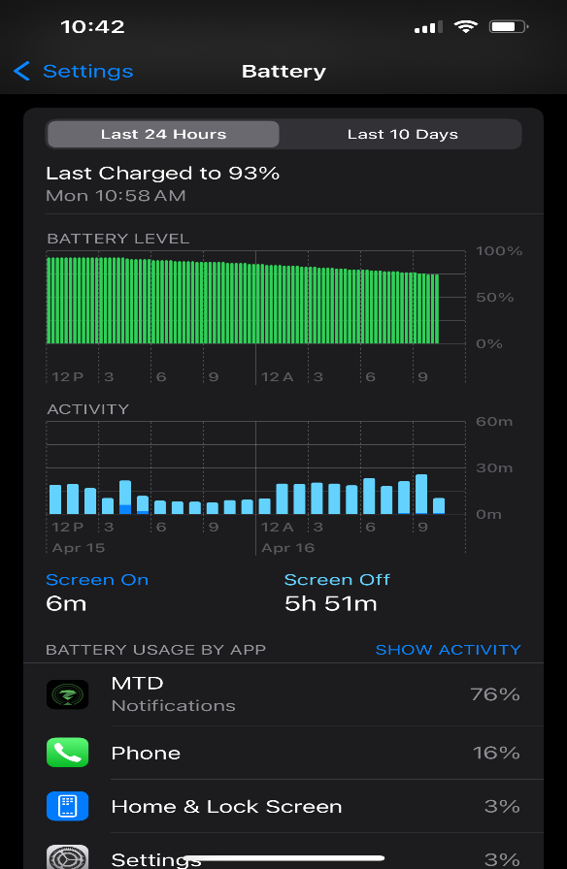

Figure 7.x.2.2.2‑2: Example input data for MTD calculation

Based on the data provided in the figure 7.x.2.2.2‑2 above, the calculation for MTD battery consumption is as follows:

- Device battery consumption since last charge = 93% − 78% = 15%

- MTD battery usage = 76% / 10 = 7.6

- True battery consumption = 15% × 7.6 = 114%

- Battery Usage by MTD per hour = 114 / 24 hrs = 4.75% per hour

### 7.x.3 Procedures

This Candidate Solution proposes a new metric that allows to measure UE application energy consumption; the procedures for reporting this metric from the UE to an external entity are described in Solution #4 in clause 7.5.

### 7.x.4 Summary

The Candidate Solution described in clauses 7.x.2.2 has the following limitations:

1. The solution evaluates the battery consumption of individual applications executing on a UE, while other energy consuming aspects such as radio transmissions (4G, 5G, Wi-Fi), etc. may have additional impact on the total battery consumption of the UE.

2. The solution is UE implementation-specific, i.e. the same feature may result in different evaluations of battery consumption of the same application running on different UEs.

3. The solution may result in different evaluations of battery consumption of the same UE depending upon the test conditions that may vary over time (e.g. environmental changes and radio conditions, etc.).

|  |
| --- |
| End of change |