3GPP SA4 #131 S4-250150
Geneva, Switzerland, 17th–21st February 2025 revision of S4aI250054

Source: InterDigital, BBC
Title: Pseudo-CR on potential solution to KI1 based Energy Information Exposure Specification to configure the exposure of the UE, network and other entities energy related information to the UE Application
Spec: 3GPP TR 26.942 V1.0.1
Agenda item: 8.8 – FS_MediaEnergyGREEN (Study on Media enerGy consumption exposuRE and EvaluatioN framework)
Document for: Agreement

1. Introduction
During the SA4-e (AH MBS SWG post 130, the contribution S4aI250043 was agreed as a potential solution to KI1 of the 3GPP TR 26.942. with the following decision: “We should continue with the proposed approach in 241927 and document it”. This is the goal of this pCR.
2. Reason for Change
The contribution S4aI250043 proposes a solution where the energy related information from the UE, core network, and other entities (e.g. Application Server) are collected, and provided to the UE Application for exposing to the user and raise awareness of environmental issues.
S4aI250043 proposes to expose an overall energy consumption, referring to the amount of energy used to deliver audiovisual content on a mobile network but does not consider energy granularities of the information between the key components of the Media Delivery system and does not consider different levels to provide the energy information:
- Energy consumption of all the active delivery sessions on the UE
- Energy consumption of a single delivery session
- Energy consumption of a specific media flow (i.e. video, audio, …)
During the last SA2 meeting in Orlando, the contribution S2-2413022 was approved and it proposes the calculation of the Energy information with such a granularity. Thus, SA4 can imagine that such information will be exposed directly by the Energy Information Function (EIF) or indirectly via the Network Exposure Function (NEF).
It also does not specify how the exposure of energy-related information is dynamically enabled or disabled in the Media Delivery System by the Media Application Provider or the Service subscriber to reach any energy regulatory goal.
Instead, the current proposal presents the creation or the use of an existing resource with a new Energy Information Exposure Specification property, which would allow Media Application Providers to configure a set of energy-related parameters for exposing energy information: mode, granularities, level, … of Media Delivery Sessions.
3. Conclusions
This document aims to propose an update of the solution #5 for KI#1 (Energy-related Information exposure) allowing the collection and exposing of the necessary information from the UE, network, and other entities, and provide this to the network and/or the UE Application for exposing to the user.
4. Proposal
It is proposed to agree the following changes to 3GPP TR 26.942 V1.0.1 after integration of the solution #5.
* * * First Change * * * *

7.1 Mapping of Solutions to Key Issues
Table 7.1-1: Mapping of solutions to Key Issues
Solutions
 | KI#1 | KI#2 | KI#3
#1 |  |  | X
#2 |  |  | X
#3 |  | X
#4 | X
#5 | X
#6 |  | X
#7 | X
#8
#9

These solutions are simply candidate solutions. Their inclusion in the following clauses does not imply that they have been agreed upon or endorsed. Any decisions and work to be done for the normative work will be detailed in the conclusions of this Technical Report.
* * * Next Change * * * *

7.6 Solution #5: Energy-related information from the network and other Service Provider entities provided to a UE application and Application Service Provider

7.6.1 Key Issue mapping
This solution addresses Key Issue #1 (Energy-related Information exposure) described in clause 6.1.

7.6.2 Functional description

7.6.2.1 Introduction
This Candidate Solution addresses how energy-related information from the device, the network and other components of the content delivery system can be provided to a UE application during media consumption for exposure to the user. The exposure of the energy-related information is enabled or disabled by the Application Service Provider over time and is expressed using an Energy Information Exposure Configuration as envisaged by the Candidate Solution in clause 7.8.

7.6.2.2 Generic reference architecture for collection and exposure of Energy Information
Figure 7.6.2.2-1 depicts a reference architecture that realises this candidate solution in the general (i.e., non-media-specific) case.
Figure 7.6.2.2-1: Generic reference architecture for collection and exposure of Energy Information
The following functions are defined in this generic reference architecture:
- The Energy Information AF is an Application Function in the Data Network with some or all of the following responsibilities, depending on its current provisioning state:
- Validates the provisioning of an Energy Information Exposure Specification which represents the configuration of the Energy Information required to be exposed to the Application Service Provider (see clause 7.8). The Energy Information Exposure Specification allows the Application Service Provider to define the Energy Information to be exposed to the UE Application, and thus to the subscriber.
- Subscribes to and consumes NF Energy Information from the Energy Information Function as defined in TS 23.501 [72]) with required granularities (UE, PDU session and/or QoS flow) in accordance with the parameters of the Energy Information Exposure Specifications.
Editor’s Note: Definition of the Energy Information Function in TS 23.501 [72] is a work in progress at the time of writing.
- Subscribes to and consumes AS Energy Information from the Application Server in accordance with the parameters of the Energy Information Exposure Specification.
- Collates, prepares and exposes the above Energy Information to the Energy Information Collector in the UE via the data plane in accordance with the Energy Information Exposure Specification.
- The Energy Information Collector is a UE function with some or all of the following responsibilities, depending on its current configuration:
- Acquires an Energy Information collection configuration derived from the Energy Information Exposure Specifications provisioned by all Application Service Providers from the Energy Information AF embedded in Service Access Information obtained from the Media AF by the Media Session Handler.
- Subscribes to and consumes Network Energy Information from the Energy Information AF according to the Energy Information collection configuration (and hence all the Energy Information Exposure Specifications).
- Collects UE Energy Information from other UE functions and about itself according to the Energy Information collection configuration (and hence all the Energy Information Exposure Specifications).
- Collates and exposes collected Energy Information to the UE Application via a client API in accordance with the parameters of the Energy Information Exposure Specification provisioned by the relevant Application Service Provider.
The following reference points are defined in this generic reference architecture:
E1 Network API used by the Application Service Provider to provision the Energy Information AF. This determines whether and which NF Energy Information and/or AS Energy Information is collected by the Energy Information AF, and which UEs are entitled to consume it expressed as the parameters of the Energy Information Exposure Specification.
E12 NF Energy Information exposed by the Energy Information Function (as defined in TS 23.501 [72]) is consumed by the Energy Information AF using a Network API according to the latter’s provisioning state.
Editor’s Note: Definition of the Energy Information Function in TS 23.501 [72] is a work in progress at the time of writing.
E3 AS Energy Information exposed by the Application Server is consumed by the Energy Information AF using a Network API according to the latter’s provisioning state.
Editor’s Note: Subject to the final design of the Energy Information Function in TS 23.501 [72], reference point E3 is not required if AS Energy Information falls within the scope of reference point E12.
E5 Network API used by the Energy Information Collector in the UE to subscribe to and receive Network Energy Information from the Energy Information AF. Network Energy Information exposed to the Energy Information Collector relates to a specific Application Service Provider.
E6 Client API used by the UE Application to subscribe to Energy Information notifications from the Energy Information Collector.
E8 This reference point is beyond the scope of 3GPP standardisation.

7.6.2.3 Instantiation in 5G Media Streaming architecture
Figure 7.6.2.3-1 illustrates how the generic reference architecture for collecting and exposing Energy Information could be instantiated in the 5G Media Streaming architecture defined in TS 26.501 [23].
Figure 7.6.2.3-1: Instantiation of generic reference architecture for collection and exposure of Energy Information in the 5GMS System
The following functions are defined in this instantiation of the generic reference architecture:
- The Energy Information AF is instantiated in the 5GMS AF and has some or all of the following responsibilities, depending on its current provisioning state obtained from the 5GMS AF (which includes the Energy Information Exposure Specification provisioned by 5GMS Application Providers – see clause 7.8):
- Subscribes to and consumes NF Energy Information from the Energy Information Function (as defined in TS 23.501 [72]) according to the Energy Exposing Specification.
- Subscribes to and consumes AS Energy Information from the Application Server according to the Energy Information Exposure Specifications.
- Collates and exposes the above Energy Information to the Energy Information Collector in the UE via the data plane.
- The Energy Information Collector is instantiated in the Media Session Handler of the 5GMS Client and has some or all of the following responsibilities, depending on its current configuration:
- Acquires an Energy Information collection configuration derived from the Energy Information Exposure Specifications provisioned by all Application Service Providers from the Energy Information AF embedded in Service Access Information obtained from the Media AF by the Media Session Handler.
- Subscribes to and consumes Network Energy Information from the Energy Information AF according to the Energy Information collection configuration (and hence all the Energy Information Exposure Specifications).
- Collects UE Energy Information from the Media Stream Handler and from the Media Session Handler according to the Energy Information collection configuration (and hence all the Energy Exposing Specifications).
- Collates and exposes collected Energy Information to the 5GMS-Aware Application via a client API in accordance with the parameters of the Energy Information Exposure Specification provisioned by the relevant 5GMS Application Provider.
The following reference points are defined in this instantiation of the generic reference architecture:
E1 This reference point is not instantiated: the Energy Information AF is instead provisioned via reference point M1.
M1 Network API used by the Media Application Provider to provision the Energy Information AF via the 5GMS AF. This determines whether and which NF Energy Information and/or AS Energy Information pertaining to the 5GMS AS is collected by the Energy Information AF, and which UEs are entitled to consume it.
NOTE 1: The service API at reference point M1 may be similar to that at reference point E1 in the generic reference architecture described in clause 7.6.2.2.
E12 This reference point is used per clause 7.6.2.2 of the present document.
M3 After configuration of the Content Hosting and/or Content Publishing and/or Content Preparation, features by the 5GMS AF, the 5GMS AS obtains a media-specific Energy Information collection configuration from the Energy Information AF instantiated in the 5GMS AF. The configuration information is embedded in Service Access Information.
E3 This reference point is used per clause 7.6.2.2 of the present document. In this instantiation, the entity exposing AS Energy Information to the Energy Information AF is the Media AS and the AS Energy Information may include the media delivery session identifier.
Editor’s Note: Subject to the final design of the Energy Information Function in TS 23.501 [72], reference point E3 is not required if AS Energy Information falls within the scope of reference point E12.
M5 Network API used by the Media Session Handler to obtain a media-specific Energy Information collection configuration from the Energy Information AF instantiated in the 5GMS AF. The configuration information is embedded in Service Access Information.
NOTE 2: The Energy Information collection configuration may be similar to that exposed at reference point E5 in the generic reference architecture described in clause 7.6.2.2.
E5 This reference point is used per clause 7.6.2.2 of the present document. The Energy Information Collector is instantiated in the Media Session Handler and the media-specific Energy Information collection configuration is instead acquired in Service Access Information via reference point M5 (see above). Media-specific Energy Information exposed to the Media Session Handler relates to a specific media delivery session in the context of a specific 5GMS Application Provider.
M11 Client API used by the Energy Information Collector to collect UE Energy Information from the Media Access Client.
E6 This reference point is not instantiated: the Energy Information is instead exposed to applications via reference point M6.
M6 Client API used by the Media-aware Application to subscribe to Energy Information notifications from the Energy Information Collector, limited by the Energy Information Exposure Specification conveyed as part of the media-specific Energy Information collection configuration at reference point M5. Notifications correlate UE Energy Information collected from the Media Access Client, AS Energy Information collected from the Media AS and NF Energy Information collected from relevant 5G Core Network Functions with individual media delivery sessions.
NOTE 3: The client API at reference point M6 may be similar to that at reference point E6 in the generic reference architecture described in clause 7.6.2.2.
E8 This reference point is not instantiated: the Energy Information is instead exposed via reference point M8.
M8 Network API used by the Media Application Provider to receive Energy Information from the Media-aware Application. This reference point is beyond the scope of 3GPP standardisation.

7.6.2.4 Instantiation in generalised Media Delivery architecture
Figure 7.6.2.4-1 illustrates how the generic reference architecture for collecting and exposing Energy Information could be instantiated in the generalised Media Delivery architecture defined in TS 26.501 [23] and TS 26.506 [59].
Figure 7.6.2.4-1: Instantiation of generic reference architecture for collection and exposure of Energy Information in the generalised Media Delivery System
Details of the functions and reference points are similar to those described in clause 7.6.2.3.

7.6.3 Procedures

7.6.3.1 Generic high-level procedures for collection and exposure of Energy Information
Figure 7.6.3.1-1 below details the different steps for Energy Information collection and reporting.
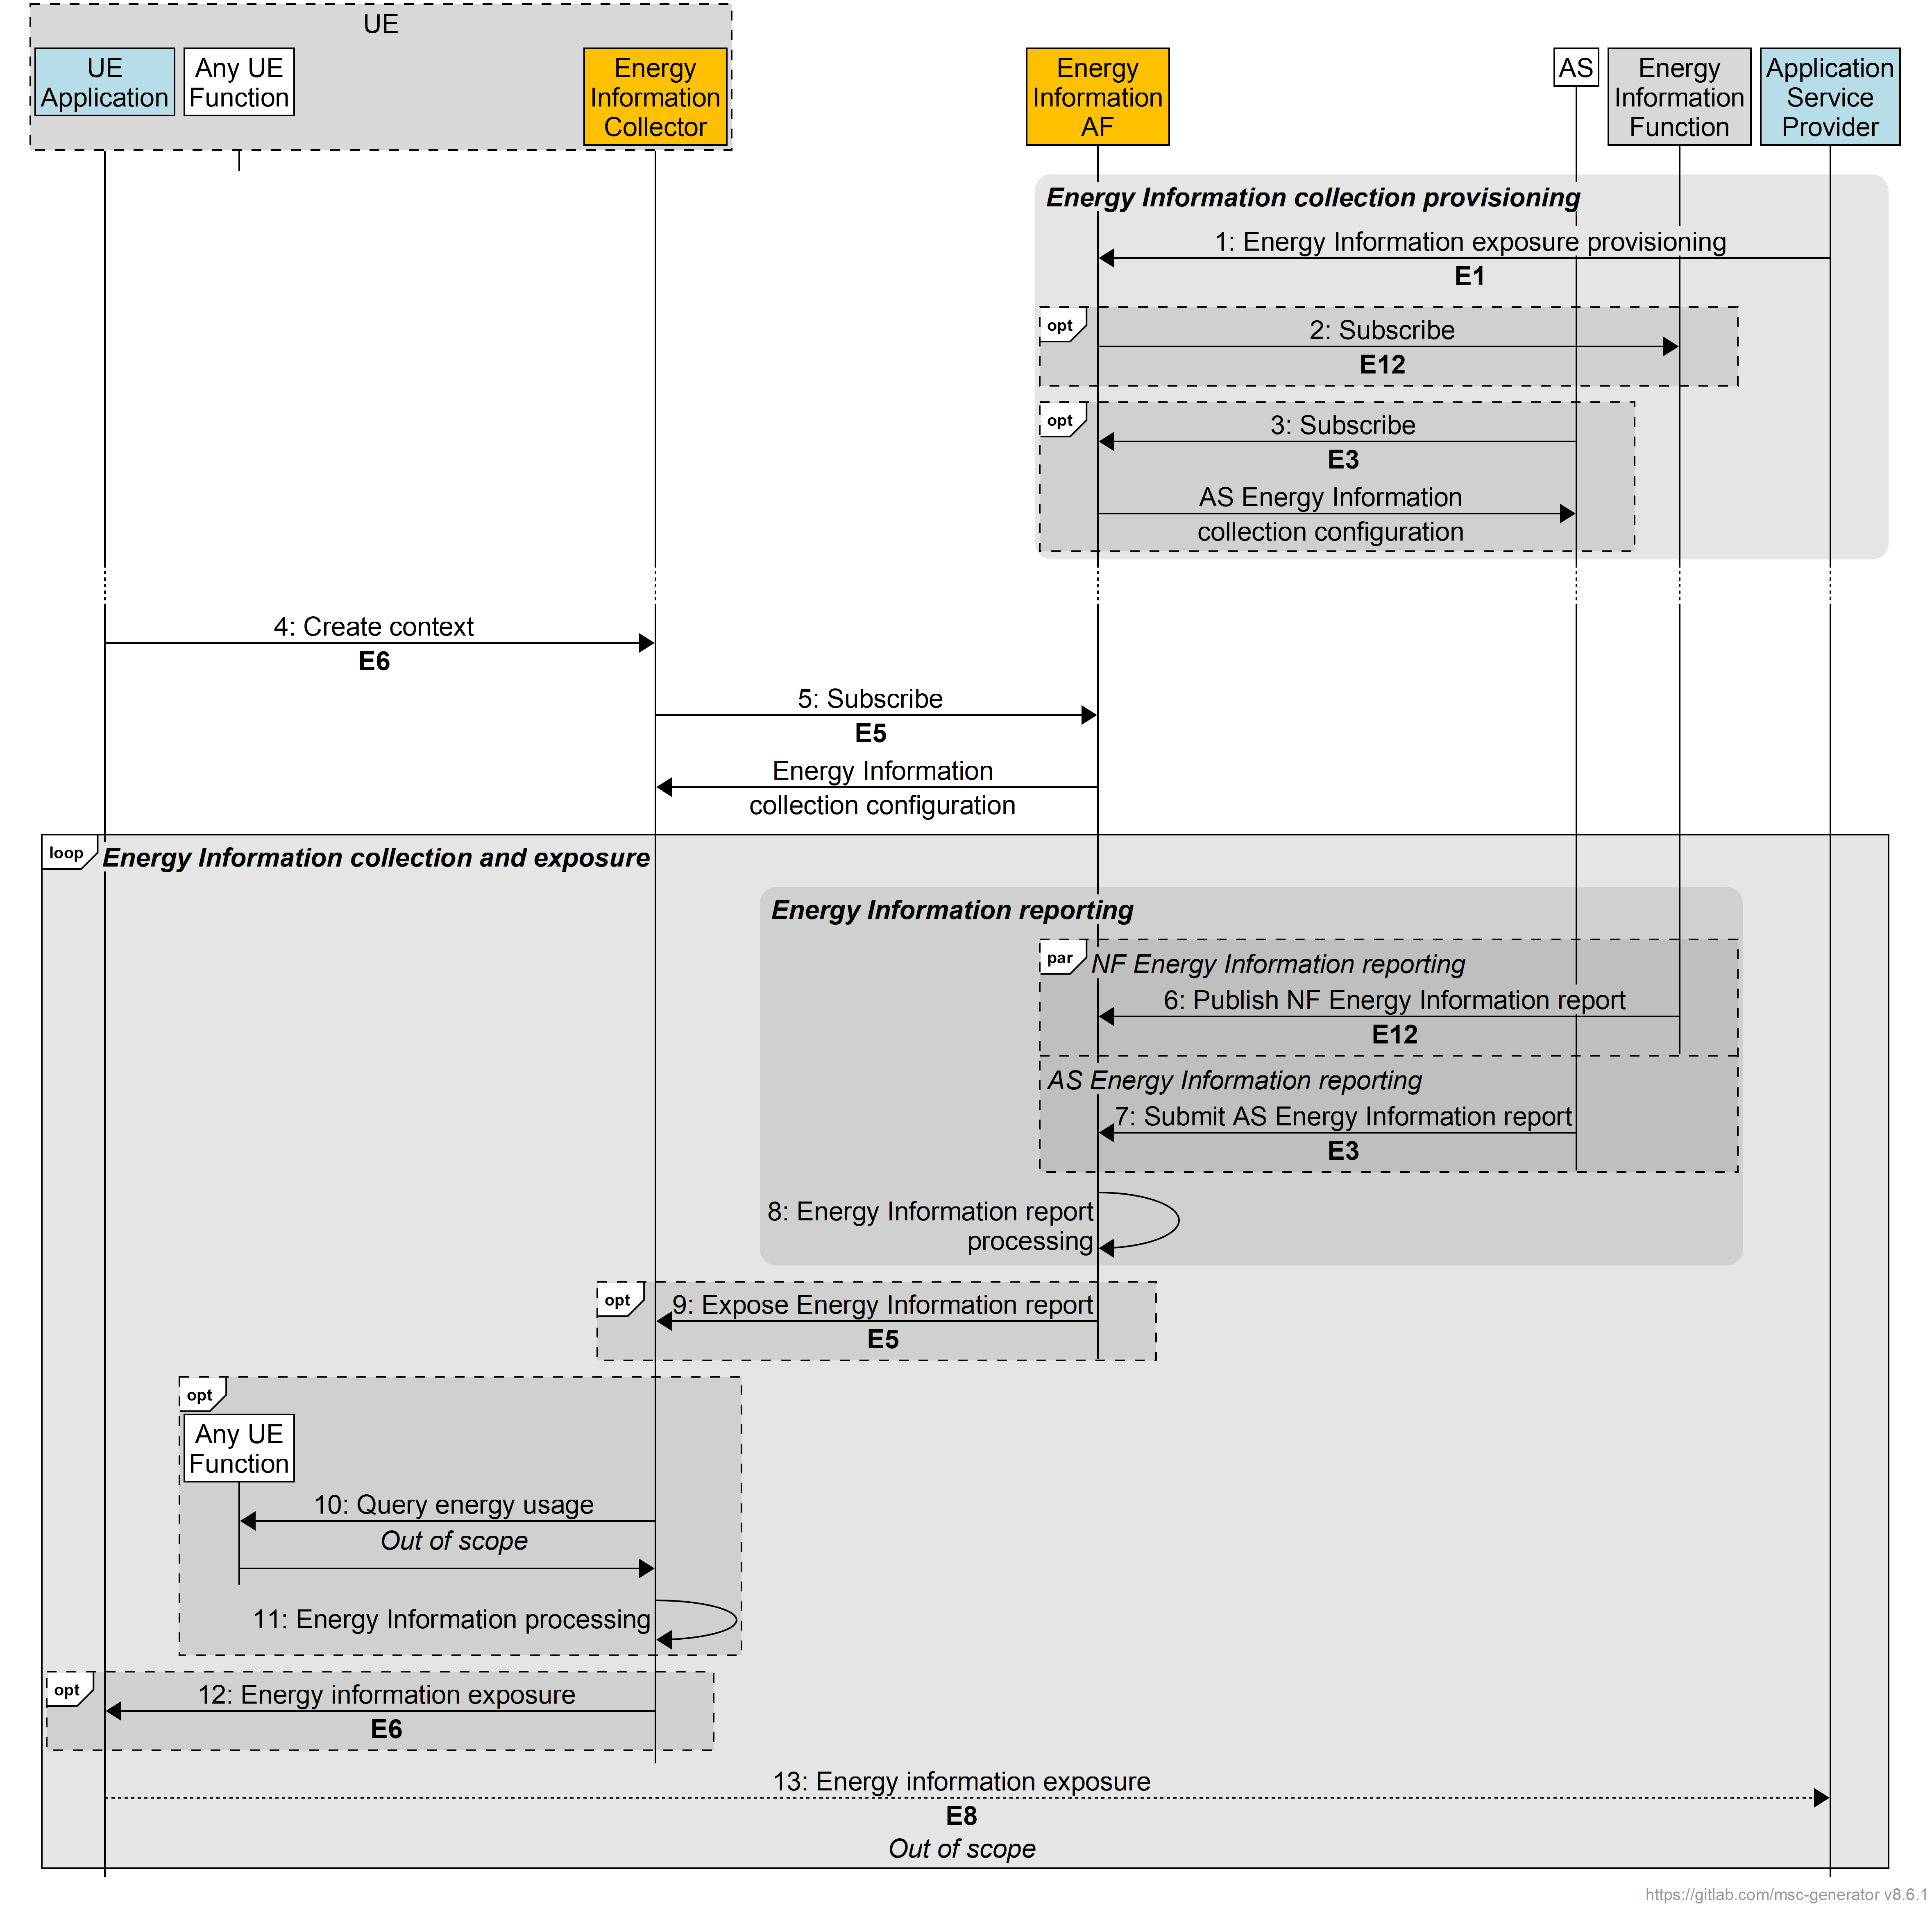
Figure 7.6.3.1-1: Procedures for Energy Information collection and reporting
A first step is required to provision Energy Information Collection:
1. The Application Service Provider provisions the Energy Information AF with an Energy Information Exposure Specification via reference point E1.
2. The Energy Information AF subscribes to receive Energy Information reporting from the Energy Information Function via reference point E12, if relevant, in accordance with the set of parameters in the Energy Information Exposure Specification.
3. The AS obtains an AS Energy Information collection configuration from the Energy Information AF via reference point E3, if relevant, in accordance with the set of parameters in the Energy Information Exposure Specification. This includes a callback endpoint on the Energy Information AF for submitting AS Energy Information reports.
Editor’s Note: This step requires further discussion. What stimulates the subscription, c.f. step 5 below.
At some later point:
4. The UE Application creates an Energy information collection and reporting context with the Energy Information Collector via reference point E6.
5. The Energy Information Collector subscribes to Energy Information reporting from Energy Information AF via reference point E5, if relevant, and receives in response a UE Energy Information collection configuration in accordance with the set of parameters in the Energy Information Exposure Specifications.
After this initialisation phase, reporting can be done:
6. The Energy Information function may submit an Energy Information report to the Energy Information AF via reference point E12.
7. The AS may submit an Energy Information report to the Energy Information AF via reference point E3 using the callback endpoint supplied in step 3.
8. The Energy Information AF processes the energy information report(s) it has received.
9. The Energy Information AF exposes a processed Energy Information report to the Energy Information Collector subscriber via reference point E5.
10.
11.
12. The Energy Information Collector exposes an Energy Information report to the subscribed UE Application via reference point E6.
13.
* * * Next Change* * *
(all new text)

7.8 Solution #7: Energy Information Exposure Specification for controlling exposure of Energy-related information to Application Service Provider

7.8.1 Key Issue mapping
This solution addresses Key Issue #1 (Energy-related Information exposure) described in clause 6.1.

7.8.2 Functional description
An Energy Information Exposure Specification represents the configuration of the Energy Information required to be exposed to a particular Application Service Provider. This Candidate Solution is intended to be used in combination with other Candidate Solutions that expose this information, including Solution #4 in clauses 7.5 and Solution #5 in clause 7.6.
Definition of the Energy Information Exposure Specification is for further study. For example, a mode of energy exposing (i.e. energy efficiency, energy consumption, power consumption or carbon emission), an exposing granularity, an exposing level (i.e. Media Delivery session, service component), an exposing time dimension, etc.

7.8.3 Procedures
Procedures for handling Energy Information Exposure Specification are proposed in clause 7.6.3.
* * * End of changes * * *

