## **3GPP TSG- Meeting #**

**, , - revision of S4aI250060**

|  |  |  |  |  |  |  |  |  |
| --- | --- | --- | --- | --- | --- | --- | --- | --- |
| *CR-Form-v12.3* | | | | | | | | |
| **CHANGE REQUEST** | | | | | | | | |
|  | | | | | | | | |
|  |  | **CR** |  | **rev** |  | **Current version:** |  |  |
|  | | | | | | | | |
| *For* [***HE******LP***](http://www.3gpp.org/3G_Specs/CRs.htm#_blank)*on using this form: comprehensive instructions can be found at* [*http://www.3gpp.org/Change-Requests*](http://www.3gpp.org/Change-Requests)*.* | | | | | | | | |
|  | | | | | | | | |

|  |  |  |  |  |  |  |  |  |
| --- | --- | --- | --- | --- | --- | --- | --- | --- |
| ***Proposed change affects:*** | UICC apps |  | ME | **X** | Radio Access Network |  | Core Network | **X** |

|  |  |  |  |  |  |  |  |  |  |  |
| --- | --- | --- | --- | --- | --- | --- | --- | --- | --- | --- |
|  | | | | | | | | | | |
| ***Title:*** |  | | | | | | | | | |
|  |  | | | | | | | | | |
| ***Source to WG:*** |  | | | | | | | | | |
| ***Source to TSG:*** |  | | | | | | | | | |
|  |  | | | | | | | | | |
| ***Work item code:*** |  | | | | |  | ***Date:*** | | |  |
|  |  | | | |  | |  | | |  |
| ***Category:*** |  |  | | | | | ***Release:*** | | |  |
|  | *Use one of the following categories:* ***F*** *(correction)* ***A*** *(mirror corresponding to a change in an earlier release)* ***B*** *(addition of feature),* ***C*** *(functional modification of feature)* ***D*** *(editorial modification)*  Detailed explanations of the above categories can be found in 3GPP [TR 21.900](http://www.3gpp.org/ftp/Specs/html-info/21900.htm). | | | | | | | | *Use one of the following releases: Rel-8 (Release 8) Rel-9 (Release 9) Rel-10 (Release 10) Rel-11 (Release 11) … Rel-17 (Release 17) Rel-18 (Release 18) Rel-19 (Release 19)  Rel-20 (Release 20)* | |
|  |  | | | | | | | | | |
| ***Reason for change:*** | | **MBS User Service and Delivery Protocols for eMBMS:** The MBS User Service architecture and protocol follows the modern design philosophies of the 5G System with separation of user services from transport, a service-based architecture and RESTful APIs. At the same time, eMBMS and enTV as used for LTE-based 5G Broadcast support a transparent delivery mode. While interworking in between MBMS and MBS is addressed in TS 23.247, interworking between these two systems at the User Service level is not addressed. In order for MBMS and LTE-based 5G broadcast to leverage MBS User Service technologies, a study is warranted to identify the gaps to fully support this functionality. For details refer to TR 26.802.  In TR 26.802, motivation for work on *MBS User Service and Delivery Protocols for eMBMS* is introduced in clause 5.10 and based on the conclusions in clause 5.10.6 has been introduced. | | | | | | | | |
|  | |  | | | | | | | | |
| ***Summary of change:*** | | *MBS User Service and Delivery Protocols for eMBMS* as introduced in clause 5.10 of TR 26.802 based on the conclusions in clause 5.10.6:   1. Fully specify support for the Joint BM-SC and MBSF Functionality. For this purpose, the gap identified in clause 5.10.4.1 of the present document needs to be addressed by documenting additional procedures and baseline parameters as required in TS 26.502 and permitting the signalling of MBMS sessions.   -Document in an informative annex to TS 26.502 the deployment architectures, client architectures and high-level call flows in clauses 5.10.2.3 and 5.10.2.4. | | | | | | | | |
|  | |  | | | | | | | | |
| ***Consequences if not approved:*** | | Feature not supported | | | | | | | | |
|  | |  | | | | | | | | |
| ***Clauses affected:*** | | 2, 4.9, Annex X (new) | | | | | | | | |
|  | |  | | | | | | | | |
|  | | **Y** | **N** |  | | | |  | | |
| ***Other specs*** | |  | **X** | Other core specifications | | | | TS/TR ... CR ... | | |
| ***affected:*** | |  | **X** | Test specifications | | | | TS/TR ... CR ... | | |
| ***(show related CRs)*** | |  | **X** | O&M Specifications | | | | TS/TR ... CR ... | | |
|  | |  | | | | | | | | |
| ***Other comments:*** | |  | | | | | | | | |
|  | |  | | | | | | | | |
| ***This CR's revision history:*** | | |  |  |  |  | | --- | --- | --- | --- | | [**S4aI250031**](https://www.3gpp.org/ftp/TSG_SA/WG4_CODEC/3GPP_SA4_AHOC_MTGs/SA4_MBS/Docs/S4aI250031.zip) | [AMD-ARCH-MED] MBS User Service and Delivery Protocols for eMBMS | Qualcomm Germany | Thomas Stockhammer |   **E-mail Discussion**: none  **Revisions**:   * [S4aI250031_BBC.docx](https://www.3gpp.org/ftp/tsg_sa/WG4_CODEC/3GPP_SA4_AHOC_MTGs/SA4_MBS/Inbox/Drafts/S4aI250031_BBC.docx) * [S4aI250031r01.docx](https://www.3gpp.org/ftp/tsg_sa/WG4_CODEC/3GPP_SA4_AHOC_MTGs/SA4_MBS/Inbox/Drafts/S4aI250031r01.docx)   **Presenter**: Thomas Stockhammer  **Online Discussion**: (January 10 2025)   * r01 version presented. * Richard: This Nmb8 star, is the intention stage 3 to make any changes?   + Thomas: I don’t believe we will change Nmb8.   + Richard: What generally is needed for Nmb10, TMGI?   + Thomas: I don't want to do this without further analysis.   + Richard: Then the study is not completed. It would be great to be able to indicate no change is needed.   + Thomas: Excellent question, I need to go back on this one.   + Richard: I think for release 19, you want compatibility with BM-SC. So updating on Figure 4.9.2.1-1 (from SA2) is pointless. And we need SA2 blessing to do that.     - Thomas: Yes. The BM-SC piece should be included in the MBSTF. * Qi: For the MB2’-U and C, I think this would be good to check with SA2. An implementation guideline in the annex would help.   + Thomas: I am fine to put this in the annex and still do this analysis. For MBSTF, it is indeed a possible implementation. * Thomas: I am OK to move this down to an implementation. But we need to check if Nmb10 should be modified.   + Richard: And a liaison to SA2 would be good.   + Thomas: OK, I can do an update for the next meeting.   **Decision**:   * January 10, 2025: Revised to move this to an informative annex in 0040. 0040 is endorsed.   [S4aI250031](https://www.3gpp.org/ftp/TSG_SA/WG4_CODEC/3GPP_SA4_AHOC_MTGs/SA4_MBS/Docs/S4aI250031.zip) is **revised to S4aI250040. S4aI250040 is endorsed.**  **This document addresses the above comments.**   |  |  |  |  | | --- | --- | --- | --- | | [**S4aI250060**](https://www.3gpp.org/ftp/TSG_SA/WG4_CODEC/3GPP_SA4_AHOC_MTGs/SA4_MBS/Docs/S4aI250060.zip) | [AMD-ARCH-MED] MBS User Service and Delivery Protocols for eMBMS | Qualcomm Germany | Thomas Stockhammer |   **E-mail Discussion**: none  **Revisions**:   * [S4aI250060_BBC.docx](https://www.3gpp.org/ftp/tsg_sa/WG4_CODEC/3GPP_SA4_AHOC_MTGs/SA4_MBS/Inbox/Drafts/S4aI250060_BBC.docx)   **Presenter**: Thomas Stockhammer  **Online Discussion**: (February 6, 2025)  **Decision**:  [S4aI250060](https://www.3gpp.org/ftp/TSG_SA/WG4_CODEC/3GPP_SA4_AHOC_MTGs/SA4_MBS/Docs/S4aI250060.zip) is **noted due to lack of time**.  Thanks for this.   |  |  |  |  |  |  | | --- | --- | --- | --- | --- | --- | | [S4aI250060](https://www.3gpp.org/ftp/TSG_SA/WG4_CODEC/3GPP_SA4_AHOC_MTGs/SA4_MBS/Docs/S4aI250060.zip) | CR | [AMD-ARCH-MED] MBS User Service and Delivery Protocols for eMBMS | Qualcomm Germany | available | Endorsement |   I only had time for a few very minor corrections. But I also squared up the big diagram a bit.  <https://www.3gpp.org/ftp/tsg_sa/WG4_CODEC/3GPP_SA4_AHOC_MTGs/SA4_MBS/Inbox/Drafts/S4aI250060_BBC.docx>  This version is based on the 0060_BBC version and addresses remaining comments. | | | | | | | | |

## ===== CHANGE =====

# 2 References

The following documents contain provisions which, through reference in this text, constitute provisions of the present document.

- References are either specific (identified by date of publication, edition number, version number, etc.) or non‑specific.

- For a specific reference, subsequent revisions do not apply.

- For a non-specific reference, the latest version applies. In the case of a reference to a 3GPP document (including a GSM document), a non-specific reference implicitly refers to the latest version of that document *in the same Release as the present document*.

[1] 3GPP TR 21.905: "Vocabulary for 3GPP Specifications".

[2] 3GPP TS 23.501: "System architecture for the 5G System (5GS)".

[3] 3GPP TS 23.502: "Procedures for the 5G System (5GS)".

[4] 3GPP TS 23.503: "Policy and charging control framework for the 5G System (5GS); Stage 2".

[5] 3GPP TS 23.247: "Architectural enhancements for 5G multicast-broadcast services; Stage 2".

[6] 3GPP TS 26.348: "Northbound Application Programming Interface (API) for Multimedia Broadcast/Multicast Service (MBMS) at the xMB reference point".

[7] 3GPP TS 26.501: "5G Media Streaming (5GMS); General description and architecture".

[8] IETF RFC 3550: "RTP: A Transport Protocol for Real-Time Applications".

[9] IETF RFC 2250: "RTP Payload Format for MPEG1/MPEG2 Video".

[10] 3GPP TS 26.247: "Transparent end-to-end Packet-switched Streaming Service (PSS); Progressive Download and Dynamic Adaptive Streaming over HTTP (3GP-DASH)".

[11] 3GPP TS 26.531: "Data Collection and Reporting; General Description and Architecture".

[12] 3GPP TS 23.468: "Group Communication System Enablers for LTE (GCSE_LTE)".

[13] Void.

[14] void

[15] 3GPP TS 29.522: "5G System; Network Exposure Function Northbound APIs; Stage 3".

[16] OMA: "OMNA BCAST Service Class Registry", <https://technical.openmobilealliance.org/OMNA/bcast/bcast-service-class-registry.html>.

[17] IANA: "Reliable Multicast Transport (RMT) FEC Encoding IDs and FEC Instance IDs", <https://www.iana.org/assignments/rmt-fec-parameters/rmt-fec-parameters.xhtml#rmt-fec-parameters-1>.

[18] 3GPP TS 33.501: "Security architecture and procedures for 5G system".

[19] 3GPP TS 33.246: "Security of Multimedia Broadcast/Multicast Service (MBMS)".

[26346] 3GPP TS 26.346: "Multimedia Broadcast/Multicast Service (MBMS); Protocols and Codecs".

[23479] 3GPP TS 23.479: "UE MBMS APIs for Mission Critical Services".

## ===== CHANGE =====

## 4.9 Interworking with eMBMS

Interworking between MBS and eMBMS is described in clause 5.2 of TS 23.247 [5] and applies at the service layer in cases where the same Multicast/Broadcast service is provided simultaneously via eMBMS and MBS. Figure 4.9‑1 depicts a combined network architecture based on figure 4.2.1-1 in the present document and figure 5.2-1 in TS 23.247 [5].



Figure 4.9‑1: MBS–eMBMS interworking system architecture

To support MBS-eMBMS interworking according to the description in clause 5.2 of TS 23.247 [5], the MBS User Services architecture supports the following functionality:

1. MBS User Services are provisioned in the MBSF via reference point Nmb10 per the present document. eMBMS User Services are separately provisioned in the MBSF at reference point xMB-C per TS 26.348 [6] or at reference point MB2-C per TS 23.468 [12]. A common TMGI is used in the MBS System and in the eMBMS System. The two User Services should be provisioned to ingest the same content if service continuity between the MBS System and the eMBMS System is required.

2. Signalling from the MBSF to the MBS Client is present in the MBS User Service Announcement indicating that the equivalent User Service is also available via eMBMS. By this, a UE that implements both an MBS Client and an eMBMS Client may choose to receive the service from either network, and may dynamically switch between them according to varying reception conditions. Such an architecture is shown in figure 4.9‑2.

3. Content for the provisioned MBS User Service is ingested logically by the MBTSF at reference point Nmb8 per the present document. Content for the provisioned eMBMS User Service is ingested logically by the MBSTF at reference point xMB-U per TS 26.348 [6] or at reference point MB-2 per TS 23.468 [12]. If these reference points are compatible, the content is ingested once to satisfy both logical ingests.

4. MBS User Services distribution methods are compatible with eMBMS delivery methods such that the same ingested content can be delivered to an MBS Client and to an eMBMS Client. UEs supporting only eMBMS are served by this architecture as well.



Figure 4.9‑2: MBS–eMBMS interworking reference architecture

Deployment guidelines for MBS via eMBMS are provided in annex X.

## ===== CHANGE =====

Annex X (informative):  
Deployment Scenarios for MBS over eMBMS

X.1 Harmonised architectures

## X.1.1 Principles

In order to minimise the implementation efforts for a service provider to support both MBS and eMBMS distribution, further harmonisation of interfaces and functions may be considered based on the architecture introduced in clause 4.9. Three main aspects are considered:

- Only the MBS northbound reference points Nmb10 and Nmb8 are exposed respectively by the MBSF and MBSTF. These are extended as required to support eMBMS transport. This is shown in figure X.1.1-1, but the interfaces are marked with an asterisk to show the extension.

- No modifications are needed at reference point Nmb8 to support MBMS data ingest.

- Provisioning of MBS User Services at reference point Nmb10 (or Nmb5/N33) requires the ability to provide additional MBMS bearer-specific information. Details are provided in the remainder of this annex.

- User Service advertisement and delivery protocols are harmonised across eMBMS and MBS by extending the MBS User Service Announcement to support eMBMS-based distribution, using common delivery protocols. Such an approach permits a single MBS/eMBMS user service client that exposes unified APIs to UE applications.

- Building on this aspect, the APIs in the client are largely agnostic to the delivery system such that UE applications are able to implement a single set of common APIs that can be used for MBS and eMBMS reception.



**Figure X.1.1-1: MBS User Services on top of eMBMS with common northbound interfaces**

## X.1.2 Reference architecture using Group Communication functionalities

In order to extend MBS User Services, a reference architecture based on eMBMS Group Communication functionalities is used. This is shown figure X.1.2-1 where a subset of MB2 procedures and protocols is used southbound of the MBSF and MBSTF to communicate with the EPS via a function implementing the Group Communication functionality of a BM-SC.

NOTE: Figure X.1.2-1 illustrates one possible deployment architecture. This annex does not define procedures at reference point MB2'.

According to TS 26.346 [26346], the Group Communication Service (GCS) AS, as defined by TS 23.468 [12], uses the MBMS Group Communication delivery method on top of MBMS bearers for MBMS delivery. However, in general, the MBMS Group Communication delivery method is available for any application. In this case, the application interfaces to the BM-SC at reference point MB2′. This carries control plane signalling (via reference point MB2′-C) and user plane data (via reference point MB2′-U) between the Application Server for Group Communication (GCS AS) and the BM-SC.

The data transferred via MBMS bearer(s) is delivered from the BM-SC using the Group Communication delivery method as defined in TS 26.346 [16]. Stage 2 procedures between the GCS AS and the BM-SC at reference point MB2 are defined in TS 23.468 [19].



**Figure X.1.2-1: MBS User Services on top of eMBMS using Group Communication**

In this deployment scenario, with reference to the interworking architecture defined in annex C of TS 23.247 [5], the MBS User Service is treated as an application on top of the Group Communication delivery method:

- The MBSF additionally implements the relevant subset of GCS AS control plane functionality, including MB2‑C provisioning operations at a new reference point MB2′-C, allowing it to control a separate BM-SC that implements at least Group Communication functionality.

- The MBSTF additionally implements the relevant subset of GCS AS user plane functionality, including MB2-U protocols at a new reference point MB2′-U to exchange user plane data with a separate BM-SC that implements at least Group Communication functionality.

- A UE connecting to the E-UTRAN implements the relevant MBS User Service functionalities and the MBMS Client to support the reception of MBS User Services via the Group Communication API as defined in TS 23.479 [23479].

The MBMS Client only includes the Access Stratum as well as the functionality to provide the Group Communication API.

Figure X.1.2-2 provides an MBS/eMBMS interworking reference architecture for this purpose including the client architecture based on what is available in figure X.1.2-1.



**Figure X.1.2-2: MBS–eMBMS interworking reference architecture on top of eMBMS  
using Group Communication**

## In this case, the application only needs to have knowledge of the MBS Client, but can use MBMS/GCS delivery. The MBS Client also plays the role of an MBMS-Aware Application that can use GCS API to consume MBS User Services from Group Communication packets delivered using the MBMS System.X.1.3 Functional extensions to support harmonised architecture

In order to support the harmonised deployment architecture based on the reference architecture in clause X.1.2, no new architectural components are required. The following functional extensions to existing MBS functions defined in clause 4.3 are needed:

- The MBSF as defined in clause 4.3.2 is extended as follows:

- The MBSF supports the configuration of a BM-SC implementing Group Communication functionality at reference point MB2′-C using a relevant subset of service operations equivalent to those defined at reference point MB2-C.

- The MBSTF as defined in clause 4.3.3 is extended as follows:

- The MBSTF also may send MBS data packets via reference point MB2′-U to a BM-SC implementing Group Communication functionality using a relevant subset of procedures and protocols equivalent to those specified at reference point MB2-U.

- The MBS Client as defined in clause 4.3.5 is extended as follows:

- The MBSF Client is able to configure the MBSTF Client to receive Group Communication packets.

- The MBSTF Client is able to receive MBS User Services data from a Group Communication Client using the GCS API.

## X.1.4 Extensions to reference points and interfaces to support harmonised architecture

In order to support the harmonised deployment architecture based on the reference architecture in clause X.1.2, no new reference points or interfaces are required externally to the joint BM-SC + MBSF function. The following extensions for reference points and interfaces as defined in clause 4.4 are needed:

MBS User Service provisiong at reference point Nmb10 is extended as follows:

- An additional value of the MBS User Service parameter *Service type* defined in table 4.5.3-1 indicates transmission via MBMS.

- Minimum parameters for MB2-C are provided in order to establish an MBMS bearer namely:

- *Temporary Mobile Group Identity (TMGI)* allocated to the corresponding MBMS bearer service,

- *MBMS Service Area*, indicating the area over which the MBMS bearer service is to be distributed.

- *Radio frequency(ies)* for transmitting the MBMS bearer service, as defined in TS 26.346 [26346] allocated by the MBSF and returned to the provisioning MBS Application Provider acting as GCS AS. In particular, the radiofrequency child element of the infoBinding information element specified in TS 26.346 [26346] needs to be provided.

## X.2 Procedures for MBS User Services architecture using Group Communication

The extended high-level baseline procedures for the MBS User Services architecture using Group Communication depicted in figure X.1.2-2 are shown in figure X.2-1, highlighting in **boldface** the extensions to the call flow compared with that in clause 5.2.1.

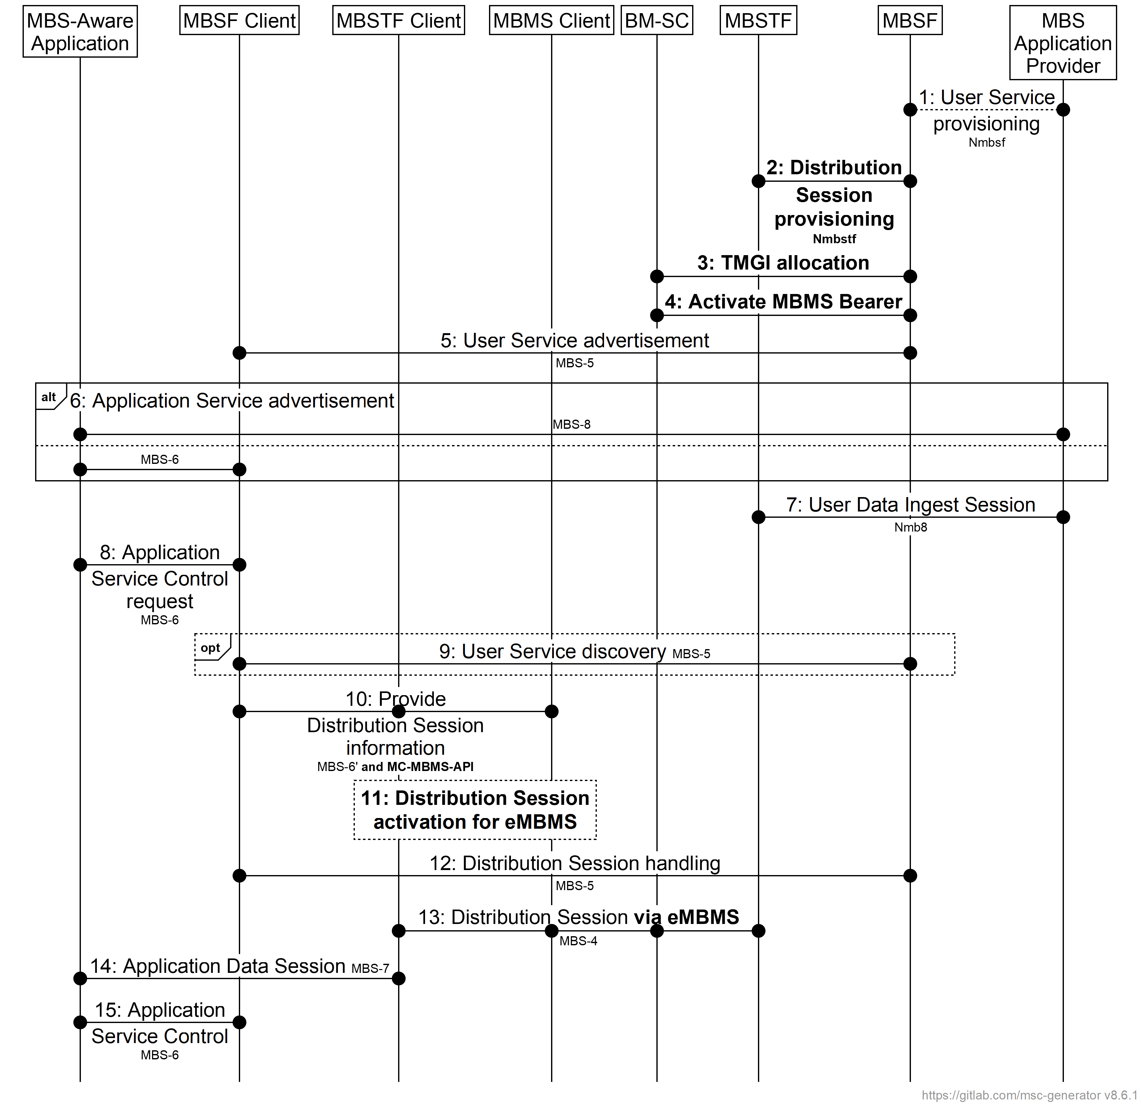

**Figure 5.7-1: MBS User Service high-level baseline procedures using Group Communication enablers and APIs**

The core extensions are:

- The Distribution Session provisioning, TMGI allocation and MBMS bearer allocation in steps 2, 3 and 4 are extended to address the allocation of bearers to support the MBMS distribution. The variant shown in the figure allows the MBSF to handle the communicaton with the MBSTF and BM-SC.

- In step 10, the MBSF Client provides information to the MBMS Client using the MC-MBMS-API in order to establish the MBMS bearer, involving also the MBSTF Client.

- In step 11, the MBMS Client activates the MBMS session to receive Group Communication data and the MBSTF Client activates the MBS User Services session to receive MBS data conveyed in the MBMS session.

- In step 13, MBS User Services session data is received through the MBMS bearer and directly provided to the MBSTF Client for relevant processing, for example FEC decoding, unicast repair determination and so on.