Source: Tencent
Title: AI/ML model format: TensorFlow
Document for: Agreement
Agenda Item: 9.7

Introduction
In this contribution, we introduce TensorFlow as an example format for AI/ML model distribution. TensorFlow is an open-source platform for building and deploying machine learning models that supports several formats for model distribution, including TensorFlow SavedModel, TensorFlow Lite, and TensorFlow.js.

- TensorFlow framework

TensorFlow is an open-source platform for creating and deploying machine learning models. It provides a wide range of tools (e.g., mode optimization) and libraries (decision forests, Ranking extensions…) for building and training models, and supports several formats for model distribution, including TensorFlow SavedModel, TensorFlow Lite, and TensorFlow.js. These formats allow models to be easily distributed across different platforms and devices, making it easier to deploy machine learning models in various applications.
- Tensor

In machine learning, a tensor is a multi-dimensional array of numerical data. A tensor may have any number of dimensions, and each dimension represents a specific feature or attribute of the data. For example, a 1-dimensional tensor usually represents a vector of values, such as a list of numbers, while a 2-dimensional tensor can represent a matrix of values, such as an image.

Tensors are are used to represent the input data and the parameters of the machine learning model. For example, in image recognition, the input data is often represented as a tensor of pixel values, while the parameters of the model, such as the weights and biases, are represented as tensors as well.

Operations applied to tensors can be addition, multiplication, and convolution. These operations are used to perform mathematical computations on the tensors, which are then used to train the machine learning model.

In summary, a tensor is a multi-dimensional array of numerical data that is a fundamental data structure used in many machine learning frameworks. It is used to represent the input data and the parameters of the machine learning model and is manipulated using mathematical operations to train the model.
- Usage of TensorFlow
The following steps are usually defined:

Definition of the computational graph: In TensorFlow, a machine learning model is represented as a computational graph, which is a series of operations (nodes) that are connected by edges. The nodes represent mathematical operations, such as addition, multiplication, or convolution, and the edges represent the flow of data between the nodes. To define the graph, developers use the TensorFlow API to create nodes and connect them in a specific order.
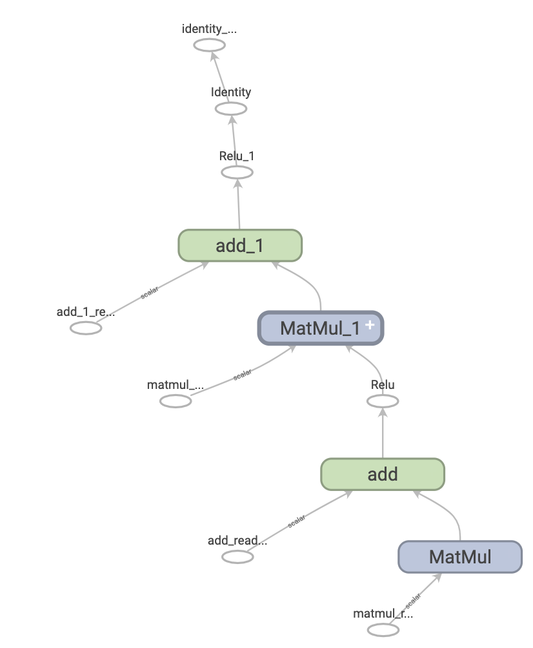
Source: https://www.tensorflow.org/guide/intro_to_graphs?hl=fr
TensorFlow graphs can be used in environments that don't have a Python interpreter, like mobile applications, embedded devices, and backend servers.

Variables Initialization: Before running the computational graph, the variables used in the graph need to be initialized. These variables represent the parameters of the machine learning model, such as weights and biases, and are updated during training to improve the model's performance.

Session execution: To execute the computational graph, a TensorFlow session is created. The session runs the graph by feeding input data into the graph and calculating the output. During training, the session updates the variables in the graph based on the loss function and optimization algorithm.

Model serialization: Once the model is trained, it can be saved in various formats for later use, such as TensorFlow SavedModel, TensorFlow Lite, or TensorFlow.js. These formats allow the model to be easily deployed on various platforms and devices, including mobile devices, web browsers, and embedded systems.
NOTE: it is expected to analyze:
- The different distribution AI/ML formats that can be used with the TensorFlow framework.
- The impacts of the selection of TensorFlow framework in terms of interoperability of the corresponding AI/ML formats.

Model deployment: To deploy the model, the saved model can be loaded into a new TensorFlow session and used to make predictions on new data. This can be done on a single machine, a cluster of machines, or in the cloud.

- Conclusion
It is proposed to list TensorFlow as part of the available framework for AI/ML model distribution in the Permanent document.

